Name:………………………………………………..Class:……..…Adm No:…….
OPENER EXAMINATION: TERM 1 2024
FORM 3
CHEMISTRY
2 HOURS

INSTRUCTIONS:
❖ Answer ALL questions in the spaces provided in the question paper
❖ All working must be clearly shown where necessary
❖ Candidates should answer the questions in English

1. Name the method of separation that can most suitably be used to separate the following mixtures
a) Gasoline from petroleum. (1mk)
……………………………………………………………………………………………
b) Benzoic acid and potassium carbonate. (1mk)
………………………………………………………………………………………………
c) Oil from cashew nuts. (1mk)
………………………………………………………………………………………………
2. The table below shows information about three solid substances A, B and C. Study it and answer the question that follow.
SOLID A | COLD WATER | HOT WATER
A | Soluble | Soluble
B | Insoluble | Insoluble
C | Insoluble | Soluble

Describe how you will separate the three solids from a mixture of these three. (3mks)
………………………………………………………………………………………………………………………………………………………………………………………………
………………………………………………………………………………………………
3. The diagram below shows the set-up that can be used to prepare and collect oxygen gas. Study it and answer the questions that follow.

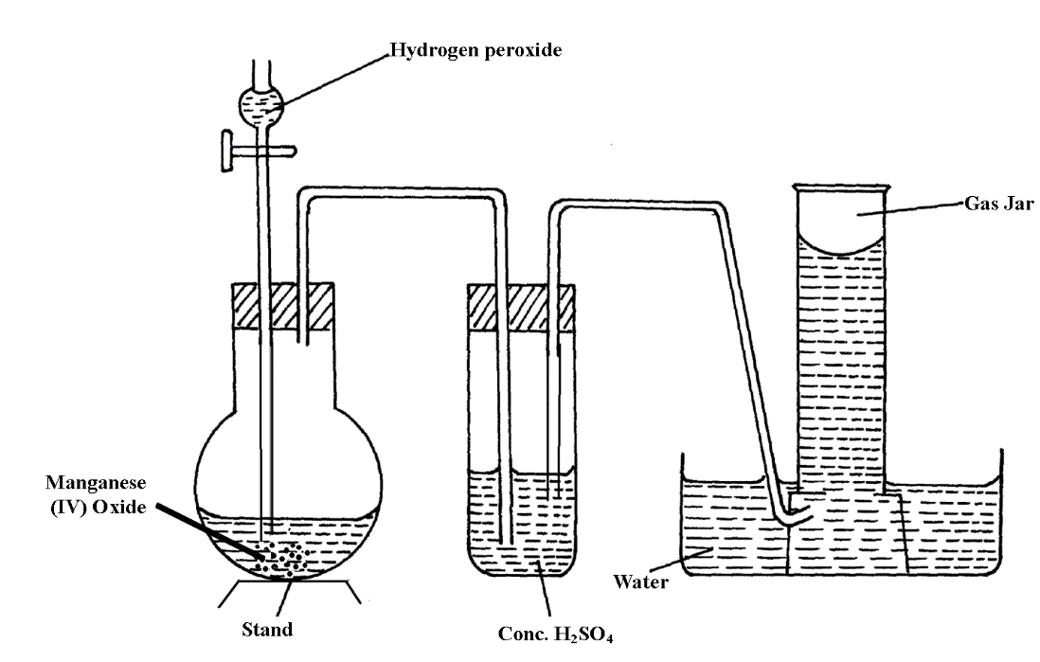

a) Identify two mistakes from the diagram which must be corrected for one to collect dry oxygen gas. (2mks)
………………………………………………………………………………………………………………………………………………………………………………………………
b) What property of oxygen gas makes it possible to be collected over water. (1mk)
…………………………………………………………………………………………
4. The table below gives information about some reactions of metals A,B, C and D and their rates.

METAL | Reaction with acid | Reaction with water | Action of heat on its nitrate
A | Hydrogen evolved | No reaction | Oxide formed
B | NO reaction | No reaction | Metal formed
C | Hydrogen evolved | Hydrogen evolved | Oxide formed
D | NO reaction | NO reaction | Oxide formed

Arrange the metals in order of decreasing activity (Starting with the most reactive) (2mks)

5. The table below gives information on four elements by letters K,L,M and N.Study it and answer the questions that follow. The letters do not represent the actual symbol of the elements
Element | Electron arrangement | Atomic radius (nm) | Ionic radius(nm)
K | 2.8.2 | 0.136 | 0.065
L | 2.8.7 | 0.099 | 0.181
M | 2.8.8.1 | 0.203 | 0.133
N | 2.8.8.2 | 0.174 | 0.099

a) Which two elements have similar properties? Explain (2mks)
………………………………………………………………………………………………………………………………………………………………………………………………
b) What is the most likely formula of the oxide of L? (1mk)
………………………………………………………………………………………………
c) Which element is a non – metal. Explain. (1mk)
…………………………………………………………………………………………
6. A student set- up the experiment below to collect gas K. The glass wool was heated before heating the zinc powder.
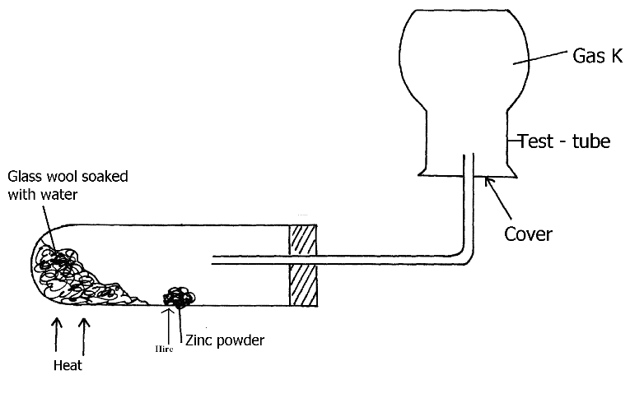
a) Why was it necessary to heat the moist glass wool before heating the zinc powder.(1mk)

b) What observation was made in the test-tube. (1mk)
………………………………………………………………………………………………………………………………………………………………………………………………
c) Explain why it’s not advisable to prepare hydrogen gas by reacting dilute sulphuric (vi) acid with calcium metal. (2mks)

7. Using dots(•) and crosses ( x) to represent the outermost electrons, draw the structure to show the bonding in CO₂ ( C = 6, O = 8) (3mks)

8. Name the particles responsible for the electrical conductivity of
a) Graphite (1mk)
………………………………………………………………………………………………
b) Molten Magnesium chloride. (1mk)
………………………………………………………………………………………………
9. Starting with calcium carbonate, describe how a solid sample of calcium sulphate can be
Prepared. (3mks)
………………………………………………………………………………………………………………………………………………………………………………………………
………………………………………………………………………………………………………………………………………………………………………………………………
………………………………………………………………………………………………………………………………………………………………………………………………
10. State and explain what would be observed when hydrogen gas is passed over heated copper (II) oxide in a combustion tube. (3mks)
………………………………………………………………………………………………………………………………………………………………………………………………………………
………………………………………………………………………………………………………………………………………………………………………………………………………………
11. Solution R, S and T have PH values shown in the table below:

Solution | pH value
R | 1.0
S | 6.5
T | 8.0

a) What do you deduce about the nature of solution R? (1mk)
………………………………………………………………………………………………………………………………………………………………………………………………
b) Which solution would react most vigorously with sodium hydrogen carbonate? (1mk)
……………………………………………………………………………………………
c) Which solution is likely to be ammonia solution? (1mk)
…………………………………………………………………………………………
12. (i) Compare the second ionisation of Magnesium with its first ionisation energy. (1mk)

(ii) Explain your answer in (i). (1mk)

- The electron arrangement of ions X⁺² and Y⁻³ are 2.8.8 and 2.8 respectively. Write the
electron arrangement of the atoms of
X (1mk)

Y (1mk)

14. (i) Which flame is produced when the air hole of a Bunsen burner is closed. (1mk)

(ii) What is the use of the Collar on a Bunsen burner? (1mk)

- State two differences between ionic bond and covalent bonding compounds. 2mks

- Group 8 elements are known as noble gases. Explain their lack of reactivity……..(2mk)

- Explain the following trends observed in the periodic table.
a) Atomic radii increases down the group in alkali metals 2mks

b) Melting point increases from sodium to aluminium in the third period. 2mks

c) Chlorine is more reactive than sulphur. 2mks

- Element M has an electronic configuration of 2.8.1. Element N forms ions by gaining two electrons and react with metals to form oxides. Element P has an atomic number of 17 and reacts with water forming acidic solutions. Element Q reacts with P forming a white solid
of formula QP. When a gas P is bubbled into colourless solution of MR, the solution turns
reddish brown. When a gas R is bubbled into a solution of MS a dark solid is formed.
- What is the valency of element P 1mk

- What is the change of ion of element N.? 1mk

- Write down the formula of the compound formed between M and N 1mk

- If element M is reacted with water, what would be the nature of the resulting
solution. Explain your answer. 3mks

- Write a balanced chemical equation for the reaction in (iv) above 2mks

- Identify elements R and S. 2mks

- Arrange elements P, R, S in order of their increasing reactivity. 1mk

- Write balanced equation for the reaction between gas P and solutions MR. 2mks

- The diagram below shows the flame of a bunsen burner with the air – holes open.

A

B

C

- On the diagram name the areas marked B and C. (1mk)

- Explain how the area marked B rises. (1mk)

- Explain how the area marked A would change when the air – holes are closed. (1mk)

- The diagram below shows two nails A and B wrapped with two different metal strips. Explain with reasons which of two nails will rust most if they are exposed to moist air. (3mks)

Magnesium strip Copper strip

21. The table below shows some properties and electrons arrangements of common ions of elements represented by letters P to X. Study the information in the table and answer the questions that follow.

Element | Formula of ion | Ion electron arrangement | Atomic radius (nm) | Ionic radius (nm)
P  Q  R  S  U  V  W  X | P²⁺  Q⁻  R⁺  S³⁺  U²⁺  V⁺  W⁺  X⁻ | 2:8:8  2:8  2:8:8  2:8  2:8  2:8  2  2:8:8 | 0.197  0.072  0.231  0.143  0.160  0.186  0.152  0.099 | 0.099  0.136  0.133  0.050  0.065  0.095  0.060  0.181

- (i) Give the atomic numbers of elements P and Q. (2mks)
P

Q

- Select elements that belong to the period 4 of the periodic table. (1mk)

- Select an elements that would react with cold water explosively evolving hydrogen gas.(1mk)

- Why is the ionic radius of element X larger than its atomic radius? (2mk)

- Write an equation for the reaction between S and Oxygen. (1mks)

22. The table below gives some properties of three substances A, B and C.
SUBSTANCE | A | B | C
Appearance | Brown solid | Yellow solid | Yellow solid
Melting point (ºC) | 1017 | 115⁰C | 402⁰C
Solubility in water | Insoluble | Insoluble | Sparingly
Electrical conductivity (solid) | Conducts | Does not conduct | Does not conduct
Electrical conductivity (liquid) | Conducts | Does not conduct | Conduct but decomposed
- Giving reasons for your answers, which of the substances A, B and C has
- Giant ionic lattice 2mks

- Simple molecular lattice 2mks

- Giant metallic lattice 2mks

- Why does C conduct electricity only in molten state but not in solid state 1mk

- Why is A not decomposed when it conducts electricity 1mk

- Explain in terms of structure and bonding why the melting point of B is lower than
that of C. 2mks

23. Salt is sprinkled on roads in Europe during winter to prevent formation of ice on roads. Explain how the salt works. (2mks)

24 .Study the information in the table below and answer the questions that follow.

Element | Atomic number | Melting point (⁰C)
P | 14 | 1410
Q | 16 | -235

In terms of structure and bonding explain the difference in the melting points. (3mks)

25 .The diagram below shows part of a temperature / time curve obtained when pure solid Naphthalene is heated.

D

B
C
Temperature
(⁰C)

A

Time / Minute
- Explain why part BC is horizontal. (1mk)

- On the axis above draw the curve for impure Naphthalene solid. (2mks)

26. (a) The relative atomic masses of some elements are not whole numbers. Explain. (1mk)

- An elements Gallium has relative atomic mass 69.8. In 100 atoms of Gallium 60atoms are Gallium 69 and 40 atoms are Gallium X.
Determine the value of X. (3mks)

27. (a) What is valency. (1mk)

(b) The valency of X is 3, what is the formula of its;
- Hydroxide. (1mk)

- Sulphate. (1mk)

