NAME: ____________________________ .ADM NO: ____________CLASS:__________

DATE: ______________________________ SIGN: _______________________
OPENER EXAMINATION: TERM 1 2024
FORM 2
CHEMISTRY

TIME: 2hours 30 minutes

INSTRUCTIONS: Answer all questions in the spaces provided

- a. Name two frequently abused drug (2mk)

b. State three long term effects of drug abuse. (3mks)

- a. Define Chemistry. (1mk)

b. Give two importance of studying Chemistry. (2mks)

- i) Identify the following apparatus and give a use for each (3mks)
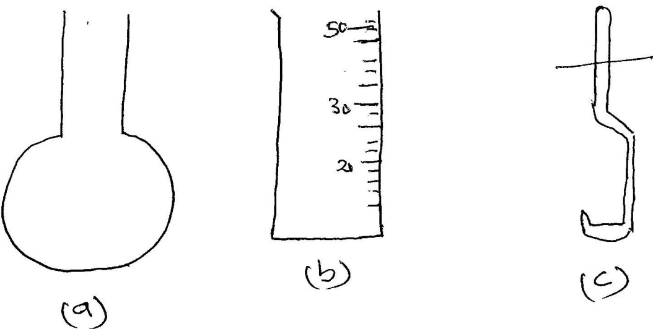

a.………………………………………..Use…………………………………………
b.………………………………………..Use………………………………………
c.………………………………………..Use…………………………………………

ii) Name another apparatus that can be used in place of (b) (1mk)

- Give four reasons why most apparatus are made of glass (4mks)

- a. What is a flame? (1mk)

b. The following diagram represent a type of flame produced by a Bunsen burner.
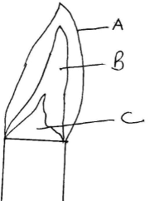

- Name the type of flame (1mk)

- The flame should be put off immediately after use or adjusted to another type of flame. Explain. (2mks)

- a. What is a mixture? (2mks)

b. Give the method used in separating the following mixtures (3mks
- Sand and water………………………………………………
- Petroleum fom crude oil………………
- Oil from groundnuts seeds………………………………

- a. Explain why water is not used as a solvent in extraction of nuts.
(2mks)

b. Name the solvent that is used in extraction of nuts.
(1mk)

- Samples of urine from three participants F, G and H at an international sports meeting were spotted onto a chromatography paper alongside two from illegal drugs A1 and A2. A chromatogram was run using methanol. The figure below shows the chromatogram.
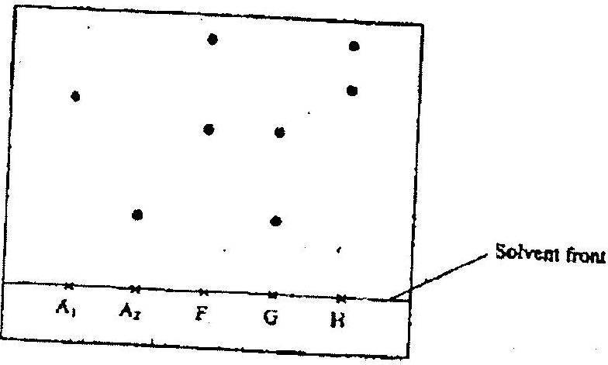
- Identify the athlete who had used an illegal drug. (1mk)

- Which drug is more soluble in methanol? (1mk)

- From the following list of compounds; zinc oxide, solid carbon (IV) oxide, sodium carbonate, nitric (V) acid, iron (III) chloride;
- Identify two that sublime. (2 mks)

- Identify a pair that react to form salt and water only. (2 mks)

- Write a word equation for the reaction between sodium carbonate and nitric (V) acid. (1 mk)

- A Magnesium ribbon was cleaned with steel wool and used in the following set up. Wet sand was heated before Magnesium ribbon.
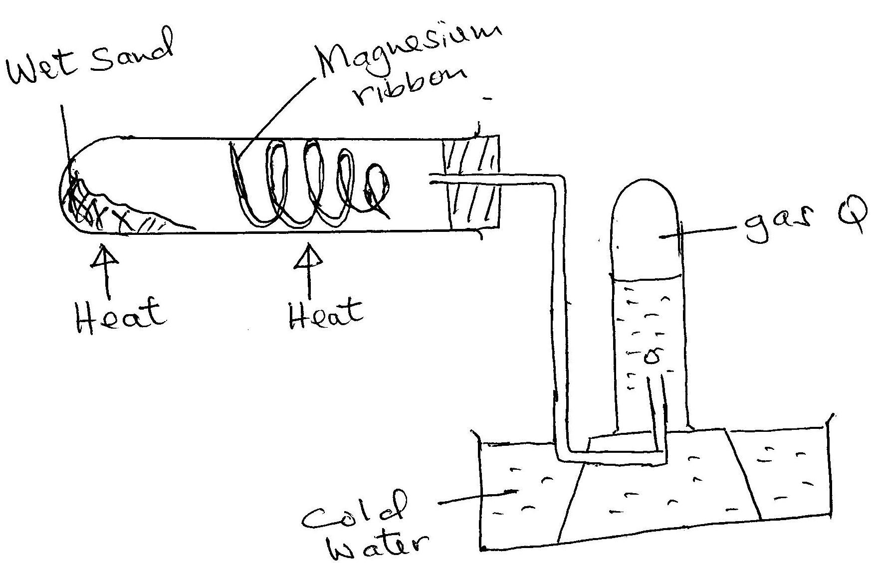
- Explain the following:
- Sand was heated first before heating Magnesium ribbon
(1mk)

- Magnesium ribbon was cleaned with steel wool
(1mk)

- Name gas R
(1mk)

- Write an equation for the reaction taking place in the combustion tube
(1mk)

- Name the method used to collect gas R
(1mk)

- Name the best method to use to separate the following mixtures.
(4 mks)
- Common salt and water.

- Coloured dyes in ethanol.

- Ammonium chloride and sodium chloride.

- Ethanol and water.

- A student was supplied with a colourless liquid suspected to be water.
- Describe one test that could be carried out to show that the liquid was water.
(2 mks)

- How could it have been shown that the liquid was pure water? (1 mk)

- When a student was stung by a stinging nettle plant, a teacher applied an aqueous solution of ammonia to the affected area of the skin and the student was relieved of pain. Explain. (2mks)

- A mixture of magnesium powder and lead (II)oxide will react vigorously when heated but no reaction occurs when a mixture of magnesium oxide and lead powder are heated.
- Explain the observations above. (2 mks)

- Write a word equation for the reaction between magnesium and lead(II) oxide.
(1 mk)

- From (b) above, identify the;

(i) oxidised substance. (1 mk)

(ii)oxidizing agent. (1 mk)
(iii)what name is given to such a reaction? (1 mk)
- Classify the following as either physical or chemical changes. (5 mks)
- Freezing of beer
- Rusting of iron
- Heating of glass until it melts
- Burning a candle.
- Heating copper (II) nitrate

- Use the information given below to answer the questions that follow:
Solution | G | H | I | J | K
pH | 1.5 | 6.5 | 13.0 | 7.0 | 8.0

- Which of the solutions would be used to relieve a stomach upset caused indigestion? (1mrk)
- Which solution is likely to be:, (2mrks)
    - Dilute sulphuric acid? (ii) Sodium hydroxide solution?
- The table shows the colours obtained when some indicators are added to solutions:-
Solution | Blue litmus paper | Indicator W
Distilled water | ………………….. | Colourless
Calcium hydroxide | Blue | Pink
Nitric acid | ………………………… | Colourless

  - Complete the table by filling in the missing colours (2mrks)
  - Identify indicator W (1mrk)

- Hydrogen can be prepared by reacting zinc with dilute hydrochloric acid.
  - Write a word equation for the reaction. (1mrk)

  - Name an appropriate drying agent for hydrogen gas. (1mrk)
  - Explain why copper metal cannot be used to prepare hydrogen gas. (1mrk)

- Write the chemical symbol for the elements;
i) Copper (1mk)

ii) Iron (1mk)
iii Calcium (1mk)
iv) Potassium (1mk)

v) Zinc (1mk)

- Moist iron wool was inverted over water. The set up was left to stand for 2 days
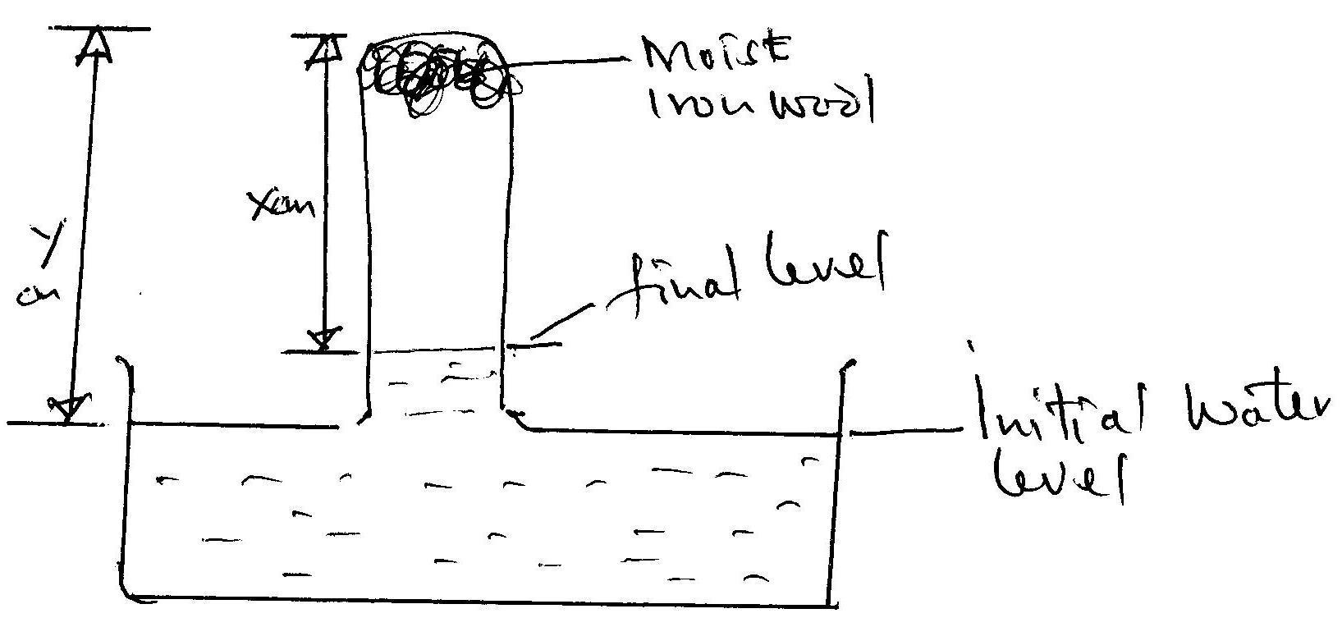
  - Explain whether rusting is a physical or chemical reaction (2mks)

  - Write an expression using X and Y to show the percentage of Oxygen (2mks)

  - What would be the effect of using a larger piece of iron wool? Explain. (2mks)

- Carbon (IV) oxide sublimes at -78ºC. It is called dry ice
  - Why is it called dry ice? (1mk)

  - It is used for keeping ice cream cold. Why is it preferred to ordinary ice? (2mks)

  - Name two other substances that behave as dry ice
(2mks)

  - Give an industrial application of sublimation
(1mk)

- In an experiment to investigate the percentage of oxygen in air,200cm³ of air was passed over heated copper turning repeatedly until a constant volume of air remained.160 cm³ of air remained at the end of the experiment.
  - Name one gas remaining in the 160 cm³ of air. (1 mk)

  - Determine the percentage of air used up during the experiment. (2 mks)

  - What observation would be made during the experiment. (1 mk)

  - Write a word equation for the reaction between copper and oxygen.
(2mks)

- A student left some crushed fruit mixture with water for some days. He found the mixture had fermented. He concluded that the mixture was contaminated with water and ethanol with boiling point of 100ºC and 78ºC respectively. The set-up of apparatus below was used to separate the mixture.

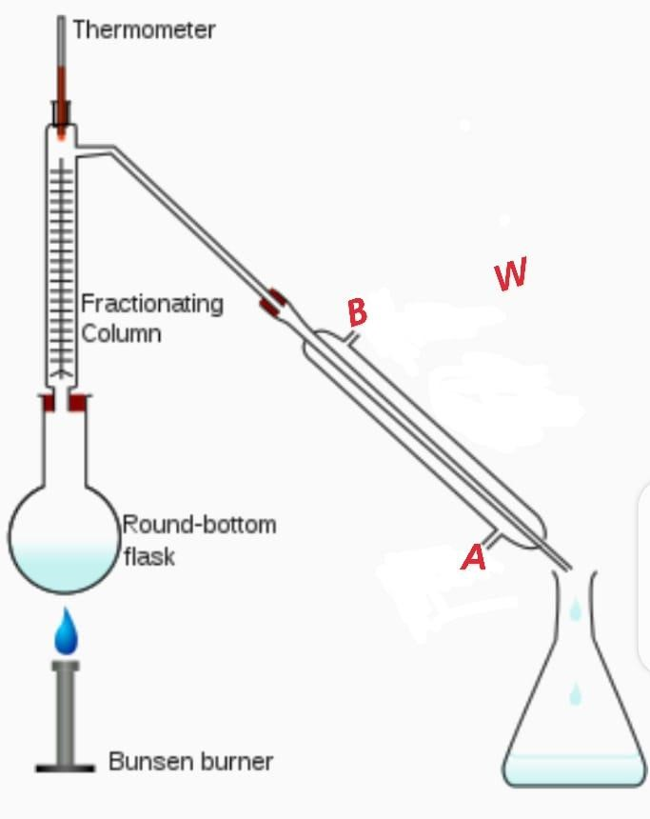

- Name the piece of apparatus labelled W . 1mrk

- What is the purpose of the fractionating column in the set-up?
1mrk

- At which end of the apparatus W should tap water be connected? 1mrk

- Which liquid was collected as the first distillate? Explain 2mrks

- What is the name given to the above method of separating mixture?
1mrk f. State two applications of the above method of separating mixtures
2mrks

