NAME:……………………………………………………ADM NO…………CLASS………….
OPENER EXAMINATION: TERM 1 2024
BIOLOGY
FORM 3
TIME:2 HRS
INSRUCTIONS
Answer All the questions in the space provided.
- Name the most appropriate tool that Biology students can use for collecting
- Crawling animals (1mk)
………………………………………………………………………………………………...……………………………………………………………………………………………………...
- Flying insects (1 mk)
………………………………………………………………………………………………...……………………………………………………………………………………………………...
- State the name given to the study of:
- Cells (1 mk)
………………………………………………………………………………………………...……………………………………………………………………………………………………...
- Classification of living organisms (1 mk)
………………………………………………………………………………………………...……………………………………………………………………………………………………...
- a) Define the term species (1 mk)
………………………………………………………………………………………………...……………………………………………………………………………………………………………………...
- A Tiger is known as Panthera Tigris
- Identify two mistakes made in writing the scientific name (2 mks)
………………………………………………………………………………………………...……………………………………………………………………………………………………...
………………………………………………………………………………………………...……………………………………………………………………………………………………...
- Explain why a Leopard and a tiger cannot breed yet they belong to the same genus (1 mk)
………………………………………………………………………………………………...……………………………………………………………………………………………………...
- A cell was magnified 200 times using a light microscope whose eye-piece lens magnification was X10. What was the magnification of the objective lens (3 mks)
………………………………………………………………………………………………...……………………………………………………………………………………………………………………...
………………………………………………………………………………………………...……………………………………………………………………………………………………..……………….
- The cell structure below was observed under the light microscope

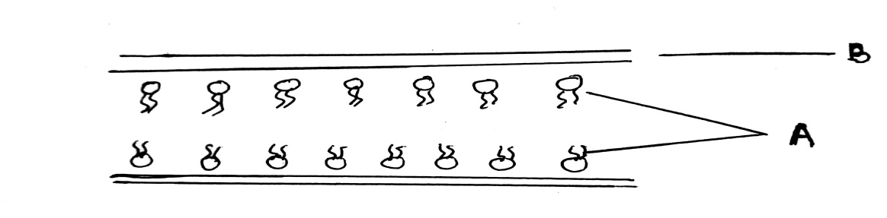

- Identify the cell structure (1 mk)
………………………………………………………………………………………………...…………………………………………………………………………………………..………………...
- Name the labeled parts A and B (2 mks)
A…………………………………………………………………………………………………….
B ……………………………………………………………………………………………………
- State one function of the above structure (1 mk)
………………………………………………………………………………………………...……
…………………………………………………………………………………………………..…...

- In an experiment equal amounts of three different sugar solutions were placed in the risking tubings X, Y and Z. the tubings were placed in a beaker of water containing 5% sugar solution. The set up was left for two hours. The results were as shown in the diagram below.
- 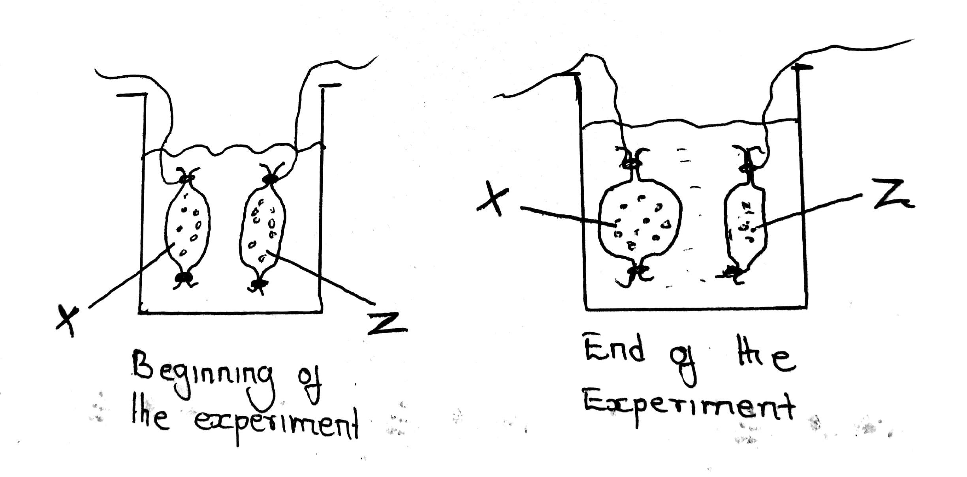

- Name the process being investigated in the experiment (1 mk)
………………………………………………………………………………………………...……………………………………………………….…………………………………………………...
- Account for the observations made at the end of the experiment (3 mks)
………………………………………………………………………………………………...…………………………………………………………………………………………………………...
………………………………………………………………………………………………...……………………………………………………………………………………………..…………...
- State three importance of the process named in (a) above in living organisms (3 mks)
………………………………………………………………………………………………...………………………………………………………………………………………………….………...
………………………………………………………………………………………………...……………………………………………………………………………………………….…………...
- i) Name the carbohydrates that is (3 mks)

- Found in abundance in mammalian blood
………………………………………………………………………………………………...…………………………………………………………………………………………..………………...
- Stored in mammalian liver
………………………………………………………………………………………………....……………………………………………………………………………………………..……………...
- Stored in plant seeds
………………………………………………………………………………………………...…………………………………………………………………………………………………………...
ii) List two importance of water in living organisms (2 mks)
………………………………………………………………………………………………...……………………………………………………………………………………………………………………...
………………………………………………………………………………………………...……………………………………………………………………………………………………………………...
- The enzyme pepsin and trypsin are secreted as inactive precursors:
- What are the name of the precursors (2 mks)
………………………………………………………………………………………………...…………………………………………………………………………………………………………...
………………………………………………………………………………………………...…………………………………………………………………………………………………………...
- Why are they secreted in an inactive form (1 mk)
………………………………………………………………………………………………...……………………………………………………………………………………………….…………...
………………………………………………………………………………………………...…………………………………………………………………………………………………..………...
- State two structural and two environmental factors that affect the rate of transpiration
- Structural (2 mks)
…………………………………………………………………….……………………….…...………………………………………………………………..…………………………………………...
……………………………………………………….…………………………………….…...………………………………………………………………..…………………………………………...
- Environmental (2 mks)
…………………………………………………………………….……………………….…...………………………………………………………………..…………………………………………...
……………………………………………………….…………………………………….…...

- The diagram below is a transverse section of a certain part of a dicotyledonous plant
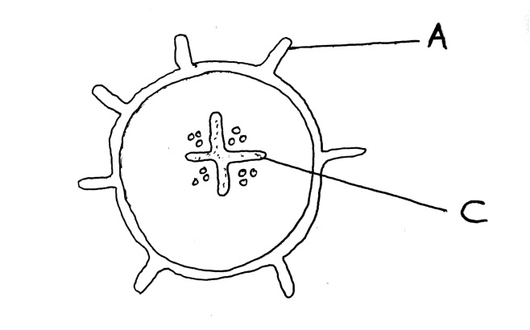
- Which part of the plant was the section made from (1 mk)
…………………………………………………………………….……………………….…...………………………………………………………………..………………………………………
- Give reasons for your answer (1 mk)
…………………………………………………………………….……………………….…...………………………………………………………………..………………………………………
- State the functions of the parts labeled A and C (2 mks)
A…………………………………………………………………….……………………….…...………………………………………………………………..……………………………………….
C…………………………………………………………………….……………………….…...………………………………………………………………..………………………………………
- Give an example of an animal with (2 mks)
- Open circulatory system
…………………………………………………………………….……………………….…...………………………………………………………………..…………………………………………...
- Closed circulatory system
…………………………………………………………………….……………………….…...………………………………………………………………..…………………………………………..

- The diagram below show the internal structure of a mammalian heart

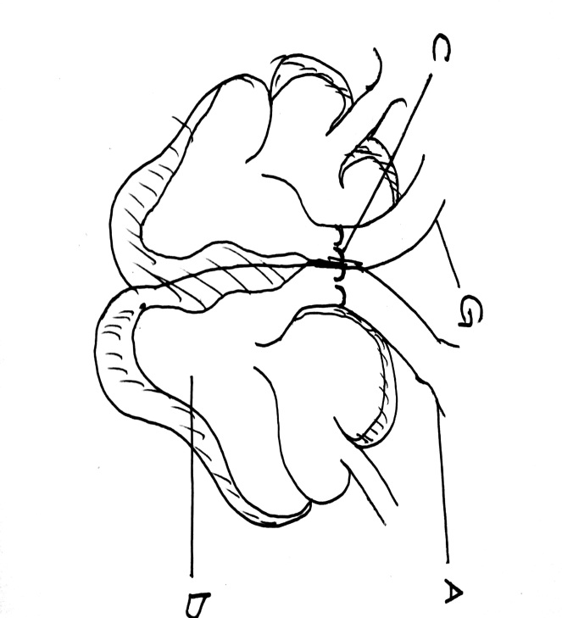
- Using arrows show the direction of blood flow in and out of the heart ( 2mks)
…………………………………………………………………….……………………….…...………………………………………………………………..………………………………………
- Name the parts labeled (2 mks)
A…………………………………………………………………….……………………….…...…
C…………………………………………………………………….……………………….…...…
- The muscular wall of chamber D is at least three times thicker than the wall of chamber E. give a reason for this difference (1 mk)
…………………………………………………………………….……………………….…...………………………………………………………………..………………………………………
- Name two special characteristics of heart muscles which distinguishes it from other parts of muscles (2 mks)
…………………………………………………………………….……………………….…...………………………………………………………………..………………………………………
……………………………………………………….…………………………………….…...………………………………………………………………..………………………………………
- In what way does the artery labeled G differ from other arteries in the body (1 mk)
…………………………………………………………………….……………………….…...………………………………………………………………..………………………………………

- The figure below is a diagram of a vertical section of a mammalian tooth

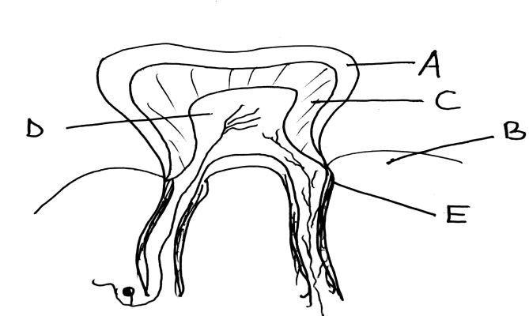

- Name the parts labeled A – F (5 mks)
A……………………………………….. D………………………….………………….
B……………………………………….. E……………………………………………...
C ………………………………………..

- How are the structures labeled A and D adapted to their functions (2 mks)
…………………………………………………………………….……………………….…...………………………………………………………………..………………………………………
- List down three ways of preventing teeth diseases (3 mks)
…………………………………………………………………….……………………….…...………………………………………………………………..………………………………………
……………………………………………………….…………………………………….…...………………………………………………………………..………………………………………

- a) Give two reasons why clotting of blood is important (2 mks)
…………………………………………………………………….……………………….…...….………………………………………………………..…………..…………………………………………...
……………………………………………………….…………………………………….…...……..…………………………………………………………..…………………………..……………………...

b) Name one enzyme and one metal ion that are required in the blood clotting process (2 mks)
…………………………………………………………………….……………………….…...….………………………………………………………..…………..…………………………………………...
……………………………………………………….…………………………………….…...……..…………………………………………………………..…………………………..……………………...
c) Explain why excessive bleeding may lead to death of a patient (3 mks)
…………………………………………………………………….……………………….…...….………………………………………………………..…………..…………………………………………...
……………………………………………………….…………………………………….…...……..…………………………………………………………..…………………………..……………………...
- Explain why deficiency of vitamin K leads to excessive bleeding even from small cuts (1 mk)
…………………………………………………………………….……………………….…...….………………………………………………………..…………..…………………………………………...
……………………………………………………….…………………………………….…...……..…………………………………………………………..…………………………..……………………...
- State and Explain five factors that determine energy requirements in human beings (10 mks)
…………………………………………………………………….……………………….…...….………………………………………………………..…………..……………………………………...……
…………………………………………………………………….……………………….…...….………………………………………………………..…………..……………………………………...……
…………………………………………………………………….……………………….…...….………………………………………………………..…………..……………………………………...……
…………………………………………………………………….……………………….…...….………………………………………………………..…………..……………………………………...……………………………………………………………………………………………………………….................................................................................................................................................................…
…………………………………………………………………….……………………….…...….………………………………………………………..…………..……………………………………...……
17. Explain how the blood vessels are involved in thermo-regulation (4mks)
…………………………………………………………………………………………………………………………………………………………………………………………………………………………………………………………………………………………………………………………………………………………………………………………………………………………………………………………………………………………………………………………………………………………………………………………………………………………………………………………………………………………………………………………………………………………………………………………………………………………………………………………………………………………………………………………………………………………………………………………...........
18. Give 5 parts of a light microscope and their functions (10mks)
.............................................................................................................................................................................................................................................................................................................................................................................................................................................................................................................................................................................................................................................................................................................................................................................................................................................................................................................................................................................................................................................................................................................................................................................................................................................................................................................................................................................................................................................................................................................................................................................................................................................................................................................................................................................................................................................................................................................................................................................................................................................................................................................................................................................................................................................................................................................................................................................................................................................................

19. Describe inhalation and exhalation in mammals (10mk)
………………………………………………………………………………………………………………………………………………………………………………………………………………………………………………………………………………………………………………………………………………………………………………………………………………………………………………………………………………………………………………………………………………………………………………………………………………………………………………………………………………………………………………………………………………………………………………………………………………………………………………………………………………………………………………………………………………………………………………………………………………………………………………………………………………………………………………………………………………………………………………………………………………………………………………………………………………
………………………………………………………………………………………………………………………………………………………………………………………………………………………………………………………………………………………………………………………………………………………………………………………………………………………………………………………………………………………………………………………………………………………………………………………………………………………………………………………………………………………………………………………………………………………………………………………………………………………………………………………………………………………………………………………………………………………………………………………………………………………………………………………………………………………………………………………………………………………………………………………………………………………………………………………………………………………………………………………………………………………………………………………………………………………………………………………………………………………………………………………………………………………………………………………………………………………………………………………………………………………………………………………………………………………………………………………………………………………………………………………………………………………………………………………………………………………………………………………………………………………………………………………...........................................................

