NAME…………………………………………………ADM. NO………………CLASS………
OPENER EXAMINATION: TERM 1 2024
BIOLOGY
FORM 2
TIME:2HRS
INSTRUCTIONS
Answer all the questions in the spaces provided.

- What is biology?
(1 mark)

- Give two skills gained by a student learning Biology. (2mks)

3a) Name the unit of classification that has the least organisms (1mk)

4. What is the importance of using a hand lens in classification of organisms (1 mark)

5.State two main branches of biology. (2 marks)

6.Define each of the following terminologies as used in biology : (2 marks)
a). Ecology

b). Anatomy

7. What characteristics of living organisms is represented by the following characteristics:
a)A cat producing kittens.

(1mk)

b) A girl dropping a hot pan.

(1mk)

c) The exhalation of carbon (IV) oxide.
(1mk)

8. Draw and label the external structures of a leaf (4mks)

9 a) An electron microscope has a much greater resolving power than a light microscope. Explain the meaning of the term resolving power.

(1 mark)

b) Give a reason why an electron microscope cannot be used to study life specimen. (1 mark)

10. What is taxonomy? (1mk)

11. Give two reasons why classification is important in biology. (2marks)

12. (a) Distinguish between growth and development. (2marks)

(b) State the importance of growth in living organisms. (1mark)

13.During a practical lesson to estimate the size of a cell, using the sketch below which some students observed, calculate the length of one cell in micrometers given that the field of view was 8mm wide. (3 marks)
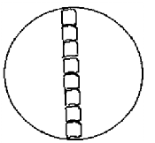

14. a) What is meant by the term Entomology. (1 mark)

b) The diagram below represents a certain apparatus used by biology students.
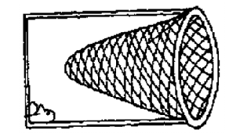
- Name the apparatus above. (1mark)

(ii) State the role of the apparatus named in b) (i) above. (1 mark)

15. Black jack (Bidens pilosa) belongs to the family Compositae.
What is it’s:
Genus. (1 mk)

Species. (1 mk)

16. a ) Define the term cell. (1 mk)

b) i) Identify the organelle represented by the diagram below. (1 mk)

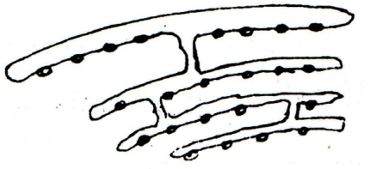

ii) State the function of the organelle identified in 2b(i) above. (1 Mark)

17. If a light microscope had an eye piece lens of X25 and an objective lens of X40, what would
the total magnification be? (2 mks)

18. State the importance of each of the following process in living things. (3 mks)
i. Respiration.

ii. Gaseous exchange

iii. Reproduction

19. Give a reason why each of the following steps are followed when preparing cross sections
of a leaf for examination under a microscope: (4mks)
a) Cutting very thin sections

b) Using sharp razor blade (scalpel) during cutting.

c) Placing the sections in water

d) Staining the sections with iodine before observing under a microscope.

20. State four properties of Enzymes (4mks)

23.Below is a structure found in plants.

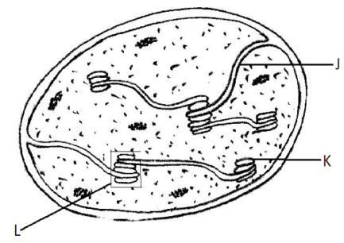

Name the organelle. (1 mk)

What is the role of the organelle you have named in (a) above. (1 mk)

Name the parts labeled J and L. (3 mks)
J

L

24. Name the five major kingdoms of classification (5mks)

25. The diagram below represents the structure of a light microscope. Study it and answer the
questions that follow.

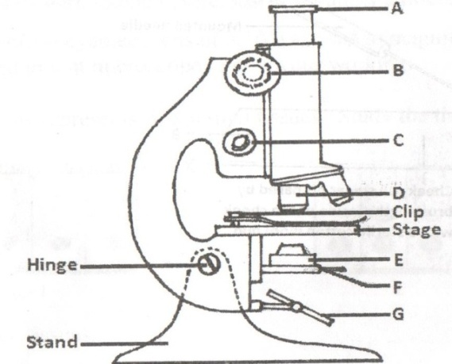

- Name the parts of the microscope labeled A to G. (7 mks)

B )State the functions of each of the parts marked E and F. (2 mks)
E

F

e) State 2 differences between light microscope and electron microscope (2mks)

26. The diagram below shows a cell as seen under a microscope.

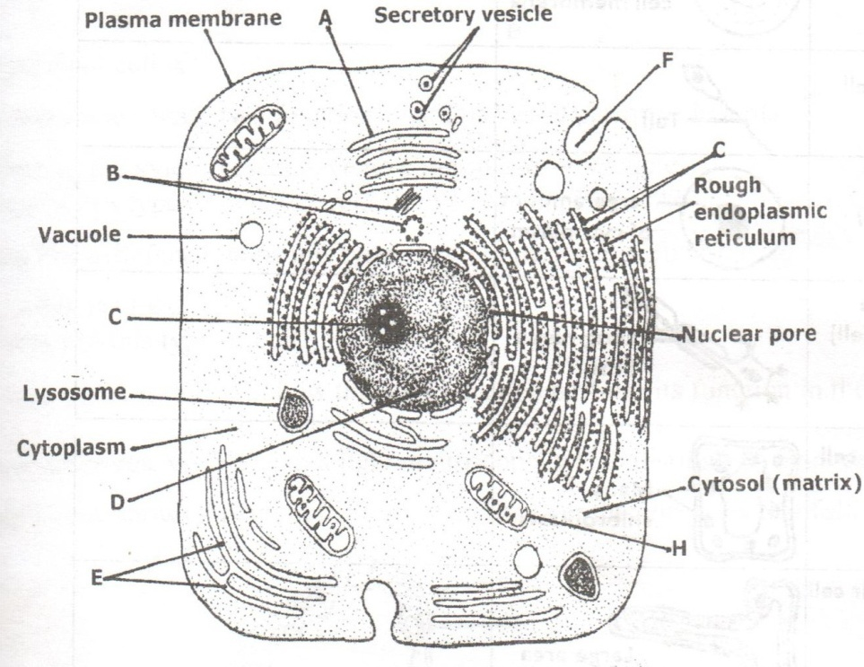

a)i. Is this observation under a light or an electron microscope? (1 mk)

ii. Give a reason for your answer. (1 mk)

i. Is this an animal or a plant cell? (1 mk)

ii. Give a reason for your answer in (b) (i) (1 mk)

b)Name the parts labeled A, B , C, E, H (5makrs)

27. Briefly and adequately explain how plants compensate for lack of movement in a constantly changing environment. (2 marks)

28. Explain 5 adaptations of the leaf for photosynthesis (10mks)

29. State 5 differeces between plants and animals (10mks)

