NAME: …………………………………………… ADM NO: ……….. CLASS: ………….
OPENER EXAMINATION: TERM 1 2024
443/1
AGRICULTURE
FORM FOUR
TIME: 2 HOURS

INSTRUCTIONS:
This paper has three sections; A, B and C. Answer all questions in section A and B. In section C, answer two questions only.

SECTION A: 30 MARKS)
Answer all the questions from this section.
1. Name three branches of horticulture. (1 ½ mks)

2. State four advantages of organic farming. (2 mks)

3. What is the importance of decomposers in agriculture. (1 mk)

4. State the three basic economic concepts. (1 ½ mks)

5. (a) What is concession company. (1m k)

(b) Give two examples of individual land tenure system. (1 mk)

6. (a) Differentiate between solifluction and landslide. (2 mks)

(b) Name four types of landslides. (2 mks)

7. Give three control measures of Blossom-end-rot disease. (1 ½ mks)

8. How are crop pests classified according to the mode of feeding? (2 mks)

9. State any three effects of diseases to crops. (1 ½ mks)

10. State six effects of weeds in a pasture crop. (3 mks)

11. List two ways of classifying herbicides based on mode of action. (1 mk)

12. State four factors considered when grading tomatoes for food market. (2 mks)

13. Give a possible cause of swelling on roots of legumes. (1 mk)

14. What is a companion crop? (1 mk)

15. List two main methods of pruning. (2 mks)

16. State two functions of polythene sheet when used as mulch material. (1 mk)

17. Give any four factors that influence seed rates. (2 mks)

SECTION: (20 MARKS)
Answer all the questions from this section.

18. The diagram below illustrates a crop. Study it and answer the questions below.

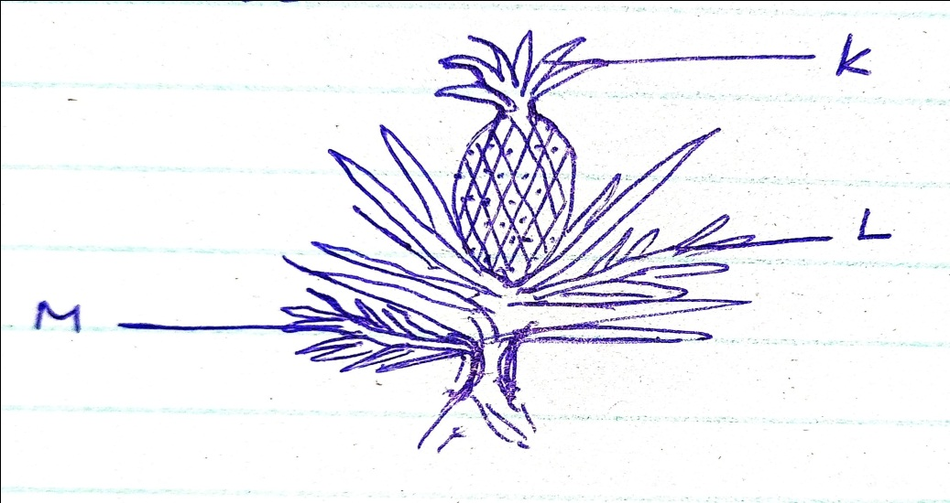
(a) Identify the parts labeled K, L and M. (3 mks)
K __________________________ L ____________________

M __________________________

(b) Apart from the parts mentioned above, list down five other vegetative materials used for
crop propagation. (2 ½ mks)

19. Study the diagram below and answer the questions that follow.

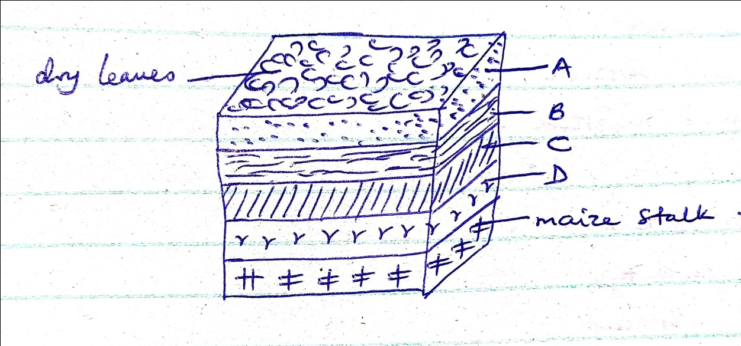

(i) What are the dimensions of the figure shown above? (1 mk)

(ii) Name the parts labeled A, B, C and D. (2 mks)

(iii) State the importance of level A in this set up. (1 mk)

(iv) State two factors considered when selecting a site for a compost pit. (2 mk)

20. A farmer with one hectare of land requires 40kg of N in his farm. He applied C.A.N. which
costs Ksh 35 per kg. C.A.N. contains 20kg N.
(a) Calculate the amount of CAN the farmer requires. (2 mks)

(b) How much will a farmer with one and a half hectares spend to apply in his farm?
(3 mks)

(c) List five characteristics of nitrogenous fertilizers. (2 ½ mks)

(d) State the two methods employed during soil sampling. (1 mk)

SECTION C: (40 MARKS)
Answer any two questions from this section.

21. (a) Discuss the importance of crop rotation to a farmer. (12 mks)

(b) Discuss the factors that determine harvesting of a crop. (8 mks)

22. (a) Discuss the process of water treatment using a chemical treatment system(12 mks)

(b) State and explain various methods used during land clearing. (8 mks)

23. (a) Explain various harmful effects of weeds. (10 mks)

(b) State ten cultural methods employed in pest control. (10 mks)

…………………………………………………………………………………………………………………………………………………………………………………………………………………………………………………………………………………………………………………………………………………………………………………………………………………………………………………………………………………………………………………………………………………………………………………………………………………………………………………………………………………………………………………………………………………………………………………………………………………………………………………………………………………………………………………………………………………………………………………………………………………………………………………………………………………………………………..
…………………………………………………………………………………………………………………………………………………………………………………………………………………………………………………………………………………………………………………………………………………………………………………………………………………………………………………………………………………………………………………………………………………………………………………………………………………………………………………………………………………………………………………………………………………………………………………………………………………………………………………………………………………………………………………………………………………………………………………………………………………………………………………………………………………………………………..
………………………………………………………………………………………………………………………………………………………………………………………………………………………………………………………………………………………………………………………………………………………………………………………………………………………………………………………………………………………………………………………………………………………………………………………………………………………………………………………………………………………………………………………………………………………………………………………………………………………………………………………………………………………………………………………………………………………………………………………………………………………………………………………………………………………………………….
…………………………………………………………………………………………………………………………………………………………………………………………………………………………………………………………………………………………………………………………………………………………………………………………………………………………………………………………………………………………………………………………………………………………………………………………………………………………………………………………………………………………………………………………………………………………………………………………………………………………………………………………………………………………………………………………………………………………………………………………………………………………………………………………………………………………………………..
…………………………………………………………………………………………………………………………………………………………………………………………………………………………………………………………………………………………………………………………………………………………………………………………………………………………………………………………………………………………………………………………………………………………………………………………………………………………………………………………………………………………………………………………………………………………………………………………………………………………………………………………………………………………………………………………………………………………………………………………………………………………………………………………………………………………………………..
…………………………………………………………………………………………………………………………………………………………………………………………………………………………………………………………………………………………………………………………………………………………………………………………………………………………………………………………………………………………………………………………………………………………………………………………………………………………………………………………………………………………………………………………………………………………………………………………………………………………………………………………………………………………………………………………………………………………………………………………………………………………………………………………………………………………………………..
…………………………………………………………………………………………………………………………………………………………………………………………………………………………………………………………………………………………………………………………………………………………………………………………………………………………………………………………………………………………………………………………………………………………………………………………………………………………………………………………………………………………………………………………………………………………………………………………………………………………………………………………………………………………………………………………………………………………………………………………………………………………………………………………………………………………………………..
…………………………………………………………………………………………………………………………………………………………………………………………………………………………………………………………………………………………………………………………………………………………………………………………………………………………………………………………………………………………………………………………………………………………………………………………………………………………………………………………………………………………………………………………………………………………………………………………………………………………………………………………………………………………………………………………………………………………………………………………………………………………………………………………………………………………………………..
…………………………………………………………………………………………………………………………………………………………………………………………………………………………………………………………………………………………………………………………………………………………………………………………………………………………………………………………………………………………………………………………………………………………………………………………………………………………………………………………………………………………………………………………………………………………………………………………………………………………………………………………………………………………………………………………………………………………………………………………………………………………………………………………………………………………………………..
…………………………………………………………………………………………………………………………………………………………………………………………………………………………………………………………………………………………………………………………………………………………………………………………………………………………………………………………………………………………………………………………………………………………………………………………………………………………………………………………………………………………………………………………………………………………………………………………………………………………………………………………………………………………………………………………………………………………………………………………………………………………………………………………………………………………………………..
…………………………………………………………………………………………………………………………………………………………………………………………………………………………………………………………………………………………………………………………………………………………………………………………………………………………………………………………………………………………………………………………………………………………………………………………………………………………………………………………………………………………………………………………………………………………………………………………………………………………………………………………………………………………………………………………………………………………………………………………………………………………………………………………………………………………………………..
…………………………………………………………………………………………………………………………………………………………………………………………………………………………………………………………………………………………………………………………………………………………………………………………………………………………………………………………………………………………………………………………………………………………………………………………………………………………………………………………………………………………………………………………………………………………………………………………………………………………………………………………………………………………………………………………………………………………………………………………………………………………………………………………………………………………………………..
…………………………………………………………………………………………………………………………………………………………………………………………………………………………………………………………………………………………………………………………………………………………………………………………………………………………………………………………………………………………………………………………………………………………………………………………………………………………………………………………………………………………………………………………………………………………………………………………………………………………………………………………………………………………………………………………………………………………………………………………………………………………………………………………………………………………………………..
…………………………………………………………………………………………………………………………………………………………………………………………………………………………………………………………………………………………………………………………………………………………………………………………………………………………………………………………………………………………………………………………………………………………………………………………………………………………………………………………………………………………………………………………………………………………………………………………………………………………………………………………………………………………………………………………………………………………………………………………………………………………………………………………………………………………………………..
…………………………………………………………………………………………………………………………………………………………………………………………………………………………………………………………………………………………………………………………………………………………………………………………………………………………………………………………………………………………………………………………………………………………………………………………………………………………………………………………………………………………………………………………………………………………………………………………………………………………………………………………………………………………………………………………………………………………………………………………………………………………………………………………………………………………………………..
………………………………………………………………………………………………………………………………………………………………………………………………………………………………………………………………………………………………………………………………………………………………………………………………………………………………………………………………………………………………………………………………………………………………………………………………………………………………………………………………

…………………………………………………………………………………………………………………………………………………………………………………………………………………………………………………………………………………………………………………………………………………………………………………………………………………………………………..
…………………………………………………………………………………………………………………………………………………………………………………………………………………………………………………………………………………………………………………………………………………………………………………………………………………………………………………………………………………………………………………………………………………………………………………………………………………………………………………………………………………………………………………………………………………………………………………………………………………………………………………………………………………………………………………………………………………………………………………………………………………………………………………………………………………………………………..
…………………………………………………………………………………………………………………………………………………………………………………………………………………………………………………………………………………………………………………………………………………………………………………………………………………………………………………………………………………………………………………………………………………………………………………………………………………………………………………………………………………………………………………………………………………………………………………………………………………………………………………………………………………………………………………………………………………………………………………………………………………………………………………………………………………………………………..
………………………………………………………………………………………………………………………………………………………………………………………………………………………………………………………………………………………………………………………………………………………………………………………………………………………………………………………………………………………………………………………………………………………………………………………………………………………………………………………………

