NAME: ………………………………… ADM NO: …………. CLASS: ……………
OPENER EXAMINATION: TERM 1 2024
FORM THREE
AGRICULTURE
TIME: 1 HOUR 45 MINS

INSTRUCTIONS:
- This paper has two sections; A and B.
- Answer all questions in section A and B in the spaces provided after the question.

SECTION A: (60 MARKS)
1. State four methods of applying fertilizers when producing crops. (4 mks)

2. State four characteristics of plants used for green manure. (4 mks)

3. Name four factors that determine the spacing of a crop. (4 mks)

4. Name four methods of clearing land before primary cultivation. (2 mks)

5. Give the field practice described by each of the following statements. (3 mks)

(i) Replacement of a destroyed seedling ……………………………………….
(ii) Uprooting excess seedlings ……………………………………………………….
(iii) Uprooting and destroying affected seedlings ……………………………

6. State four types of records kept by a maize farmer. (2 mks)

7. Define the following as applied in agriculture. (2 mks)

(i) Crop pathology –

(ii) Entomology –

8. Mention four divisions in livestock farming. (4 mks)

9. Give two underground water sources in the farm. (1 mk)

10. Calculate the plant population per hectare of maize crop planted at a spacing of 100cm x
50cm. Show your working. (2 mks)

11. State four climatic factors that influence the process of soil formation. (2 mks)

12. The diagram below shows a common field pest.
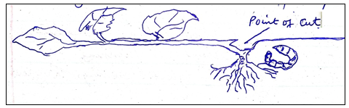
(a) Identify the pest shown above. (1 mk)

(b) Name two crops commonly attacked by the pest. (2 mks)

(c) State one control measure of the pest. (1 mk)

13. The diagram below shows a tertiary operation in the field.
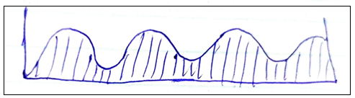
(a) Name the field practice above. (1 mk)

(b) State the importance of the practice named in (a) above. (1 mk)

(c) Apart from the practice above, name two other tertiary operations in the field. (2 mks)

14. (a) Define the term layering. (1 mk)

(b) Use the diagram below to answer the questions that follow.
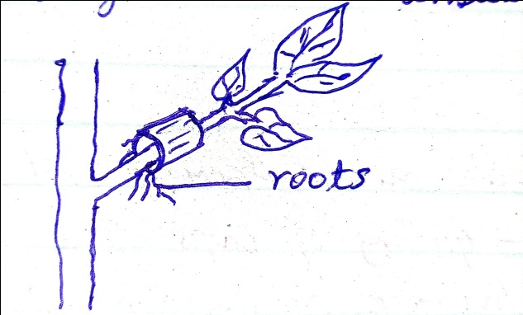
(i) Identify the type of layering shown above. (1 mk)

(ii) Apart from the type named in (i) above, name three other types practiced by farmers. (3 mks)

15. A farmer was advised to apply 200kg CAN/h while top dressing while topdressing the maize
crop. CAN contains 20% nitrogen.
(a) Calculate the amount of nitrogen applied/h. (2 mks)

(b) If CAN fertiliser costs Kshs 150 per kg, how much did the farmer spend to buy the fertiliser? (2 mks)

16. State four characteristics of fertile soils. (4 mks)

17. Name four constituents that make up soil. (4 mks)

18. Differentiated between mixed farming and mixed cropping. (2 mks)

19. Name three methods used in table formation in tea using pegs. (3 mks)

SECTION B: (40 MARKS)
20. The diagram below shows a digestive system of a farm animal.
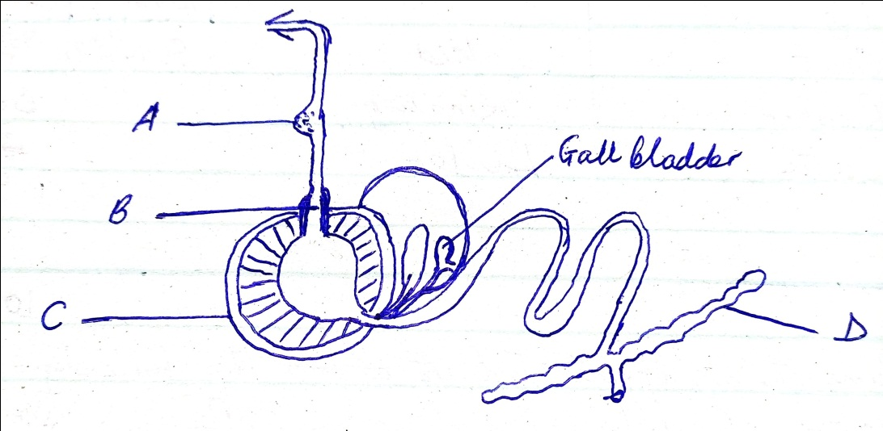
(a) Name one example of a farm animal with the system above. (1 mk)

(b) Name the parts labeled D, C, B and A. (4 mks)

(c) State two functions of a gall bladder in a mammal. (2 mks)

(d) State three adaptations of part C to its function. (3 mks)

21. (a) A farmer is to prepare a ration containing 20% DCP using cotton seedcake and maize meal
containing 30% DCP AND 15% DCP respectively. Calculate the amount of each feedstuff
the farmer requires to constitute a bag of 60kg. Show your working. (4 mks)

22. Fill in the table below with the correct term.
ANIMAL | FROM BIRTH TO  WEANING | ADULT
…………………  Pig  Goat  Rabbit  ………………… | ………………………….  ………………………….  ………………………….  …………………………..  Heifer | Ram  ……………….  ………………. | ……………….  ……………….  ………………..  Doe  ………………..  .
23. Name the appropriate tool to perform the following: (6 mks)
(i) Cutting hard branches in coffee ………………………………………..
(ii) Cutting wood along the grains ………………………………………..
(iii) Measuring squareness on a piece of wood …………………………..
(iv) Cutting thick sheets of metal …………………………………………..
(v) Placing mortar between construction stones ……………………………
(vi) Driving in and removing nails from wood …………………………….

24. Below is a diagram of a livestock parasite. Use it to answer the questions that follow.

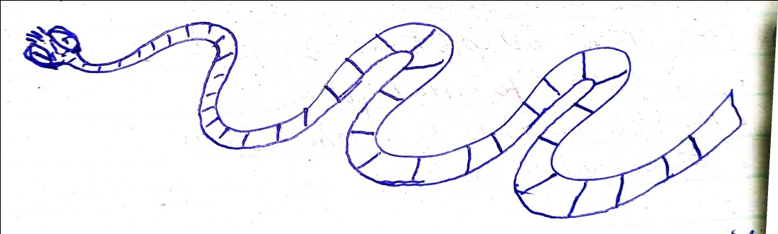

(a) Name two intermediate hosts of the parasite. (2 mks)

(b) State four control measures of the parasite. (4 mks)

(c) Name two other internal parasites found in farm animals. (2 mks)

(d) State the two main categories of parasites. (2 mks)

25. a) Give four plants sources of protein concentrates in animal ration. (4 marks)

b) Explain six functions of water in nutrition. (6 marks)

