CLASS:………………………………………………………………………………………………CLASS:……………………..ADM:………….

OPENER EXAMINATION: TERM 1 2024
AGRICULTURE
FORM 2
TIME:1 HR 45 MINS

INSTRUCTIONS:
Answer all questions in section A and B in the spaces provided after the question.

- Give the terms that describe the following livestock. (5mks)
- Young castrated male cattle. ………………………………………….

- Young one of cattle………………………………………………………………

- Young female of pig from weaning up to first parturition. ………………………………………….

- A mature male pig ……………………………………………………………………………

- A mature male bird ………………………………………………………………………………….

- State four uses of farm records. (4mks)

- State the importance of the following in the preparation of compost manure . (4mks)
- Well rotter manure

- Wood ash

- A layer of top soil

- Water

- State four importance of drainage (4mks)

- Mention four importance of water treatment on the farm. (4mks)

- State four importance of secondary cultivation (4mks)

- Differentiate between the following
- Apiculture and pomology. (2mks)

- Olericulture and pastoralism (2mks)

- Name four biotic factors that affect agriculture negatively. (4mks)

- State four factors influencing soil formation. (4mks)

- Write down the stages involved in process of water treatment. (6mks)

- State four factors determining quality of farmyard manure. (4mks)

- State four methods of drainage on the farm. (4mks)

- State three physical properties of soil. (3mks)

- State four methods of farming (4mks)

- State two aspects of light influencing crop growth. (2mks)

SECTION B (40MKS)
- Use the diagram below to answer the questions.

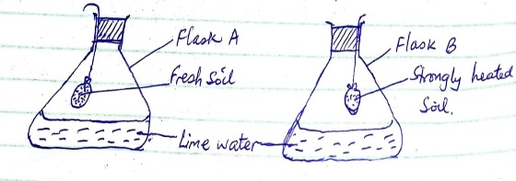

- State the aim of the experiment. (1mk)

- State the expected results after 24 hours in flask A and B. (2mks)

- Explain the reason for the observation made after 24 hours. (2mks)

- Study the diagram below of farm tools and equipment.

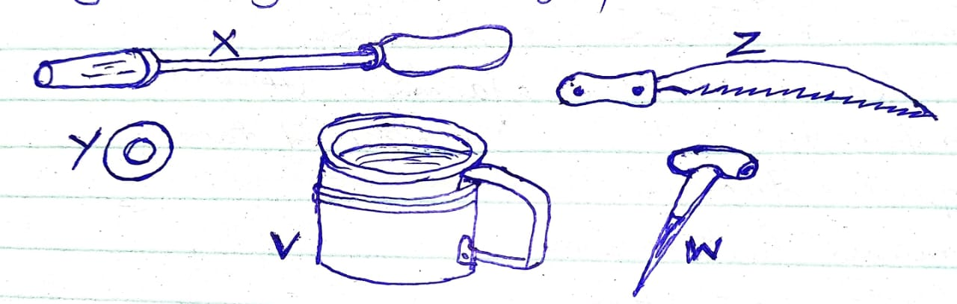

- Give the names of tools X, Y and Z. (3mks)

X

Y

Z

- State the function of tools V and W (2mks)
V

W

- State five reasons for maintain farm tools and equipment. (5mks)

- (a) State the three basic economic concepts. (3mks)

(b) Name the two types of labour records. (2mks)

- Study the diagram below and answer the questions.

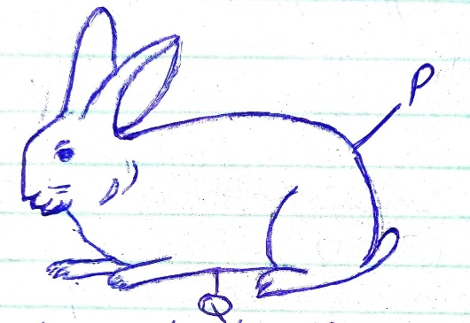

(a) Identify the part labelled P and Q. (2mks)
P

Q

(b) State three reasons why farmers keep rabbits. (3mks)

- (a) Name any four breeds of sheep reared in Kenya. (2mks)

(b) Sate two species of camels reared in Kenya. (2mks)

© Name a breed of pig that is pure black in colour. (1mk)

- Use the diagram below to answer the questions.

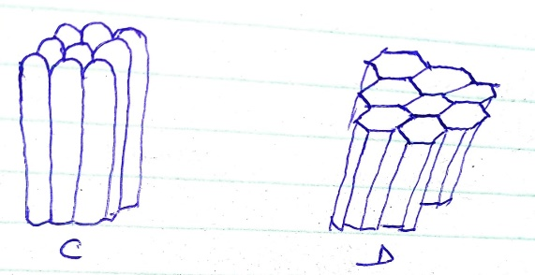

- Identify the type of soil structure C and D. (2mks)

C

D

- State three farming practices that influence soil structure. (3mks)

- State five importance of primary cultivation. (5mks)

