Name__________________________________________ Adm No __________
Date___________________________________________ Sign______________
JOINT EXAMINATION
312/1
GEOGRAPHY
2¾ HOURS
END TERM III EXAM
FORM THREE
INSTRUCTIONS TO CANDIDATES
- This paper consists of two sections A and B.
- Answer all the questions in section A.
- In section B answer question six and any other two questions
- All answers must be written in the answer booklet provided.
- Candidates should check the question paper to ascertain that all the pages are printed
and that no questions are missing.

Questions | Maximum score | Candidate score
1-5 | 25
6 | 25
 | 25
 | 25

SECTION A (25 MARKS)
Answer all questions in this section.
- a) What is the difference between a meteor and a meteorite (2mks) ………………………………………………………………………………………………………………………………………………………………………………………………………………………………………………………………………………………………………………………………………………………………………………………………………………………………………………………………
b) State three effects of earth’s revolution (3mks) ………………………………………………………………………………………………………………………………………………………………………………………………………………………………………………………………………………………………………………………………………………………………………………………………………………………………………………………………………………………………………………………………………………………………………………………………………………………………………………………………………………………………
- a) List two elements of weather(2mks) ………………………………………………………………………………………………………………………………………………………………………………………………………………………………………………………………………………………………………………………………………………………………………………………………………………………………………………………………
b) Name three processes through which the atmosphere is heated (3mks) ………………………………………………………………………………………………………………………………………………………………………………………………………………………………………………………………………………………………………………………………………………………………………………………………………………………………………………………………………………………………………………………………………………………………………………………………………………………………………………………………………………………………
- a) What is weathering (2mks) ………………………………………………………………………………………………………………………………………………………………………………………………………………………………………………………………………………………………………………………………………………
b) Give three processes of chemical weathering (3mks) ………………………………………………………………………………………………………………………………………………………………………………………………………………………………………………………………………………………………………………………………………………………………………………………………………………………………………………………………………………………………………………………………………………………………………………………………………………………………………………………………………………………………
- a) Name three types of coral reefs (3mks) ………………………………………………………………………………………………………………………………………………………………………………………………………………………………………………………………………………………………………………………………………………………………………………………………………………………………………………………………………………………………………………………………………………………………………………………………………………………………………………………………………………………………
b) What are the benefits of coral reefs in the areas they have developed (2mks) ………………………………………………………………………………………………………………………………………………………………………………………………………………………………………………………………………………………………………………………………………………………………………………………………………………………………………………………………
- a) Define the term waterfall (2mks) ………………………………………………………………………………………………………………………………………………………………………………………………………………………………………………………………………………………………………………………………………………………………………………………………………………………………………………………………
b) The diagram below shows a waterfall.
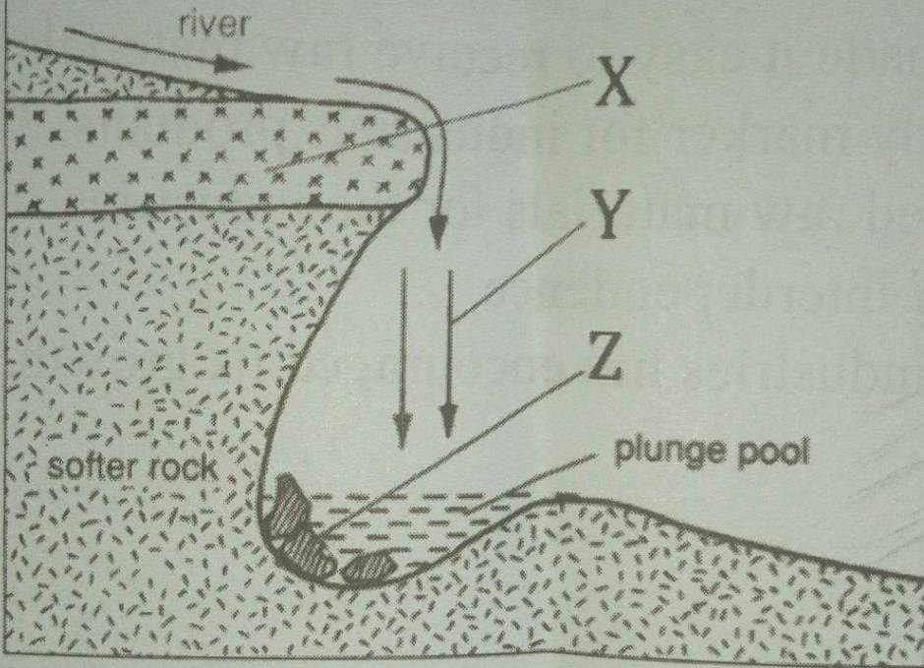
Name the features marked X, Y, and Z (3mks)
X …………………………………………………………………………………………………………
Y …………………………………………………………………………………………………………
Z …………………………………………………………………………………………………………

SECTION B (75MARKS)
Answer question 6 and any other two questions from this section.
- Use the map of Nyeri to answer question 6
a) i) What is the sheet title? (1mk)
ii) Identify two districts found in Nyeri (2mks)
iii) Identify index to adjoining sheet found in the Northern and Southern (2mks)
b) i) Name any three types of land transport in Nyeri (3mks)
ii) Name two physical features found in grid square 6258 (2mks)
c) Describe relief of the area covered by the map (7mks)
d) Citing evidence, explain four physical factors which favour cattle keeping (8mks)

- a) i) Apart from surface run off, give two other processes in the hydrological cycle. (2mks)
ii) State three factors that determine the amount of surface run off. (3mks)
b) Explain three factors that influence the transportation of materials by a river. (6mks)
c) i) What is river rejuvenation? (2mks)
ii) Explain three conditions that lead to rejuvenation of a river. (6mks)
d) Explain three negative effects of rivers to the human environment. (6mks)

- a) Differentiate between folding and faulting (2mks)
b) The table below shows types of folds and faults. For each, identify the type it belongs to.
- Asymmetrical (1mk)
- Reverse (1mk)
- Isoclinals (1mk)
- Shear (1mk)
- Over thrust (1mk)
c) Using well labelled diagrams, describe how Fold Mountains are formed. (11mks)
d) Describe how a high fold mountain located at a coastal region influences the formation of rainfall
(7mks)

- a) i) Differentiate between a soil profile and soil catena (2mks)
ii) Draw a well labeled diagram of a mature soil profile (4mks)
b) i) Other than topography name three factors that influence formation of soil (4mks)
ii) Explain how topography influences formation of soil (3mks)
iii) List three characteristics of desert soils (3mks)
c) i) Give three types of soil erosion (3mks)
ii) Explain three effects of soil erosion on human activities (6mks)

- a)Differentiate between weather and climate.(2mks)
b)Give four factors that should be considered when citing a weather station.(4mks)
c)Name four instruments placed in Stevenson screen.(4mks)
d) (i)What is weather forecasting(2mks)
(ii)Explain three factors that influence weather.(6mks)
e)(i)Using a well label diagram,describe how relief rainfall is formed(6kms)
(ii)Give three characteristics of relief rainfall (3mks)

