**NAME: …………………………………….…………ADM NO: ………… CLASS: …….**

**SCHOOL………………………………………………………………………………**

**JOINT EXAMINATION**

**TERM THREE, 2023**

**FORM ONE**

**MATHEMATICS**

**Time: 2 hours 30 MINUTES**

**Instructions to students**

1. Write your ***NAME****,* ***ADMISSION NUMBER*** and ***CLASS*** in the spaces provided above.
2. This paper consists of ***TWO SECTIONS***: ***SECTION I*** and ***SECTION II*.**
3. Answer ***ALL*** the questions in ***SECTION I*** and ***ONLY FIVE*** questions from ***SECTION II*.**
4. All answers and working must be written on the question paper in the spaces provided below each question.
5. Show all the steps in your calculations, giving your answers at each stage in the spaces below each question**.**
6. Marks may be given for correct working even if the answer is wrong.
7. Non-programmable silent electronic calculators and KNEC Mathematical tables may be used except where stated otherwise.

**For Examiner’s use only**

**Section I (50mks)**

|  |  |  |  |  |  |  |  |  |  |  |  |  |  |  |  |  |
| --- | --- | --- | --- | --- | --- | --- | --- | --- | --- | --- | --- | --- | --- | --- | --- | --- |
| **1** | **2** | **3** | **4** | **5** | **6** | **7** | **8** | **9** | **10** | **11** | **12** | **13** | **14** | **15** | **16** | **Total** |
|  |  |  |  |  |  |  |  |  |  |  |  |  |  |  |  |  |

**Section II (50mks)**

|  |  |  |  |  |  |  |  |  |
| --- | --- | --- | --- | --- | --- | --- | --- | --- |
| **17** | **18** | **19** | **20** | **21** | **22** | **23** | **24** | **Total** |
|  |  |  |  |  |  |  |  |  |

**Grand Total**

1. Evaluate: (3mks)



1. Write down the following number in words . (1mk)  
   35,000,900,010
2. The GCD of two numbers is 7 and their LCM 140. If one of the numbers is 20, find the other number. (3mks)
3. a) Simplify the expression (3mks)



b) Solve for X in the equation below (2mks)



1. use a number line to work out the following
2.  (2mks)
3.  (2mks)
4. The length of an arc of a circle is 88cm. Find the radius of the circle if the arc substends an angle of 144 $°$ at the centre (take $π$ = $\frac{22}{7}$) (3mks)
5. Ten men working six hours a day take 12 days to complete a job. How long willit take eight men working 12 hours a day to complete the same job? (3mks)
6. A shopkeeper made a loss of 20% by selling a trouser at sh 960. What percentage profit would he have made if he sold it at sh 1500. (3mks)
7. If a:b=2:3 and b:c 5:9, find the ratio a:c (2mks)
8. Express recurring decimal as a fraction. (3mks)
9. Three bells ring at interval ring of 40minutes 45 minutes and 60 minutes. If they ring simultaneously at 6.30am, at what time will they ring next together?. (3mks)
10. The size of an interior angle of a regular polygon is $3x°$ while its exterior angle is $(x-20)°$

Find the value of $x$. (2mks)

b) The sum of interior angles of a regular polygon is 1440 $°$.Find the number of sides of the polygon hence name the polygon. (3mks)

1. In the figure below, lines AB and LM are parallel. Find the values of the angle marked a, b and c. (3mks)

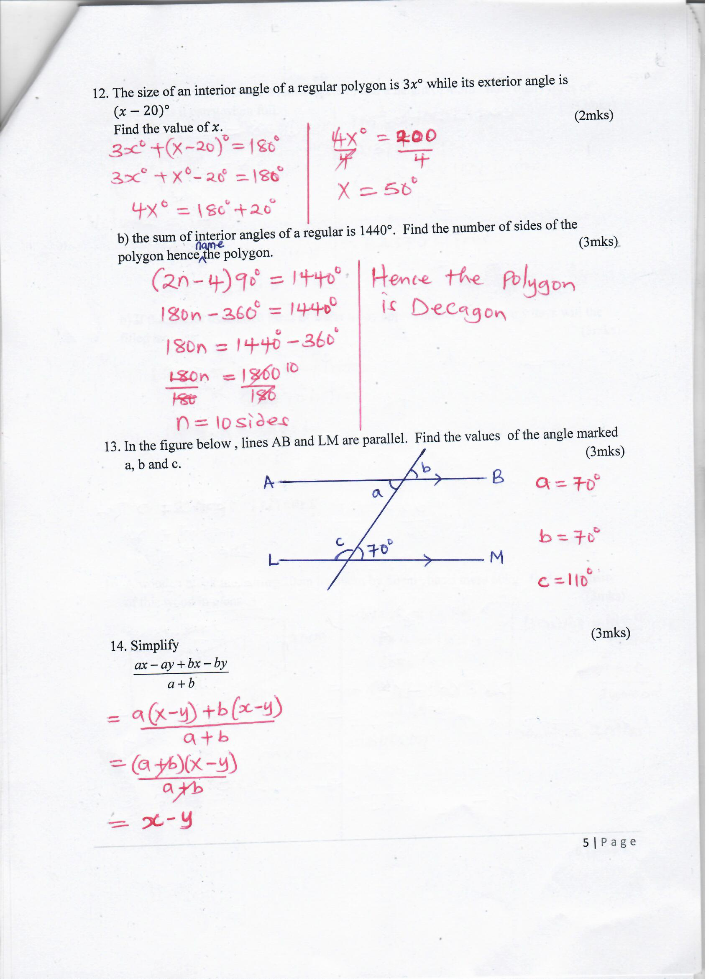

1. Simplify (3mks)  
   
2. a) A school water tank has a radius of 2.1 m and a height of 4.5m. how many litres of water does it carry when full. (3mks)

b) If the school uses 5000 litres of water a day approximately, how many days will the filled tank last. (3mks)

1. A wooden block measuring 20cm by 30cm by 50cm , has a mass 60kg. Find the density of this wood in g/cm3. (3mks)

**SECTION B**

**Answer any five questions only. (50marks)**

1. A floor of a room is in the shapeof arectangle 3000cm long by 300cm wide. Square tiles of length 30cm are to be fitted onto the floor
2. Calculate the number of tiles needed for the floor. (4mks)
3. A dealer wishes to buy enough tiles for fifteen such rooms .the tiles are packed in cartons .Each carton containing 20 tiles. The cost of each carton is ksh 800. Calculate;
4. The cost of the tiles for the fifteen such rooms. (5mks)
5. If in addition the dealer spends kshs 2,600 on transport. Calculate the total cost (1mk)
6. Three towns X,Y, and Z are such that Y is 500km on a bearing of 315 $°$ from X. Z is on a bearing of 230 from X. given that the direction between Y and Z is 800km.
7. Using a scale of 1cm represent 100km, draw a scale diagram to show the position of the towns. (6mks)
8. Find the bearing of ;
9. X from Z. (1mk)
10. Z from Y (1mk)
11. Use the scale drawing to find the distance from X to Z. (2mks)
12. (a) Solve the following simultaneous equation suing elimination method. (3mks)



(b) Given that $a=5, b=10 and c=6$ solve the following equation. (3mks)



(c) Complete this table below and use it to draw the graph . given that $y=2x+1$ (5mks)

|  |  |  |  |  |
| --- | --- | --- | --- | --- |
| X | -2 |  | 1 |  |
| Y |  | 1 |  | 5 |

1. Measurements of a maize field using a base line XY were recorded as shown below. (measurements are in metres)

Y

To N 160 240

200 80 to R

To M 80 120

X

1. Using a scale of 1cm rep 40m to draw the map of the maize field.(5mks)
2. Find the area of the field in hectares. (5mks)
3. (a) Using a ruler and a pair of compass only. Construct a triangle ABC in which angle BAC=90 $°$, AC =4cm and BC=5cm and draw a circle to pass through points A,B,C. (5mks)

(b) Find the area of the triangle ABC. (2mks)

(c) Measure the radius of the circle passing through points A,B and C and use it to find its area. (3mks)

1. A) A football match lasts 90 minutes with a break of 15 minutes at half-time. If a referee allows five minutes extra for injuries and stoppage, what time did the match kick off if it ends at 4.30 pm. (3mks)

(b) A services vehicle which left Mombasa for Nairobi at 1800hrs has a puncture after travelling for 4 hrs 20 minutes fixing a new tyre took 30 minutes .The vehicle then travelled for another1 hour 20 minutes to reach Nairobi. At what time did it arrive? (4mks)

(c) The table below is a matatu timetable for journeys between towns A and D via towns B and C.

|  |  |  |
| --- | --- | --- |
| time | arrival | departure |
| A  B  C  D | 1045h  1230h  1400h | 0930h  1055h  1245h |

Use the table to answer the following questions

1. What time does the matatu depart from B?. (1mk)
2. How long does it take the matatu to travel from towns A to town D? (2mks)
3. During a certain month the exchange rates in a bank were as follows;

|  |  |  |
| --- | --- | --- |
|  | Buying (Ksh | Selling (Ksh) |
| 1 US dollars | 91.65 | 91.80 |
| 1 Euro | 103.75 | 103.93 |

A tourist left Kenya to the United State with Ksh 1,000,000. On the airport he exchanged all the money to US dollars and spent 190 dollars on air ticket. While in US he spend4500 dollars for upkeep and proceeded to Europe while in Europe he spent a total of 2000 Euros.

1. How many US dollars he had before spending on air ticket. (2mks)
2. Calculate amount of money he had before proceeding to Europe in Kenya shillings to the nearest shillings. (4mks)
3. How many money in Euro’s did he remain at the end of the journey. (4mks)
4. Munyua spent ¼ of his net January salary on school fees. He spent ¼ of the remainder of electricity and water bills. He spent $1/9$ of what remained on transport. If he finally has sh 3400, calculate ;
5. His net January salary. (5mks)
6. Money spent on school fees. (1mk)
7. Money spent on transport . (2mks)
8. Money spent on electricity and water bills. (2mks)