Name: ………………………………………………..………Adm No: ….…………Class: ………… Candidate’s Sign: ………...............Date: ………………………………............................................
OPENER EXAMS
TERM 3 2023
FORM TWO CHEMISTRY

- An element Y has the electron arrangement of 2,8,3.
- What is its most likely valency? (1 mark)
………………………………………………………………………………………………………………………
- Which of the ion Y²⁺ and Y³⁺ is most stable? Explain. (2 marks)
………………………………………………………………………………………………………………………
………………………………………………………………………………………………………………………
- Give the electronic arrangement of the ion you gave in (b) above. (1 mark)
………………………………………………………………………………………………………………………
- (a) Give 2 advantages of carrying out experiment in apparatus made of glass. (2 marks)
………………………………………………………………………………………………………………………
………………………………………………………………………………………………………………………
………………………………………………………………………………………………………………………
(b) State 2 reasons why candle is not preferred for heating in laboratory. (2 marks)
………………………………………………………………………………………………………………………
………………………………………………………………………………………………………………………
………………………………………………………………………………………………………………………

- The following set up was used to investigate rusting in iron. Study it and answer the questions that follows.
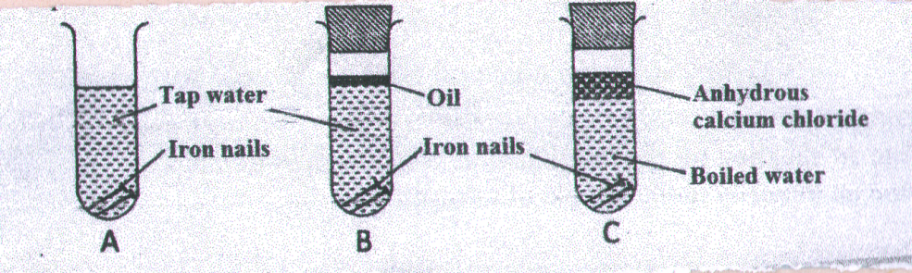

a). Name 2 conditions that accelerate rusting process. (2 marks)
………………………………………………………………………………………………………………………
………………………………………………………………………………………………………………………
………………………………………………………………………………………………………………………
b) Give why rusting did not occur in test-tube C. (1 mark)
………………………………………………………………………………………………………………………
………………………………………………………………………………………………………………………
c) Aluminum is used to protect iron from rusting. Explain two ways in which aluminum protect iron from rusting. (2 marks)
………………………………………………………………………………………………………………………
………………………………………………………………………………………………………………………
………………………………………………………………………………………………………………………
- State one advantage of rusting. (1 mark)
………………………………………………………………………………………………………………………

- An element Z has atomic number 12. And relative atomic mass of 24.3. it consist of 3 isotopes of mass number 24,25 and 26
- What is the mass number of the most abundant isotope? Give reasons for your answer. (2 marks)
………………………………………………………………………………………………………………………
………………………………………………………………………………………………………………………
- How many neutrons does the nucleus of isotope with mass number of 26 contain? (1 mark)
………………………………………………………………………………………………………………………
- What is the oxidation number of the ion formed by Z? (1 mark)
………………………………………………………………………………………………………………………
- a) Starting with copper, describe how a sample of copper(ii)carbonate can be prepared. (4 marks)
………………………………………………………………………………………………………………………
………………………………………………………………………………………………………………………
………………………………………………………………………………………………………………………
………………………………………………………………………………………………………………………
………………………………………………………………………………………………………………………
………………………………………………………………………………………………………………………
………………………………………………………………………………………………………………………

b) Distinguish between deliquescent and efflorescent as used in chemistry. (2 marks)
………………………………………………………………………………………………………………………
………………………………………………………………………………………………………………………
………………………………………………………………………………………………………………………

c) Write a chemical equation to show the effect of heat on nitrate of:
i) Potassium (1 mark)
………………………………………………………………………………………………………………………
ii) Silver (1 mark)
………………………………………………………………………………………………………………………
- Use dots(.) and crosses (x) to represent bonding in the following compounds.
- NaF (Na=11, F=9) (2 marks)

- PH₄⁺ (P=15, H=1) (2 marks)

- CH₄ (C=6, H=1) (2 marks)

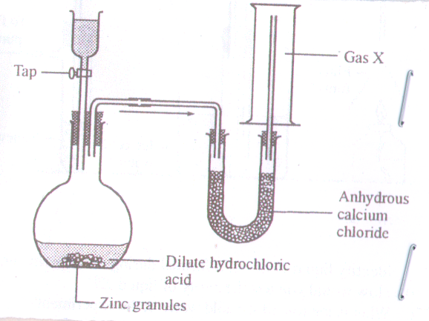
- Study the set-up below and answer the questions that follows.
- Identify gas x (1 mark)
………………………………………………………………………………………………………………………
- Write the equation for the reaction that leads to liberation of gas x. (1 mark)
………………………………………………………………………………………………………………………
- Why is it not advisable to use sodium in this method of preparing hydrogen gas? (1 mark)
………………………………………………………………………………………………………………………
- What is the purpose of anhydrous calcium chloride in the u-tube? (1 mark)
………………………………………………………………………………………………………………………
………………………………………………………………………………………………………………………
- Name other compound that can serve the same purpose as anhydrous calcium chloride. (1 mark)
………………………………………………………………………………………………………………………
- Name the method of gas collection in the above setup and state the property that enables the gas to be collected using the method. (2 marks)
………………………………………………………………………………………………………………………
………………………………………………………………………………………………………………………
- Why is it necessary to discard the first jar of the gas collected? (1 mark)
………………………………………………………………………………………………………………………
- State the industrial use of gas x. (2 marks)
………………………………………………………………………………………………………………………

- a) Describe how the PH of an anti-acid can be determined in the laboratory. (3 marks)
………………………………………………………………………………………………………………………
………………………………………………………………………………………………………………………
………………………………………………………………………………………………………………………
………………………………………………………………………………………………………………………
b) The table below shows the PH values of compounds D, E, F,G
COMPOUNDS | D | E | F | G
PH value | 2 | 5 | 7 | 14

c) State the compound that is likely to be: (3 marks)
i) Sodium Chloride
………………………………………………………………………………………………………………………
ii) Nitric (v) acid
………………………………………………………………………………………………………………………
iii) Lemon Juice
………………………………………………………………………………………………………………………

- The table below gives the atomic numbers of the element D to K. Study the table and answer the questions that follows. (the letter do not represent the actual symbol of elements)
element | Atomic no. | Electron arrangement
D | 11
E | 12
F | 13
G | 14
H | 15
I | 16
J | 17
K | 18

- Complete the table by filling the electronic arrangement of each element. (4 marks)

- To which period of periodic table do these elements belong? Give reasons for your answer. (1 marks)
………………………………………………………………………………………………………………………
………………………………………………………………………………………………………………………
- Which element is the most un reactive? Give reasons. (1 marks)
………………………………………………………………………………………………………………………
- Which element react vigorously with water? Give a chemical equation for the reaction. (2 marks)
………………………………………………………………………………………………………………………
………………………………………………………………………………………………………………………
- Give the formula of the oxide formed when H reacts with air. What is the nature of the oxide? (2marks)
………………………………………………………………………………………………………………………
………………………………………………………………………………………………………………………
- Compare the electrical conductivity of E and F. (2 marks)
………………………………………………………………………………………………………………………
………………………………………………………………………………………………………………………

