Name: ………………………………………………..………Adm No: ….…………Class: ………… Candidate’s Sign: ………...............Date: ………………………………............................................
OPENER EXAMS
TERM 3 2023
FORM ONE CHEMISTRY

1(a) Define the term matter? (1 mark)
………………………………………………………………………………………………………………
………………………………………………………………………………………………………………
(b)Complete the table below
Substance | Physical State
Copper
Water
Oxygen
2. Name the most suitable apparatus for carrying out the following tasks in the laboratory
(a)Measuring exactly 0.5g of sodium chloride solid (1 mark)
………………………………………………………………………………………………………………
(b)Measuring exactly 85cm³ of water (1 mark)
………………………………………………………………………………………………………………
(c)Measuring exactly 1 litre of water (1 mark)
………………………………………………………………………………………………………………

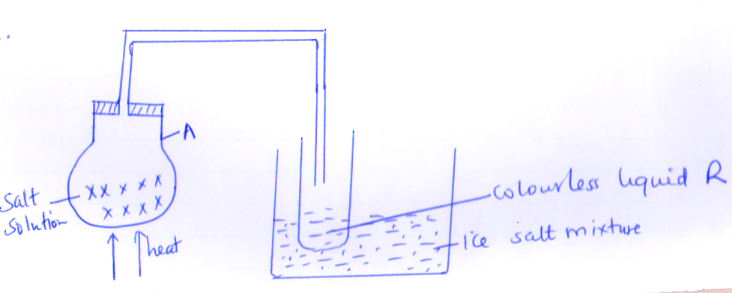
3. Study the diagram and answer the questions that follow

(a)Identify the method of separation of the mixture shown above (1 mark)
………………………………………………………………………………………………………………

(b)Name the colourless liquid R and state its physical test (2 marks)
………………………………………………………………………………………………………………
………………………………………………………………………………………………………………
(c) Name the apparatus labelled A (1 mark)
………………………………………………………………………………………………………………
(d)What is the purpose of ice salt mixture? (1 mark)
………………………………………………………………………………………………………………
(e)Name substance that can be used as ice salt mixture (1 mark)
………………………………………………………………………………………………………………
4. The diagram below shows charges on physical states. When substances are subjected to different conditions of temperatures, study it to answer the questions that follows
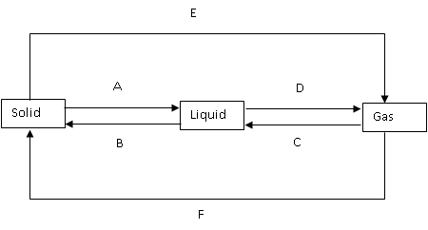
(a)Identify the physical process labeled (4 marks)
A …………………………………………………………………………………..
D…………………………………………………………………………………..
E…………………………………………………………………………………..
F…………………………………………………………………………………..

(b)Name the condition necessary for these process to occur
A …………………………………………………………………………………..
C…………………………………………………………………………………..
(c)Name two substances that undergo process E and F (3 marks)
………………………………………………………………………………………………………………
………………………………………………………………………………………………………………
5(a) Define the term drug (1 mark)
………………………………………………………………………………………………………………
………………………………………………………………………………………………………………
(b)State three commonly abused harmful drugs in Kenya today (3 marks)
………………………………………………………………………………………………………………
………………………………………………………………………………………………………………
………………………………………………………………………………………………………………
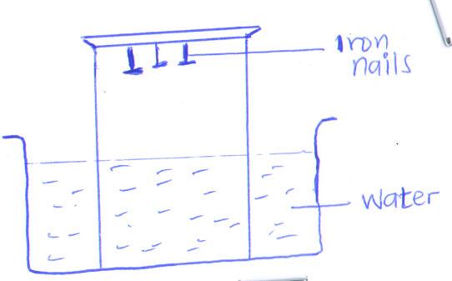
6. The diagram below shows an experiment performed to study a chemical process

(a)State two observations made after five days (1 mark)
………………………………………………………………………………………………………………
………………………………………………………………………………………………………………
(b)What is the name of the chemical process (1 mark)
………………………………………………………………………………………………………………
(c)Write a word equation for the above process (1 mark)
………………………………………………………………………………………………………………
(d)Give the conditions necessary for the process above to take place (2 marks)
………………………………………………………………………………………………………………
………………………………………………………………………………………………………………
7.Solutions P,Q,R,S T and U have PH values as shown in the table below
Solution | p | Q | R | S | T | U
PH value | 9.0 | 6.5 | 11 | 4.5 | 7 | 2

(a)Identify from the table above the PH value of the solution which is most likely to be;
(i) Weak acid (½ mark)
………………………………………………………………………………………………………………
(ii)Neutral solution (½ mark)
……………………………………………………………………………………………………………
(iii) Strong base ( ½ mark)
………………………………………………………………………………………………………………
(b)Identify the solution which is likely to be
(i)Lemon juice solution ( ½ mark)
………………………………………………………………………………………………………………
(ii)Tooth paste solution ( ½ mark)
………………………………………………………………………………………………………………
(iii)Hydrochloric acid solution ( ½ mark)
………………………………………………………………………………………………………………
(iv}Rain water ( ½ mark)
………………………………………………………………………………………………………………

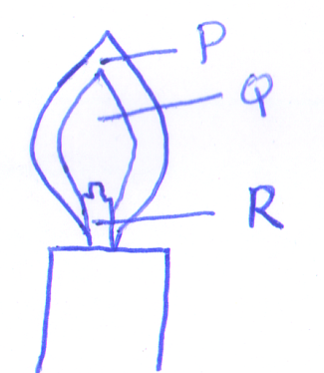
8. Study the diagram below

(a)Label the regions represented by P and Q (2 marks)
………………………………………………………………………………………………………………
………………………………………………………………………………………………………………
(b)Name the type of flame above (1 mark)
………………………………………………………………………………………………………………
(c)Under which condition is the above type of flame produced in a bursen burner (1 mark)
………………………………………………………………………………………………………………
(d)Which of the part labelled P, Q and R is the hottest? Explain (2 marks)
………………………………………………………………………………………………………………
………………………………………………………………………………………………………………
………………………………………………………………………………………………………………
(e)State the other type of flame produced by a bursen burner (1 mark)
………………………………………………………………………………………………………………

9. The diagram below represents paper chromatogram of four brands of cosmetics suspected to contain banned ingredients
S T U V W

(a)On the diagram, label the baseline and solvent front (2 marks)
(b)Name a possible solvent that can be used (1 mark)
………………………………………………………………………………………………………………
(c)A manufacturer intends to make a new brand of cosmetic W which will contain ingredients found in S and U. On the diagram show the chromatogram of W (1 mark)
(d)Name two practical application of the process indicated by the diagram above (2 marks)
………………………………………………………………………………………………………………
………………………………………………………………………………………………………………
10. Sodium chloride is contaminated with copper II oxide. Explain how pure sodium can be obtained from the mixture (3 marks)
………………………………………………………………………………………………………………
………………………………………………………………………………………………………………
………………………………………………………………………………………………………………
………………………………………………………………………………………………………………

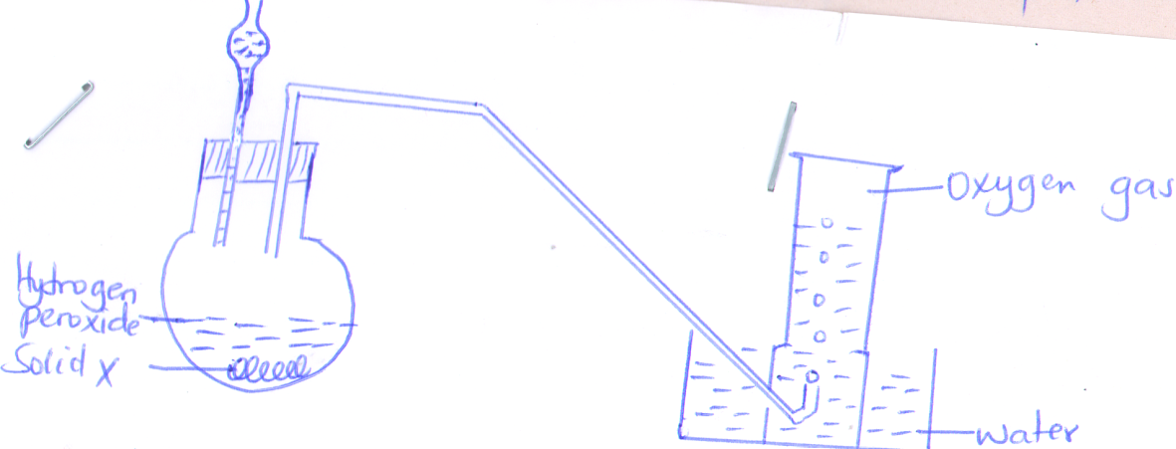
11. The diagram below is a set-up of apparatus used by a student in an attempt to prepare oxygen gas

(a)Identify one mistake in the set-up of apparatus above
………………………………………………………………………………………………………………
………………………………………………………………………………………………………………
(b)i) Name solid X (1 mark)
………………………………………………………………………………………………………………
(ii)What is the role of solid X (1 mark)
………………………………………………………………………………………………………………
(c)Write a word equation for the reaction taking place in the experiment (1 mark)
………………………………………………………………………………………………………………
………………………………………………………………………………………………………………
(d)Name the method of gas collection shown above (1 mark)
………………………………………………………………………………………………………………
(e)State the test for oxygen gas (1 mark)
………………………………………………………………………………………………………………
(f)State two industrial uses of oxygen gas (2 marks)
………………………………………………………………………………………………………………
………………………………………………………………………………………………………………

