TERM 2 - 2023
PHYSICS – PRACTICAL (232/3)
FORM FOUR (4)
Time - 2$\frac{1}{2}$ Hours
INSTRUCTIONS
- Answer all the questions in this paper
- You are supposed to spend the first 15 minutes of the $2\frac{1}{2}$ hours allowed for this paper reading the whole paper carefully before starting your work.
- Marks are given for clear record of the observations made, their suitability and accuracy and the use made of them.
- Candidates are advised to record observations as soon as they are made
- Mathematical table and electronic calculators may be used.

For Examiner’s use only:
QUESTION | TOTAL MARKS | CANDIDATE’S SCORE
1 | 20
2 | 20
GRAND TOTAL | 40

This paper consists of 8 printed pages

QUESTION ONE
You are provided with the following apparatus:
- An ammeter (0-1 A)
- Voltmeter (0-3 V)
- Two dry cells
- Cell-holder
- Variable resistor (0-100 Ω)
- Connecting wires
- Switch
Proceed as follows:
- Connect the apparatus as shown in figure 1 below:
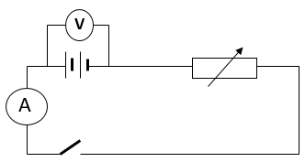

Figure 1
- With the switch open, measure and record the voltmeter reading, V₀

V₀ = .......................... (1 mark)

- Now, remove the voltmeter and connect it across the variable resistor (as shown in figure 2).

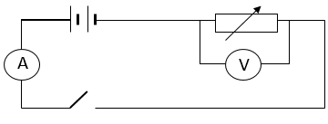

Figure 2

- Adjust the variable resistor until you obtain a reading of 1.0 V on the voltmeter. Record the corresponding ammeter reading. Continue to adjust the variable resistor to obtain the voltmeter readings shown in table 1, each time recording the corresponding current value.

Table 1:
Voltage, V | 1.0 | 1.5 | 2.0 | 2.5
Current, A
$$R=\frac{V}{I} \left(Ω\right)$$
$$\frac{1}{I} (A^{-1})$$

- complete the table 1 above: (6 marks)

- Plot a graph of resistance, R against $\frac{1}{I}$ (5 marks)

- Determine the slope of your graph (3 marks)

- Given that: $\frac{V}{I}=\frac{P}{I}-K,$ where P and K are constants. From the graph determine the values of P and K.
- P ($2$ marks)

- K (2 marks)

- State the significance of K (1 mark)

QUESTION TWO
PART A
You are provided with the following apparatus:
- Complete retort stand
- Cork
- Optical pin (for suspending the cardboard)
- Stop-watch
- Half-metre rule
- Knife-edge
- Rectangular Cardboard (40cm by 5 cm by 0.5cm)
PROCEED AS FOLLOWS:
- Using the knife-edge, determine the centre of gravity of the cardboard. Mark it as G.
- From G, cut holes 1, 2, 3, 4, 5 and 6 at intervals of 3 cm. measure and record the distance, L of each of the holes from G.
- Now set-up the apparatus as shown in figure 3, below:

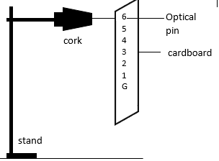
Figure 3

- Displace the strip through a small angle, θ and release it to oscillate. Determine time, t for 10 oscillations and fill in your results in table 2 below: (8 marks)

Table 2
hole | 1 | 2 | 3 | 4 | 5 | 6
Distance, L
(cm)
Time, t for 10 oscillations (s)
Periodic time, T (s)
T² (s²)
T²L (ms²)
L²(m²)

- Determine Z, given that: $Z=\frac{A}{B}$ , where A, is the average value of T²L and B is the average value of T² (2 marks)

PART B
You are provided with the following apparatus:
- A thermometer (range: -10⁰c- 110⁰c)
- A 250 ml beaker
- Measuring cylinder
- Retort stand, clamp and boss
- Stop watch
- Source of boiling water or Bunsen burner
- Some tissue paper
Proceed as follows:
- Record the temperature reading, T₀ of the thermometer provided

T₀ = ................................. (1 mark)

- State the significance of the temperature, T₀ above. (1 mark)

- Now pour 200ml of hot (boiling) water from the source into the beaker and immediately insert the thermometer as shown in figure 1 below. Ensure it is at a temperature above 85⁰C.
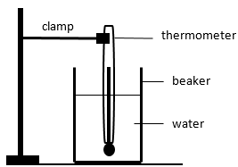

Figure 4
- Start the stop watch when the temperature falls to 80⁰c. Record the temperature of the water as it cools down after every two minutes for about ten minutes. Record your results in the table below: (5 marks)
Table 3:
Time, t (minutes) | 0 | 2 | 4 | 6 | 8 | 10
Temperature, T (⁰C)

- Given that the specific heat capacity of water is 4J/g⁰C. determine the heat lost when the water cools from 80⁰c to the temperature in (a) above. (assume: 1ml = 1g) (3 marks)

THIS IS THE LAST PRINTED PAGE

