TERM 2 - 2023
PHYSICS – PAPER ONE (232/1)
FORM FOUR (4)
Time - 2 Hours
Name …………………………………………….……… Admission Number …………….
Candidate’s Signature ………………….…...……….. Class ……………………………

Instructions to candidates

- This paper consists of two sections A and B.
- Answer all the questions in the two sections in the spaces provided after each question
- All working must be clearly shown.
- Electronic calculators, mathematical tables may be used.
- All numerical answers should be expressed in the decimal notations.
- You may use:
- ‘Gravitational acceleration, g, as 10m/s²
- Density of water = 1000kg/m³
- Density of air = 1.25kg/m³

For Examiner use only
SECTION | QUESTION | MAX MARKS | CANDIDATE’S SCORE
A | 1 – 13 | 25
B | 14 | 12
 | 15 | 11
 | 16 | 12
 | 17 | 10
 | 18 | 10
 | TOTAL | 80

This paper consists of 12 printed pages. Candidates should check to ascertain that all pages are printed as indicated and that no questions are missing.

SECTION A (25 MARKS)

- Explain the meaning of ‘geometrical optics’ as a branch of physics (1 mark)

- The figure below shows a section of a micrometer screw gauge with a thimble scale of 50 divisions. When the spindle is in contact with the anvil, the device reads 0.25mm. The screw gauge is used to measure the diameter of a spherical ball and the scale reading is as shown below.
State the actual diameter of the ball.
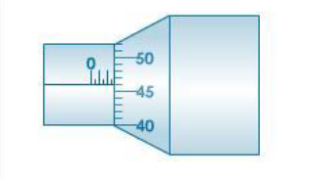
(2 marks)

Figure 1

- Alcohol in glass thermometer cannot be used when boiling water is used in an experiment. Explain. (1mark)

- Explain briefly how the temperature in a green house is kept higher than outside. (2 marks)

- A wooden bench feels neither warm nor cold when touched by bare hands. Explain this observation. (2 marks)

- The reading on a mercury barometer at Mombasa is 760mm. Calculate the pressure at Mombasa in N/m² (density of mercury = 1.36 x 10⁴ Kg/m³) (2 marks)

- The diagram shown in figure 2 below is an arrangement of three pulley wheels used to help in lifting loads. The system has a velocity ratio of 3. Complete the diagram to show the threading of the rope and the position of effort, load (3 marks)
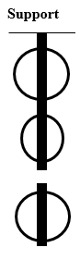
Figure 2

- State the meaning of the term ‘radian’ as a unit of measurement (1 mark)

- A stone of volume 800 cm³ experiences an upthrust force of 6.5 N when fully immersed in a liquid. Determine the density of the liquid. (2 marks)

- Figure 3 shows air flowing through a pipe of different cross-sectional areas. Two pipes A and B are dipped into water.
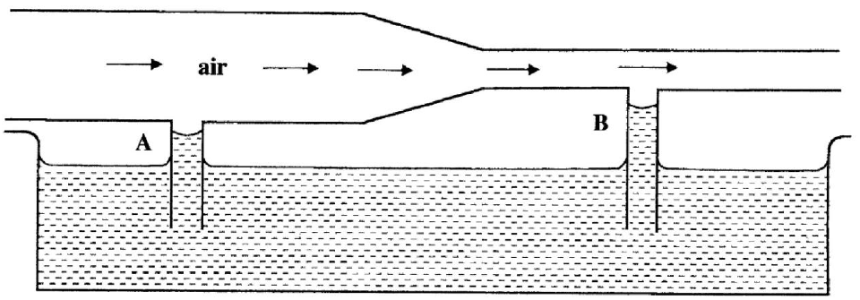
Figure 3
Explain the cause of the difference in the levels of water in the pipes A and B. (2 marks)

- A balloon is filled with hydrogen gas and then released into the air. The balloon is observed to expand as the balloon rises. Explain why it expands. (2 marks)

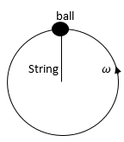
- The figure 4 below shows a ball being whirled in a vertical plane. Mark on the same figure, as A, the position where the string is likely to snap if the angular velocity of the ball is increased. Explain your answer. (2 marks)
Figure 4

- A uniform metre-rule balances at the 30cm mark when a mass of 500g is placed at the 25cm mark as shown in the figure 5 below. (Not drawn to scale).

Figure 5
Determine the mass of the meter-rule (3 marks)

SECTION B (55 MARKS)
- The diagram below shows a spring balance tied to an object of mass 500g and rotated in a circular path of radius 50 cm.
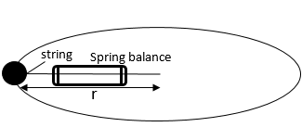

Figure 6

- State the source of force that keeps the object moving in a circular path. (1mark)

- The speed of the object is constant but the body is accelerating on the circular path. Explain (1 mark)

- If the object is whirled faster, what would happen to the spring balance reading? (1 mark)

- Give a reason for your answer in, c (i) above (2 marks)

- If the spring balance reads 81N. Determine:
- the linear velocity, v of the body (3 marks)

- centripetal acceleration of the body (3 marks)

- State the purpose of banking roads at bends (1 mark)

- State the law of flotation (1 mark)

- Figure 7 below shows a test-tube whose cross-sectional area is 2cm² partially filled with lead shot floating vertically in water.
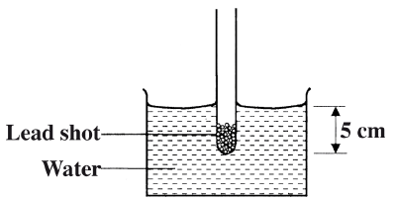
Figure 7

Determine the:
- Volume of water displaced (2 marks)

- Weight of displaced water (3 marks)

- State the combined weight of the test-tube and the lead-shot (1 mark)

- Determine the length of the test-tube that would be submerged if a liquid of density 0.8g/cm³ is used. (3 marks)

- The set-up in figure 7 may be used as a hydrometer. Suggest any one change that can be made so that it measures small differences in densities of liquids (1 mark)

- Define the following terms as used in machines:
- Efficiency (1 mark)

- Velocity ratio (1 mark)

- The figure below shows a 200g mass placed on a frictionless surface and attached to a spring.
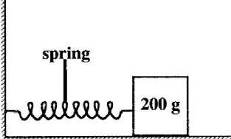
Figure 8
The spring is compressed then released. If the elastic potential energy of the compressed spring is 2.7×10⁻²J, determine the maximum speed with which the block moves after it is released. (3 marks)

- A spherical ball is released vertically from a height, h. Sketch on a diagram to show the forces acting on the ball just after it is released. (3 marks)

- Sketch a graph of potential energy against kinetic energy as the ball falls to the ground
(2 marks)

- State two ways in which an inclined plane can be made to reduce the applied effort when pulling a load along the plane (2 marks)

- State what is meant by an ideal gas (1 mark)

- The pressure acting in a gas in a container was changed steadily while the temperature of the gas was maintained constant. The value of volume V of the gas measured various values of pressure. The graph in the figure 9 shows the relation between the pressure P and the reciprocal of volume, V⁻¹.
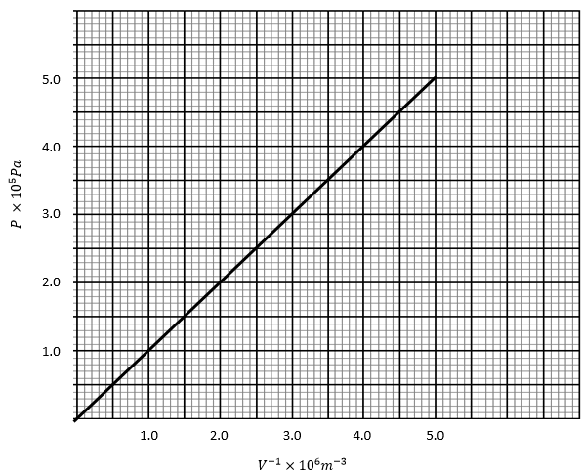
Figure 9

- Identify the gas law being verified by the above graph (1 mark)

- Given that the relation between the pressure P and the value, V of the gas is given by the equation: PV = k, where k is a constant, use the graph to determine the value of k
(3 marks)

- A gas occupies a volume of 4000 litres at a temperature of 37°C and normal atmosphere pressure. Determine the new volume of the gas if it is heated at constant pressure to a temperature of 67°C (normal atmosphere pressure P = 1.01 x 105pa) (3 marks)

- State two limitations of gas laws (2 marks)

- State the principle of transmission of pressure (1 mark)

- The diagram below shows a U-tube filled with two liquids X and Y.

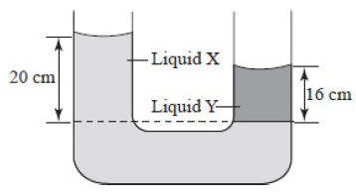
Figure 10
If the density of liquid Y is 1.26 g cm^{–3}, determine the density of liquid X. (3 marks)

- The figure 11 below shows water getting in and out of a pipe.

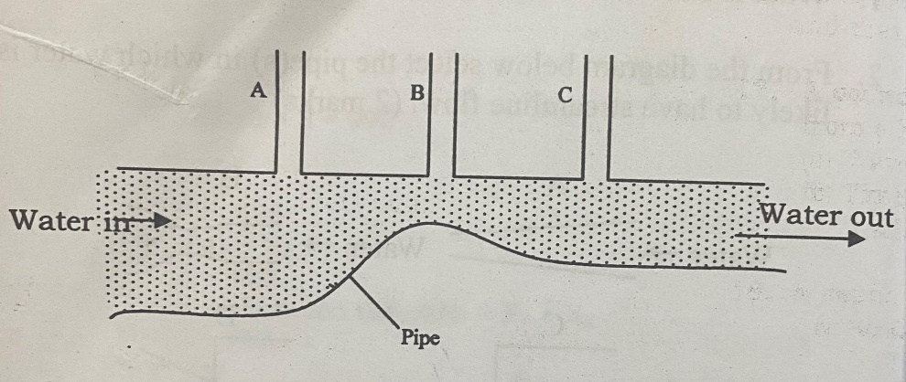
Figure 11

If the water in the pipe is flowing continuously and has a streamline flow:
- Show on the diagram the relative level of water in tubes A, B and C (1 mark)

- Explain your answer above (1 mark)

- A strong wind lifted off the roof of a classroom. Explain how this could happen (2 marks)

- The speed of air at the upper part of an airplane wing is 120m/s and the lower side is 100m/s. The area of the airplane wing is 12m². Calculate the pressure difference on the wings
(2 marks)

This is the last printed page

