TERM 2 - 2023
PHYSICS – PAPER ONE (232/1)
FORM THREE (3)
Time - 2 Hours
Name …………………………………………….……… Admission Number …………….
Candidate’s Signature ………………….…...………... Date ……………………………
Instructions to candidates

- This paper consists of two sections A and B.
- Answer all the questions in the two sections in the spaces provided after each question
- All working must be clearly shown.
- Electronic calculators, mathematical tables may be used.
- All numerical answers should be expressed in the decimal notations.
- You may use:
- ‘Gravitational acceleration, g, as 10m/s²
- Density of water = 1000kg/m³

For Examiner use only
SECTION | QUESTION | MAX MARKS | CANDIDATE’S SCORE
A | 1 – 12 | 25
B | 13 | 11
 | 14 | 11
 | 15 | 14
 | 16 | 10
 | 17 | 09
 | TOTAL | 80

This paper consists of 12 printed pages. Candidates should check to ascertain that all pages are printed as indicated and that no questions are missing.

- A stop watch reads 06:30:94 and 09:10: 20 at the start and end of an experiment respectively. Determine:
- The accuracy of the stop watch used (1 mark)

- The duration of the experiment in SI units. (2marks)

- In an experiment to demonstrate Brownian motion, smoke was placed in an air cell and observed under a microscope, Smoke particles were observed to move randomly in the cell.
- Explain the observation (1mark)

- Give a reason for use of smoke in this experiment (1 mark)

- The reading on a mercury barometer at Mombasa is 760mm. Express this pressure in SI units. (density of mercury = 1.36 x 10⁴ Kg/m³) (2 marks)

- When a mercury thermometer is used to measure the temperature of hot water, it is observed that the mercury level first drops before beginning to rise. Explain. (2marks)

- Figure below shows a u-tube manometer containing a liquid L. One end of the tube is connected to a gas tap. Given that the atmosphere pressure is 1.0×10⁵pa, determine the pressure of the gas (density of liquid L is 900kg/m³, g=10N/kg) (2marks)
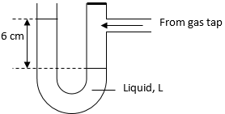

Figure 1

- For a fluid flowing at a velocity, V in a tube of cross-sectional area, A, VA= constant. State two assumptions made in deriving this equation. (2 marks)

- The figure 2 shows the graph of extension against force for a certain spring.
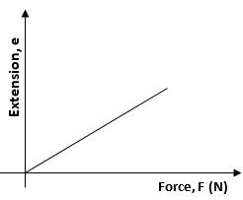

Figure 2
On the same diagram, sketch the graph of extension against force for a spring with a lower value of spring constant. (1 mark)

- An object is thrown vertically upwards at an initial velocity of 30m/s. Determine its maximum height. (2 marks)

- A solid marble is resting in a bowl as shown below.
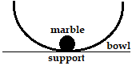

Figure 3
Suggest its state of equilibrium. Explain your answer (2 marks)

- The diagram below (not drawn to scale) shows part of the motion of a tennis ball, which is projected vertically upwards from the ground and allowed to bounce on the ground.
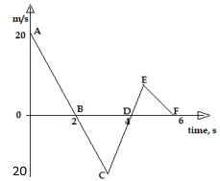Figure 4
Calculate the height of the ball above the ground at the end of the 3rd second
(3 marks)

- The figure below shows a uniform metal rod balanced at its centre by various forces.
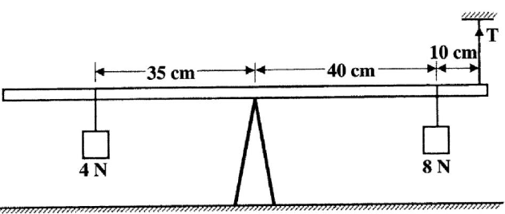
Figure 5

Determine the tension, T. (3 marks)

- A high jumper lands on saw dust. Explain how the saw dust helps in reducing the force of impact. (1 mark)

SECTION B (55 MARKS)

- Define ‘Centre of gravity’ of a body (1 mark)

- Explain why a lorry loaded with bags of maize packed high up is likely to topple when negotiating a corner. (2 marks)

- The figure below is an aluminium metal sheet used for manufacturing bodies of motor vehicles.

Figure 6
Determine its Centre of gravity (2 marks)

- You are provided with the following apparatus: Plumb-line, thread, stand, irregular cardboard. Using a suitable set-up diagram, describe how you would determine the Centre of gravity of the irregular cardboard. (6 marks)

- State Bernoulli’s principle (1 mark)

- It is dangerous to stand close to a railway line on which a fast-moving train is passing. (2 marks)

- The diagram below shows the mercury levels when no air is blown into the tube.
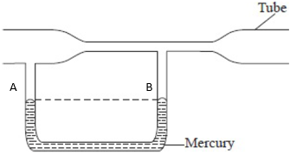

Figure 7
On the same diagram, indicate the new level of mercury when air is continuously moving fast through the tube. Explain your answer. (3 marks)

- A pipe has a cross-sectional area of 40cm². The speed of water is 9 m/s at this end. if the speed increases to 15m/s in a constriction in the pipe, find the area of the narrow part of the pipe. (3 marks)

- Other than density, state any other factor which affect pressure in fluid (1 mark)

- State the assumption on which Pascal’s principle is based (1 mark)

- Define the term ‘velocity ratio’ of a machine (1 mark)

- The figure below shows part of a hydraulic press. The plunger is the position where the effort is applied while the Ram piston is the position where the load is applied. The plunger has cross-section area, a m² while the Ram piston has cross-section area, A m².
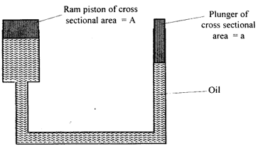
Figure 8
When the plunger moves down a distance, d the Ram piston moves up a distance, D.
- State one property of the oil used in the hydraulic press (1 mark)

- Determine the velocity ratio of the press in terms of A and a (4 marks)

- A machine of velocity ratio 45 overcomes a load of 4500N when an effort of 135N is applied. Determine:
- the mechanical advantage of the machine (2 marks)

- the efficiency of the machine (3 marks)

- percentage of work that goes to waste (2 mark)

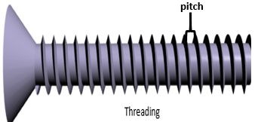
- Figure 9 shows a threaded bolt.

Figure 9

- Explain how a metre-rule can be used to measure the pitch (distance between adjacent peaks) of the threading (2 marks)

- Figure 10 is a screw-jack whose pitch is 1mm and has a handle of 25 cm long. Determine the velocity ratio of the jack (3 marks)
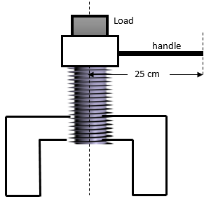

Figure 10

- A bullet of mass 60g is travelling at 800m/s hits a tree and penetrates a depth of 15 cm before coming to rest.
- Describe the energy changes of the bullet as it penetrates the tree (2 marks)

- Determine the average retarding force of the bullet (3 marks)

- Define ‘atmospheric pressure’ and state it’s SI unit (1 mark)

- In an experiment to demonstrate the existence of atmospheric pressure, a plastic bottle is partially filled with hot water and the bottle is then tightly corked. After sometime the bottle starts to get deformed.
- State the purpose of the hot water (1 mark)

- Explain why the bottle gets deformed (2 marks)

- A trolley is pulled a long a smooth horizontal surface by a constant force as shown below:
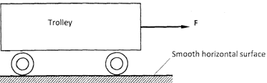

Figure 11
- On the axes provided, sketch the velocity-time graph for the motion (1 mark)
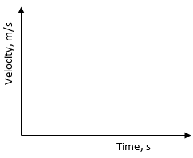

- State the assumption made in part (i) above (1 mark)

- A parachute falling through air soon attains terminal velocity. Explain the meaning of the term terminal velocity (2 marks)

- State the equation showing the relationship among the various forces acting on the parachute soon after it attains the terminal velocity. (1 mark)

This is the last printed page.

