END TERM EXAMINATIONS – TERM TWO 2023
121/2 -MATHEMATICS
Paper 2
FORM 4
July 2023 - 2½ Hours

Name: ………………………………………………….....…… Adm No: ……….……
School: ………………………………………………………….. Class: …………………
Candidate’s Signature: …….………...................................... Date: …..…………….

INSTRUCTIONS TO CANDIDATES
- Write your name, admission number, school, and class in the spaces provided at the top of this page.
- Sig and write the date of the examination in the spaces provided above.
- This paper consists of two sections: Section I and Section II.
- Answer ALL questions in Section I and all the questions from Section II.
- Show all the steps in your calculations, giving your answers at each stage in the spaces provided below each question.
- Marks may be given for correct working even if the answer is wrong.
- Non-programmable silent electronic calculators and KNEC Mathematical Tables may be used.
- This paper consists of 17 printed pages.
- Candidates should check the question paper to ensure that all the pages are printed as indicated and no questions are missing.

For Examiners’ Use Only
SECTION I
1 | 2 | 3 | 4 | 5 | 6 | 7 | 8 | 9 | 10 | 11 | 12 | 13 | 14 | 15 | 16 | Total

SECTION II
17 | 18 | 19 | 20 | 21 | 22 | 23 | 24 | Total | Grand Total

SECTION I (50 Marks)
Answer all the questions in this section
- The position vectors of three points P, Q, and R are such that $p=2i+3j+4k$, $q=-i-2j+k$ and $r=5i+8j+7k$. Show that the points P, ,Q and R lie on a straight line. (3 marks)

- Find the constant term in the expansion of the binomial (2 marks)
$${\left(x^{2}-\frac{1}{x}\right)}^{6}$$

- The figure below shows a circle with segments cut off by a triangle whose longest side XY is the largest possible chord of the circle. XY=14 cm and XZ=YZ
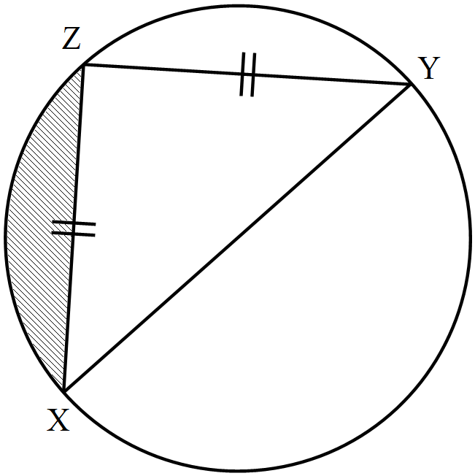

Calculate the area of the shaded part, correct to 2 decimal places. Use π = $\frac{22}{7}$ (3 marks)

- Make $t$ the subject of the formula (3 marks)
$$m=\sqrt{\frac{ht^{2}}{t^{2}+2w}}$$

- The table below represents a relationship between two variables $Q$ and $R$, connected by the equation $Q=kR+c$ where $k$ and $c$ are constants.

$$R$$ | $$0.1$$ | $$0.2$$ | $$0.3$$ | $$0.4$$ | $$0.5$$ | $$0.6$$
$$Q$$ | $$6.2$$ | $$5.6$$ | $$4.8$$ | $$4.0$$ | $$3.4$$ | $$2.7$$

- On the grid provided, draw the line of best fit for the data. (3 marks)

- Use the graph in (a) above to find the value of $c$ (1 mark)

- The mass ($M$) of a cylinder varies jointly as the square of the radius ($r$) and inversely as the square root of the height ($h$). If the radius is reduced by 25% and the height increased by 21%, calculate the percentage change in the mass of the cylinder. (3 marks)

- A school buys a lawn mower at Kshs. 48,000. The lawn mower depreciates in value at a rate of 15% per annum for the first year. Thereafter, the rate of depreciation annually is 10% for the subsequent years. Find the time it will take its value to be half the buying price. (3 marks)

- The figure below shows two circles.
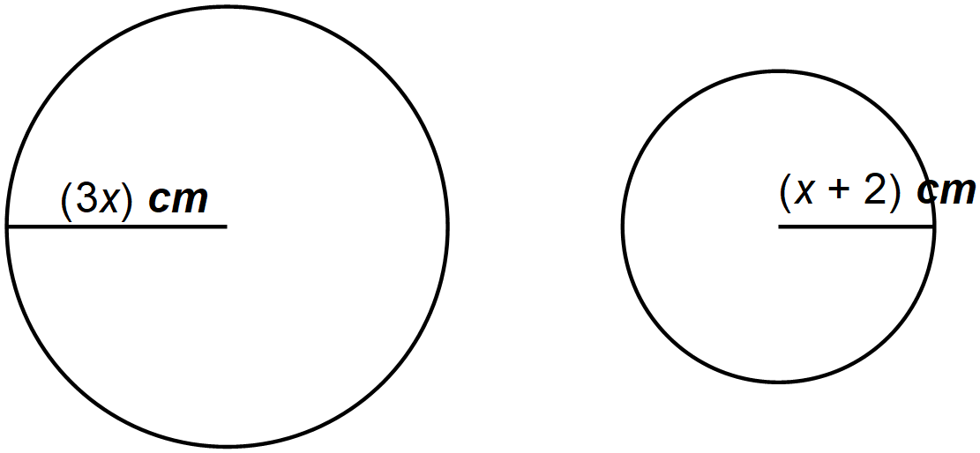

Find the value of $x$ if the difference of their areas is given by 20π cm² (3 marks)

- Use trigonometric identities to show that (2 marks)
$$\tan{θ+\frac{1}{\tan{θ}}=\frac{1}{\sin{θ\cos{θ}}}}$$

- Find the values of $a$ and $b$ in the expression below. Do not use a calculator or mathematical tables. (3 marks)
$$\frac{\sqrt{48}}{2}+\frac{6}{\sqrt{5}-\sqrt{3}}=a\sqrt{5}+b\sqrt{3}$$

- An auditorium is designed so that the next row of seats has $d$ less seats than the row behind it. The first row has $a$ seats while the tenth row has 435 seats. There are 25 rows of seats in all. The entire auditorium contains 9000 seats. Find the values of $a$ and $d$. (3 marks)

- The period of the function below is 540⁰
$$y=\frac{4}{3}{\sin\left(kθ-40\right)}^{0}$$
- Find the value of $k$ (1 mark)

- Determine the maximum displacement of the curve over the x-axis. (1 mark)

- Ujenzi Quarries Limited is contracted to supply ballast for the construction of a health centre. The construction is estimated to use 144 tonnes of ballast. The firm intends to use two trucks; Fuso and Faw to transport this ballast. A Fuso truck can carry 8000 kg of ballast while the Faw truck can carry 12,000 kg of ballast per trip. The Fuso truck should make less than 9 trips and the Faw truck should make at most twice the number of trips made by the Fuso truck. The total number of trips should be at least 10 trips. By letting $x$ and $y$ to represent the Fuso and Faw trucks respectively, write down all the inequalities to represent the above information. (4 marks)

- 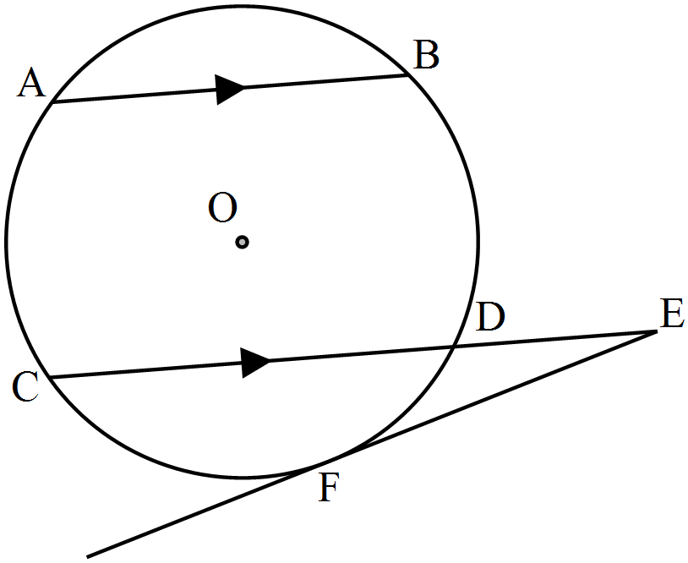The figure below shows a circle centre O, with two parallel chords AB and CD. Chord CD is produced to E and EF is a tangent to the curve at F. The radius of the circle is 5 cm, and chords AB and CD are 5 cm apart.

Calculate correct to 1 decimal place:
- The length of the chord CD. (2 marks)

- The length FE if $\text{DE}=\frac{3}{2}\text{CD}$. (2 marks)

- The ratio of Ali’s wages to Ben’s earnings is 5:3. If Ali’s earnings increase by 12%, his new earning becomes Ksh. 5,040. Find the corresponding percentage change in Ben’s earnings if the sum of their new earnings is Ksh. 8,145. (4 marks)

- Below is a line segment $XY$. Using a ruler and a pair of compasses only construct the locus of a variable point $P$ above $XY$ such that angle $XPY≥{60}^{0}$ and the area of Δ$XPY>8.75$ cm². (4 marks)

SECTION II (50 Marks)
Answer any five questions in this section
- A triangle $T$ with vertices $A(2, 3)$, $B(5, 3)$ and $C(4, 1)$ is mapped onto triangle $T'$ whose vertices are $A'(-4, 3)$, $B'(-1, 3)$ and $C'(x, y)$ by a transformation $M$.
- Find:
- The transformation matrix represented by $M$. (3 marks)

- The coordinates of $C'$ (2 marks)

- Triangle $T''$ is the image of $T'$ under a reflection in the line $y-x=0$. Find the coordinates of $T''$. (3 marks)

- Determine a single matrix of transformation that maps triangle $T$ onto $T''$. (2 marks)

- A cargo plane leaves an airport P(60⁰N, 20⁰E) and flies due west to airport Q(60⁰N, 25⁰W). 100 minutes later, it then flies due South for 5400 nautical miles to airport R.
- Find the position of airport R. (2 marks)

- Calculate the total distance that the plane travelled between airports P and Q via R in kilometres. Use the radius of the earth R=6370 km and π = $\frac{22}{7}$. (3 marks)

- If the average speed of the plane was 600 knots, calculate the total time that the plane was airborne. (3 marks)

- If the plane arrived at Q on Sunday 0215 hours. At what time and day did it leave airport P? (2 marks)

- Aggie’s earnings were as follows:
- Basic salary – Ksh. $38,000$ per month
- House allowance – Ksh. $14,000$ per month
- Transport allowance – Ksh. $8,500$ per month
- Medical allowance – Ksh. $3,300$ per month

In that year, income tax was charged as shown in the table below
Taxable Income  Kenya Pound (K£) per annum | Tax Rate  (Ksh per K£)
1 – 6,000  6,001 – 12,000  12,001 – 18,000  18,001 – 24,000  24,001 – 30,000  30,001 – 36,000  Excess of 36,000 | 2  3  4  5  6  7  8

Aggie was entitled for a tax relief of Ksh. 18,000 for that year.
- Calculate
- Aggie’s taxable income in K£ per annum. (2 marks)

- Aggie’s pay as you earn. (5 marks)

- Aggie is deducted the following monthly:
- Provident fund – Ksh. 1,000
- Loan Repayment – Ksh. 6,250
- Union dues – Ksh. 500
- NHIF – Ksh. 1,000
- Cooperative shares – Ksh. 3,000

Calculate her net monthly salary in Ksh. (4 marks)

- (a) Kisumu Boys High School relies entirely on three sources of power: Kenya Power, a school generator, and a solar system. The probabilities that the three sources are working at any given time are $\frac{4}{5}$, $\frac{3}{4}$ and $\frac{2}{3}$ respectively. Calculate the chance that:
- There is power in the school. (2 marks)

- Only two sources are providing power to the school at a given time. (3 marks)

(b) The table below shows the number of Form 1 students per stream and the percentage that do a foreign language as an optional subject

Stream | Number of students | Percentage that do Foreign Languages
Blue | 40 | 15
Green | 56 | 25
Pink | 45 | 20
Yellow | 60 | 40

A form 1 student is selected at random. Determine the probability that she:
- is from stream Blue or Yellow (2 marks)

- is from Green or Pink and does not take any foreign language as an optional subject (3 marks)

- Three ships X, Y, and Z are approaching a harbour H. X is 16 km from the harbour and due East. Y is 14 km from the harbour on a bearing of 130⁰, and Z is 26 km to the West of Y and on a bearing of 240⁰ from the harbour.
- Sketch the relative positions of X, Y, Z, and H. (2 marks)

- Calculate the distance of Y from Z correct to 2 decimal places. (3 marks)

- The bearing of X from Y to the nearest one degree. (3 marks)

- A patrol ship P is sighted such that it is equidistant from ships X, Y and Z. Calculate the distance of P from H. (2 marks)

- The table below shows the distribution of marks scored by 80 students in a Maths Olympiad contest.
Marks | 1 – 10 | 11 – 20 | 21 – 30 | 31 – 40 | 41 – 50 | 51 – 60 | 61 – 70 | 71 – 80 | 81 – 90
Number of Students | 3 | 5 | 7 | 9 | 11 | 15 | 14 | 10 | 6

- Using an assumed mean of 55.5, calculate the mean mark. (4 marks)

- On the grid provided, draw an ogive to represent the information above. (2 marks)

- Use the ogive in (b) above to:
- Determine the number of students who scored 60% and above. (2 marks)

- Find the interquartile range. (2 marks)

- Kajiado county government has two water supply points with pipes A and B. Pipe A pumps at the rate of 2.1 m/s and has a radius of 10 cm while pipe B pumps water at a rate of 1.4 m/s and has a radius of 12 cm. The water is pumped into a reservoir tank with a circular base of diameter 28 m and a height of 15 m. Use π = $\frac{22}{7}$.
- Calculate the capacity of water in litres that is supplied in one hour by both pipes A and B. (3 marks)

- The time in hours that it takes the reservoir tank to be three-quarters full. (3 marks)

- Find the time it takes the full tank to reduce to 25% in height if a discharge pipe C of radius 15 cm drains the tank at the rate of 1.05 m/s. (4 marks)

- (a) Use the trapezium rule with seven ordinates to estimate the area bounded by the curve $y=\frac{1}{3}x^{2}-3$ and the lines $x=-1$, $x=5$ and the $x$-axis (4 marks)

(b) Calculate the exact area in (a) above by integration. (4 marks)

(c) Hence calculate the percentage error in using the trapezium rule (2 marks)

