**FORM THREE**

**TERM 2 2023**

**121/1**

**MATHEMATICS PAPER 1 (Alt. A)**

July/August 2023 – 2 ½ hours

**Name**: …………………………………………………………. **Adm** **No**: ……………….

**School**: ……………………………………………………….. **Class**: …………………..

**Signature**: …………………………………………………….. **Date**: …………………...

**Instructions to candidates**

1. *Write your name and admission number in the spaces provided above.*
2. *Write your class, and the date of examination, and sign in the spaces provided above.*
3. *This paper consists of* ***two*** *sections;* ***Section I*** *and* ***Section II****.*
4. *Answer all the questions in* ***Section I*** *and only* ***five*** *questions from* ***Section II****.*
5. ***Show all the steps in your calculations, giving your answers at each stage in the spaces provided below each question.***
6. *Marks may be given for correct working even if the answer is wrong.*
7. ***Non – programmable*** *silent electronic calculators* ***and*** *KNEC Mathematical tables may be used, except where stated otherwise.*
8. ***Candidates should check the question paper to ascertain that all the pages are printed as indicated and that no questions are missing.***
9. ***Candidates should answer the questions in English.***

**For Examiner’s Use Only**

**Section I**

|  |  |  |  |  |  |  |  |  |  |  |  |  |  |  |  |  |
| --- | --- | --- | --- | --- | --- | --- | --- | --- | --- | --- | --- | --- | --- | --- | --- | --- |
| **1** | **2** | **3** | **4** | **5** | **6** | **7** | **8** | **9** | **10** | **11** | **12** | **13** | **14** | **15** | **16** | **Total** |
|  |  |  |  |  |  |  |  |  |  |  |  |  |  |  |  |  |

**Section II**

|  |  |  |  |  |  |  |  |  |  |  |
| --- | --- | --- | --- | --- | --- | --- | --- | --- | --- | --- |
| **17** | **18** | **19** | **20** | **21** | **22** | **23** | **24** | **Total** | **Grand Total** |  |
|  |  |  |  |  |  |  |  |  |

**SECTION I** (50 Marks)

*Answer* ***all*** *the questions in this section in the spaces provided.*

1. Without using a mathematical table or a calculator, evaluate leaving your answer as a fraction in its simplest form. (3 marks)



1. Three bells in a school are set to ring after every 40 minutes, 48 minutes and 1 hour. They are set to ring simultaneously on Monday 8.00 a.m. Find the number of times they will ring together by Thursday 4.00 p.m. in the same week. (3 marks)
2. A salesman is paid a monthly salary of Ksh 36 000. In addition, he gets a commission of 4% on the amount of sales above Ksh 400 000. In a certain month, he earned Ksh 45 120. Calculate the amount of sales he made in that month. (3 marks)
3. A Kenyan bank buys and sells foreign currencies as shown.

Buying (Kshs.) Selling (Kshs.)

1 Euro 84.15 84.26

100 Japanese Yen 65.37 65.45

A Japanese travelling from France to Kenya had 5000 Euros. He converted all the 5000 Euros to Kenya shillings at the bank. While in Kenya, he spent a total of Kshs. 289,850 and then converted the remaining Kenya shilling to Japanese Yen. Calculate the amount in Japanese Yen that he received. (3 marks)

1. Use tables of reciprocal only to evaluate  hence evaluate :  (3 marks)
2. The size of the interior angle of a regular polygon with *n* sides is  more than the size of the interior angle of another regular polygon with (*n* – 1) sides. Calculate the value of *n*. (4 marks)
3. Given that , find  without using a calculator or mathematical tables. (3 marks)
4. Machine A working alone can do a piece of work in 4 hours. Machines A and B working together can complete the same work in 2 hours 24 minutes. Find the duration that machine B would take to complete the same piece of work alone. (3 marks)
5. ABCD is a trapezium in which AB is parallel to DC and angle . AB = 18 cm, DC = 12 cm and the area of the trapezium is .

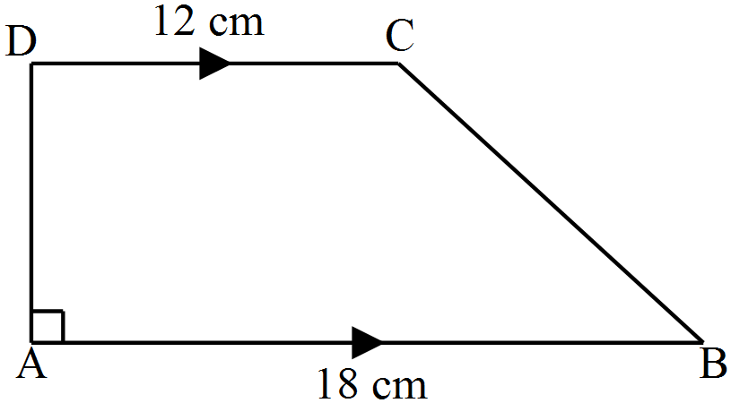

Calculate the perimeter of the trapezium. (3 marks)

1. The total cost of a book and a pen in a shop is Ksh 360. If the price of a book is increased in the ratio 6:5 while that of a pen is decreased in the ratio 4:5, the total cost of the items becomes Ksh 346. Find the price of each item. (3 marks)
2. Simplify . (3 marks)
3. Triangle PQR has vertices at P(1,1), Q(4,1) and R(3,4) as shown in the figure below.  is the image of triangle PQR under a  turn about the origin followed by a reflection in the line . On the grid below, draw the triangle . (3 marks)

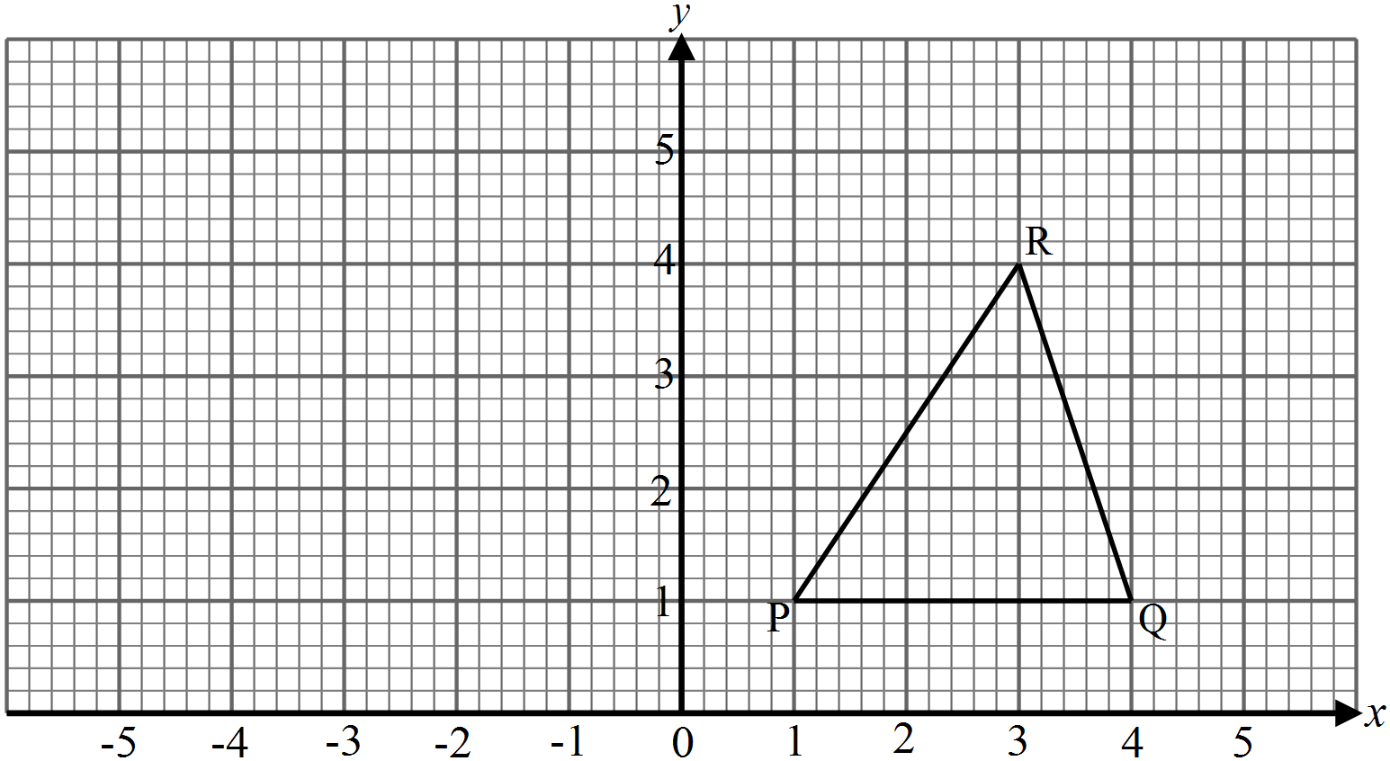

1. Use the inequality below to find the integral values of x that satisfy the inequality and show the solution on the number line. (4 marks)

3x + 1 ≤ 4x + 5 ≤x + 13

1. In the figure below, A and B are points (2,4) and (3,2) respectively. 5**OA** = 2**BC** and M is the midpoint of **AC**.

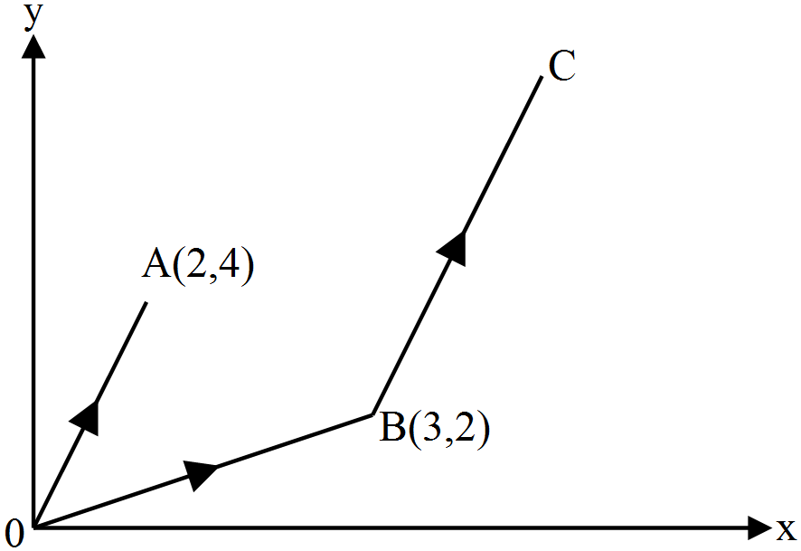

Find the coordinates of M. (3 marks)

1. Solve the equation 64x – 121 = 7 – 4x (3 marks)
2. In the figure below, P is the centre of the arc AQB and O is the centre of the semi – circle APB.

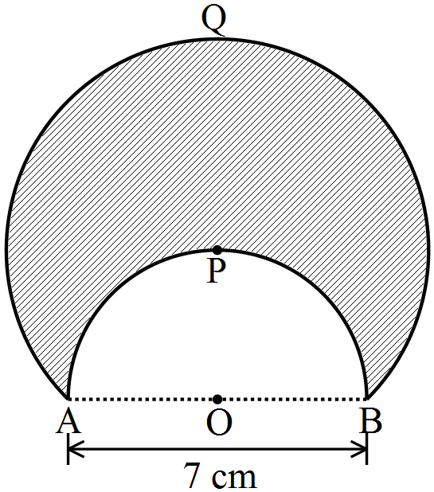

Given that AB = 7 cm, and taking  to be , calculate the area of the shaded region correct to 1 decimal place. (4 marks)

**SECTION II** (50 Marks)

*Answer only* ***five*** *questions from this section in the spaces provided.*

1. In the figure below, AC = 4 cm and BD = 9 cm. ADB = ABC, DAB = ACB and.

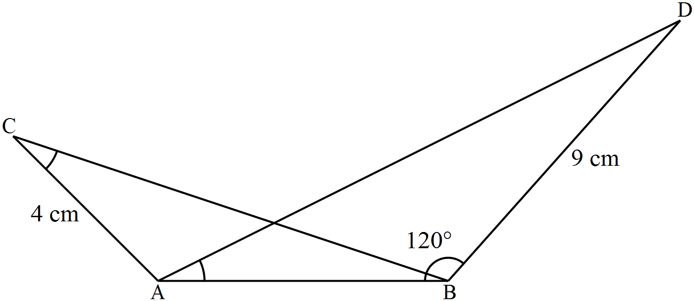

1. Calculate:
2. The length of AB. (3 marks)
3. The perpendicular height of point D from AB produced correct to 1 decimal place.

(2 marks)

1. Calculate correct to 2 decimal places:
2. The length of AD. (3 marks)
3. The size of angle ADB. (2 marks)
4. The data below are marks scored by 45 students in a Mathematics test.



1. Using the data above, complete the frequency distribution table below. (2 marks)



1. Draw a histogram to represent the data above. (3 marks)

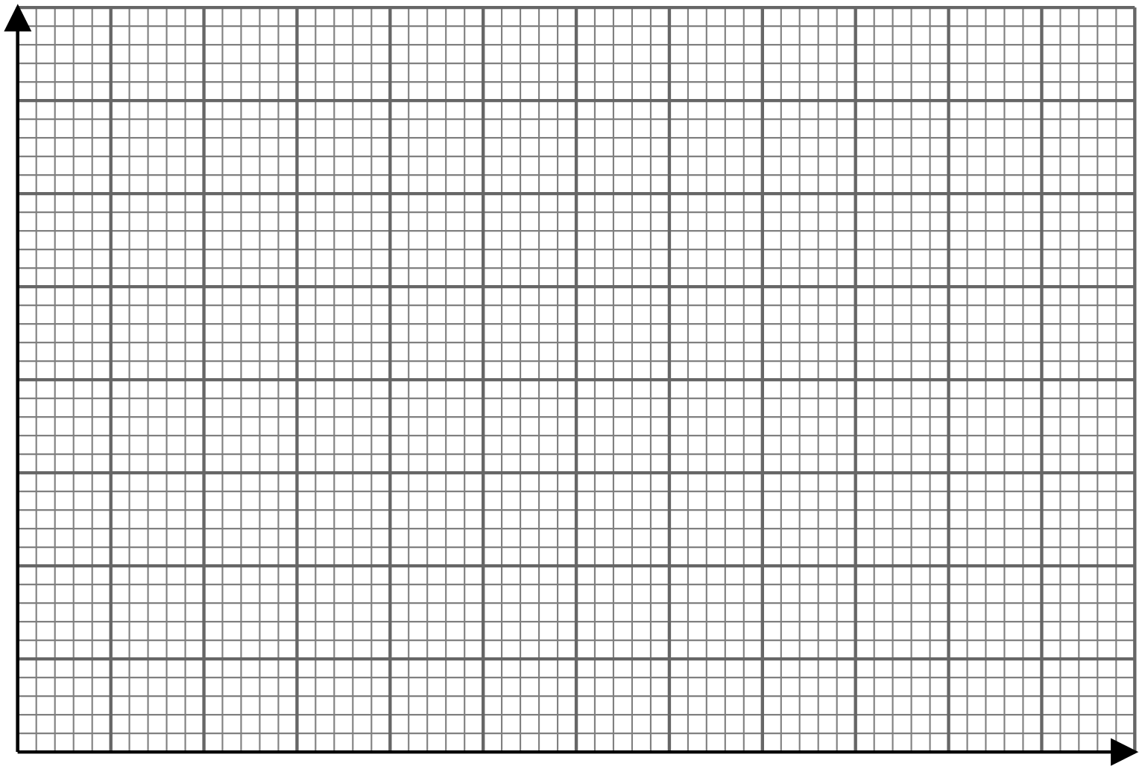

1. Using the histogram in (b) above, determine:
2. The median mark. (3 marks)
3. The number of students that failed if the pass mark was 49.5. (2 marks)
4. Two circles of radii 3.5 and 4.2 cm with centres O1 and O2 respectively intersect at points A and B

as shown in the figure below. The distance between the two centres is 6 cm.

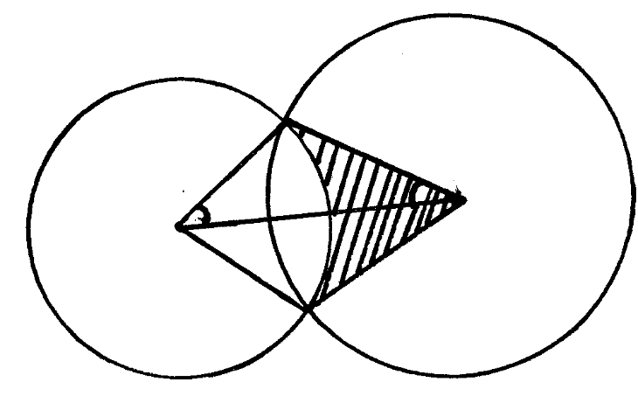

**A**

**O2**

**O1**

**3.5 cm**

**4.2 cm**

**B**

**α**

Calculate

1. The size of AO1B ( to the nearest degree) ( 3mks)
2. The size of  A O2 B ( to the nearest degree) ( 3mks)
3. The area of quadrilateral O1AO2B, correct to 2 decimal places. (2mks)
4. The shaded area correct to 2 significant figures. ( take ) ( 2mks)



1. The figure below shows a frustrum container with base radius 8 cm and top radius 6 cm. The slant height of the frustrum is 30cm . The container 90 percent full of water.

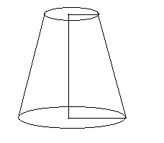

* 1. Calculate the surface area of the frustrum (3 marks)
  2. Calculate the volume of water. (4 marks)
  3. All the water is poured into a cylindrical container of circular radius 7cm, if the cylinder has the height of 35cm; calculate the surface area of the cylinder which is not in contact with water. (3 marks)

1. A straight line L1 passes through the points  and . Another line L2 is the image of L1 after a translation vector .
2. Find:
3. The equation of L1 in the form  where a, b and c are positive integers. (3 marks)
4. The *x* and *y* intercepts of line L2. (3 marks)
5. Another line L3 passes through point  and is perpendicular to L2 at point P. Find the coordinates of P. (4 marks)
6. In the figure below, BD is a minor diagonal of a rhombus ABCD. Angle  and the diagonals of the rhombus ABCD intersect at O.

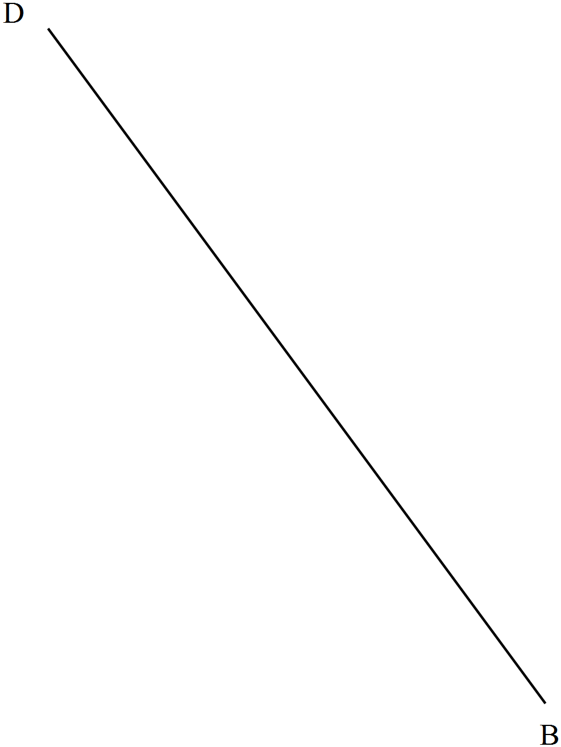

1. Using a ruler and a pair of compasses only, complete the rhombus. (3 marks)
2. Draw and measure:
3. The major diagonal AC. (1 mark)
4. The shortest distance from O to the side AB. (2 marks)
5. Draw the circle that touches the sides of the rhombus hence, calculate the area in the rhombus not covered by the circle. Take  to be 3.142. (4 marks)
6. Two friends Sheryl and Emmy live 40km apart. One day Sheryl left her house at 9.00a.m and cycled towards Emmy's house at an average speed of 15km/hr. Emmy left at 10.30a.m on the same day and cycled towards Sheryl’s house at an average speed of 25km/hr.
7. Determine
8. The distance from Sheryl's house, where the two friends met (4 marks)
9. The time they met (2 marks)
10. How far Sheryl was from Emmy's house when they met (2 marks)
11. The two friends took 10 minutes at the meeting point and they cycled to Emmy's house at an average speed of 12km/hr. Find the time they arrived at Emmy's house. (2 marks)
12. Four towns P, Q, R and S are such that town Q is 120km due East of town P, Town R is 160km due North of Town Q, Town S is on a bearing of 330o from P and on a bearing of 300o from R
13. i) draw a sketch to show the relative positions of the town. (1 mark)

ii) Using a ruler and a pair of compasses only, show the relative positions of towns P, Q R and S. Take a scale of 1 cm rep 50km. (5 marks)

1. determine
2. the distance SP in km (2 marks)
3. the bearing of S from Q (2 marks)