Term 2 - 2023
GEOGRAPHY
FORM THREE
TIME: 2 ¾ HOURS

Name: …………………………………………………………. Adm No: ……………….
School: ……………………………………………………….. Class: …………………..
Signature: …………………………………………………….. Date: …………………...

INSTRUCTIONS TO CANDIDATES:

- This paper consists of two sections: A and B
- Answer all the questions in section A
- Answer question 6 and any two questions from section B
- All answers must be written in the answer booklet provided

SECTION A: 25 MARKS
Answer all the questions from this section.
1. (a) What is the relationship between Geography and Chemistry? (2 marks)
(b) The diagram below shows the internal structure of the earth.

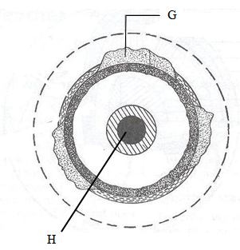

(i) Name the parts marked G and H. (2 marks)
(ii) Name the dominant mineral in the mantle. (1 mark)
2. (a) Differentiate between absolute and relative humidity. (2 marks)
(b) State the significance of humidity in the atmosphere. (3 marks)
3. (a) Differentiate between a mineral and a rock (2 marks )
b) Highlight three methods of alluvial / placer mining (3 marks)
4. a) Define the terms
i) Forest (1 mark)
ii) Forestry (1 mark)
b) State three main types of forests (3 marks)
5. (a) Identify two scales used to measure the intensity of an earthquake. (2 marks)
(b) Give three major earthquake zones of the world. (3 marks)

SECTION B: 75MARKS
Answer question 6 and any other two questions from this section.

6 .Study the photograph below and answer the questions that follow.

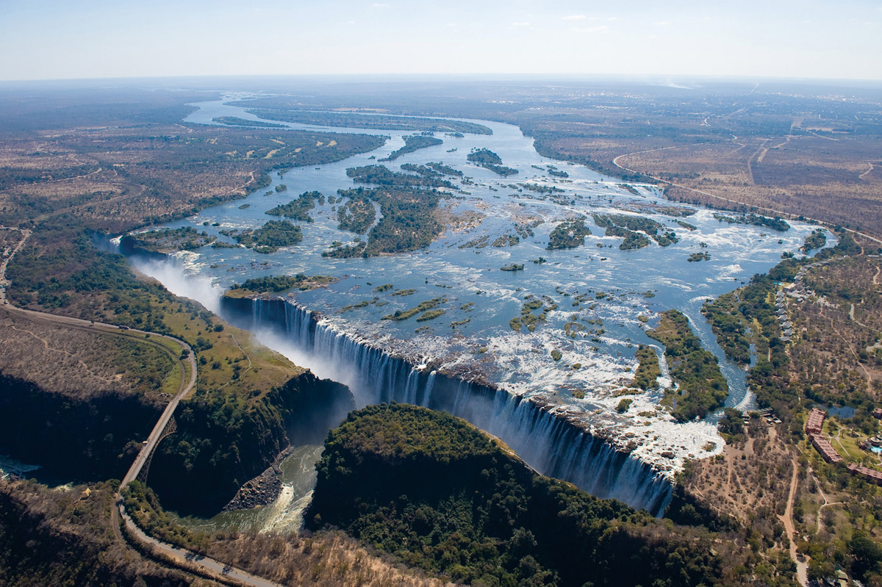

- Name the type of photograph shown above. (2mks)
- Name the drainage feature represented by the photograph above. (1mk)
- Name two erosional features that can be seen from the drainage system shown in the photograph above. (2mks)
- Name two indicators seen on the photograph that show the drainage feature above might be in its old stage. (2mks)
- Describe the relief of the area covered by the photograph. (2mks)
- Citing evidences from the photograph, give two economic activities that likely takes place in the area in the area shown by the photograph. (4mks)
- Draw a rectangle measuring 15cm by 10cm to represent the photograph above and on it show the main features. (6mks)
- Students in a school near the feature conducted a field study in this region.
- Name two tools they would need. (2mks)
- State one objective for their study (1mk)
- Name three methods they would use to collect data. ( 3mks)

7.
a) i) Name three types of faults. (3mks)
ii) Apart from compressional forces, explain two other processes that may cause faulting. (4mks)
b) i)With, the aid of a well labeled diagram, describe how a rift valley is formed by compressional forces. (6mks)

ii) Explain three ways in which faulting may influence drainage system. (6mks)
c) Explain three ways in which faulting is of significance to human activities. (6mks)

8

a. i. What is an air mass? (2marks)
ii. Distinguish between maritime and continental air masses. (2marks)
b. Explain briefly how the following factors influence rainfall.
i. Forests. (4marks)
ii. Water bodies. (2marks)
c. i. State any two ways in which climate change can result from natural causes. (2marks)
ii. State five effects of aridity and desertification. (5marks)
iii. Explain any four possible solutions to aridity and desertification (8marks)

9
(a) (i) Differentiate between a barrier reef and a fringing reef (2 marks)
(ii) Give three causes of oceans currents (3 marks)
(b) The diagram below shows Coastal features. Use it to answer questions b (i).
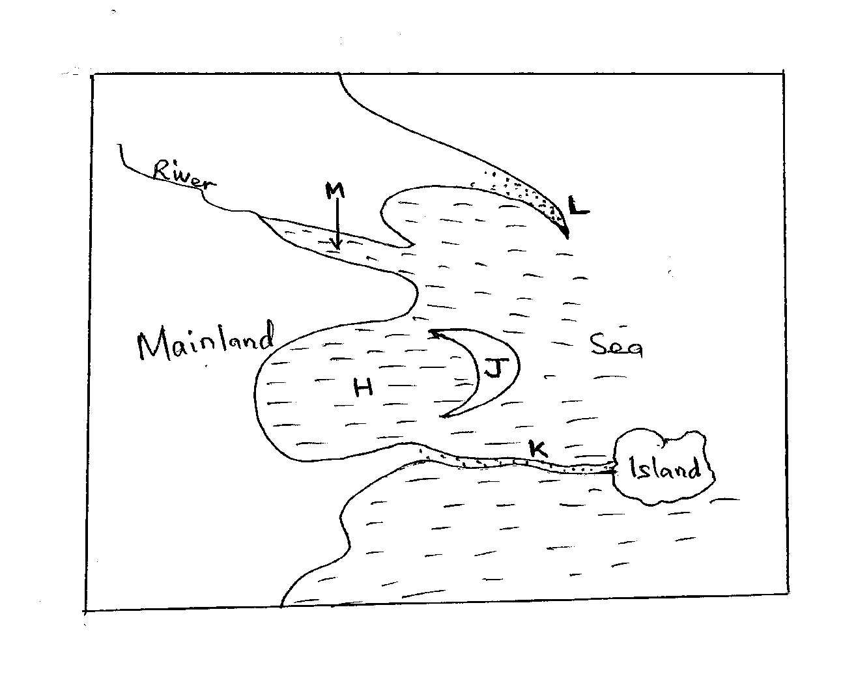
(i) Name the coastal features marked H, J, K, L. (4 marks)
(c) With the aid of diagrams describe how a wave – cut platform is formed (6 marks)
(d) Explain how the following factors influence development of coasts
(i) Climate (2 marks)
(ii) Gradient of the Coast (2 marks)
(e) Your class intends to carry out a field study on the features along the coast of Kenya.
(i) Why would they need to carry out reconnaissance (3 marks)
(ii) Give three disadvantages of using observation to collect data (3 marks)

10. a. i. Name two types of desert surface. (2 marks)
ii. Give two reasons why wind action is effective in the hot desert. (2 marks)
iii. Explain processes of wind erosion in desert areas. (4 marks)

b. i. Apart from rock pedestal, name two other erosional features formed by wind in desert. (2 marks)
ii. With aid of well labeled diagrams, describe the formation of rock pedestal. (6 marks)
c. i. State three factors that influence the transportation of materials in the desert by wind. (3 marks)
ii. Explain three negative effects of desert land forms. (6 marks)

