Term 2 - 2023
GEOGRAPHY 312
FORM 2
Time: 2 Hours

Name: …………………………………………………………. Adm No: ……………….
School: ……………………………………………………….. Class: …………………..
Signature: ………………………………………..…………… Date: …..……………….
This paper consists two sections; A and B. Answer ALL Questions
SECTION A
- a) Define the following terms;
(i) Geography (2 marks)
__________________________________________________________________________________________________________________________________________________________________________
(ii) Habitat (2 marks)
__________________________________________________________________________________________________________________________________________________________________________
b) What is the relationship between Geography and Agriculture? (2 marks)
_______________________________________________________________________________________________________________________________________________________________________________________________________________________________________________________________
c) List two areas studied under Practical Geography. (2 marks)
__________________________________________________________________________________________________________________________________________________________________________
d) State two reasons for studying Geography in Kenyan Secondary Schools. (2 marks)
_______________________________________________________________________________________________________________________________________________________________________________________________________________________________________________________________
- a) (i) What is meant by the term ‘Solar System’? (2 marks)
__________________________________________________________________________________________________________________________________________________________________________
(ii) Name two planets without satellites. (2 marks)
__________________________________________________________________________________________________________________________________________________________________________
b) (i) Describe origin of the solar system according to the Passing Star Theory. (4 marks)
____________________________________________________________________________________________________________________________________________________________________________________________________________________________________________________________________________________________________________________________________________________
(ii) State two weaknesses of the Passing Star Theory. (2 marks)
__________________________________________________________________________________________________________________________________________________________________________
- a) (i) What do we call the shape of the earth? (1 mark)
_____________________________________________________________________________________
(ii) Highlight the forces responsible for the earth’s shape. (3 marks)
__________________________________________________________________________________________________________________________________________________________________________
b) Explain three proofs that the earth is Spherical. (6 marks)
______________________________________________________________________________________________________________________________________________________________________________________________________________________________________________________________________________________________________________________________________________________________________________________________________________________________________________________________________________________________________________________________
- a) (i) Distinguish between Earth’s Rotation and Earth’s Revolution. (2 marks)
_______________________________________________________________________________________________________________________________________________________________________________________________________________________________________________________________
(ii) Give two Effects of Earth’s Revolution? (2 marks)
__________________________________________________________________________________________________________________________________________________________________________
b) What is the time at Kitale 35⁰E when the time at Mogadishu 39⁰E is 1pm. (2 marks)
__________________________________________________________________________________________________________________________________________________________________________
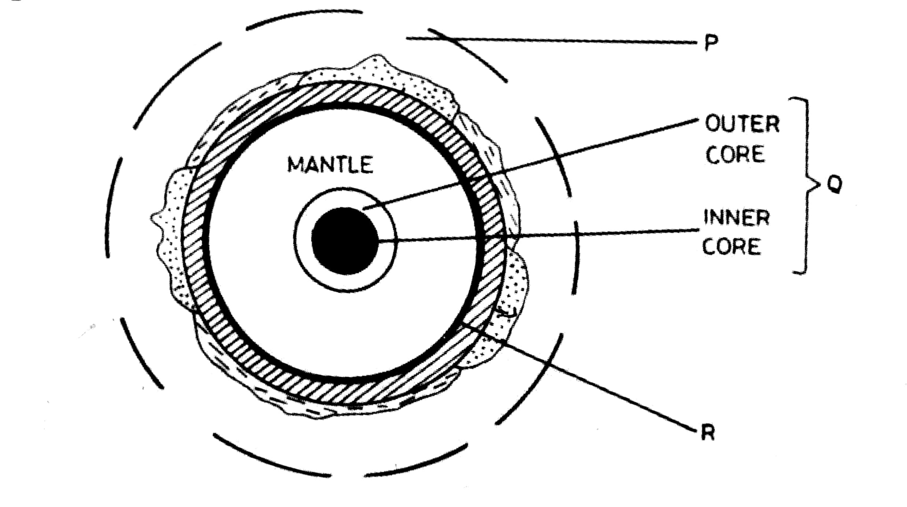
- a) The diagram below represents the structure of the earth. Use it to answer question (a)
- Name: (i) the parts marked P and Q (2 marks)
____________________________________ _________________________________
(ii) the discontinuity marked R (1 mark)
_____________________________________________________________________________________
- Outline two characteristics of the mantle. (2 marks)
__________________________________________________________________________________________________________________________________________________________________________
- State three reasons why the interior of the earth is hot. (3 marks)
_______________________________________________________________________________________________________________________________________________________________________________________________________________________________________________________________

SECTION B
Answer all Questions in this Section.
- The photograph below shows cattle rearing in an area in Kenya. Use it to answer the following questions;

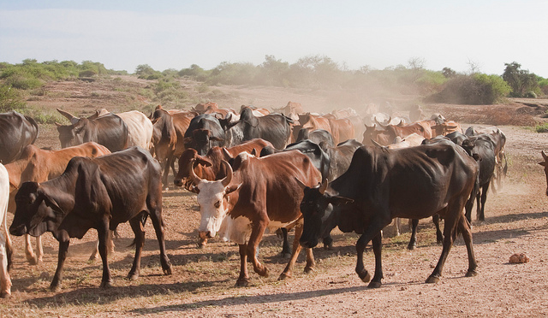

- (i) Name the type of photograph shown above (1 mark)
(ii) What economic activity is carried out on the area shown by the photograph? (1mark)
(iii) Give one reason for your answer in (i) above. (1 mark)
(iv) Draw a rectangle measuring 12cm by 7cm to represent the area of the photograph. On it sketch and label the main features shown on the photograph (5 marks)
7. (a)(i) Distinguish between a mineral and a rock. (2mks)
(ii) Give three examples of energy mineral. (3mks)
(b)(i) Give the two types of extrusive igneous rocks. (2mks)
(ii) Describe how the following types of rocks are formed;
Chemically formed sedimentary rock. (4mks)
Dynamic metamorphic rock. (3mks)
Thermal metamorphic rock. (3mks)
- You intend to carry out field study on rocks around your school.
- Give two economic reasons for conducting such a field study. (2mks)
- State two reasons for preferring direct observation to administering interview during the field study. (2mks)
- Give 2 physical importance of rocks. (2mks)
8.(a) What is a fold? (2mks)
(b) Describe plate tectonic theory. (4mks)
(c)(i) Name any two features that formed at the extensional boundary. (2mks)
(ii) Using well labelled diagrams describe the formation of Fold Mountain . (9mks)
(d)(i) Give the major fold ranges in the following countries in Africa;
South Africa (1mk)
Morocco (1mk) Ethiopia (1mk)
(ii) State any five effects of Fold Mountain to the environment. (5mks)

