TERM 2 - 2023
DRAWING AND DESIGN
PAPER 1
FORM FOUR (4)
Time: 2½ Hours

Name: …………………………………………………………. Adm No: ……………….
School: ……………………………………………………….. Class: …………………..
Signature: …………………………………………………….. Date: …………………...
Instructions to Candidates

(a) You should have the following materials:

Drawing instruments.
3 sheets of drawing paper size A3;
(b) This paper consists of three sections; A, B and C.
(c) Answer all the questions in sections A and B and any two questions from section C.
(d) Questions in Section A must be answered in the spaces provided.
(e) Questions in Section B and C should be answered on the A3 sheets of drawing paper provided.
(f) All dimensions are in millimeters unless otherwise stated.
(g) Candidates may be penalized for not following the instructions given in this paper.
(h) This paper consists of 8 printed pages.
(i) Candidates should check the question paper to ascertain that all the pages are printed as
Indicated and that no questions are missing.
(j) Candidates should answer the questions in English.

FOR EXAMINERS USE ONLY
1 | 2 | 3 | 4 | 5 | 6 | 7 | 8 | 9 | 10 | 11 | 12 | 13 | TOTAL

SECTION A (50 marks)
Answer all the questions in this section on the answer sheet provided
1.(a) State two disadvantages of using tape to hold drawing paper on the drawing board. (2marks)
- Tears the paper
- Di

(b) Name two methods of sharpening pencils leads and state where each is applied in
Technical drawing. (2 marks)
- Chisel shape used for drawing construction lines
- Conical shape used for drawing visible outline
2. Sketch the conventional symbol for each of the following as used in drawing: (3 marks)

(a) Planned timber.

(b) Third angle projection.

(c) Earth wire

3. (a) State two advantages of plywood over solid timber. (2 marks)
………………………………………………………………………………………………………………………………………………………………………………………………………………………………………………………………………………………………………………………………………………………
(b) Define each of the following properties of materials. (3 marks)
(i) Plasticity.

(ii) Elasticity.

4. Figure 1 shows a simple shaped block drawn full size (Scale 1:1) in isometric projection.
Copy figure and dimension it fully. (4marks)
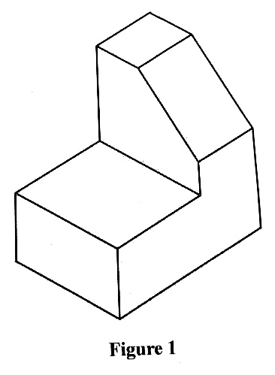

5. (a) State two reasons why care must be taken when storing drawing instructions. (1 mark)

(b) Name four components of a computer and state the use of each. (4 marks)

6. Figure 2 shows a truncated cone whose base is 50mm and a perpendicular height of 60mm.
Copy the figure and draw the following: (5 marks)
(a) Complete plan.
(b) True shape of the truncated section.
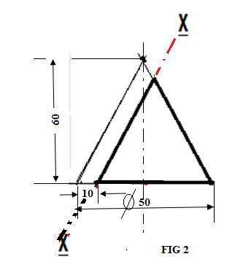

7. Construct an involute of a square whose side are 35 mm. (6marks)

8. Figure 3 shows a diagonal scale.
(a) Determine the accuracy of the scale. (1 mark)

(b) Outline the steps to follow in order to obtain reading “p”. (4 marks)
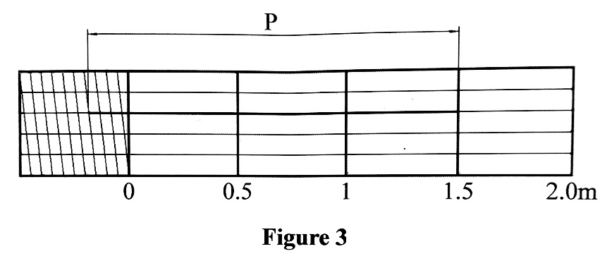

9. Figure 4 shows a shape block drawn in isometric projection.
Sketch in good proportion the following views in first angle projection: (6 marks)
(a) Front elevation in the direction of Arrow A.
(b) End elevation in the direction of Arrow B.
(c) Plan
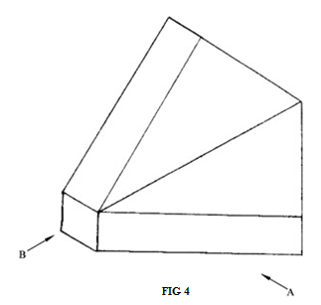

10. Figure 5 shows two views of a solid block drawn in first angle projection.
In good proportion draw the block in Isometric projection with A as the front face (7 marks)
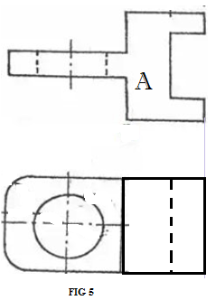

SECTION B (20 marks)
This question is compulsory:
It should be answered on the A3 paper provided.
Candidates are advised not to spend more than one hour on this question
11. Figure 6 shows parts of a towing device drawn in first angle projection. Assemble the parts and draw full size the following views in third angle projection:
(a) Sectional front elevation along the cutting plane P-P
(b) Sectional Plan along the cutting plane K-K

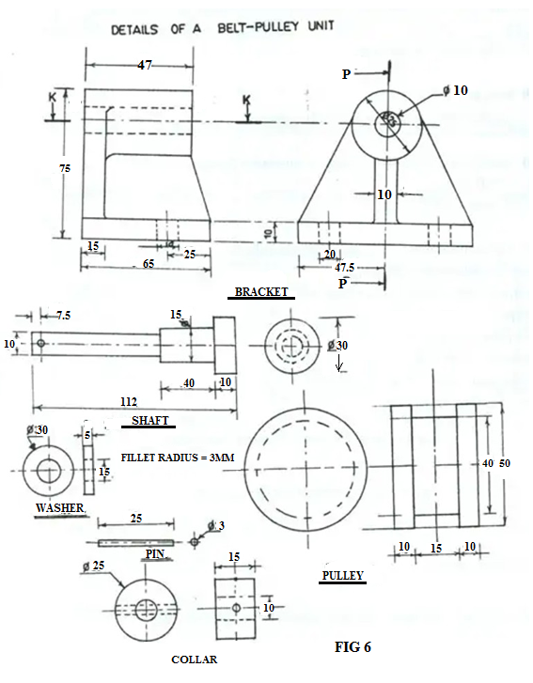

SECTION C (30 marks)
Answer any two questions from this section on the A3 paper provided
12. The Figure 7 shows a block drawn in isometric projection. Draw FULL SIZE in first angle projection the three orthographic views of the block. (15 marks)
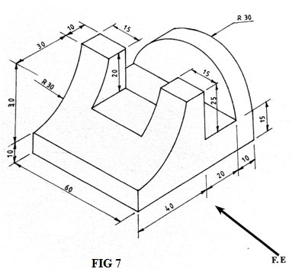

13. The Figure 8 shows a branch pipe A connected to a conical shaped base of a chimney B. Draw the curves of intersection between the pipe and the conical base in: (15mks)
- Front elevation
- plan
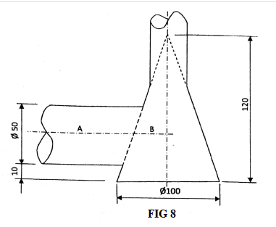
14. The Figure 9 shows an inclined plan of a block and its front elevation. Copy the given layout and draw a two-point perspective of the block showing the construction details. (15mks)
