**TERM 2 - 2023**

**DRAWING AND DESIGN**

**FORM TWO (2)**

**Time: 2½ Hours**

**Name: …………………………………………………………. Adm No: ……………….**

**School: ……………………………………………………….. Class: …………………..**

**Signature: …………………………………………………….. Date: …………………...**

**INSTRUCTIONS TO CANDIDATES:**

**Answer all questions in both section A & B in the separate sheets of A3 papers provided**

|  |  |  |
| --- | --- | --- |
| **QUESTIONS** | **MAXIMUM SCORE** | **CANDIDATE SCORE** |
| **1-13** | **100** |  |

**SECTION A (55 MARKS)**

1. Give two reason for manufacturing drawing boards using block boards. (1mks)
2. Construct a heptagon within a circle of Ø70mm. (2mks)
3. Construct an ellipse using concentric circle method with major and minor axes of 86 and 50mm respectively. Draw a tangent on the resultant ellipse. (7mks)
4. construct a regular octagon whose distance across flats is 60mm. (6mks)

1. Draw a triangle whose perimeter is 100mm and the ratio of sides are 3:4:5. (3mks)
2. Figure below shows an incomplete plan of a pentagonal pyramid. The length of sides are 30mm and its perpendicular height is 60mm. (6 mks)

Draw the following

1. Complete plan
2. Front Elevation
3. End Elevation

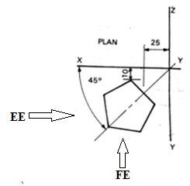

1. Sketch the figure below in oblique projection (8 mks)



1. **OG** is a crank of length 25mm free to move around a fixed point **O.**

**GP** is an arm of length 90 mm is constrained to move such that **D, 70mm** from **G,** must slide horizontally along the horizontal centre line **OF.**

Draw the locus of **P** as **OG** rotates through **3600.** (9 marks)

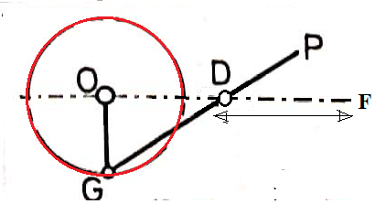

1. The figure shows orthographic views of a shaped block. Construct a two-point perspective from these views below the horizon line. (7mks)

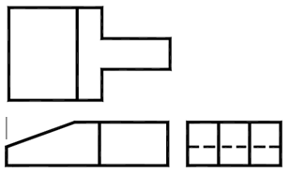

1. The figure shown below is a diagram of a shaped isometric block. Draw the three orthographic views of the block in ***first angle projection*** (6mks)

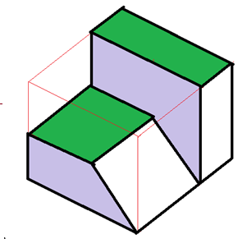

**SECTION B (45 MARKS)**

1. Using the given orthographic views, draw a pictorial drawing in isometric form taking “P” as the lowest point. (15Mks)

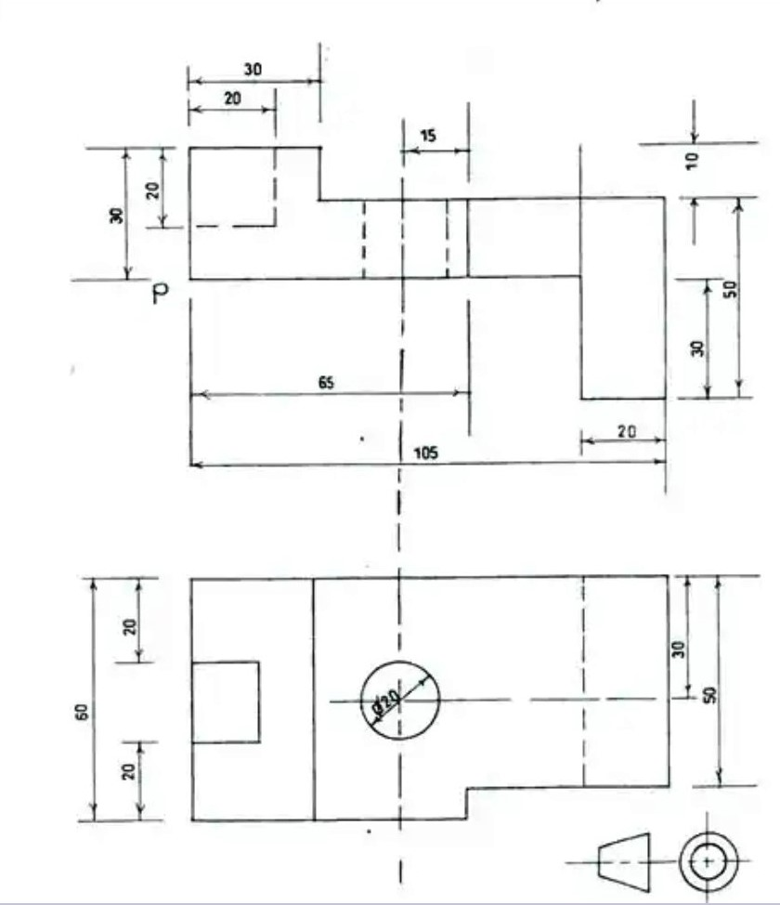

1. Construct a plain scale in which 30mm represent 10mm whose accuracy is 1mm to read up to 50mm. Show a reading of 36mm.Using the constructed scale, draw by construction a diagram shown below. (15mks)

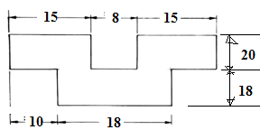

1. The figure below shows a machine component drawn in isometric. Draw full size the following views in first angle projection:
2. Front Elevation,
3. End Elevation, and
4. PLAN.

The front is observed as indicated. (15mks)

