TERM 2 - 2023
DRAWING AND DESIGN

FORM ONE (1)
Time: 2½ Hours
Name: …………………………………………………………. Adm No: ……………….
School: ……………………………………………………….. Class: …………………..
Signature: …………………………………………………….. Date: …………………...

INSTRUCTIONS TO CANDIDATES:
Answer all questions in the separate sheets of A3 papers provided
Answer all questions

QUESTIONS | MAXIMUM SCORE | CANDIDATE SCORE
1-18 | 100

- State six different drawings commonly used in different engineering fields. (6mks)

- a) State any four methods of mounting drawing paper on drawing board surface. (4mrks)

b) List three factors that contribute to quality drawings (3mks)

- Explain how technical drawing can assist you as a person in future. (4mks)

- a) state the importance of using quality pencils in producing drawings. (1mk)

b) Illustrate how H pencil is sharpened. (1mk)

c) Give one reason why the tip of the rubber should be chisel shaped or sharp. (1mk)

- Indicate whether each of the following drawings is a convention or a symbol. (2 mks)
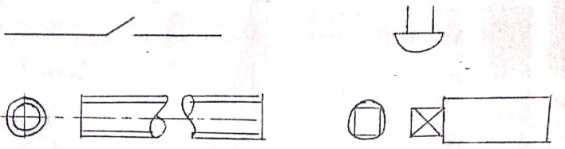

- List four factors to be considered during a design process. (4mks)

- Use sketches to differentiate between leader line and extension line. (2mks)

- Draw a line 98mm long and subdivide proportionally into seven equal portions (4mks)

- Name the following drawing tools. (2mks)
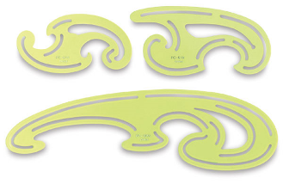
A
B

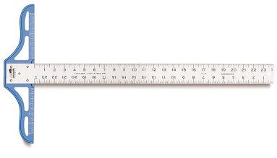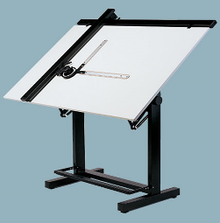

C
D
- List three disadvantages of using masking tape to mount drawing papers. (3mks)

- Construct an equilateral triangle whose length of sides being 60mm (6mks)

- State three functions of a pair of compass. (3mks)

- List three factors that contribute to quality drawings (6mks)

- Draw a trapezium whose base length is 70mm, two parallel sides are 55mm apart and one included angle being 75⁰. (8mks)

- Draw a scale 1 cm represent 1metre, to measure maximum distance of 6 m.
Show on it a distance of 5.9 m and 2.7 metres. (6 marks)

- Name the following symbols (4mks)
- 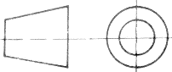………………… ………………………………

- 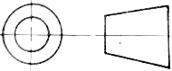………………… ……………………………………..

- Ø .......................................................................................................................

- C/C………………………… ……………………………….

- Draw the following views of the isometric block shown below in first angle orthographic projection.. (15mks)
  - Front Elevation in the direction of arrow A
  - End elevation in the direction of arrow B
  - The plan.
  - Insert six main dimensions.
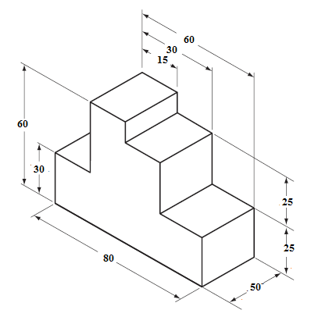

- Three views of a machine component are shown below. Draw the figure in isometric projection. (15 marks)
