TERM 2 - 2023
CHEMISTRY – PAPER ONE (233/1)
FORM FOUR (4)
Time - 2 Hours

Name …………………………………………….……… Admission Number …………….
Candidate’s Signature ………………….…...………... Class ……………………………

INSTRUCTIONS TO CANDIDATES:
- Answer ALL questions in the spaces provided for each question.
- All working must be clearly shown where necessary.
- Mathematical tables and silent electronic calculators may be used.
- All workings MUST be clearly shown where necessary.

FOR EXAMINER’S USE ONLY:
QUESTION | MAXIMUM  SCORE | CANDIDATES  SCORE
1 - 27 | 80

- (a) What is radioactivity? (1 mark)
………………………………………………………………………………………………………………………………………………………………………………………………………………
(b) The half-life of a radioisotope is 2.5 hours. If the initial radioactivity of the radioisotope is 800 counts per minute, how long will it take for the count to fall to 75 counts per minute? (2 marks)
………………………………………………………………………………………………………………………………………………………………………………………………………………
………………………………………………………………………………………………………………………………………………………………………………………………………………

- (a) Complete the table below to:
- deduce the number of protons, electrons and neutrons in the magnesium atom and copper ions shown.
- identify the atom or ion represented by the final row. (2 ½ marks)
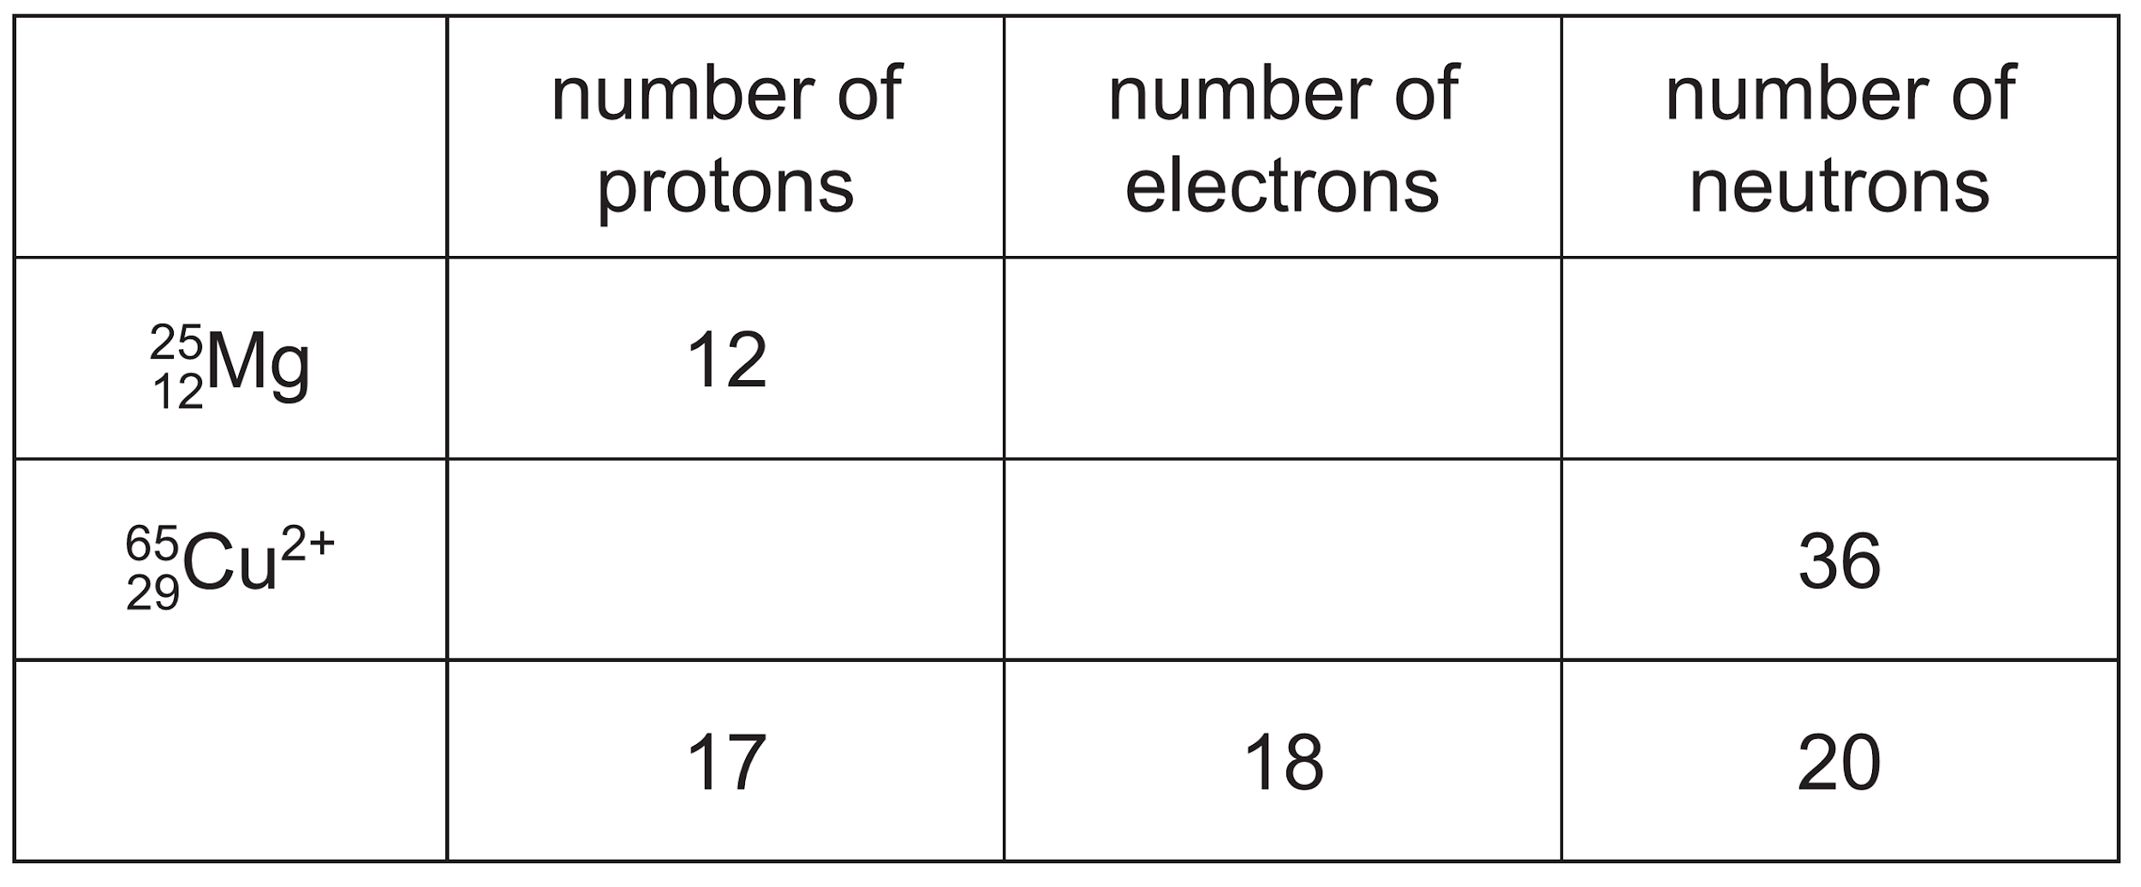
(b) Give the meaning of the term cation. ( ½ mark)
………………………………………………………………………………………………………
………………………………………………………………………………………………………
- Calcium reacts with water to form two products. A colourless gas Q and an alkaline solution P.
- Name colourless gas Q. (1 mark)
………………………………………………………………………………………………………
………………………………………………………………………………………………………
- Give the ions responsible for making solution P alkaline. (1 mark)
………………………………………………………………………………………………………
………………………………………………………………………………………………………

- Write the chemical equation for the reaction. (1 mark)
………………………………………………………………………………………………………
………………………………………………………………………………………………………
- (a) Give the meaning of the term enthalpy of formation. (1 mark)
………………………………………………………………………………………………………
………………………………………………………………………………………………………
(b) Determine the enthalpy of the following reaction: (2 marks)
C₂H₄ + Cl₂ → C₂H₄Cl₂
Bond | Bond energy (kJ/mol)
C-C | 348
C = C | 612
Cl – Cl | 242
C – Cl | 338
C – H | 413
………………………………………………………………………………………………………
………………………………………………………………………………………………………
………………………………………………………………………………………………………
………………………………………………………………………………………………………
………………………………………………………………………………………………………
- Draw a set-up that can be used to prepare and collect nitrogen (IV) oxide in the laboratory. (2 marks)

- (a) Explain the difference in boiling points between magnesium oxide and oxygen gas. (2 marks)
………………………………………………………………………………………………………
………………………………………………………………………………………………………………………………………………………………………………………………………………
(b) Give the meaning of the term electron affinity. (1 mark)
………………………………………………………………………………………………………
………………………………………………………………………………………………………
- (a) Explain why it is not advisable to use potassium sulphate as a salt bridge in an electrochemical cell formed between the following half cells.
Pb(s) | Pb²⁺ (aq) E^{θ} = -0.13 V and Cu (s) | Cu²⁺ (aq) E^{θ} = +0.34 V (1 mark)
………………………………………………………………………………………………………
………………………………………………………………………………………………………
(b) Calculate the emf of the cell formed by combining the two half cells in (a) above.
(2 marks)
………………………………………………………………………………………………………
………………………………………………………………………………………………………
………………………………………………………………………………………………………
………………………………………………………………………………………………………

- The figure below shows the blast furnace for the extraction of iron.
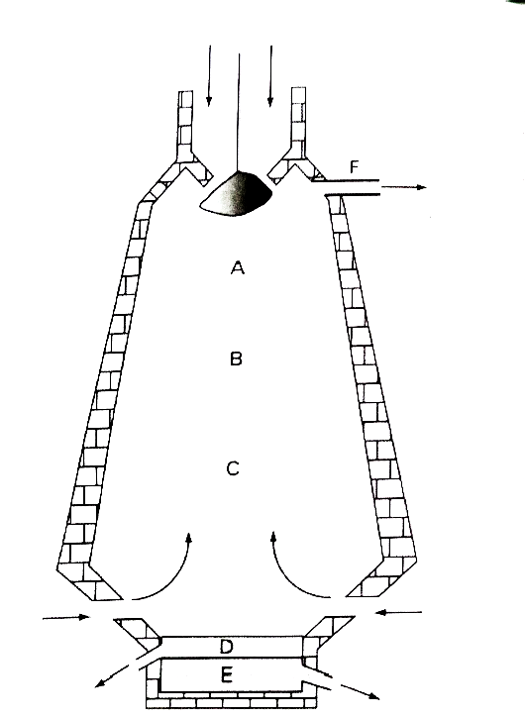
- Give the name of the two substances coming from point F. (1 mark)
………………………………………………………………………………………………………
………………………………………………………………………………………………………
- Write the equation for the reaction taking place at point B. ( 1 mark)
………………………………………………………………………………………………………
………………………………………………………………………………………………………
- The iron obtained from the blast furnace is impure. State how the impurities are removed from the molten iron. (1 mark).
………………………………………………………………………………………………………
………………………………………………………………………………………………………
- (a) Describe how sodium chloride can be prepared in the laboratory using direct synthesis
method. (2 marks)
………………………………………………………………………………………………………
………………………………………………………………………………………………………
………………………………………………………………………………………………………
………………………………………………………………………………………………………

(b) Write an equation for the thermal decomposition of silver nitrate. (1 mark)
………………………………………………………………………………………………………
………………………………………………………………………………………………………
- When sulphur is heated, it melts into an amber-coloured liquid. On further heating, the liquid darkens and becomes viscous. Explain these observations. (2 marks)
………………………………………………………………………………………………………
………………………………………………………………………………………………………………………………………………………………………………………………………………
………………………………………………………………………………………………………
………………………………………………………………………………………………………
………………………………………………………………………………………………………
- (a) The diagram below shows three methods of gas collection.
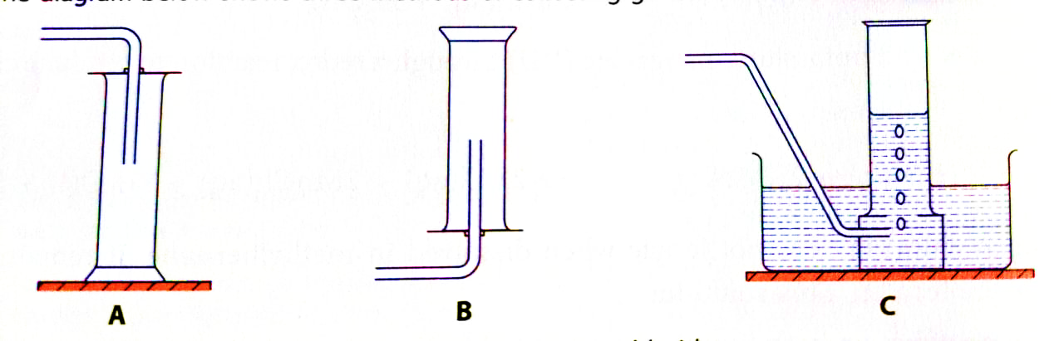
Which method of gas collection is most suitable for collecting dry chlorine gas? Explain.
(1 mark)
………………………………………………………………………………………………………
(b) Why was the use of DDT as a pesticide banned? (1 mark)
………………………………………………………………………………………………………
………………………………………………………………………………………………………
………………………………………………………………………………………………………
………………………………………………………………………………………………………
- List two uses of hydrochloric acid. (1 mark)
………………………………………………………………………………………………………
………………………………………………………………………………………………………
- In a titration, a student added 25.0 cm³ of 0.200 mol / dm³ aqueous sodium hydroxide to a conical flask. The student then added a few drops of methyl orange to the solution in the
conical flask. Dilute sulphuric (VI) acid is then added from a burette to the conical flask. The volume of dilute sulphuric (VI) acid needed to neutralise the aqueous sodium hydroxide was 20.0 cm³.
- What is the colour of methyl orange in aqueous sodium hydroxide? (1 mark)
………………………………………………………………………………………………………
………………………………………………………………………………………………………
- Calculate the concentration of sulphuric (VI) acid in mol/dm³. (2 marks)
………………………………………………………………………………………………………
………………………………………………………………………………………………………………………………………………………………………………………………………………
………………………………………………………………………………………………………
………………………………………………………………………………………………………
………………………………………………………………………………………………………
- Determine the time it would take 300cm³ of oxygen to diffuse through a small aperture if it takes 500cm³ of nitrogen (I) oxide 475 seconds to diffuse through the same aperture under the same conditions of temperature and pressure. (N = 14, O = 16) (3 marks)
………………………………………………………………………………………………………
………………………………………………………………………………………………………………………………………………………………………………………………………………
………………………………………………………………………………………………………
………………………………………………………………………………………………………
- (a) Explain the ‘strike back’ phenomenon that occurs during the lighting of the Bunsen burner. (2 marks)
………………………………………………………………………………………………………
………………………………………………………………………………………………………………………………………………………………………………………………………………

- What is the use of an aspirator in the laboratory? (1 mark)
………………………………………………………………………………………………………
………………………………………………………………………………………………………
- (a) What is the meaning of the term melting point? (1 mark)
………………………………………………………………………………………………………
………………………………………………………………………………………………………
- Element X undergoes the following physical changes.
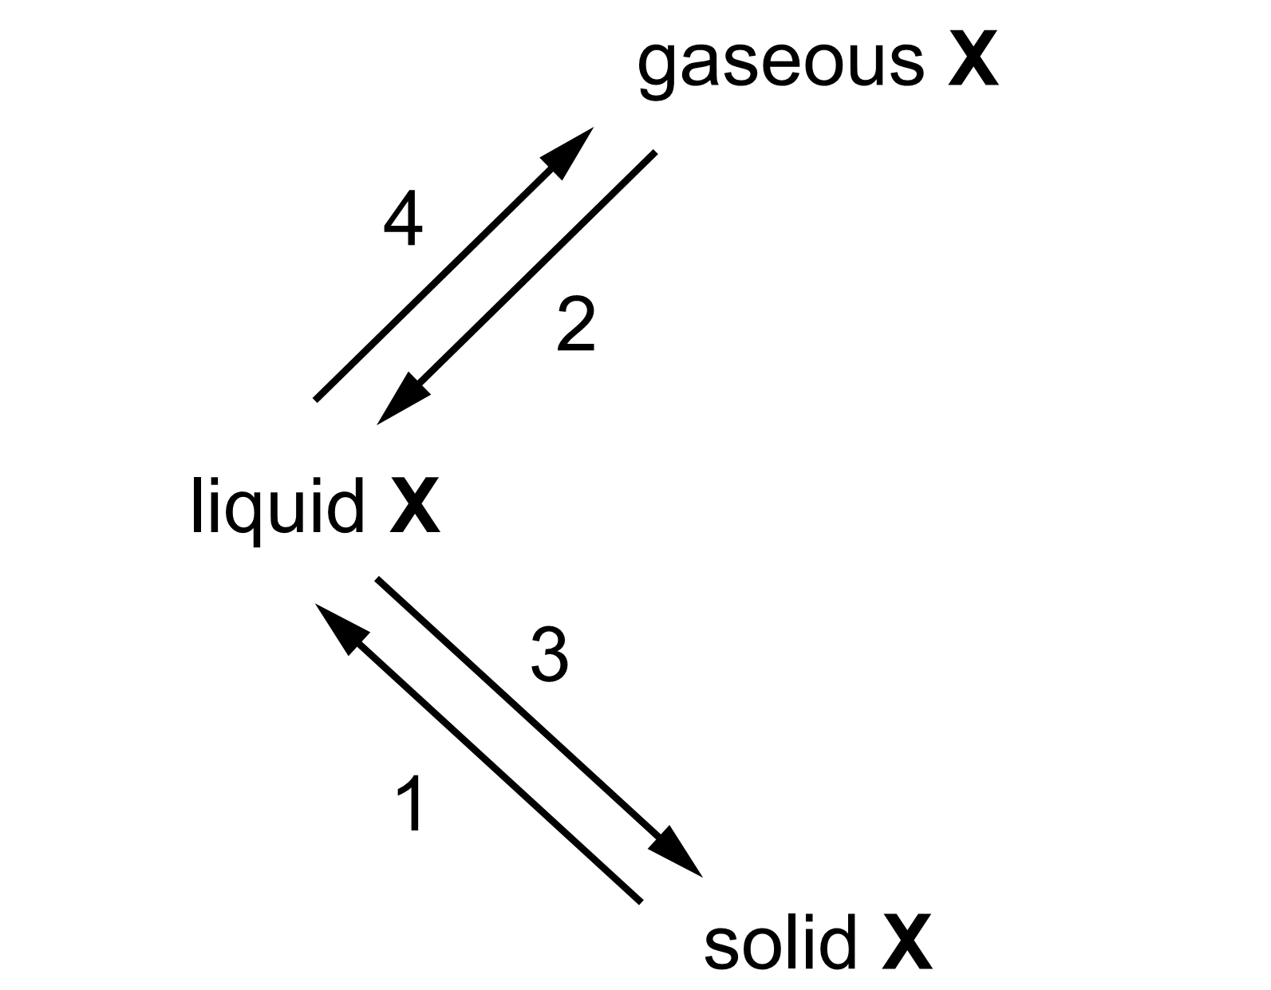
- Name each of the numbered physical changes. (2 marks)
1………………………………………………. 2………………………………….
3……………………………………………….. 4………………………………….
- Element X is a group III metal. Write an equation for the reaction of element X and oxygen gas. (1 mark)
………………………………………………………………………………………………………
………………………………………………………………………………………………………
- (a) State and explain the observation made when iron nails are left outside the laboratory for two weeks during the rainy season. (2 marks)
………………………………………………………………………………………………………
………………………………………………………………………………………………………
- Give two uses of oxygen gas. (1 mark)
………………………………………………………………………………………………………
………………………………………………………………………………………………………

- The rate of reaction between a metal and an acid can be investigated using the apparatus shown in the figure below.
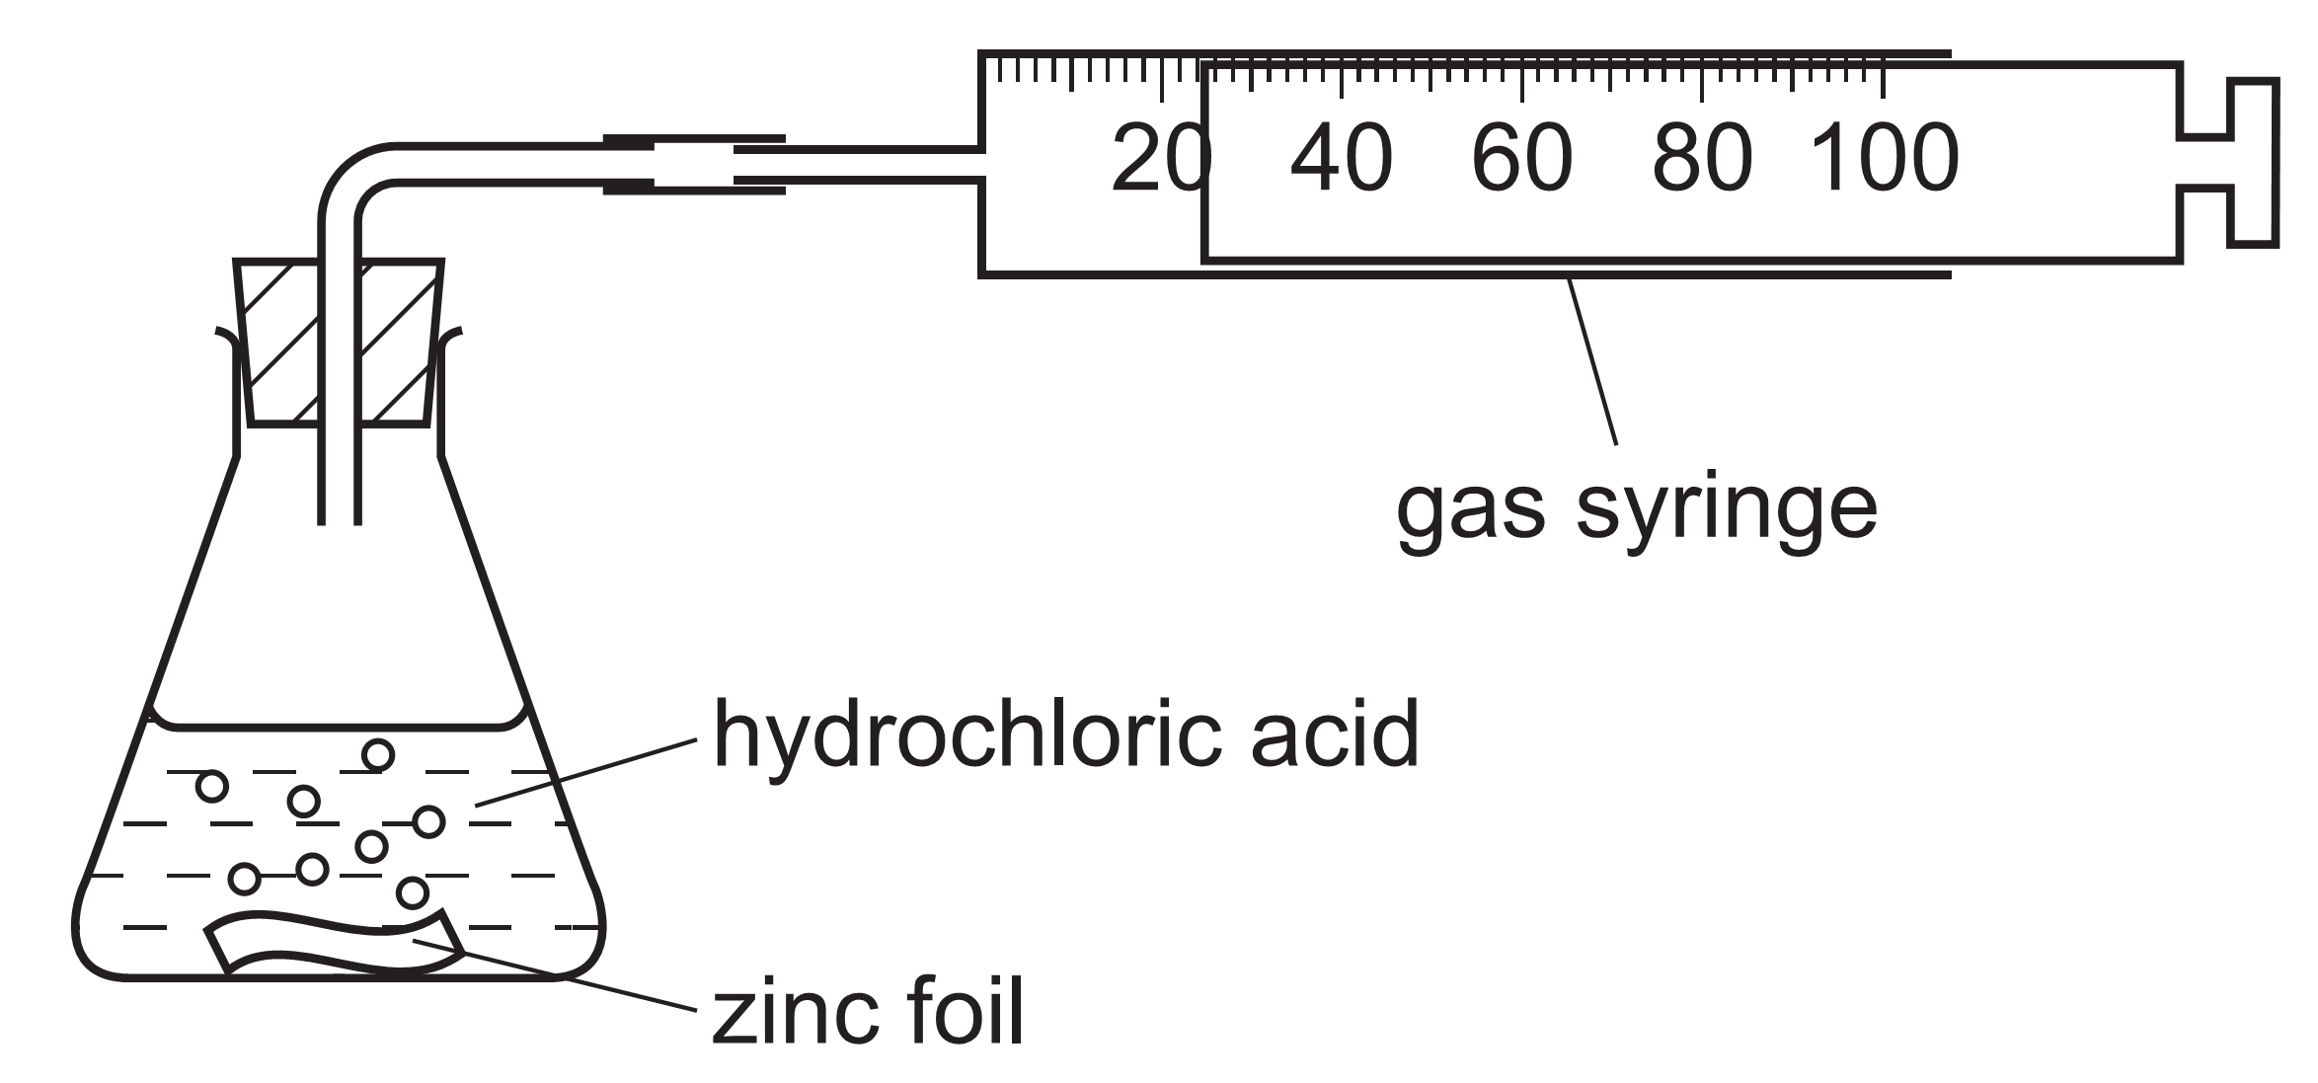
A piece of zinc foil was added to 50 cm³ of hydrochloric acid, of concentration
2.0 mol/dm³. The acid was in excess. The hydrogen evolved was collected in the gas syringe and its volume measured every minute.
(a) Sketch a graph of volume against time for the reaction above. Label it graph 1.
(2 marks)

- On the same graph, sketch another graph that would be obtained if the experiment was repeated using the same amounts of reagents and copper (II) sulphate crystals added into the mixture. Label it graph 2. (1 mark)
- (a) Suggest the structures and bonds of the following substances. (2 marks)
Substance | Bonds | Structure
Naphthalene
Copper
- Draw the dot (.) and cross (x) diagram to show bonding in tetrachloromethane.
(1 mark)

- (a) Deduce the molecular formula of the alkanol whose molecular mass is 158. (1 mark)
………………………………………………………………………………………………………
………………………………………………………………………………………………………
………………………………………………………………………………………………………
………………………………………………………………………………………………………
- Explain why the following alcohols are isomers. (1 mark)
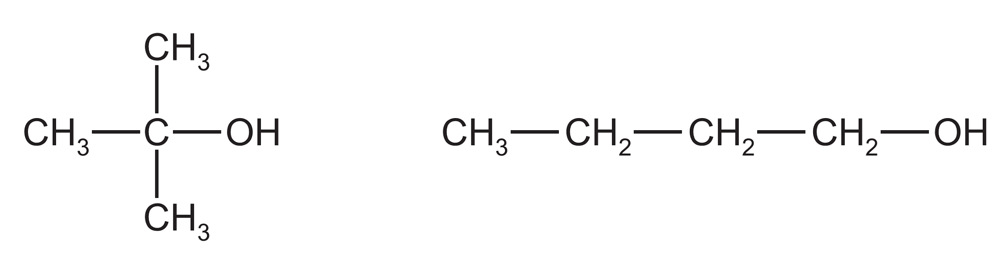
………………………………………………………………………………………………………
………………………………………………………………………………………………………
- Ethanol is oxidized by acidified potassium manganate (VII). Deduce the name and write the structural formula of the organic product. (1 mark)
Name…………………………. Structure:

- The diagram below shows the electrolysis of concentrated zinc (II) chloride solution.
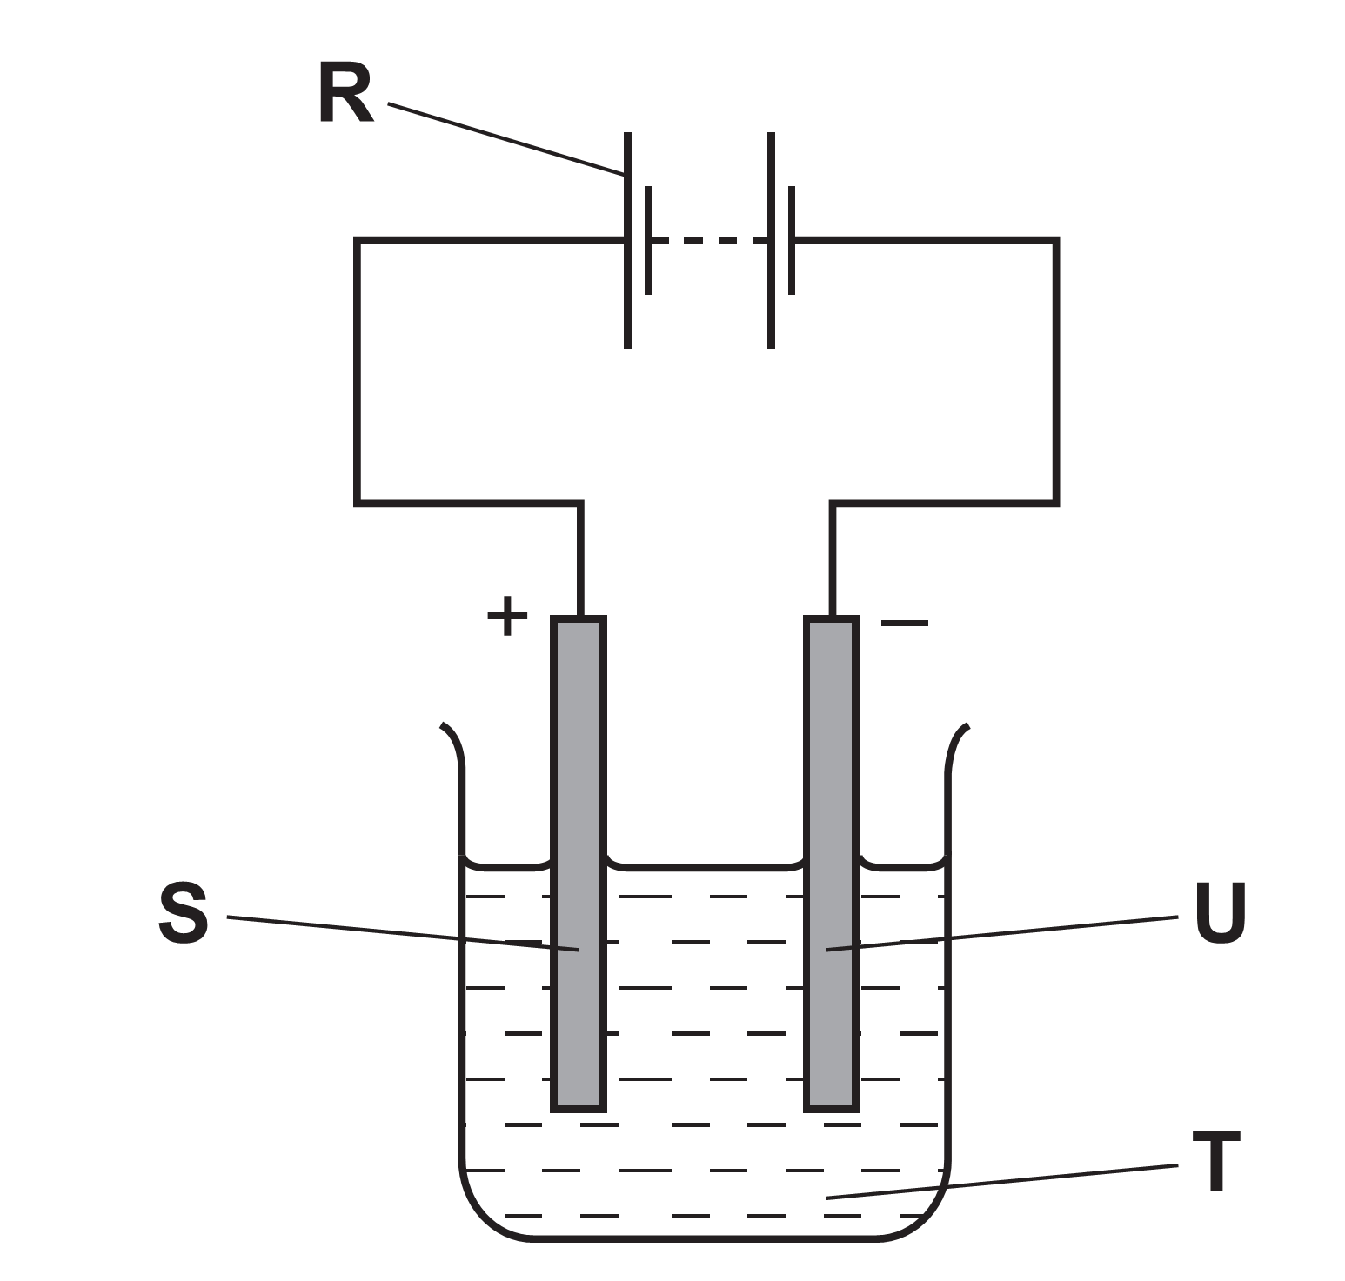
- Which letter in the diagram, R, S, T, or U represents the cathode? (1 mark)
………………………………………………………………………………………………………
- Write the equation for the reaction that takes place at the anode. (1 mark)
………………………………………………………………………………………………………
- What is electrolysis? (1 mark)
………………………………………………………………………………………………………
- Study the diagram below and answer the following questions.
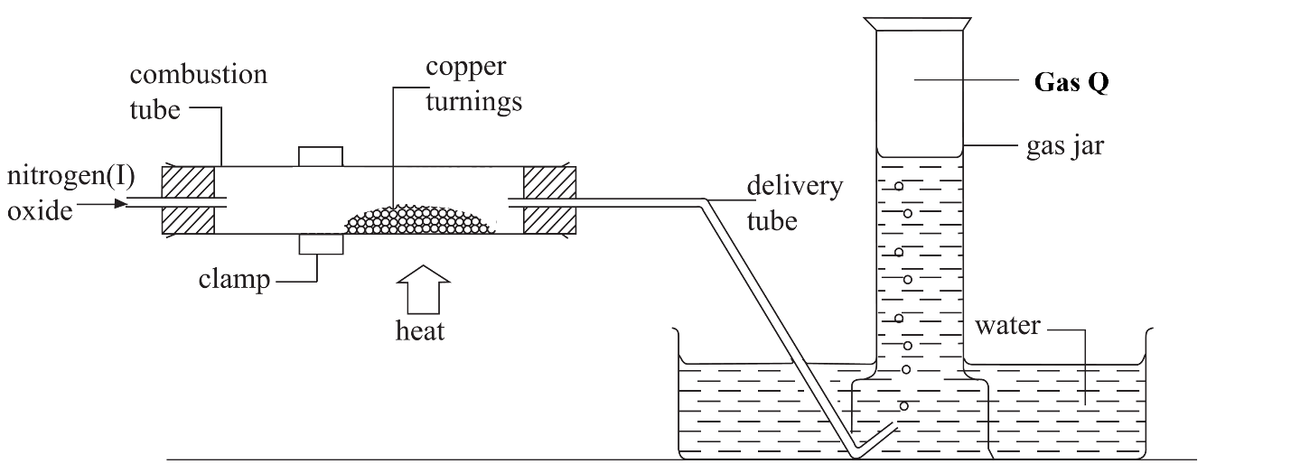
- Identify gas Q. (1 mark)
………………………………………………………………………………………………………
………………………………………………………………………………………………………
- State and explain the observation made in the combustion tube. (1 mark)
………………………………………………………………………………………………………
………………………………………………………………………………………………………
- Write the equation for the reaction that takes place in the combustion tube. (1 mark)
………………………………………………………………………………………………………
………………………………………………………………………………………………………
- Water hardness is caused by dissolved minerals that contain calcium ions and magnesium ions.
- Give another method of removing permanent water hardness apart from distillation.
(1 mark)
………………………………………………………………………………………………………
………………………………………………………………………………………………………

- 60 g of a saturated solution of salt W at 20ºC was evaporated to dryness over a water bath and yielded 24g of solid. Calculate the solubility of the salt at 20ºC. (2 marks)
………………………………………………………………………………………………………
………………………………………………………………………………………………………………………………………………………………………………………………………………
………………………………………………………………………………………………………

- Use the enthalpy of the following reactions to answer the questions that follow.
H₂O (s) → H₂O (l) ∆H₁ = +6.02 kJ/mol
MgO (s) → MgO (l) ∆H₂ = +77.4 kJ/mol
- What is the name given to ∆H₁? (1 mark)
………………………………………………………………………………………………………
………………………………………………………………………………………………………
- Explain the difference between ∆H₁ and ∆H₂. (2 marks)
………………………………………………………………………………………………………
………………………………………………………………………………………………………………………………………………………………………………………………………………
………………………………………………………………………………………………………
- The Solvay process is used to manufacture sodium carbonate.
- Give two raw materials used in the Solvay process apart from brine. (1 mark)
………………………………………………………………………………………………………
………………………………………………………………………………………………………
- Explain why potassium carbonate cannot be manufactured by simply replacing the brine with potassium chloride in the Solvay process. (1 mark)
………………………………………………………………………………………………………
………………………………………………………………………………………………………
- How is carbon (IV) oxide used as a refrigerant? (1 mark)
………………………………………………………………………………………………………
………………………………………………………………………………………………………

- The following table shows the pH values of some solutions.
Solution | pH value
A | 2.1
B | 4.5
C | 13.5
D | 7.0
- Name the indicator used to determine the pH values. (1 mark)
………………………………………………………………………………………………………
………………………………………………………………………………………………………
- Which solution is likely to react with ethanoic acid? (1 mark)
………………………………………………………………………………………………………
………………………………………………………………………………………………………
- 1 cm of magnesium ribbon was placed in separate beakers containing 2M solution A and 2M solution B. State and explain the difference in the observations made. (1 mark)
………………………………………………………………………………………………………
………………………………………………………………………………………………………
- Study the scheme below and answer the questions that follow.
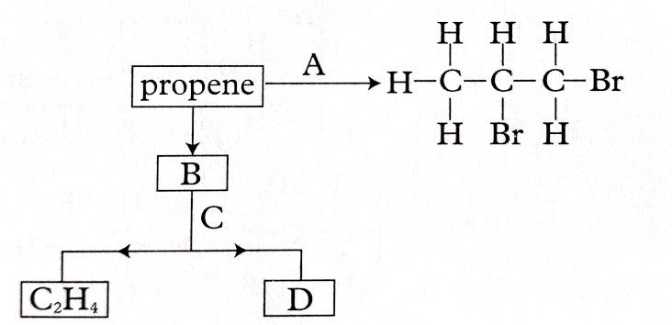
- Give the name of: (1 mark)
- Reagent A
……………………………………………………………………..
- Process C
……………………………………………………………………..

- Write the equation for the reaction of 1 mole of B and 1 mole of chlorine gas. (1 mark)
………………………………………………………………………………………………………………………………………………………………………………………………………………
- Draw the structure of substance D. (1 mark)

- Describe how a mixture of silver chloride, magnesium chloride and iron (III) chloride can be separated in the laboratory. (3 marks)
………………………………………………………………………………………………………
………………………………………………………………………………………………………………………………………………………………………………………………………………
………………………………………………………………………………………………………………………………………………………………………………………………………………
………………………………………………………………………………………………………

This is the last printed page.

