TERM 2 - 2023
CHEMISTRY – PAPER TWO (233/2)
FORM THREE (3)
Time - 2 Hours

Name …………………………………………….……… Admission Number …………….
Candidate’s Signature ………………….…...………... Class ……………………………

Instructions to candidate
- Write your name, admission number, and stream in the spaces provided.
- Answer ALL questions in the spaces provided.
- All working MUST be clearly shown where applicable.
- KNEC mathematical tables and silent non-programmable electronic calculators may be used.
- This paper consists of 8 printed pages.
- The candidate should check the question paper to ascertain that all the pages are printed as indicated and that no question is missing.

FOR EXAMINERS’ USE ONLY
Question | Maximum Score | Candidate’s Score
1 – 8 | 80

- Below is a grid representing part of t]he periodic table. Study it and use it to answer the questions that follow. The letters do not represent actual symbols of elements.
M |  |  | Z |  | R | A | D | X
E | J |  | W | Y |  | H | V
Q
- Compare the atomic radii of M and A. Explain (2 marks)
___________________________________________________________________________
___________________________________________________________________________
___________________________________________________________________________
- Using dots and crosses to represent elements, show the bonding in the compounds formed between atoms of:
- D to form a molecule (2 marks)

- W and V (2 marks)

- 6 atoms of M (2 marks)

- State two attributes of element W that makes it the preferred material for use in making overhead power cables (2 marks)
___________________________________________________________________________
___________________________________________________________________________
- Element W was heated in the presence of chlorine gas. The residue was dissolved in water. State and explain the observations made when a spatula of sodium hydrogen carbonate is added to the resultant solution. (2 marks)
___________________________________________________________________________
___________________________________________________________________________
___________________________________________________________________________
- A burning sample of element J was lowered into a gas jar of carbon (IV) oxide.
- State and explain the observation made (2 marks)
___________________________________________________________________________
___________________________________________________________________________
___________________________________________________________________________
- Write an equation for the reaction that took place in the gas jar (1 mark)
___________________________________________________________________________
- During the laboratory preparation of hydrogen gas, 3g of Zn metal was added to 50cm³ of 1.5M hydrochloric acid solution. The following information was indicated on the label of the bottle containing the stock solution used to prepare the 1.5M hydrochloric acid solution: (Zn = 56)
Percentage purity – 37%
Density – 1.18g/cm³
Formula mass – 36.6
- Determine the reactant that was in excess (2 marks)
___________________________________________________________________________
___________________________________________________________________________
___________________________________________________________________________
- If all the products were collected, and the setup was cooled to room temperature after the experiment, determine the volume of gas collected (molar gas volume at r.t.p. = 24,000cm³) (2 marks)
___________________________________________________________________________
___________________________________________________________________________
___________________________________________________________________________
- Calculate the molarity of the concentrated acid that was used in preparing the 50cm³ of 1.5M hydrochloric acid solution (2 marks)
___________________________________________________________________________
___________________________________________________________________________
___________________________________________________________________________
- Calculate the volume of the concentrated acid that was diluted to form the 1.5M hydrochloric acid solution (2 marks)
___________________________________________________________________________
___________________________________________________________________________
- If each student in a class of 45 was to carry out the experiment individually, determine the total volume of dilute acid to be prepared (1 mark)
___________________________________________________________________________
___________________________________________________________________________
- The setup below was used to prepare and collect nitrogen gas in the laboratory. Study it and use it to answer the questions that follow.
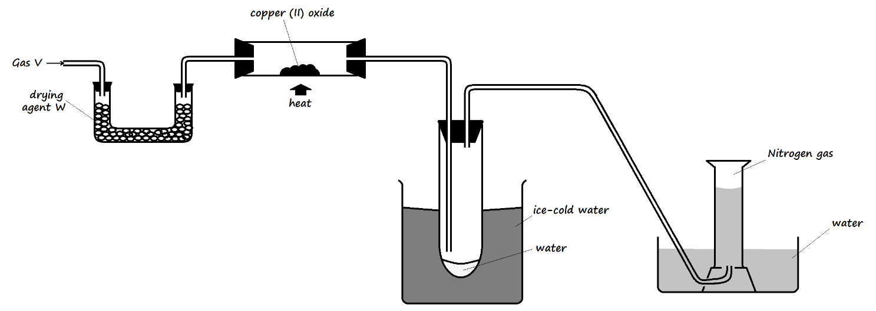
- What property of nitrogen allows it to be collected as shown? (1 mark)
___________________________________________________________________________
___________________________________________________________________________
- State and explain the observation made in the combustion tube during the experiment (2 marks)
___________________________________________________________________________
___________________________________________________________________________
___________________________________________________________________________
- Write an equation for the reaction that took place in the combustion tube (1 mark)
___________________________________________________________________________
- State and explain the observation made in the combustion tube if copper (II) oxide is replaced with magnesium oxide. (2 marks)
___________________________________________________________________________

- Describe a positive chemical test for the gas collected when copper (II) oxide is replaced with magnesium oxide (2 marks)
___________________________________________________________________________
___________________________________________________________________________
- What property of gas V is demonstrated in the experiment? (1 mark)
___________________________________________________________________________
- Name any one gas that can be used to replace gas V. (1 mark)
___________________________________________________________________________
- 300cm³ of nitrogen gas at 30ºC takes 40 seconds to diffuse through a membrane at 740mmHg pressure.
- How long will it take 70cm³ of oxygen to diffuse through the membrane under the same conditions of temperature and pressure? (N = 14, O = 16) (3 marks)
___________________________________________________________________________
___________________________________________________________________________
___________________________________________________________________________
- What is the molecular mass of 200cm³ of gas M, that takes 11.7 seconds to travel through the same membrane? (2 marks)
___________________________________________________________________________
___________________________________________________________________________
___________________________________________________________________________
- What will be the volume of gas M at 50ºC and 760mmHg? (2 marks)
___________________________________________________________________________
___________________________________________________________________________
- The pressure of a fixed mass of gas increases with a decrease in volume at constant temperature. Explain this observation. (2 marks)
___________________________________________________________________________
___________________________________________________________________________
___________________________________________________________________________
- Compound W is a white crystalline substance. When heated strongly in a boiling tube it yielded a solid residue G and fumes of a brown gas L. Residue G was added to warm dilute hydrochloric acid to form a colourless solution V which formed a white precipitate when the setup was allowed to cool to room temperature.
- Name:
- Compound W ______________________________________________________ (½ mark)
- Residue G ______________________________________________________ (½ mark)
- Write a chemical equation for:
- The thermal decomposition of compound W (1 mark)
___________________________________________________________________________
- The formation of solution V (1 mark)
___________________________________________________________________________
- State another observation that is made in the boiling tube during the process. (1 mark)
___________________________________________________________________________
- State and explain the observation made if residue G was added to warm dilute sulphuric (VI) acid. (2 marks)
___________________________________________________________________________
___________________________________________________________________________
___________________________________________________________________________
- During the process of heating, the gas V was passed through a U-tube dipped in a large beaker with ice-salt mixture to form substance E
- Name substance E (1 mark)
___________________________________________________________________________
- Describe the appearance of substance E. (1 mark)
___________________________________________________________________________
___________________________________________________________________________
- The metal in compound W is not suitable for use in making overhead power transmission cables. Give two reasons for this. (2 marks)
___________________________________________________________________________
___________________________________________________________________________
- The following is a list of reagents that were assembled for use in the preparation of some substances in the laboratory: Sodium sulphate, copper (II) carbonate, copper (II) oxide, dilute hydrochloric acid, calcium granules, sodium hydroxide solution, and dilute sulphuric (VI) acid, dilute nitric (V) acid, distilled water.
- Name the reagent which would react with dilute sulphuric (VI) acid and give off:
- Hydrogen gas (1 mark)
___________________________________________________________________________
- Carbon (IV) oxide (1 mark)
___________________________________________________________________________
- What name is given to the reaction between sodium hydroxide and the two acids in separate boiling tubes? (1 mark)
___________________________________________________________________________

- Write an ionic equation for the reaction between solid copper (II) oxide and dilute hydrochloric acid (1 mark)
___________________________________________________________________________
- Name three reagents in the list above that can be used to efficiently prepare calcium sulphate (3 marks)
___________________________________________________________________________
___________________________________________________________________________
- Describe how calcium sulphate may be prepared using the reagents named in (d) above. (3 marks)
___________________________________________________________________________
___________________________________________________________________________
___________________________________________________________________________
___________________________________________________________________________
- When a 10g sample of zinc carbonate was heated in a boiling tube, 6.48g of residue was left.
- State the observation made in the boiling tube during reaction. (1 mark)
___________________________________________________________________________
___________________________________________________________________________
- Write a chemical equation representing the reaction in (a) above. (1 mark)
___________________________________________________________________________
- If 25cm³ of hydrochloric acid reacted completely with the residue determine:
- The expected colour change in the reaction vessel if methyl orange indicator was used. (1 mark)
___________________________________________________________________________
- The concentration of the acid. (Zn = 65, C = 12, O = 16, Cl = 35.5) (3 marks)
___________________________________________________________________________

- The mass of salt that may be obtained if the solution is crystallized and all the salt recovered (2 marks)
___________________________________________________________________________
___________________________________________________________________________
___________________________________________________________________________
- Study the table below and use it to answer the questions that follow.
Element | A | D | E | G | J | L | M | Q
Atomic number | 11 | 12 | 13 | 14 | 15 | 16 | 17 | 18
Atomic radii (nm) | 0.191 | 0.160 | 0.130 | 0.118 | 0.110 | 0.102 | 0.099 | 0.095
Boiling point (ºC) | 890 | 1110 | 2470 | 2360 | 280 | 445 | 34.2 | -186
Formula oxide |  | DO |  |  | J₂O₅ |  | M₂O
Boiling point of oxide (ºC) | 1193 | 3075 | 2045 | 1728 | 563 | -72 | -91

- Complete the table to show the formulae of the oxides of A, E, G, and L (2 marks)

- Select an oxide that reacts with both sodium hydroxide solution and dilute hydrochloric acid solution (1 mark)
___________________________________________________________________________
- Explain the difference in atomic radii between elements E and M (2 marks)
___________________________________________________________________________
___________________________________________________________________________
- Write the formula of the compound formed between elements E and M (1 mark)
___________________________________________________________________________
- Explain the difference in boiling points between the oxides of elements D and L (2 marks)
___________________________________________________________________________
___________________________________________________________________________
- Write a chemical equation for the reaction between the oxide of element D and water. (1 mark)
___________________________________________________________________________
- State and explain an observation made in the reaction vessel in (f) above (1 mark)
___________________________________________________________________________

