TERM 2 - 2023
CHEMISTRY – PAPER ONE (233/1)
FORM THREE (3)
Time - 2 Hours

Name ……………………………………………. Admission Number ………………………...
Candidate’s Signature ………………….…...………. Class ……………………………………

Instructions to candidate
- Write your name, admission number, and stream in the spaces provided.
- Answer ALL questions in the spaces provided.
- All working MUST be clearly shown where applicable.
- KNEC mathematical tables and silent non-programmable electronic calculators may be used.
- This paper consists of 10 printed pages.
- The candidate should check the question paper to ascertain that all the pages are printed as indicated and that no question is missing.

FOR EXAMINERS’ USE ONLY
Question | Maximum Score | Candidate’s Score
1 – 28 | 80

- Hydrogen is a group I element:
- It is the lightest known element but cannot be used in hot air balloons. Explain (1 mark)
___________________________________________________________________________
___________________________________________________________________________
- State any one use of hydrogen gas which is also a use of carbon (II) oxide gas (1 mark)
___________________________________________________________________________
___________________________________________________________________________
- A piece of burning magnesium was lowered into a gas jar of nitrogen gas, and it was observed to be burning even brighter.
- Explain this observation (1 mark)
___________________________________________________________________________
___________________________________________________________________________
- Write an equation for the reaction which took place in the gas jar in (a) above (1 mark)
___________________________________________________________________________
- Water was added to the product formed above and the resultant solution was tested with litmus paper. State and explain the observation that was made. (2 marks)
___________________________________________________________________________
___________________________________________________________________________
___________________________________________________________________________

- What is a saturated solution? (1 mark)
___________________________________________________________________________
___________________________________________________________________________
- Describe a laboratory procedure that can be used to determine that a given solution is saturated. (2 marks)
___________________________________________________________________________
___________________________________________________________________________
___________________________________________________________________________
- Trona is a double salt that contains sodium carbonate and sodium hydrogen carbonate. It exists in alkaline lakes, mixed with sodium chloride. Name the method of separation that is used to obtain it from its mixture with sodium chloride. (1 mark)

- Using the listed reagents only, describe the steps that can be used to obtain a dry sample of lead (II) sulphate in the laboratory: lead (II) carbonate powder, sodium sulphate solution, and dilute nitric (V) acid solution. (3 marks)
______________________________________________________________________________
______________________________________________________________________________
______________________________________________________________________________
______________________________________________________________________________
- Iron (II) bromide can be prepared in the laboratory by passing dry bromine vapour over hot iron wool.
- Name this method of salt preparation (1 mark)
___________________________________________________________________________
- Iron (II) bromide must be prepared in a dry environment. Explain. (1 mark)
___________________________________________________________________________
___________________________________________________________________________
- During this preparation, calcium oxide is preferred to anhydrous calcium chloride as a drying agent. Explain. (1 mark)
___________________________________________________________________________
___________________________________________________________________________
- When iron filings and sulphur powder are put together in a glass beaker, the resultant substance is only said to be a mixture. When the beaker is heated gently, a red glow is observed, and the resultant substance is now said to be a compound.
- Explain these observations. (2 marks)
___________________________________________________________________________
___________________________________________________________________________
___________________________________________________________________________
- State any characteristics of the type of change that occurs when the glass beaker is heated (2 marks)
___________________________________________________________________________
___________________________________________________________________________

- State Charles’ Law. (1mark)
___________________________________________________________________________
___________________________________________________________________________

- An L.P.G. gas cylinder had gas which occupied 300cm³ when the warehouse temperature was 47ºC. what volume will the gas occupy when the warehouse temperature is reduced to the s.t.p. in readiness for refilling? (2 marks)
___________________________________________________________________________
___________________________________________________________________________
___________________________________________________________________________
- 15cm³ of an acid with the formula H₂Y required 25cm³ of 0.1M NaOH for complete neutralization.
- How many moles of sodium hydroxide reacted with the acid? (1 mark)
___________________________________________________________________________
___________________________________________________________________________
- Calculate the concentration of the acid in moles per litre. (2 marks)
___________________________________________________________________________
___________________________________________________________________________
___________________________________________________________________________
- An oxide of element Q has the formula Q₂O₃.
- State the valency and oxidation number of element Q (1 mark)
Valency________________________Oxidation number _____________________________
- What is the most likely structure of the compound Q₂O₃? (1 mark)
___________________________________________________________________________
- Distinguish the term ‘allotrope’ from ‘isotope’. (2 marks)
______________________________________________________________________________
______________________________________________________________________________
______________________________________________________________________________
- A hot piece of aluminium metal was lowered into a gas jar of chlorine gas. The resulting residue was mixed with water and filtered. 3 drops of methyl orange indicator were added to the filtrate.
- State and explain the observation made when methyl orange was added to the filtrate. (2 marks)
___________________________________________________________________________
______________________________________________________________________________

- Name the process that occurred when the residue was added to water (1 mark)
___________________________________________________________________________
___________________________________________________________________________
- A hydrated salt has the following composition by mass: Iron 20.2%, Oxygen 23.0%, sulphur 11.5% and the rest is water. Determine the formula of the hydrated salt (Fe = 56, S = 32, O = 16, H = 1) (3 marks)
______________________________________________________________________________
______________________________________________________________________________
______________________________________________________________________________
- A sample of the compound CH₃CCH was burnt in the laboratory. State and explain the observations made during the burning process. (2 marks)
______________________________________________________________________________
______________________________________________________________________________
- Concentrated hydrochloric acid was added to potassium manganate (VII) crystals in flat bottomed flask. The gas produced was bubbled through water.
- State the colour of solution formed (1 mark)
___________________________________________________________________________
- Blue litmus paper was dipped into the solution. State and explain the observation made. (2 marks)
___________________________________________________________________________
___________________________________________________________________________
___________________________________________________________________________
- Write an equation for the reaction that occurred in (b) above. (1 mark)
___________________________________________________________________________
- Solid W is a white crystalline substance. It readily dissolves in water to form a colourless solution. It melts at low temperature to yield a liquid that does not conduct electricity. Its solution does not cause a bulb to light when inert electrodes are introduced. State and explain the most likely structure of solid W. (2 marks)
______________________________________________________________________________
______________________________________________________________________________
______________________________________________________________________________

- Study the compound shown and use it to answer the questions that follow.
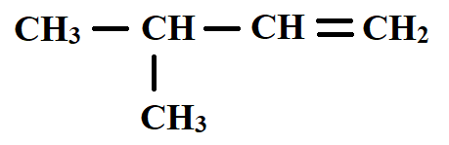
- To which homologous series does the compound belong? (1 mark)
___________________________________________________________________________
- State the IUPAC name of the compound (1 mark)
___________________________________________________________________________
- Draw the structure of any isomer of the compound. (1 mark)

___________________________________________________________________________
- A form three student weighed a piece of plain paper and wrote his name on it using a pencil of pure graphite. He then re-weighed the paper and obtained the following results:
Mass of plain paper = 1.042g
Mass of paper after writing = 1.143g
Determine the number of carbon atoms present in the pencil marks (C = 12.0, L = 6.023X10²³) (2 marks)
______________________________________________________________________________
______________________________________________________________________________
______________________________________________________________________________

- The scheme below shows a series of reactions, starting with a solid W.

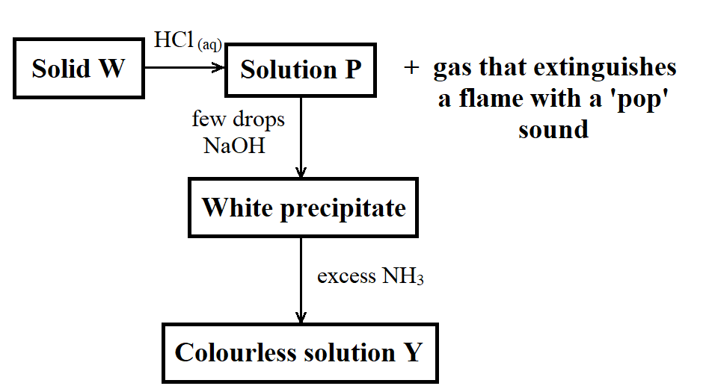
- Identify solid W (½ mark)
___________________________________________________________________________
- Write an equation for the reaction that occurs between solid W and dilute hydrochloric acid (1 mark)
___________________________________________________________________________
- Write the formula of the complex ion present in solution Y. (½ mark)
___________________________________________________________________________

- The setup below was arranged and used to study the characteristics of a Bunsen burner flame.
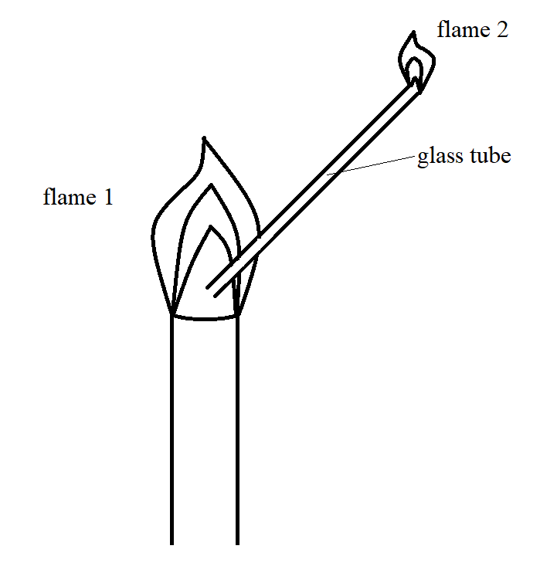
- What does the experiment show? (1 mark)
___________________________________________________________________________
___________________________________________________________________________
- Name the type of flame labelled flame 1. (1 mark)

- What type of flame is shown by flame 2? Explain. (2 marks)
___________________________________________________________________________
___________________________________________________________________________
- Some potassium carbonate of unknown mass was dissolved in water and the solution made up to the 250cm³ mark. 25cm³ of this solution neutralized 20cm³ of 0.25M nitric (V) acid solution. Determine the unknown mass of potassium carbonate used. (K = 39, O = 16, C = 12) (3 marks)
______________________________________________________________________________

- State Gay Lussac’s Law. (1 mark)
___________________________________________________________________________
___________________________________________________________________________
___________________________________________________________________________
- What volume of a hydrocarbon gas (CH₄) would remain if a burner containing 40cm³ of the gas burns in 40cm³ of enclosed air? (Assume oxygen is 20% by volume of air) (2 marks)
___________________________________________________________________________
___________________________________________________________________________
___________________________________________________________________________
- During the laboratory preparation of carbon (II) oxide, an acid G is added to solid substance L. The product is bubbled through concentrated potassium hydroxide solution, and carbon (II) oxide gas collected over water.
- Name:
- Acid G _____________________________________________________________(1 mark)

- Solid L _____________________________________________________________(1 mark)

- What is the role of the concentrated potassium hydroxide solution? (1 mark)
___________________________________________________________________________
- What would be observed if the concentrated potassium hydroxide solution was replaced with calcium hydroxide solution? (1 mark)
___________________________________________________________________________
___________________________________________________________________________
- Organic compounds CH₃CH₂OH and CH₃CH₂CH₂CH₃ have close molecular masses. However, CH₃CH₂OH exists as a liquid at room temperature, while CH₃CH₂CH₂CH₃ exists as a gas at room temperature. Explain this observation (2 marks)
______________________________________________________________________________
______________________________________________________________________________
______________________________________________________________________________
- Element R has two isotopes $69 31$R and $71 31$R the percentage composition of the isotope with lower mass is 60%.
- Calculate the R.A.M. of R. (2 marks)
___________________________________________________________________________
___________________________________________________________________________
___________________________________________________________________________
- Isotopes have similar chemical properties but may have different physical properties. Explain this observation. (2 marks)
___________________________________________________________________________
___________________________________________________________________________
___________________________________________________________________________
- A 5.0g of an alloy of platinum and zinc was reacted with excess dilute hydrochloric acid. 840cm³ of hydrogen gas was evolved at s.t.p. Calculate the percentage of zinc in the alloy. (Zn = 56, molar gas volume at s.t.p. = 22400cm³). (3 marks)
______________________________________________________________________________
______________________________________________________________________________
- When a few drops of aqueous ammonia are added to a copper (II) nitrate solution, a pale blue precipitate is formed. On addition of more aqueous ammonia, a deep blue solution is formed.
- Identify the pale blue precipitate (1 mark)
___________________________________________________________________________
- Write the formula of the complex ion present in the deep blue solution (1 mark)

- The diagram below shows a part of the Solvay Process
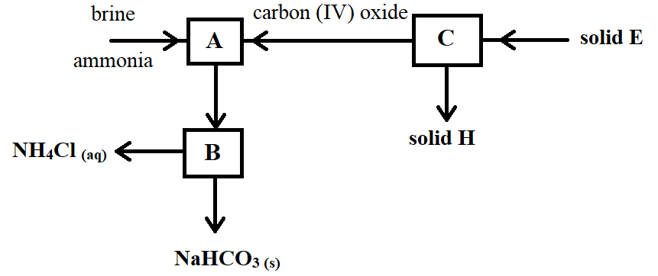
- Write the overall equation for the reaction that takes place in A (1 mark)
___________________________________________________________________________
- Name solid E (1 mark)
___________________________________________________________________________
- State any one use of solid H (1 mark)
___________________________________________________________________________
___________________________________________________________________________
- Name any one apparatus/material that can be used in the laboratory to carry out the process that takes place in chamber B (1 mark)
___________________________________________________________________________

