TERM TWO
565/1- BUSINESS STUDIES
FORM THREE
Time: 2½ Hours
Name …………………………………………….……… Admission Number …………….
Candidate’s Signature ………………….…...……….. Date ……………………………

INSTRUCTIONS TO CANDIDATES

- Write your name and Index number in the spaces provided above.
- Write the date of examination in the spaces provided above.
- Answer ALL the questions.
- ALL answers must be written in the spaces provided in this booklet.

FOR EXAMINER’S USE ONLY

Question | 1 | 2 | 3 | 4 | 5 | 6 | 7 | 8 | 9 | 10 | 11 | 12 | 13
Marks

Question | 14 | 15 | 16 | 17 | 18 | 19 | 20 | 21 | 22 | 23 | 24 | 25 | TOTAL
Marks

Section A – 72 Marks (Answer all questions in this section)

1. Outline four elements that may comprise the external environment of a business. (4mks)
(i) ………………………………………………………………………………………………
(ii) ………………………………………………………………………………………………
(iii) ………………………………………………………………………………………………
(iv)
………………………………………………………………………………………………
2. State four benefits that a farmer may derive from being a member of a producer
co-operative society. (4mks)
(i)
……………………………………………………………………………………………
(ii) ………………………………………………………………………………………………
(iii) ………………………………………………………………………………………………
(iv)
……………………………………………………………………………………………
3. A lucrative business has been consistently releasing toxic wastes into the neighbourhood. Outline four measures you can take to stop the firm from such malpractices. (4mks)
(i)
……………………………………………………………………………………………
(ii)
……………………………………………………………………………………………
(iii)
……………………………………………………………………………………………
(iv)
……………………………………………………………………………………………

4. Give four reasons why a person would send a message by mail rather than by telephone. (4mks)
(i)
……………………………………………………………………………………………

(ii)
……………………………………………………………………………………………
(iii)
……………………………………………………………………………………………

(iv)
……………………………………………………………………………………………

5. Give four factors that may encourage entrepreneurship development in Kenya today. (4mks)
(i)
……………………………………………………………………………………………

(ii)
……………………………………………………………………………………………

(iii)
……………………………………………………………………………………………

(iv)
……………………………………………………………………………………………

6. Ouma, a trader at Nangina Marketing Centre in Busia County sells cows but does not know how to determine the best prices for his commodities. Advice him on four methods of achieving this objective. (4mks)
(i)
……………………………………………………………………………………………

(ii)
……………………………………………………………………………………………

(iii)
……………………………………………………………………………………………
(iv)
……………………………………………………………………………………………
7. Outline four main problems encountered towards the satisfaction of human wants in the Kenyan economy. (4mks)
(i)
……………………………………………………………………………………………
(ii)
……………………………………………………………………………………………
(iii)
……………………………………………………………………………………………
(iv)
……………………………………………………………………………………………

8. Study the diagram below and answer the questions below.

d₁
d₁
d₁
d₀
d₀
Quantity demanded
0
Price

State four possible factors which might have caused the shift in the demand curve above (4mks)
(i)
……………………………………………………………………………………………

(ii)
……………………………………………………………………………………………
(iii)
……………………………………………………………………………………………

(iv)
……………………………………………………………………………………………
9. Your father would like to take life assurance cover with the insurance company. Advise him on why he should undertake an endowment policy than a whole-life policy. (4mks)
(i)
……………………………………………………………………………………………

(ii)
……………………………………………………………………………………………

(iii)
……………………………………………………………………………………………

(iv)
……………………………………………………………………………………………

10. Highlight four circumstances under which air transport is suitable over other means of transport. (4mks)
(i)
……………………………………………………………………………………………

(ii)
……………………………………………………………………………………………

(iii)
……………………………………………………………………………………………

(iv)
……………………………………………………………………………………………

11. Highlight four ways that a manager can adopt to improve the productivity of labour. (4mks)
(i)
……………………………………………………………………………………………

(ii)
……………………………………………………………………………………………

(iii)
……………………………………………………………………………………………

(iv)
……………………………………………………………………………………………

12. Give four main benefits of establishing an electronic filing system in an organization. (4mks)
(i)
……………………………………………………………………………………………

(ii)
……………………………………………………………………………………………

(iii)
……………………………………………………………………………………………

(iv)
……………………………………………………………………………………………

13. Outline four circumstances that necessitate the use of shorter channels of distribution over longer channels in rural Kenya. (4mks)
(i)
……………………………………………………………………………………………

(ii)
……………………………………………………………………………………………

(iii)
……………………………………………………………………………………………
(iv)
……………………………………………………………………………………………
14. Draw four main problems associated with use of output approach by the government in measuring and determining the level of its national income (4mks)
(i)
……………………………………………………………………………………………

(ii)
……………………………………………………………………………………………

(iii)
……………………………………………………………………………………………
(iv)
……………………………………………………………………………………………
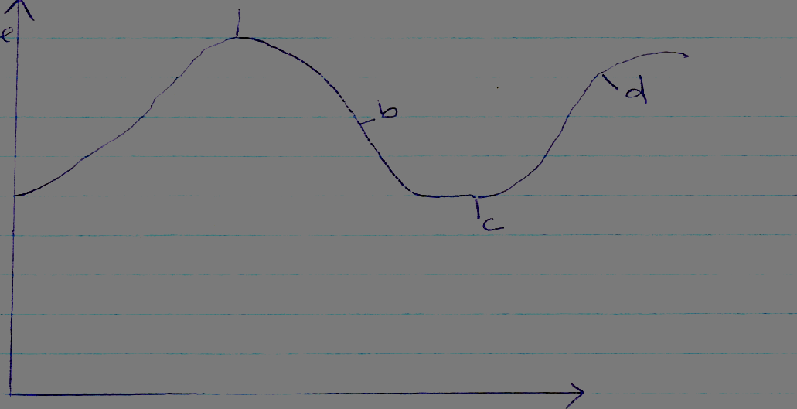
15. Study the diagram below on cyclical unemployment and answer it by giving an appropriate term to the letters indicated. (4mks)

a

b

d

c

0

Time

Income

a ................................................... c ...................................................
b .................................................. d ..................................................

16. Identify four circumstances under which utility is created in a commodity within a firm. (4mks)
(i)
……………………………………………………………………………………………

(ii)
……………………………………………………………………………………………

(iii)
……………………………………………………………………………………………

(iv)
……………………………………………………………………………………………

17. Under what four circumstances would cheque payment be preferred more than cash payment? (4mks)
(i)
……………………………………………………………………………………………

(ii)
……………………………………………………………………………………………

(iii)
……………………………………………………………………………………………

(iv)
……………………………………………………………………………………………

18. Identify four common documents in home trade that are used for credit transactions in the Delivery stage. (4mks)
(i)
……………………………………………………………………………………………

(ii)
……………………………………………………………………………………………

(iii)
……………………………………………………………………………………………

(iv)
……………………………………………………………………………………………

SECTION B – 28 Marks
(Answer question 19 and any other one question in this section)
19. (a) Fill in the table below. (5 marks)
Fixed Assets | Current Assets | Long Term Liabilities | Current Liabilities | Capital
42,360 | 12,230 |  | 2,780 | 45,000
 | 234,510 | 67,455 | 56,470 | 456,780
123,670 | 234,170 | 34,700 | 56,600
365,700 |  | 155,800 | 176,800 | 457,950
978,340 | 978,500 | 543,000 |  | 1,250,000

(b) The following balances were extracted from the books of Kazuri Enterprises on 31st December 2021.
Machinery 243,250. Furniture 125,345.
Creditors 495,000. Building 845,000.
Cash 148,650 Bank Overdraft 85,250.
Stock 745,400 Debtors 135,400.
4-year Bank Loan 650,000.
The following transactions took place during the month of January 2022.
January 2 Received a cheque of Shs 57,450 from a debtor.
January 5 Sold goods worth shs 120,000 for shs. 232,000 duly banked.
January 12 Sold part of machinery worth shs 43,250 for 40,000 cash.
January 15 Paid a creditor shs. 200,000 by cheque.
January 20 Banked shs 150,000 from the cash till.
Required:
(i) Kazuri Enterprises balance sheet as at 31st December 2021. (6 marks)
(ii) Kazuri Enterprises balance sheet as at 31st January 2022. (7 marks)
20. (a) Highlight five channels for distributing fish from Lake Victoria to the Kenyan consumer. (5 marks)
(b) Give five importance of the Nairobi security market to the Kenyan economy. (5 marks)
21. (a) Highlight five merits of localization of industries. (5 marks)
(b) Businesses are currently employing new product promotional strategies as a way of boosting their sales volumes. Identify five such strategies. (5 marks)

