TERM 2 - 2023
BIOLOGY – PAPER TWO (231/2)
FORM FOUR (4)
Time - 2 Hours
Name …………………………………………….……… Admission Number …………….
Candidate’s Signature ………………….…...………... Class ……………………………
Instruction to Candidates:
- Write your name and index number in spaces provided above.
- Sign and write the date.
- This paper consists of two sections; A and B. Answer ALL the questions in section A in the spaces
- provided.
- In section B answer Question 6 (compulsory) and either question 7 or 8 in the spaces provided.
- Additional pages must not be inserted.

For Examiner’s Use Only

QUESTION | MAXIMUM SCORE | CANDIDATE’S SCORE
1 | 8
2 | 8
3 | 8
4 | 8
5 | 8
6 | 20
7 | 20
8 | 20
TOTAL SCORE | 80

This paper consists of 12 printed pages.
Candidates should check to ensure that all pages are printed as indicated and no questions are missing

SECTION A: (40 Marks)
Answer all the questions in this section.
- In an experiment to investigate an aspect of digestion, two test tubes P and Q were set up as shown in the diagram below.
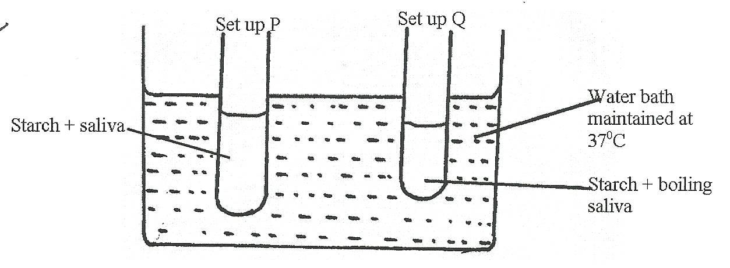
The test tubes were left in the bath for 30 minutes. The content of each test tube was then tested for starch using iodine solution.
- What was the aim of the experiment? (1 mark)
…………………………………………………………………………..……………………
………………………………………………………………………………………..………
- What results were expected in test tube P and Q? (2 marks)
…………………………………………………………………………………………….……
………………………………………………………………………………………………….
- Account for the results you have given in (b) in test tube P and Q. (2 marks)
…………………………………………………………………………………...….……….…
…………………………………………………………………………………………….……
…………………………………………………………………………………………….……
…………………………………………………………………………………….……………………………………………………………………………………………………………….
- Why was the set up left at 37⁰C ? (1 mark)

……………………………………………………………………………………….…………

- Name the carbohydrate stored in: (2 marks)
- Mammalian liver……………………………………………………..…………………
- Potato tuber……………………………………………………………..………………

2. In a certain family where the fathers had blood group A and the mother had blood group B, one of the children had blood group O.
- Work out the possible genotype of the children obtained in the F₁ generation. (4 marks)

- What is the phenotypic ratio of F₁ generation? (1 mark)
……………………………………………………………………………………………….…………
…………………………………………………………………………………………….……………

- (i) Which child can receive blood from all other members of the family? (1 mark)
………………………………………………………………………………………………….………
……………………………………………………………………………………………….…………

(ii) Give a reason for your answer in (a) above. (1 mark)
………………………………………………………………………………………………….………
…………………………………………………………………………………………………………

- What is Erythroblastosis foetalis? (1 mark)
……………………………………………………………………………………….…………………
…………………………………………………………………………………………………….……

3.The equation below shows a chemical reaction that takes place in green plants under certain conditions.
Carbon (IV) oxide + Water Glucose + X

- What is the name of substance X ? (1 mark)
…………………………………………………………………………………………………………

- Other than the reagents, state two conditions necessary for this reaction. (2 marks)
…………………………………………………………………………………………………………
…………………………………………………………………………………………………………

- Name two types of cells in which this process occurs. (2 marks)
…………………………………………………………………………………………………………
…………………………………………………………………………………………………………

- Name the process represented by the equation given above. (1 mark)
…………………………………………………………………………………………………………

(e) Name products of the above process, other than glucose. (2 marks)

4.The table below gives information about an aquarium community which is ecologically balanced;

Type of organism | Weight in grammes
Insect larva  Fishes  Water plants  Bacteria | 500gms  1200gms  5000gms  10gms

(a) What do you understand by the term ecological balance? (1 mark)
…………………………………………………………………………………………………………
…………………………………………………………………………………………………………

(b) Calculate the total biomass of the aquarium. (2 marks)

(c) Which organism in the table is
(i) Primary producer? (1 mark)
…………………………………………………………………………………………………………
(ii) Secondary consumer? (1 mark)
…………………………………………………………………………………………………………

(d) Construct a food web of the aquarium. (3 marks)

5. Below is a diagram of a mammalian skin, use it to answer the questions that follow.
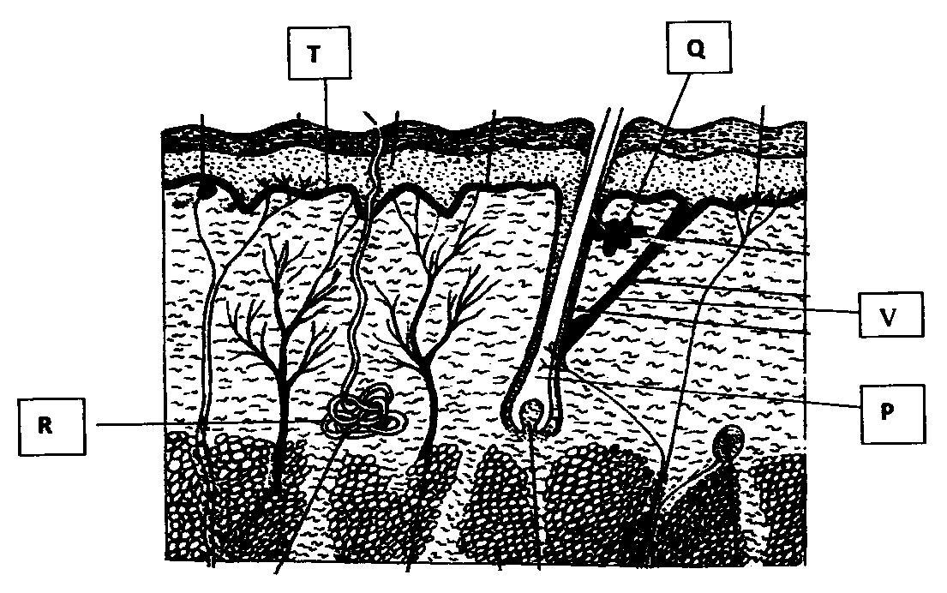
- Name the parts labelled P, Q, R. (3 marks)
P ……………………………………………………………………………..
Q ……………………………………………………………………………..
R ……………………………………………………………………………..
- Give the function of the parts labelled Q and T. (2 marks)
Q ……………………………………………………………………………………………………...
T ……………………………………………………………………………………………………..
- Briefly explain how the part labelled R contribute to lowering of body temperature on a hot day. (2 marks)
………………………………………………………………………………………………………………………………………………………………………………………………………………………………………………………………………………………………………………………………Give one function of the mammalian skin other than thermoregulation. (1 mark)
……………………………………………………………………………………………………………………………………………………………………………………………………………………

SECTION B. (40 Marks)
In Section B answer question 6(Compulsory) and either question 7 or 8 in the spaces provided after question 8.

6. A research was carried out to determine the trend of growth for some boys and girls. Their average mass in kilograms was taken separately for a period of 20 years and tabulated as shown in the table below.

Age | Average Mass of boys (kg) | Average mass of girls (kg)
0 | 2.5 | 2.5
2 | 11.1 | 11.5
4 | 15.0 | 16.0
6 | 18.5 | 19.3
8 | 22.1 | 27.1
10 | 25.1 | 27.1
12 | 27.5 | 30.5
14 | 37.0 | 35.5
16 | 44.0 | 44.0
18 | 46.9 | 52.5
20 | 48.5 | 55.0

- On the same axis draw a graph of average mass of girls and of boys against the age.
(7 marks)

- From the graph , determine the;
- Mass for boys at the age of 11 years. (1 mark)
……………………………………………………………………………………….….

- Growth rate in girls between ages 13 and 15. (3 marks)

- Account for the change in the mass of girls during the age stated in (ii) above. (2 marks)
………………………………………………………………………………………………………………………………………………………………………………………………………………………………………………………………………………………………………
- Explain the trend observed in the curves for both boys and girls. (2 marks)
………………………………………………………………………………………………………………………………………………………………………………………………………………………………………………………………………………………………………………………………………………………………………………………………………………………………………………………………………………………………..…………..
- Why do girls above 10 years require intake of food that is richer in iron than boys of the same age. (1 mark)
……………………………………………………………………………………………………………………………………………………………………………………………………
- Mention two other factors apart from the diet that affect the rate of growth in boys and girls. (2 marks)
…………………………………………………………………………………………………………………………………………………………………………………………………………………………………………………………………………………………………………………………………………………………………………………………………………
- Apart from using average mass to estimate growth in human beings, name two other parameters that can be used. (2 marks)
………………………………………………………………………………………………………………………………………………………………………………………………………………………………………………………………………………………………………
7. Explain the different evidences of organic evolution. (20 marks)

8. Describe the adaptations of the ileum to its function. (20 marks)

……………………………………………………………………………………………………………………………………………………………………………………………………………………………………
…………………………………………………………………………………………………………………………………………………………………………………………………………………………………….
…………………………………………………………………………………………………………………………………………………………………………………………………………………………………….
…………………………………………………………………………………………………………………………………………………………………………………………………………………………………….
…………………………………………………………………………………………………………………………………………………………………………………………………………………………………….
……………………………………………………………………………………………………………………………………………………………………………………………………………………………………..
……………………………………………………………………………………………………………………………………………………………………………………………………………………………………..
…………………………………………………………………………………………………………………………………………………………………………………………………………………………………….
…………………………………………………………………………………………………………………………………………………………………………………………………………………………………..
…………………………………………………………………………………………………………………………………………………………………………………………………………………………………..
……………………………………………………………………………………………………………………………………………………………………………………………………………………………………
……………………………………………………………………………………………………………………………………………………………………………………………………………………
……………………………………………………………………………………………………………………………………………………………………………………………………………………
……………………………………………………………………………………………………………………………………………………………………………………………………………………
…………………………………………………………………………………………………………………………………………………………………….………………………………………………
…………………………………………………………………………………………………………………………………………………………………………………………………….…………..………………….
…………………………………………………………………………………………………………………………………………………………………………………………………………………………………….
…………………………………………………………………………………………………………………………………………………………………………………………………………………………………….
…………………………………………………………………………………………………………………………………………………………………………………………………………………………………….
……………………………………………………………………………………………………………………………………………………………………………………………………………………………………
…………………………………………………………………………………………………………………………………………………………………………………………………………………………………….
…………………………………………………………………………………………………………………………………………………………………………………………………………………………………….
……………………………………………………………………………………………………………………………………………………………………………………………………………………………………
……………………………………………………………………………………………………………………………………………………………………………………………………………………………………
…………………………………………………………………………………………………………………………………………………………………………………………………………………………………….
……………………………………………………………………………………………………………………………………………………………………………………………………………………………………
……………………………………………………………………………………………………………………………………………………………………………………………………………………………………
…………………………………………………………………………………………………………………………………………………………………………………………………………………………………….
…………………………………………………………………………………………………………………………………………………………………………………………………………………………………….
…………………………………………………………………………………………………………………………………………………………………………………………………………………………………….
………………………………………………………………………………………………………………….…………………………………………………………………………………………………………………..
…………………………………………………………………………………………………………………..
…………………………………………………………………………………………………………………………………………………………………………………………………….…………..………………….
……………………………………………………………………………………………………………………………………………………………………………………………………………………………………
……………………………………………………………………………………………………………………………………………………………………………………………………………………………………
……………………………………………………………………………………………………………………………………………………………………………………………………………………………………
……………………………………………………………………………………………………………………………………………………………………………………………………………………………………
……………………………………………………………………………………………………………………………………………………………………………………………………………………………………
……………………………………………………………………………………………………………………………………………………………………………………………………………………………………
…………………………………………………………………………………………………………………………………………………………………………………………………………………………………….
……………………………………………………………………………………………………………………………………………………………………………………………………………………………………
…………………………………………………………………………………………………………………………………………………………………………………………………………………………………….
……………………………………………………………………………………………………………………………………………………………………………………………………………………………………
…………………………………………………………………………………………………………………………………………………………………………………………………………………………………..
……………………………………………………………………………………………………………………………………………………………………………………………………………………………………
………………………………………………………………………………………………………………….

THIS IS THE LAST PRINTED PAGE.

