TERM 2 - 2023
BIOLOGY – PAPER ONE (231/1)
FORM FOUR (4)
Time - 2 Hours
Name …………………………………………….……… Admission Number …………….
Candidate’s Signature ………………….…...………... Class ……………………………

INSTRUCTIONS TO CANDIDATES
- Write your name and admission number on the space provided.
- All questions are compulsory.
- Answer all the questions in the spaces provided after the questions.
- Wrong spelling of technical terms shall be penalized.
- This paper consists of 13 pages.
- Candidates should check the question paper to ascertain that all pages are printed as indicated and that no question is missing.

Max  Score | Student’s Score
80

Answer all the questions in this paper.
- a) Name the instrument used to measure the level of humidity in the environment during an ecological study (1 mark)
……………………………………………………………………………………..………………
- Give two reasons why an ecosystem is said to be a self-sustaining unit. (2 marks)
………………………………………………………………………………………….…………………………………………………………………………………………………….…………………………………………………………………………………………….…………………

- Modern technology has enabled scientists to analyze genetic material of living organisms to reveal order of Nitrogenous bases in their Deoxyribonucleic Acid (DNA) through a process called Gene Sequencing. Give two ways in which this development has been beneficial to genetic research. (2 marks)
………………………………………………………………………………………………………………………………………………………………………………………………………………………………………………………………………………………………………………………………………………………………………………………………………………………………………………………………

- State the importance of the following features of a respiratory surface. (2 marks)
- Being moist.
……………………………………………………………………………………………………………………………………………………………………………………………………………………………..
- Having thin lining.
……………………………………………………………………………………………………………………………………………………………………………………………………………………………..

- Name the causal organisms for the following diseases. (2 marks)
- Amoebiasis …………………………………………………………………………….
- Cholera …………………………………………………………………………………
- The following is a reaction that takes place in the human body
Ammonia + Carbon (IV) Oxide Compound Q + Water
- Name the enzyme that catalyses this process. (1 mark)
………………………………………………………………………………………………
- Why should Ammonia be converted to Compound Q before being excreted? (2 marks)
……………………………………………………………………………………..………………………………………………………………………………………………………….….………

- Previously, human insulin was extracted from cows but currently, insulin is produced through use of a strain of bacteria called Escherincia coli.
i) Why is it advantageous to produce insulin by use of E. coli instead of using cows? (1 mark)
………………………………………………………………………………………….…………………………………………………………………………………………………………….…
ii) Why is synthetic insulin administered as an injection and not orally? (1 mark)
………………………………………………………………………………………………………………………………………………………………………………………...........................

- The diagram shown below is a section of the human alimentary canal.
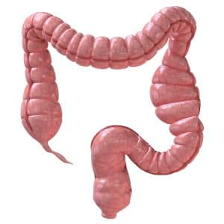

X
Y
- Why is the part labelled Y referred to as a vestigial structure? (2 marks)
……………………………………………………………………………….……………………
- State two roles of part labelled X . (2 marks)
………………………………………………………………………………………….……………………………………………………………………………………………………….……………………..

- Name the disease conditions that result from inadequate amounts of the following in the human body: (2 marks)
- Vasopressin ……………………………………………………………………………
- Iodine ………………………………………………………………………………….

- A picture of interaction between two animals in the same ecosystem is shown below.
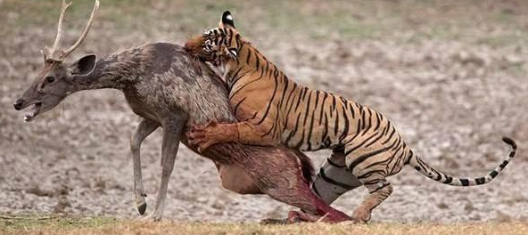

S
T
- What is the advantage of the feeding relationship illustrated above. (1 mark)
………………………………………………………………………………….…………………
- Why would animal S have a shorter alimentary canal than T? (2 marks)
……………………………………………………………………………….…………………………………………………………………………………………………….……………………

- The graph of body temperature changes of two animals is shown below
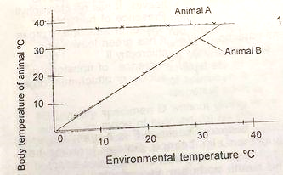
- Which animal represents a poikilotherm? ……………………………………… (1 mark)
- State two advantages animal A has over animal B. (2 marks)
…………………………………………………………………………………………………………………………………………………………………………………………………..

- Name the organelle found in animal cells but absent in members of the following Kingdoms. (2 marks)
- Plantae ……………………………………………………………………..………………….
- Monera …………………………………………………………………..……………………

- An image of behaiour of an insect is shown in the diagram below.
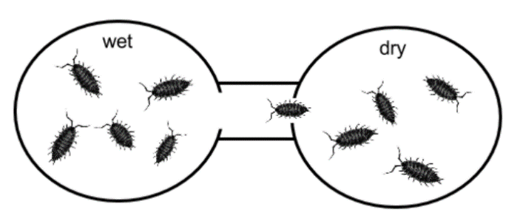
- Name the response shown above …………………………………………………. (1 mark)
- What is the survival importance of the response shown above to the insect? (1 mark)
…………………………………………………………………………………………………………………………………………………………………………………………………………

- Form 3 learners encountered the skull below during a field study.
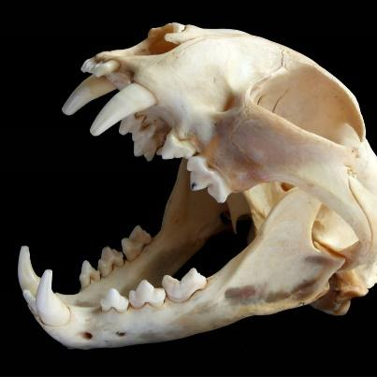
- One of the learners mentioned to the class that the animal with the skull above belongs to Class Mammalia. Give a reason to support the student’s suggestion. (1 mark)
………………………………………………………………………………………………...……
- Give two functions of the skull to the animal. (2 marks)
……………………………………………………………………………………...………………………………………………………………………………………………………………...…….
- Different types of flowers are shown below.
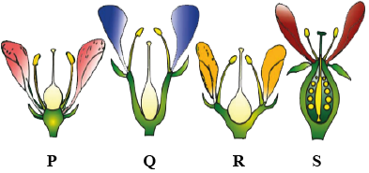

X
Y
- Which letters refer to flowers with the following descriptions: (2 marks)
- Perigynous ……………………………………………………………………..
- Hypogynous ……………………………………………………………………
- State the function of part labelled X. (1 mark)
………………………………………………………………………………………...……………

- Name the growth response by which pollen tube grows to reach the part labelled Y.
(1 mark)
……………………………………………………………………………………………………...

- The following graph shows the relationship between light and amount of bubbles formed in an experiment involving pondweed.
- Name the process responsible for bubble formation. (1 mark)
……………………………………………………………………………………….……………
- Account for the amount of bubbles formed at 5cm. (3 marks)
………………………………………………………………………………………………………………………………………………………………………………………………………………………………………………………………………………………………………………

- The photograph shown below is of blood from a patient observed under a microscope.
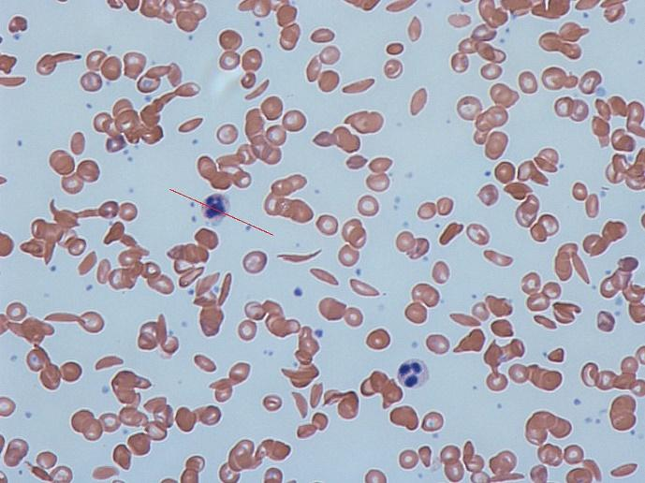

G
- State the function of cell G in the human body. (1 mark)
……………………………………………………………………………………………………...
- Identify the genetic disorder represented by the photograph shown above. (1 mark)
……………………………………………………………………………………………….……..
- Using A to represent the normal gene and T to represent the defective gene:
i) Write the genotype of the person with the genetic disorder named in (b).
(1 mark)
…………………………………………………………………………………………………
ii) Write the genotypes of offsprings obtained from a marriage of two persons with the genetic disorder shown above. (2 marks)
………………………………………………………………………………………………....
- Why is there a higher prevalence of the genetic disorder above in malaria-prone areas?
(1 mark)
………………………………………………………………………………………..………………………………………………………………………..…………………………………………

- State the advantage organisms with the following features have over the rest.
- Inter-ventricular septum in their hearts. (1 mark)
………………………………………………………………………………………..………………………………………………………………………..…………………………………………
- Sexual form of reproduction. (1 mark)
…………………………………………………………………..………………………………..
- Explain two ways in which the excretory system adapts the desert rat to water conservation. (2 marks)
………………………………………………………………………………………..………………………………………………………………………..……………………………………………………………………………………………..……………………………………………….…

- Use the section of eye retina shown below to answer questions that follow.

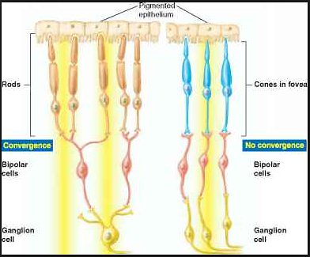

A
B
a) What is the survival importance of having both cells A and B in the same eye of an animal? (1 mark)
………………………………………………………………………………………..………………………………………………………………………..…………………………………………
b) i) Which letter represents the cell that gives the eye a high visual acuity? (1 mark)
………………………………………………………………………………………………..……

ii) Give a reason for your answer in b (i). (1 mark)
…………………………………………………………………..…………………………………

- A field of view of a light microscope with a radius of 2.5mm had 10 cells along its diameter. Determine the diameter of one cell in micrometers. (3 marks)
………………………………………………………………………………………..………………………………………………………………………..…………………………………………………………………………………………………………………..………………………………………………………………………..…………………………………………………………

- An illustration of the human testis is shown below.
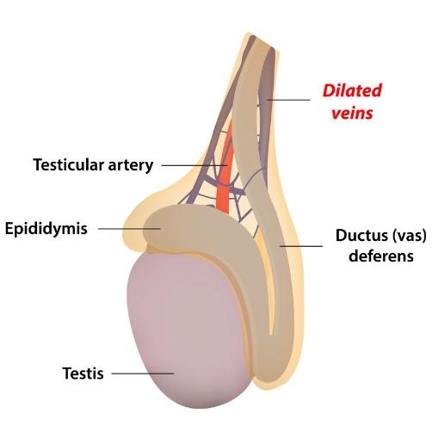
- State the following functions of the human testis. (2 marks)
i) Endocrine function ………………………………………………………………….
ii) Reproductive function ………………………………………………………………
- The blood vessels leaving and entering the testicles are close to each other and blood flow shows a counter current flow. Explain the significance of this to the testis. (2 marks)
…………………………………………………………………….…………………..……………………………………………………………………….…………..……………………

- An image of germinating seed is shown below.
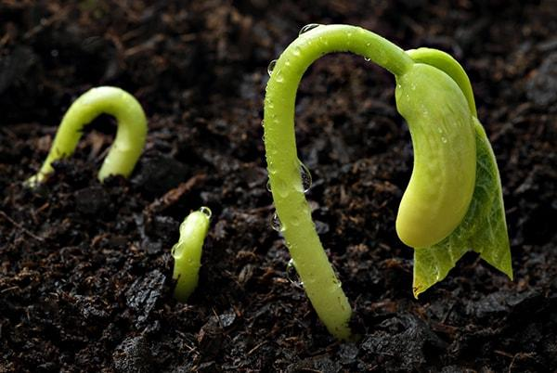
- Give a reason to show that the above is an illustration of epigeal germination. (1 mark)
…………………………………………………………………..…………………………………
- What is the significance of the shoot emerging in a curved manner as shown. (1 mark)
………………………………………………………………………………………..………………………………………………………………………..…………………………………………

- Tar present in burning tobacco has been found to be carcinogenic leading to lung cancer.
- Name a plant waste product that can be used in lung cancer therapy. (1 mark)
………………………………………………………………………………………………..……
- State two means of lung cancer treatment. (2 marks)
………………………………………………………………………………………..………………………………………………………………………..……………………………………………………………………………………………………………………………………..…………

- The diagram shown below represents an experiment done by Form 1 students and they obtained the results after 30 minutes.
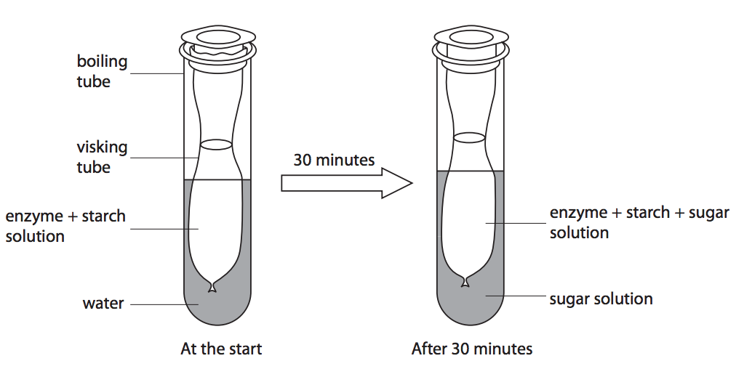
- Which physiological process was being investigated in this experiment? (1 mark)
………………………………………………………………………………………..………………………………………………………………………..…………………………………………
- State two adjustments learners could have done in the set up in order to obtain the same results within 10 minutes or less. (2 marks)
………………………………………………………………………………………..……………………………………………………………………………………………..………………………………………………………………………..…………………………………………………
- Account for the results obtained after 30 minutes. (3 marks)
………………………………………………………………………………………..……………………………………………………………………………………………..………………………………………………………………………..…………………………………………………
- Distinguish between an allograft and an autograft. (2 marks)
………………………………………………………………………………………..………………………………………………………………………..……………………………………………………………………………………………..…………………………………………………

- State two principles of the theory of chemical evolution on origin of life. (2 marks)
………………………………………………………………………………………..………………………………………………………………………..……………………………………………………………………………………………..………………………………….………………

- a) What is an allergen? (1 mark)
………………………………………………………………………………………..………………………………………………………………………..…………………………………………
b) Describe how an allergic condition occurs in a human body. (3 marks)
………………………………………………………………………………………..………………………………………………………………………..…………………………………………………………………………………………………………………..…………………………………………………………………………………………………………………...……………………………………………………………………………………………………………………...

