TERM 2 - 2023
BIOLOGY – PAPER ONE (231/1)
FORM THREE (3)
Time - 2 Hours

Name …………………………………………….……… Admission Number …………….
Candidate’s Signature ………………….…...………... Class ……………………………
Instructions to candidates:
- Write your name, class and admission number in the space provided above.
- Write the date of the examination and sign in the space provided above.
- Answer all the questions in the spaces provided.
- You may be penalized for wrong spelling, especially of technical terms.

For Examiner’s Use Only
Question | Maximum Score | Candidate’s Score
1-31 | 80

This paper consists of 13 printed pages. Candidates should check the question paper to ascertain that all the pages are printed as indicated and no questions are missing

1. State two environmental problems that can be solved by studying biology. (2 marks)
………………………………………………………………………………………………………………………………………………………………………………………………………………………………………………………………………………………………………………………………………
2. Below is a photograph of an organism.
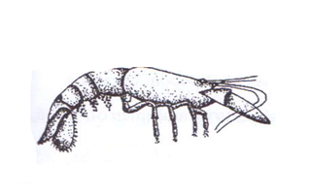
(i) Identify the class to which this organism belongs. (1 mark)
………………………………………………………………………………………………………
(ii) Give reasons for your answer in (i). (2 marks)
……………………………………………………………………………………………………………………………………………………………………………………………………………………………………………………………………………………………………………………………………………………………………………………………………………………………………………………
3. Account for the difference in amount of energy yielded by aerobic and anaerobic respiration. (3 marks)
……………………………………………………………………………………………………………………………………………………………………………………………………………………………………………………………………………………………………………………………………………………………………………………………………………………………………………………

4. The photograph illustrates an organism found in aquatic habitat.
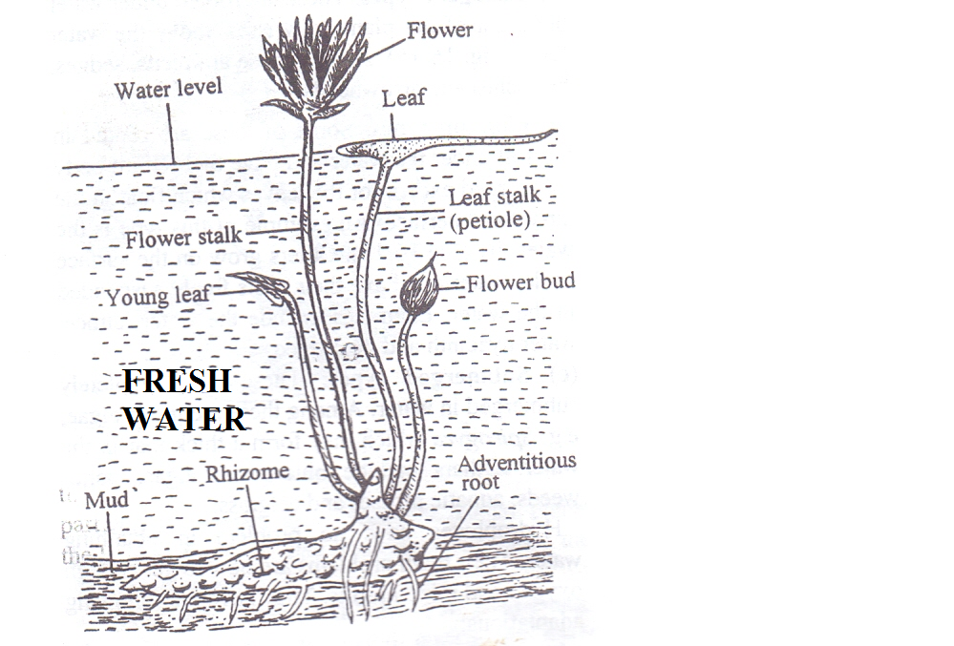
(a) Give the type of the plant. (1 mark)
………………………………………………………………………………………………………
(b) Describe three adaptations of the organism to its habitat. (3 marks)
…………………………………………………………………………………………………………………………………………………………………………………………………………………………………………………………………………………………………………………………………………………………………………………………………………………………………………………………………………………………………………………………………………………………………

5. Below is the basic functional unit of an organism.
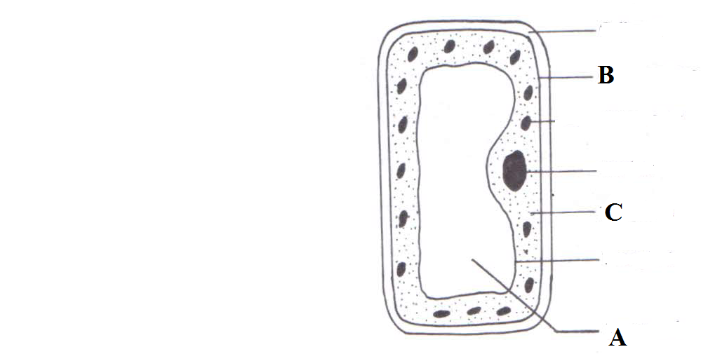
State the functions of the parts labeled:
(i) A………………………….…………………………………………………………. (1 mark)
(ii) B………………………….………………………………………………………… (1 mark)
(iii) C……………………………….…………………………………………………… (1 mark)

6. A student smeared the abdomen of a locust with Vaseline.
(a) What were the likely results after ten minutes? (1 mark)
…………………………………………………………………………………………………………………………………………………………………………………………………………………………
(b) Account for the results obtained above. (2marks)
………………………………………………………………………………………………………………………………………………………………………………………………………………………………………………………………………………………………………………………………………………………………………………………………………………………………………..……………

7. Use the illustration below to answer questions that follow.
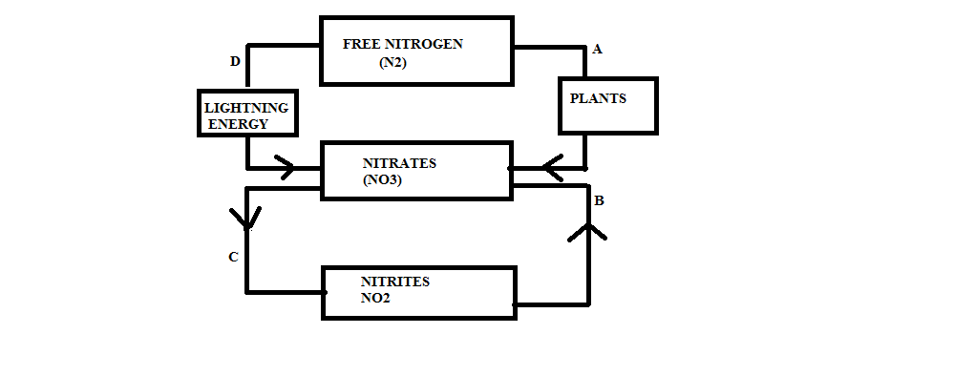
(a) Name the processes labeled:
(i) B…………………………………………………………………………….…………. (1 mark)
(ii) C……………………………………………………………………………….…….. (1 mark)
(b) Name the site where process A occurs. (1 mark)
………………………………………………………………………………………………………
(c) Explain why process C is not beneficial to plants. (1 mark)
………………………………………………………………………………………………………
8. What is the significance of photolysis? (2 marks)
………………………………………………………………………………………………………………………………………………………………………………………………………………………………………………………………………………………………………………………………………

9. The following table shows the volume of gases carried by 100cm³ of blood.
Gas | Blood entering lungs | Blood leaving lungs
Nitrogen | 0.9 cm³ | 0.9 cm³
Oxygen | 10.6 cm³ | 19.0 cm³
Carbon (IV) oxide | 58.0 cm³ | 50.0 cm³

(a) Which blood has a higher content of carbon (IV) oxide? (1 mark) ………………………………………………………………………………………………………
(b) Explain the difference in the content of oxygen and carbon (IV) oxide in blood entering the lungs and that leaving the lungs. (2 marks) ……………………………………………………………………………………………………………………………………………………………………………………………………………………………………………………………………………………………………………………………………………………………………………………………………………………………………………………
10. State the function of the following apparatus.
(i) Specimen bottle (1 mark) …………………………………………………………………………………………………………………………………………………………………………………………………………………………
(ii) Bait trap (1 mark) …………………………………………………………………………………………………………………………………………………………………………………………………………………………
11. Name the causative agents of the following diseases:
(a) Cholera………………………………………………………………………………… (1 mark)
(b) Malaria …………………….………………………………………………………….. (1 mark)
12. Explain why young onion root tip is ideal for examining the stages of mitosis. (1 mark) ……………………………………………………………………………………………………………………………………………………………………………………………………………………………………………………………………………………………………………………………………………………………………………………………………………………………………………………
13. Below is a set up to investigate a certain phenomenon.
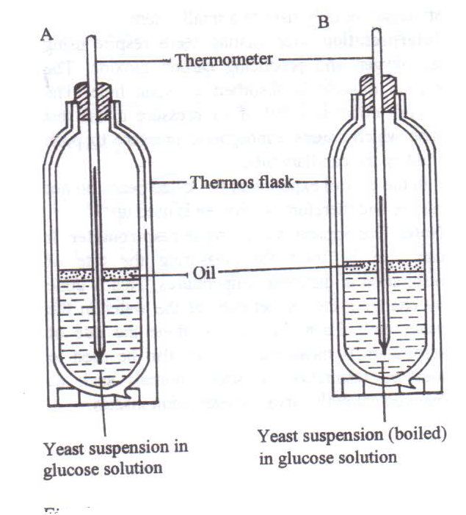
(a) State the aim of the experiment. (1 mark)
………………………………………………………………………………………………………

(b) Account for the observations made after 30 minutes in set-up A (2 marks)
………………………………………………………………………………………………………………………………………………………………………………………………………………………………………………………………………………………………………………………………………

14. State the characteristics that can separate the following organisms into respective classes.
Millipede, tsetse fly, and spider. (3 marks)
……………………………………………………………………………………………………………………………………………………………………………………………………………………………………………………………………………………………………………………………………………………………………………………………………………………………………………………
15. Name the blood vessel that transports blood from:
- Heart to the lungs (1 mark)
……………………………………………………………………………………………
- Small intestines to the liver (1 mark)
……………………………………………………………………………………………
16. a) State the role of light in the process of photosynthesis (1 mark)
………………………………………………………………………………………………………
b) Name one of the end products of dark reaction in photosynthesis (1 mark)
………………………………………………………………………………………………………
17. Give any two benefits of transport in plants (2 marks)
…………………………………………………………………………………………………………………………………………………………………………………………………………………………
18. (a) Form three students carried out a practical activity to estimate the number of tsetse flies in a small bush near the school. At first they caught 600 tsetse flies, marked, and released them. After five days they caught 500 tsetse flies of which 200 had been marked.

i) Calculate the tsetse flies population in the study area. (3 marks)

(b) State one abiotic and one biotic factors that influence tsetse fly population in a bush. (2 marks)
i) Abiotic factors
……………………………………………………………………………………………………
- Biotic factors
……………………………………………………………………………………………………

19. State the functions of the following parts of a light microscope.
(i) Coarse adjustment knob. (1 mark)
…………………………………………………………………………………………………………………………………………………………………………………………………………………………
(ii) Condenser. (1 mark)
…………………………………………………………………………………………………………………………………………………………………………………………………………………………
20. Below are photographs of fruits
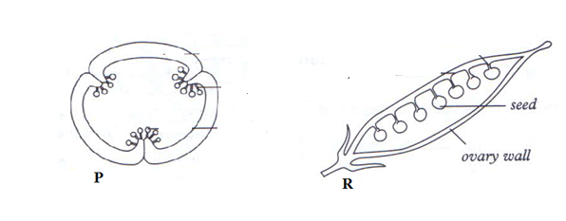
Identify the type of placentation shown above.
(i) P………………………………………………………………………………………. (1 mark)
(ii) R………………………………………………………………………..……………. (1 mark)

21. Use the diagram below to answer questions that follow.
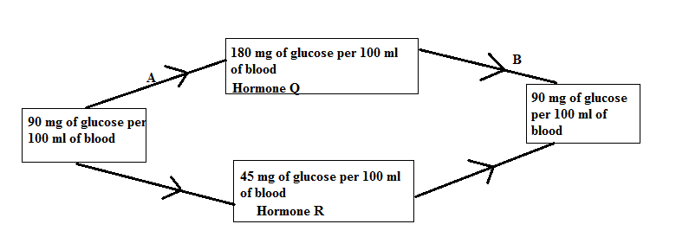
(a) Name the feedback mechanism labeled B. (1 mark)
………………………………………………………………………………………………………
(b) Identify hormone R (1 mark)
……………………………………………………………….……………………………………..
22. Show that you understand the terms below as used in describing flowers.
(i) Polypetalous. (1 mark)
………………………………………………………………………………………………………
(ii) Staminate flowers. (1 mark)
………………………………………………………………………………………………………

23. Name three food substances acquired by herbivores feeding on green sprouting grass exposed to maximum sunlight during the day. (3 marks)
………………………………………………………………………………………………………………………………………………………………………………………………………………………………………………………………………………………………………………………………………
24. Define the following concepts of ecology
(i) Ecological niche. (1 mark)
…………………………………………………………………………………………………………………………………………………………………………………………………………………………
(ii) Biomass. (1 mark)
…………………………………………………………………………………………………………………………………………………………………………………………………………………………
25. A certain animal has no incisors, no canines, 6 premolars and 6 molars in its upper jaw while in its lower jaw there are 6 incisors, 2 canines, 6 premolars and 6 molars.
(a) Write its dental formula. (1 mark)

(b) Identify the mode of nutrition of the organism. (1 mark) ……………………………………………………………………………………………………………

(c) Give a reason for your answer in (b) above. (1 mark) …………………………………………………………………………………………………………
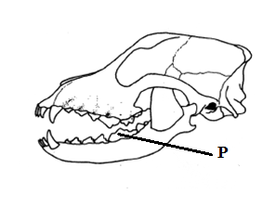
26. The photograph below shows a skull of an organism

(i) Name the tooth labeled P and give its function. (2 marks)
…………………………………………………………………………………………………………………………………………………………………………………………………………………………
27. State one roles of an acrosome. (1 mark)
………………………………………………………………………………………………………………………………………………………………………………………………………………………………………………………………………………………………………………………………………
28. Distinguish between
(i) cytology and entomology. (1 mark)
…………………………………………………………………………………………………………………………………………………………………………………………..……………………………..
(ii) botany and zoology. (1 mark)
…………………………………………………………………………………………………………………………………………………………………………………………..……………………………..

29. Explain the importance of the following processes when making microscopic sections:
(i) Cutting very thin sections. (1 mark)
……………………………………………………………………………………………………………………………………………………………………………………………………………….…………
(ii) Using a sharp scalpel to cut thin sections. (1 mark)
………………………………………………………………………………………………………………………………………………………………………………………………………………….………
30. Describe how the granum is adapted to its photosynthetic function. (2 marks) …………………………………………………………………………………………………………………………………………………………………………………………………………………………
31. Below is a photograph of a fruit.
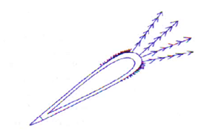
(a) State the agent of dispersal of the fruit. (1 mark) ……………………………………………………………………………………………………………
(b) Give a reason for your answer in (a) above. (1 mark)
…………………………………………………………………………………………………………………………………………………………………………………………………………………………

THIS IS THE LAST PRINTED PAGE.

