TERM 2 - 2023
ART AND DESIGN
PAPER 1
FORM FOUR (4)
Time: 2 Hours

Name: …………………………………………………………. Adm No: ……………….
School: ……………………………………………………….. Class: ……………………
Signature: …………………………………………………….. Date: …………………...

Instructions
- Write your name and index number in the spaces provided
- This paper consists of THREE sections A, B and C.
- Answer ALL the questions in section A and B.
- Answer any ONE question in section C.
- Answers to all questions must be written in the spaces provided.
- Where drawings and diagrams are appropriate, they should be included within the context of your answers.
- The candidates should ensure that the question paper has all printed pages and no missing questions.
- Answer the questions in English

Question |  | Candidate’s score | Max Score.
SECTION A |  |  | 20mks
B |  |  | 25mks
C |  |  | 15Mks
 | TOTAL SCORE | 60 mks

SECTION A. [20 marks]
Answer all questions in this section in the spaces provided.
1a) Name the most outstanding element and principle in the work bellow.
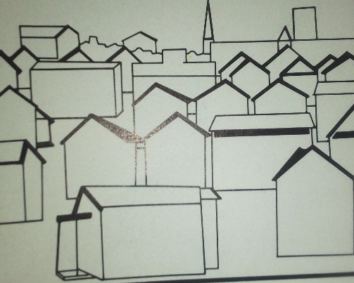
Element……………………………………………………………………………… [1mk]
Principle…………………………………………………………………………….. [1mk]
b). Explain porosity as used in Art(1mk) ……………………………………………………………………………………………………………………………………………………………………………………………………………………………………………………………………………………………………………………………………………………………………………………………………………………………………………………………………………………..
(c)Explain the term mounting and give two types of mounting in art works[3mks] ……………………………………………………………………………………………………………………………………………………………………………………………………………………………………………………………………………………………………………………………………………………………………………………………………………………………………………………………………………………………………………………………………………………………………………………………………………………………………………………………..
(d)State two uses of a book cover (2mks)
………………………………………………………………………………………………………………………………………………………………………………………………………………………………………………………………………………………………………………………..
(e)Name three approaches to painting. (3mks)
……………………………………………………………………………………………………………………………………………………………………………………………………………………………………………………………………………………………………………………………………………………………………………………………………………………………………………………………………………………………………….
(f) Name and specific the art work bellow and label any two of its elements.

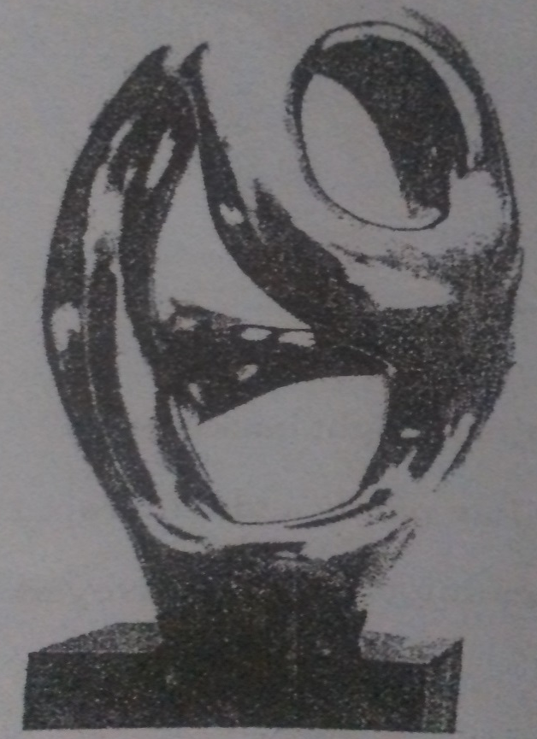

Name……………………………………………………………………………. (1mk)
Labelling elements…………………………………………………..
………………………………………………….. (2mks)
(g) Give two reasons why paper is preferred as a suitable surface for painting (2mks)
……………………………………………………………………………………………………………………………………
…………………………………………………………………………………………………………………………………….
h) Differentiate between “tracking” and “Kerning” as used in typography (2mks)
………………………………………………………………………………………………………………………………………………………………………………………………………………………………………………………………………………………………………………………………………………………………………………………………………………………………………………………………………..
(I)Define and give an alternative name for simulated texture. (2mks)
…………………………………………………………………………………………………………………………………………………………………………………………………………………………………………………………………………………………………………………………………………………………………………………………………………………

SECTION B [25marks]
Answer all questions in this section in the spaces provided.
2. Study the Picture below and answer the questions:
(i) Identify and name the type of repeat below. (1mk)
…………………………………………………………………………………………………………………………………………
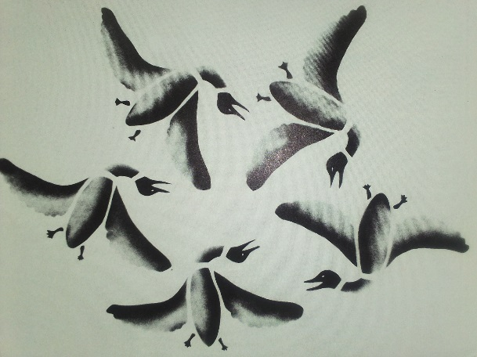
(ii)Apart from the above, name any other three types of repeats (3mks)
………………………………………………………………………………………………………………………………………………………………………………………………………………………………………………………………………………………………………………………………………………………………………………………………………………………………………………………………………………………………………
(iii) Suggest a suitable subject matter of the motif in the artwork above (1mk)
………………………………………………………………………………………………………………………………………………………………
(iv) The technique used to produce the above art work [1mk] ………………………………………………………………………………………………………………………………………………………………
3. (a) Give any two resist methods of fabric decoration (2mks). ………………………………………………………………………………………………………………………………………………………………………………………………………………………………………………………………………………………………………………………………………………………………………………………………………………………………………………………………………………………………………
(b)Why should a fabric be washed before dying? (2mks) ………………………………………………………………………………………………………………………………………………………………………………………………………………………………………………………………………………………………………………………………………………………………………………………………………………………………………………………………………..

c) Using an illustration, Describe a double container and its use in an art work technique (3mks) ………………………………………………………………………………………………………………………………………………………………………………………………………………………………………………………………………………………………………………………………………………………………………………………………………………………………………………………………………..

4. The illustration below shows an art technique in progress. Identify the technique (1 mks)
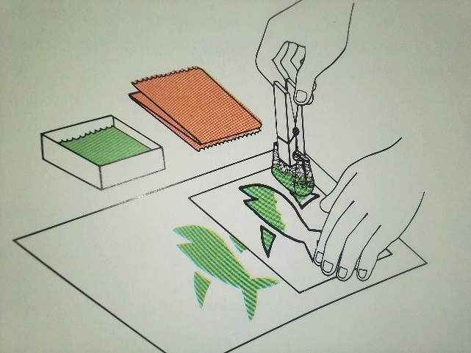
(ii) Name any other two techniques that can be used to achieve the results as of the artwork above (2mks) ……………………………………………………………………………………………………………………………………………………………………………………………………………………………………………………………………………………………………………………………………
(iii) The technique bellow is used to show depth and illusion as a result of distance/. Identify the technique and type shown ( 2mk)
Name other two types apart from the one above (2mks) ……………………………………………………………………………………………………………………………………………………………………………………………………………………………………………………………………………………………………………………………………
5. (a) Using illustrations, explain to weaving defects and their causes(4mks) ………………………………………………………………………………………………………………………………………………………………………………………………………………………………………………………………………………………………………………………………………………………………………………………………………………………………………………………………………..

(b) Differentiate floats and sheds as applied in weaving (2mks) ………………………………………………………………………………………………………………………………………………………………………………………………………………………………………………………………………………………………………………………………………………………………………………………………………………………………………………………………………..

(c) Explain a tabby weave (1mk) ………………………………………………………………………………………………………………………………………………………………………………………………………………………………………………………………………………………………………………………………………………………………………………………………………………………………………………………………………..

SECTION C -15 Marks
[Answer only one question from this section in the spaces provided at the back].
4(a) Distinguish between Jewellery and ornamentation (2mks)
(b)Briefly describe the process of making the following artworks
(i) Masai collar (3mks)
(ii) Glossy paper beadworks (3mks)
(c)i) Name any three techniques of ornamentry(3mks)
ii) What are the factors to consider when designing ornaments? (4mks)

4. (a) What is sculpturing/(2mk)
(b) Mentioning the different types and sculptural techniques, explain how you would develop different types of sculptures using the techniques mentioned. (13mks)

5. (a) Give three characteristics that make clay a suitable material for pottery (3mks)
(b) Explain clay preparation processes (4mks)
(c) With reference to ceramics, differentiate the following (4mks)
(i) Leather hard clay and bone-dry clay
(ii) Glassware and bisque ware
(iii) Slip and grog
(iv) Embedding and Embossing
(v) List any two firing techniques in ceramics. [1mk]
(d) Explain the uses and how pyro metric cones work in a ceramic process. (3mks)
…………………………………………………………………………………………………………………………………………………………………………………………………………………………………………………………………………………………………………………………………………………………………………………………………………………………………………………………………………………………………………………………………………………………………………………………………………………………………………………………………………………………………………………………………………………………………………………………………………………………………………………………………………………………………………………………………………………………………………………………………………………………………………………………………………………………………………………………………………………………………………………………………………………………………………………………………………………………………………………………………………………….
…………………………………………………………………………………………………………………………………………………………………………………………………………………………………………………………………………………………………………………………………………………………………………………………………………………………………………………………………………………………………………………………………………………………………………………………………………………………………………………………………………………………………………………………………………………………………………………………………………………………………………………………………………………………………………………………………………………………………………………………………………………………………………………………………………………………………………………………………………………………………………………………………………………………………………………………………………………………………………………………………………………….
…………………………………………………………………………………………………………………………………………………………………………………………………………………………………………………………………………………………………………………………………………………………………………………………………………………………………………………………………………………………………………………………………………………………………………………………………………………………………………………………………………………………………………………………………………………………………………………………………………………………………………………………………………………………………………………………………………………………………………………………………………………………………………………………………………………………………………………………………………………………………………………………………………………………………………………………………………………………………………………………………………………….
…………………………………………………………………………………………………………………………………………………………………………………………………………………………………………………………………………………………………………………………………………………………………………………………………………………………………………………………………………………………………………………………………………………………………………………………………………………………………………………………………………………………………………………………………………………………………………………………………………………………………………………………………………………………………………………………………………………………………………………………………………………………………………………………………………………………………………………………………………………………………………………………………………………………………………………………………………………………………………………………………………………….
…………………………………………………………………………………………………………………………………………………………………………………………………………………………………………………………………………………………………………………………………………………………………………………………………………………………………………………………………………………………………………………………………………………………………………………………………………………………………………………………………………………………………………………………………………………………………………………………………………………………………………………………………………………………………………………………………………………………………………………………………………………………………………………………………………………………………………………………………………………………………………………………………………………………………………………………………………………………………………………………………………………….
…………………………………………………………………………………………………………………………………………………………………………………………………………………………………………………………………………………………………………………………………………………………………………………………………………………………………………………………………………………………………………………………………………………………………………………………………………………………………………………………………………………………………………………………………………………………………………………………………………………………………………………………………………………………………………………………………………………………………………………………………………………………………………………………………………………………………………………………………………………………………………………………………………………………………………………………………………………………………………………………………………………….
…………………………………………………………………………………………………………………………………………………………………………………………………………………………………………………………………………………………………………………………………………………………………………………………………………………………………………………………………………………………………………………………………………………………………………………………………………………………………………………………………………………………………………………………………………………………………………………………………………………………………………………………………………………………………………………………………………………………………………………………………………………………………………………………………………………………………………………………………………………………………………………………………………………………………………………………………………………………………………………………………………………….
…………………………………………………………………………………………………………………………………………………………………………………………………………………………………………………………………………………………………………………………………………………………………………………………………………………………………………………………………………………………………………………………………………………………………………………………………………………………………………………………………………………………………………………………………………………………………………………………………………………………………………………………………………………………………………………………………………………………………………………………………………………………………………………………………………………………………………………………………………………………………………………………………………………………………………………………………………………………………………………………………………………….
…………………………………………………………………………………………………………………………………………………………………………………………………………………………………………………………………………………………………………………………………………………………………………………………………………………………………………………………………………………………………………………………………………………………………………………………………………………………………………………………………………………………………………………………………………………………………………………………………………………………………………………………………………………………………………………………………………………………………………………………………………………………………………………………………………………………………………………………………………………………………………………………………………………………………………………………………………………………………………………………………………………….
…………………………………………………………………………………………………………………………………………………………………………………………………………………………………………………………………………………………………………………………………………………………………………………………………………………………………………………………………………………………………………………………………………………………………………………………………………………………………………………………………………………………………………………………………………………………………………………………………………………………………………………………………………………………………………………………………………………………………………………………………………………………………………………………………………………………………………………………………………………………………………………………………………………………………………………………………………………………………………………………………………………….
…………………………………………………………………………………………………………………………………………………………………………………………………………………………………………………………………………………………………………………………………………………………………………………………………………………………………………………………………………………………………………………………………………………………………………………………………………………………………………………………………………………………………………………………………………………………………………………………………………………………………………………………………………………………………………………………………………………………………………………………………………………………………………………………………………………………………………………………………………………………………………………………………………………………………………………………………………………………………………………………………………………….
……………………………………………………………………………………………………………………………………………………………………………………………………………………………………………………………………………………………………………………………………………………………………………………………………………………………………………………………………………………………………………………………………………………………………………………………………………………………………………………………………………………………………………………………………………………………………………………………………………………………………………………………………………………………………………………………………………………………………………………………………………………………………………………………………………………………………………………………………………………………………………………………………………………………………………………………………………………………………………………………………………………

THIS IS THE LAST PRINTED PAGE

