TERM 2 - 2023
ART AND DESIGN
FORM TWO (2)
Time: 2 Hours

NAME....................................................................... ADM NO………………………………
DATE ………………………………CANDIDATES SIGNATURE ………..…………...

Instructions
- Write your name and Admin number in the spaces provided
- This paper consists of TWO sections A, and B.
- Answer ALL the questions in both sections.
- Answers to all questions must be written in the spaces provided.
- Where drawings and diagrams are appropriate, they should be included within the context of your answers.
- The candidates should ensure that the question paper has all printed pages and no missing questions.
Question |  | Candidate’s score | Max Score.
SECTION A |  |  | 40mks
B |  |  | 60mks
 | TOTAL SCORE | 100 marks

SECTION A (40 Mks)
Answer all questions in this section:
1[a] Define an ornament [2mk]
……………………………………………………………………………………………………………………………………………………………………………………………………………………………………………………………………………………………………………………………………………………………………………………………………………………………………………………………………………………………………..
(ii) Give an two functions of ornaments [2mks] …………………………………………………………………………………………………………………………… ……………………………………………………………………………………………………………………………
B [i] what do you understand by the term radial balance [2mks]
……………………………………………………………………………………………………………………………………………………………………………………………………………………………………………………………………………………………………………………………………………………………………………………………………………………………………………………………..

[ii] Using illustrations, explain any other two types of balance [4mks]
……………………………………………………………………………………………………………………………………………………………………………………………………………………………………………………………………………………………………………………………………

C [i] Name any two approaches to painting [2mks]
……………………………………………………………………………………………………………………………………………………………………………………………………………………………………………………………………………………………………………………………………
[ii]Explain the advantage of painting from observation [2mks]
……………………………………………………………………………………………………………………………………………………………………………………………………………………………………………………………………………………………………………………………………………………………………………………………………………………………………………………………..
D [i] what is an easel? [1mks]
……………………………………………………………………………………………………………………………………………………………………………………………………………………………………………………………………………………………………………………………………………………………………………………………………………………………………………………………..
[ii] Sketch a view finder on a drawing [2mks]

[iii] Identify and give the most outstanding principle in the illustration bellow and how it has been portrayed [2mks]
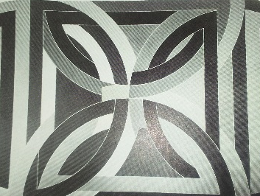
e [i] In terms of colour, what do you understand by the term complimentary colours? [2mks]
……………………………………………………………………………………………………………………………………………………………………………………………………………………………………………………………………………………………………………………………………………………………………………………………………………………………………………………………..
[ii]Give two example of the colours above [2mks]
……………………………………………………………………………………………………………………………………………………………………………………………………………………………………………………………………………………………………………………………………
[iii] Give two characteristics of warm colours [2mks]
…………………………………………………………………………………………………………………………………………………………………………………………………………………………………………………………………………………………………………………………………..
f [i] Differentiate between serifs and san serifs in lettering [2mks]
…………………………………………………………………………………………………………………………………………………………………………………………………………………………………………………………………………………………………………………………………………………………………………………………………………………………………………………………………………………………………….
…………………………………………………………………………………………………………………………………………………………………
[ii] Name three main parts of a book cover and at least two components of each [6 mks]
…………………………………………………………………………………………………………………………………………………………………………………………………………………………………………………………………………………………………………………………………………………………………………………………………………………………………………………………………………………………………….
g [i] Name three stages of drawing [3mks]
……………………………………………………………………………………………………………………………………………………………………………………………………………………………………………………………………………………………………………………………………………………………………………………………………………………………………………………………………………………………………..
[ii]What do you understand by the term unity [2mk ]
……………………………………………………………………………………………………………………………………………………………………………………………………………………………………………………………………………………………………………………………………………………………………………………………………………………………………………………………..
[h] What is the difference between montage and photomontage? [2mks]
……………………………………………………………………………………………………………………………………………………………………………………………………………………………………………………………………………………………………………………………………………………………………………………………………………………………………………………………..
SECTION B [60mks]
Answer all questions:
2[i] State the origin and meaning of the word” Graphics” [2mks]
……………………………………………………………………………………………………………………………………………………………………………………………………………………………………………………………………………………………………………………………………
[ii] In the space bellow, sketch and show the difference between Stem, cross bar and cross strokes in letter anatomies. [3mks]

3(i) using the illustration bellow, define and show value. [3mks]
……………………………………………………………………………………………………………………………………………………………………………………………………………………………………………………………………………………………………………………………………
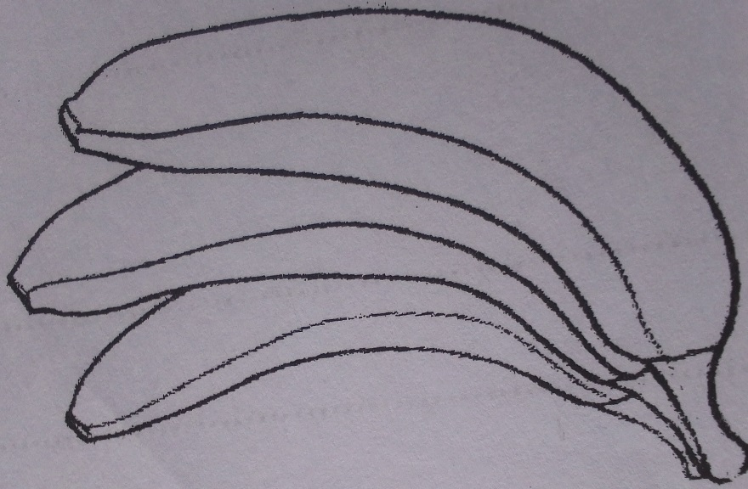
[ii]State two functions of value in a pictorial composition [2mks]
……………………………………………………………………………………………………………………………………………………………………………………………………………………………………………………………………………………………………………………………………
4[a] [a] Define weaving[2mk] ……………………………………………………………………………………………………………………………………………………………………………………………………………………………………………………………………………………………………………………………………………………………………………………………………………………………………………………………………………………………………
b [i]Name any 3 weaving techniques [3mks]
…………………………………………………………………………………………………
……………………………………………………………………………………………….
…………………………………………………………………………………………………
[ii] Name any two animal fibers used for weaving. [2mks]
…………………………………………………………………… …………………………………………………………………
5a[i] Using an illustration, of a spread umbrella, differentiate between bird’s eye and worm’s eye level [4mks]
…………………………………………………………………………………………………………………………………………………………………………………………………………………………………………………………………………………………………………………………………………………………………………………………………………………………………………………………………………………………………….

[ii] With reference to land scape drawing, Differentiate between a horizon an a varnishing point [2mks]
……………………………………………………………………………………………………………………………………………………………………………………………………………………………………………………………………………………………………………………………………………………………………………………………………………………………………………………………..

[b] Use illustration to show the above named concepts in 5a above [4mks]

6[i] what are illustrations [2mks]
……………………………………………………………………………………………………………………………………………………………………………………………………………………………………………………………………………………………………………………………………………………………………………………………………………………………………………………………..
[ii] Mention any two types of illustrations using relevant examples in the spaces below [4mks]

…………………………………………………………………………………………………………………………………………………………………

…………………………………………………………………………………………………………………………………………………………………
[ii]Differentiate a logo and a monogram [2mks]
……………………………………………………………………………………………………………………………………………………………………………………………………………………………………………………………………………………………………………………………………………………………………………………………………………………………………………………………..
…………………………………………………………………………………………………………………………………………………………………………………………………………………………………………………………………………………………..
7[a] Differentiate between shading and tinting [2mks]
……………………………………………………………………………………………………………………………………………………………………………………………………………………………………………………………………………………………………………………………………………………………………………………………………………………………………………………………………………………………………..
[b] Name any three painting techniques [3mks]
……………………………………………………………………………………………………………………………………………………………………………………………………………………………………………………………………………………………………………………………………………………………………………………………………………………………………………………………..
8[i] Name any two adhesives used in mosaic [2mks
……………………………………………………………………………………………………………………………………………………………………………………………………………………………………………………………………………………………………………………………………
[ii]State the characteristics of collage [3mks] ……………………………………………………………………………………………………………………………………………………………………………………………………………………………………………………………………………………………………………………………………………………………………………………………………………………………………………………………………………………………………
9[i] what is portraiture? [1mk]
……………………………………………………………………………………………………………………………………………………………………………………………………………………………………………………………………………………………………………………………………………………………………………………………………………………………………………………………..
[ii]Name the difference between still life and nature drawing categories [2mks]
……………………………………………………………………………………………………………………………………………………………………………………………………………………………………………………………………………………………………………………………………………………………………………………………………………………………………………………………..
[iii] Give two techniques of mounting a 2D art work [2mks]
……………………………………………………………………………………………………………………………………………………………………………………………………………………………………………………………………………………………………………………………………
10. In the space bellow, draw a model posed for a selfie
Or
In good calligraphic fonts, Design the extract ‘’
There’s no mistake in art, a mistake in art, well manipulated makes a design”. [10mks]

This is the last printed page

