TERM 2 - 2023
AGRICULTURE
PAPER 1
FORM FOUR (4)
Time: 2 Hours
Name: …………………………………………………………. Adm No: ……………….
School: ……………………………………………………….. Class: …………………..
Signature: …………………………………………………….. Date: …………………...
INSTRUCTIONS TO THE CANDIDATES
- Write your name and index number in the spaces provided above.
- This paper consists of three sections;-A, B and C.
- Answer all questions in section A and B and any two questions in section C
- All answer must be written in the spaces provided.
- This paper consist of 14 printed pages.
- Candidates should check the question papers to ascertain that all the pages are printed as indicated and that no questions are missing.
- Candidates should answer the question in English.
FOR EXAMINER'S USE ONLY
SECTION | QUESTIONS | MAX SCORE | CANDIDATE’S SCORE
A | 1-15 | 30
B | 16-19 | 20
C | 20 | 20
 | 21 | 20
 | 22 | 20
TOTAL |  | 90

SECTION A (30MKS)
ANSWER ALL QUESTION

1. List four practices carried out in ranching as an improved system of nomadic pastoralism (2marks)
……………………………………………………………………………………………………………………………………………………………………………………………………………………………………………………………………………………………………………………………………………………………………………………………………………………………………………………………………...…………………………………………………………………………………………………………………...…………………………………………………
2. State four ways by which government policy influences agriculture (2marks)
………………………………………………………………………………………………………………………………………………………………………………………………………………………………………………………………………………………………………………………………………………………………………………………………………………………………
3. Name four ways by which plants harness more light intensity (2marks) ……………………………………………………………………………………………………………………………………………………………………………………………………………………………………………………………………………………………………………………………………………………………………………………………………………………………………………………………………...…………………………………………………………………………………………………………………...…………………………………………………
4. State four ways through which farmers reduce the effects of water shortage during crop production (2marks) ……………………………………………………………………………………………………………………………………………………………………………………………………………………………………………………………………………………………………………………………………………………………………………………………………………………………………………………………………...…………………………………………………………………………………………………………………...…………………………………………………

5. State four ways of improving a sandy soil for crop production (2marks) ………………………………………………………………………………………………………………………………………………………………………………………………………………………………………………………………………………………………………………………………………………………………………………………………………………………………
……………………………………...…………………………………………………………………………………………………………………...…………………………………………………
6. State four effects of soil PH in crop production (2marks) ………………………………………………………………………………………………………………………………………………………………………………………………………………………………………………………………………………………………………………………………………………………………………………………………………………………………
……………………………………...…………………………………………………………………………………………………………………...…………………………………………………
7. Give four reasons why it is advantageous to use farm yard manure instead of straight fertilizer. (2marks)
…………………………………………………………………………………………………………………...…………………………………………………………………………………………………………………...………………………………………………………………………………………………………………...…………………………………………………………………
……………………………………...…………………………………………………………………………………………………………………...…………………………………………………
8. State four methods of reclamation farmers can carry out. (2marks)
…………………………………………………………………………………………………………………...…………………………………………………………………………………………………………………...…………………………………………………………………………………………………………………...………………………………………………………………
……………………………………...…………………………………………………………………………………………………………………...…………………………………………………

9. State four benefits of land consolidation. (2marks)
…………………………………………………………………………………………………………………...…………………………………………………………………………………………………………………...…………………………………………………………………………………………………………………...………………………………………………………………
……………………………………...…………………………………………………………………………………………………………………...…………………………………………………
10. State four factors that determine the spacing of maize crops. (2marks)
…………………………………………………………………………………………………………………...…………………………………………………………………………………………………………………...…………………………………………………………………………………………………………………...………………………………………………………………
……………………………………...…………………………………………………………………………………………………………………...…………………………………………………
11. State four factors which may affect the quality of hay. (2marks)
…………………………………………………………………………………………………………………...…………………………………………………………………………………………………………………...…………………………………………………………………………………………………………………...………………………………………………………………
……………………………………...…………………………………………………………………………………………………………………...…………………………………………………
12. State four factors that affect the effectiveness of a pesticide. (2marks)
…………………………………………………………………………………………………………………...…………………………………………………………………………………………………………………...…………………………………………………………………………………………………………………...………………………………………………………………
……………………………………...…………………………………………………………………………………………………………………...…………………………………………………

13. State four importance of practicing agroforestry. (2marks)
…………………………………………………………………………………………………………………...…………………………………………………………………………………………………………………...…………………………………………………………………………………………………………………...…………………………………………………………………………………………………………………...…………………………………………………

14. Name four natural factors that may influence soil erosion. (2marks)
…………………………………………………………………………………………………………………...…………………………………………………………………………………………………………………...…………………………………………………………………………………………………………………...………………………………………………………………

15. State two conditions that should be observed when harvesting to ensure that cotton picked is of high quality. (2marks)
………………………………………………………………………………………………………
………………………………………………………………………………………………………

SECTION B 20 MARKS
ANSWER ALL THE QUESTIONS
16. The photograph below illustrate a seed potato prepared for planting. Study it and answer the questions that follow.
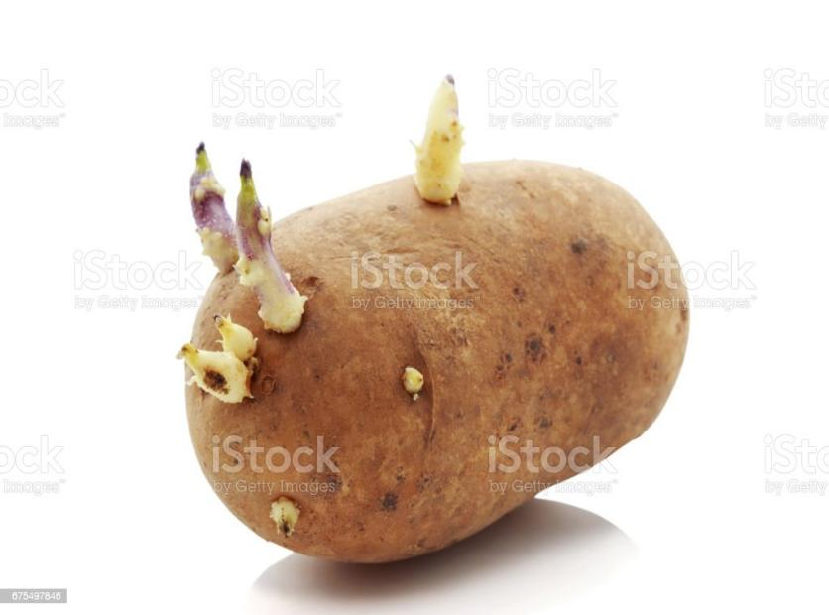

- Name the practice used to prepare the seed potato above for planting (1mark)
…………...…………………………………………………………………………………………………………………...…………………………………………………………………………………………………………………...…………………………
- Describe the procedure followed in preparing the seed potatoes for planting (4marks)
…………...…………………………………………………………………………………………………………………...…………………………………………………………………………………………………………………...…………………………………………………………………………...…………………………………………………………………………………………………………………...…………………………………………………………………………………………………………………...…………………………………………………………………………...…………………………………………………………………………………………………………………...………………………………………………………………………
17. The photograph below illustrate a type of erosion. study it and answer the questions that follow.
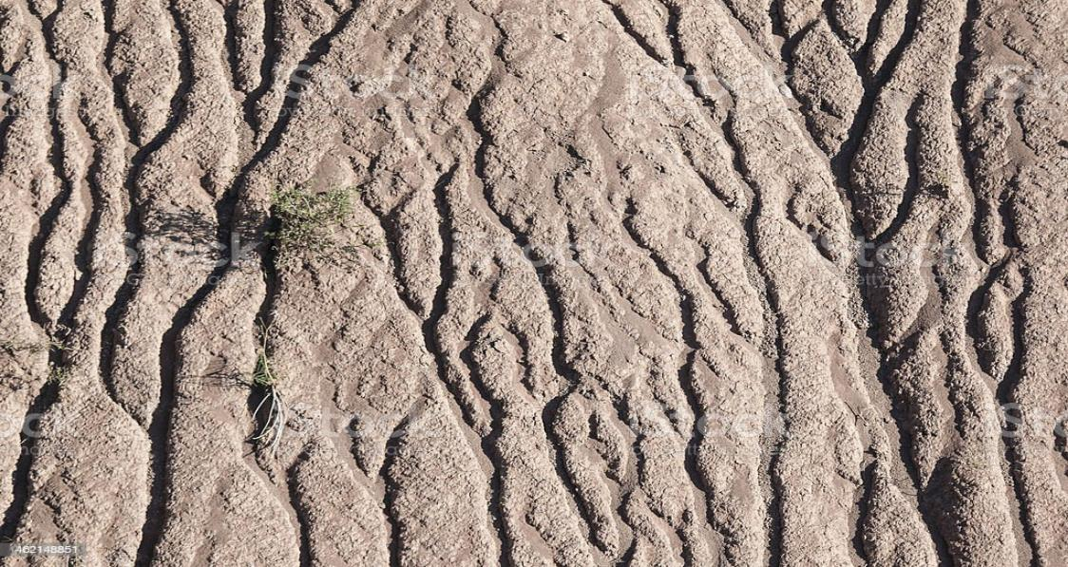
- Identify the type of erosion (1mark)
…………...…………………………………………………………………………………………………………………...…………………………………………………………………………………………………………………...…………………………
- How does the type of erosion shown above occur (2marks)
…………...…………………………………………………………………………………………………………………...…………………………………………………………………………………………………………………...…………………………………………………………………………...…………………………………………………………………………………………………………………...………………………………………………………………………………………………………………………………….

- How does planting of grass help to control the type of erosion shown (2marks)
…………...…………………………………………………………………………………………………………………...…………………………………………………………………………………………………………………...…………………………………………………………………………...…………………………………………………………………………………………………………………...……………………………………………………………………………………………………………
18. The photograph below illustrate a method of irrigation. study it and answer the questions that follow.

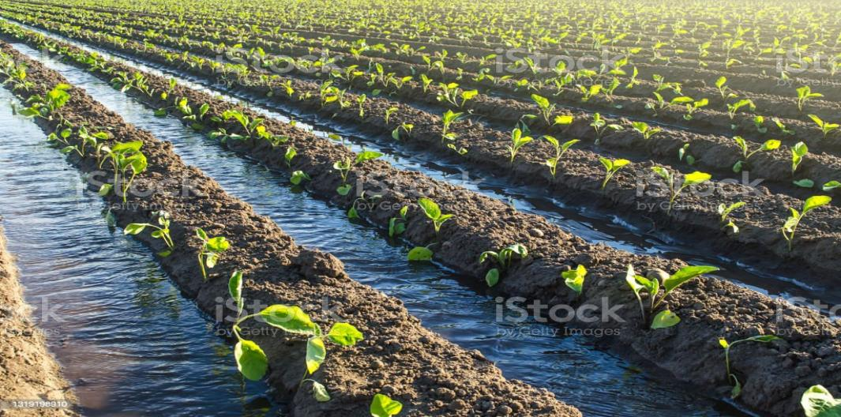

- Identify the method of irrigation illustrated above (1mark)
…………...…………………………………………………………………………………………………………………...…………………………………………………………………………………………………………………...………………………………………

- State two advantages of using the above method of irrigation (2marks)
…………...…………………………………………………………………………………………………………………...…………………………………………………………………………………………………………………...…………………………………………………………………………...…………………………………………………………………………………………………………………...……………………………………………………………………………………………………………
- Give two maintenance practices carried out on the above method of irrigation (2marks)
…………...…………………………………………………………………………………………………………………...…………………………………………………………………………………………………………………...…………………………………………………………………………...…………………………………………………………………………………………………………………...……………………………………………………………………………………………………………

19. Below is a photograph showing harvesting of trees in agroforestry. Study it and answer questions that follow
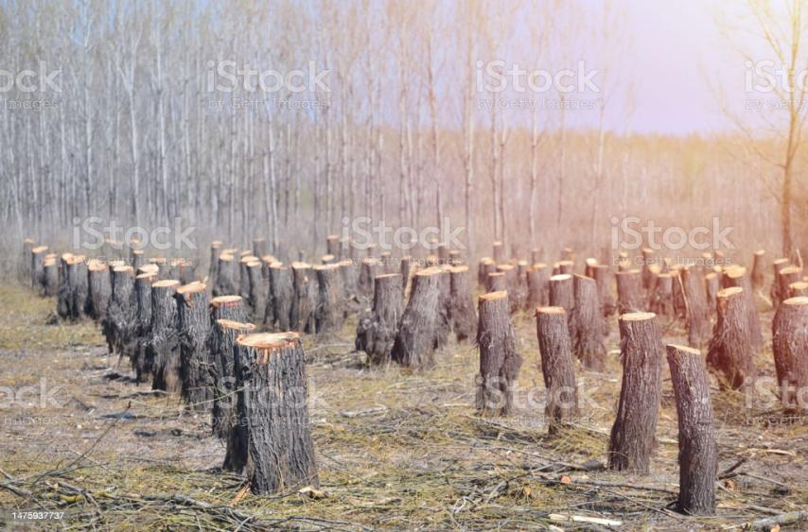
- Identify the practice (1mark)
…………...…………………………………………………………………………………………………………………...…………………………………………………………………………………………………………………...…………………………………………………
- Name two other methods used in harvesting agroforestry trees (2marks)
…………...…………………………………………………………………………………………………………………...…………………………………………………………………………………………………………………...…………………………………………………………………………...…………………………………………………………………………………………………………………...……………………………………………………………………………………………………………
- Give two sites where agroforestry trees are planted (2marks)
…………...…………………………………………………………………………………………………………………...…………………………………………………………………………………………………………………...…………………………………………………………………………...…………………………………………………………………………………………………………………...……………………………………………………………………………………………………………

SECTION C (40 MARKS)
ANSWER ANY TWO QUESTIONS FROM THIS SECTION IN THE SPACES PROVIDED
20. a) Outline seven roles of a good farm manager (7marks)
b) Explain problems encountered in the marketing of cabbages. (9marks)
c) Explain four factors that make weeds propagate successfully. (4marks)
21. a) Give four agricultural practices that pollute water (4marks)
b) Explain the factors that determine a crop rotation programme in crop production (8marks)
c) State four advantages of overhead irrigation (4marks)
b) State four disadvantages of communal land tenure (4marks)
22. a) Describe the production of maize under the following sub heading.
i) Land preparation (4 marks)
ii) Planting (4 marks)
b) Describe physical methods used in pest control (6 marks)
c) Discuss the post harvesting practices that should be carried out on cereals crop before storage (6 marks)

……………………………………………………………………………………………………………………………………………………………………………………………………………………………………………………………………………………………………………………………………………………………………………………………………………………………………………………………………………………………………………………………………………………………………………………………………………………………………………………………………………………………………………………………………………………………………………………………………………………………………………………………………………………………………………………………………………………………………… ……………………………………………………………………………………………………………………………………………………………………………………………………………………………………………………………………………………………………………………………………………………………………………………………………………………………………………………………………………………………………………………………………………………………………………………………………………………………………………………………………………………………………………………………………………………………………………………………………………………………………………………………………………………………………………………………………………………………………………………………………………………………………………………………………………………………………………………………………………………………………………………………………………………………………………………………………………………………………………………………………………………………………………………………………………………………………………………………………………………………………………………………………………………………………………………………………………………………………………………………………………………………………………………………………………………………………………………………………………………………………………………………………………………………………………………………………………… ……………………………………………………………………………………………………………………………………………………………………………………………………………………………………………………………………………………………………………………………………………………………………………………………………………………………………………………………………………………………………………………………………………………………………………………………………………………………………………………………………………………………………………………………………………………………………………………………………………………………………………………………………………………………………………………………………………………………………… ……………………………………………………………………………………………………………………………………………………………………………………………………………………………………………………………………………………………………………………………………………………………………………………………………………………………………………………………………………………………………………………………………………………………………………………………………………………………………………………………………………………………………………………………………………………………………………………………………………………………………………………………………………………………………………………………………………………………………… ……………………………………………………………………………………………………………………………………………………………………………………………………………………………………………………………………………………………………………………………………………………………………………………………………………………………………………………………………………………………………………………………………………………………………………………………………………………………………………………………………………………………………………………………………………………………………………………………………………………………………………………………………………………………………………………………………………………………………… ……………………………………………………………………………………………………………………………………………………………………………………………………………………………………………………………………………………………………………………………………………………………………………………………………………………………………………………………………………………………………………………………………………………………………………………………………………………………………………………………………………………………………………………………………………………………………………………………………………………………………………………………………………………………………………………………………………………………………… ……………………………………………………………………………………………………………………………………………………………………………………………………………………………………………………………………………………………………………………………………………………………………………………………………………………………………………………………………………………………………………………………………………………………………………………………………………………………………………………………………………………………………………………………………………………………………………………………………………………………………………………………………………………………………………………………………………………………………… ……………………………………………………………………………………………………………………………………………………………………………………………………………………………………………………………………………………………………………………………………………………………………………………………………………………………………………………………………………………………………………………………………………………………………………………………………………………………………………………………………………………………………………………………………………………………………………………………………………………………………………………………………………………………………………………………………………………………………… ……………………………………………………………………………………………………………………………………………………………………………………………………………………………………………………………………………………………………………………………………………………………………………………………………………………………………………………………………………………………………………………………………………………………………………………………………………………………………………………………………………………………………………………………………………………………………………………………………………………………………………………………………………………………………………………………………………………………………… ……………………………………………………………………………………………………………………………………………………………………………………………………………………………………………………………………………………………………………………………………………………………………………………………………………………………………………………………………………………………………………………………………………………………………………………………………………………………………………………………………………………………………………………………………………………………………………………………………………………………………………………………………………………………………………………………………………………………………… ……………………………………………………………………………………………………………………………………………………………………………………………………………………………………………………………………………………………………………………………………………………………………………………………………………………………………………………………………………………………………………………………………………………………………………………………………………………………………………………………………………………………………………………………………………………………………………………………………………………………………………………………………………………………………………………………………………………………………… ……………………………………………………………………………………………………………………………………………………………………………………………………………………………………………………………………………………………………………………………………………………………………………………………………………………………………………………………………………………………………………………………………………………………………………………………………………………………………………………………………………………………………………………………………………………………………………………………………………………………………………………………………………………………………………………………………………………………………… ……………………………………………………………………………………………………………………………………………………………………………………………………………………………………………………………………………………………………………………………………………………………………………………………………………………………………………………………………………………………………………………………………………………………………………………………………………………………………………………………………………………………………………………………………………………………………………………………………………………………………………………………………………………………………………………………………………………………………… ……………………………………………………………………………………………………………………………………………………………………………………………………………………………………………………………………………………………………………………………………………………………………………………………………………………………………………………………………………………………………………………………………………………………………………………………………………………………………………………………………………………………………………………………………………………………………………………………………………………………………………………………………………………………………………………………………………………………………… ……………………………………………………………………………………………………………………………………………………………………………………………………………………………………………………………………………………………………………………………………………………………………………………………………………………………………………………………………………………………………………………………………………………………………………………………………………………………………………………………………………………………………………………………………………………………………………………………………………………………………………………………………………………………………………………………………………………………………… ………………………………………………………………………………………………………………………………………………………………………………………………………………

