GEOGRAPHY FORM ONE
OPENER EXAM TERM 2 2023
NAME:_______________________________STREAM______DATE:________
SECTION A
- (a) Give two Greek words from which the term geography was coined. (2mks)
(b) Define the term geography. (2mks)
- (a) What is environment? (2mks)
(b) Describe the following types of environment giving example in each case. (4mks)
- (a) Name three main components of the universe. (3mks)
(b) Apart from the moon, give two other natural satellites. (2mks)
- (a) Explain the relationship between geography and mathematics. (2mks)
(b) Name three study areas under human geography. (3mks)
- State five reasons why the study of geography is important. (5mks)

SECTION B
Answer all the questions in this section
- (a) (i)What is a weather station? (2mks)
(ii) State four factors considered when citing a weather station. (4mks)
(b) The diagram below show the formation of some type of rainfall .Use it to answer questions (i) and (ii)
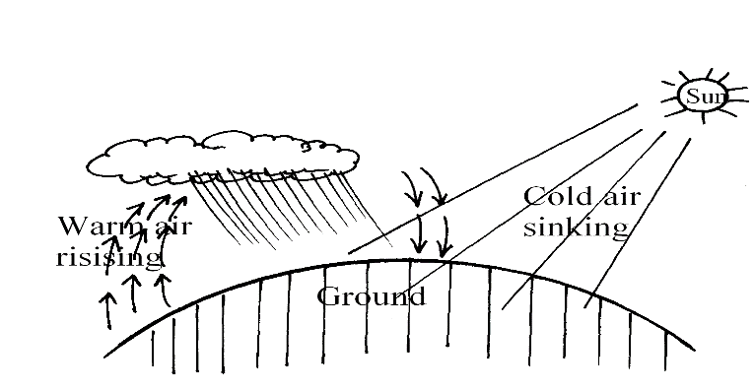
(i) Name the type of rainfall shown by this diagram. (1mk)
(ii) Name the type of cloud marked. (1mk)
(iii) List three weather conditions associated with the above named type of rainfall. (3mks)
(iv) Give two factors that influence rainfall. (2mks)
(c) (i) Define the term humidity. (2mks)
(ii) Name two types of humidity. (2mks)
(iii) Explain three roles of moisture in the atmosphere. (6mks)
(d) State three factors that influence air temperature. (3mks)

- (a)State three effects of the revolution of the Earth on its Orbit. (3mks)
(b)The diagram below shows the structure of the Earth. Use it to answer questions below:
- Name the parts marked P,Q and R (3mks)
- State three characteristics of the earth’s oceanic crust (sima) (3mks)
- State four proofs that the earth is spherical. (4mks)
(b) (i) Identify the shape of the earth. (2mks)
(ii) The time at Conakry (Guinea) 10º W is 10.00am. What is the time at Mogadishu 37ºE? (2mks)
(c) (i)Identify two types of high level clouds. (2mks)
(ii) Identify any three characteristics of troposphere. (3mks)

