CHEMISTRY FORM ONE
OPENER EXAM TERM 2 2023
NAME:_______________________________STREAM______DATE:__________

INSTRUCTIONS TO THE CANDIDATES:-

- Write your Name and Admission number in the spaces provided.
- Answer all the questions in the spaces provided.
- All working MUST be clearly shown where necessary.

For Examiner’s Use Only
Question | Maximum score | Candidate’s score
1-21 | 80

This paper consists of 12 printed pages. Candidates should check to ascertain that all pages are printed as indicated and that no questions are missing
1(a). Name one frequently abused drug (1mk)
__________________________________________________________________________________________________________________________________________________________________________________________________________________________________________
(b). State two long term effects of drug abuse. (2mks)
__________________________________________________________________________________________________________________________________________________________________________

2. (i). Define Chemistry. (1mk)
__________________________________________________________________________________________________________________________________________________________________________________________________________________________________________

(ii) Give two importance of studying Chemistry. (2mks)
__________________________________________________________________________________________________________________________________________________________________________________________________________________________________________

3(a). The following are laboratory apparatus used in Chemistry. Name them and give their uses.
Apparatus | Use
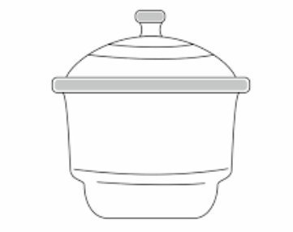 | 1mk
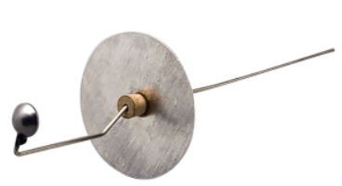 | 1mk

(b). Give two reasons why most laboratory apparatus are made of transparent glass.
(2mks)
__________________________________________________________________________________________________________________________________________________________________________________________________________________________________________
4.(i) What is a flame? (1mk)
_________________________________________________________________________________________________________________________________________________________________________________________________________________________
_________________

(ii). The following diagram represent a type of flame produced by a Bunsen burner.

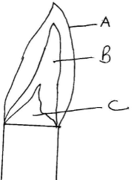

- Name the type of flame 1mk
_____________________________________________________________________________________________________________________________________________________________________________________________________________________________________________
(b). The flame should be put off immediately after use or adjusted to another type of flame. Explain (2mks)
__________________________________________________________________________________________________________________________________________________________________________________________________________________________________________

(iii). A wooden splint slipped through region B of the above flame laboratory. The splint was burnt as shown in the diagram below.
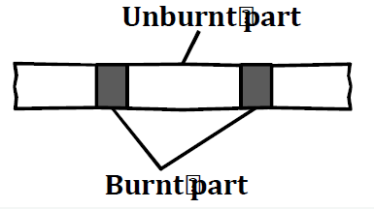

Explain why the splint was burnt the way it is shown in the diagram. (2mk
_____________________________________________________________________________________________________________________________________________________________________________________________________________________________________________

5. Heating solids in a test tube of boiling tube is part of the task a learner is supposed to undertake in a given class experiment. Explain the two precautions a learner should observe
(2mks)
_____________________________________________________________________________________________________________________________________________________________________________________________________________________________________________
6. a) What is a mixture? (2mks)
_____________________________________________________________________________________________________________________________________________________________________________________________________________________________________________

b) State two physical means of separating a mixture. (2mks)
_____________________________________________________________________________________________________________________________________________________________________________________________________________________________________________

7. A form one student accidentally mixed sulphur and iron filings.
(a). Suggest an appropriate method of separation you would advise him to use to separate the mixture. (1mk)

(b). Give a reason for the choice of your answer. (1mk)
____________________________________________________________________________________________________________________________________________________________________________________________________________________________________________
- Describe how he would use the method named in a above 3mks
__________________________________________________________________________________________________________________________________________________________________________________________________________________________________________

8. (a). Name two substances that sublime when heated. (2mks)
_____________________________________________________________________________________________________________________________________________________________________________________________________________________________________________

(b). Give two reasons why dry ice (solid carbon (IV) oxide) is preferred to be used in cold boxes by ice cream vendor over ordinary ice. (2mks)
_____________________________________________________________________________________________________________________________________________________________________________________________________________________________________________
9. A form one student at wanted to separate and obtain iodine and sodium chloride (common table salt) from a mixture of the two. He set the experimental set up shown below.

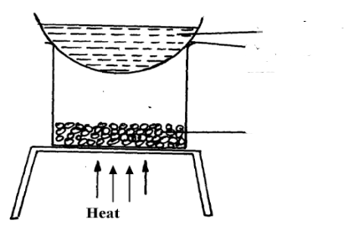
Mixture of salt and iodine
cold water
Watch glass

(a). The mixture was heated for some time and left to cool. On cooling, shiny black crystals and white crystals were observed on the surface of the watch glass and in the beaker respectively. Name:
I. Shiny black crystals (1mks)
____________________________________________________________________________________________________________________________________________________________
II. White crystals. (1mks)
__________________________________________________________________________________________________________________________________________________________________________

(b). What was the purpose of the cold water in the watch glass? (2mks)
____________________________________________________________________________________________________________________________________________________________

(c). Explain how the shiny black crystals on the surface of the watch glass is formed. (2mks)

____________________________________________________________________________________________________________________________________________________________

(d). What property of iodine makes it be collected on the watch glass as shown?
(1mk)
_____________________________________________________________________________________________________________________________________________________________________________________________________________________________________________

10. (a). Define the following terms:

- A saturated solution. (1mks)

_________________________________

- Crystallization. (1mks)
__________________________________________________________________________________________________________________________________________________________________
(b)(i). Describe how copper (II) sulphate crystals can be obtained from copper (II) sulphate solution. (3mks)

(ii). Give two industrial applications of crystallization as a method of separating soluble substances from their solutions. (2mks)
_____________________________________________________________________________________________________________________________________________________________________________________________________________________________

11. The following are hazard symbols were observed by a student in one of the stock bottle in chemistry laboratory. Identify the symbols
 | Symbol
A | 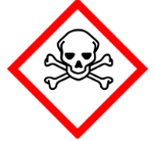 | 1mk
B | 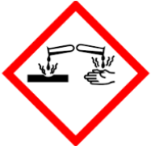 | 1mk

- State what students should do in case of a major accident such as fire outbreak in the chemistry laboratory (3mks)
____________________________________________________________________________________________________________________________________________________________________________________________________________________________________________________________________________________________________________________________________________________________________________________________________________________________________________________________________________________

- Give two differences between luminous and non luminous flames (2mks)
____________________________________________________________________________________________________________________________________________________________
- .Give the method used in separating the following mixtures (3mks
- Sand and water………………………………………………
- Petroleum fom crude oil………………
- Oil from groundnuts seeds………………………………

- a) Explain why water is not used as a solvent in extraction of nuts.
2mks
________________________________________________________________________________________________________________________________________________________

b).Name the solvent that is used in extraction of nuts.
1mk
________________________________________________________________________________________________________________________________________________________
- The following set up was used to separate sand and water .study it and answer the questions that follows.

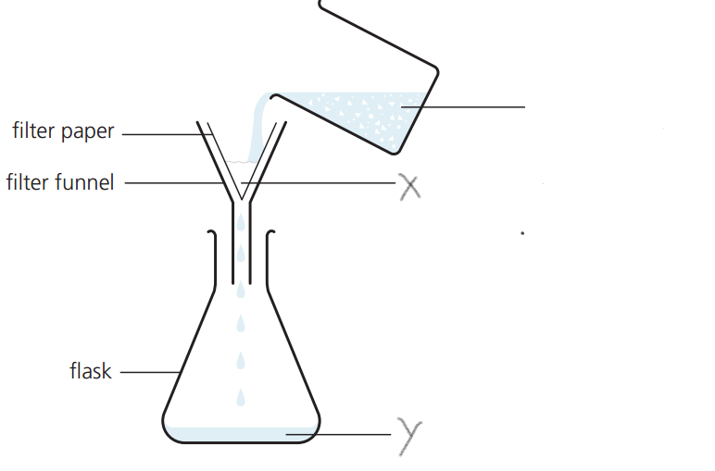

- Identify the method of separation.
1mk
- ____________________________________________________________________________________________________________________________________________________________
- Give a special name given to solid X and liquid Y. 2mks
____________________________________________________________________________________________________________________________________________________________
- State an advantage of this method over decantation. 1mk
__________________________________________________________________________________________________________________________________________________________________________

- State two major differences between those of solids and those of gases
(2mks)
_____________________________________________________________________________________________________________________________________________________________________________________________________________________________________________
- Salt is normally sprinkled on roads during winter in temperate countries
- State and explain why salt is put on roads during winter (2mks)
____________________________________________________________________________________________________________________________________________________________________________________________________________________________________________

- Why is this practice of great concern to motorist (1mk)
__________________________________________________________________________________________________________________________________________________________________

- Substance A is highly soluble in propane while B has low in propane.
- Which of the two substances will travel the shortest distance on an adsorbent material during paper chromatography? Explain 2mk
__________________________________________________________________________________________________________________________________________________________________

- Which other property determine the distance travelled by the substance? 1mk
____________________________________________________________________________________________________________________________________________________________
- What is chromatography? 1mk
__________________________________________________________________________________________________________________________________________________________________Give two applications of chromatography 1mk

20. The setup below was used to separate two miscible liquids Q and T
(Boling points; Q =98° C, T=78°C)

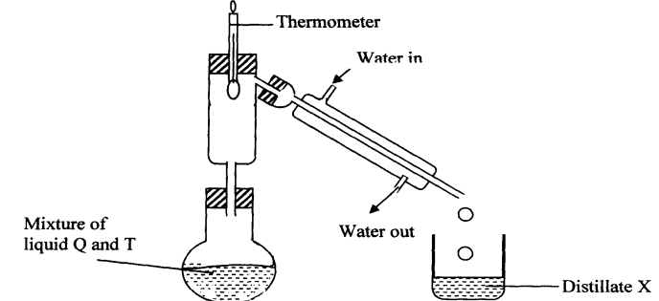

(a) Identify the mistakes in the setup above 2mk
__________________________________________________________________________________________________________________________________________________________________________
(b) Identify Distillate X 1mk
__________________________________________________________________________________________________________________________________________________________________________

21. The laboratory rules that should be applied to prevent the following accidents
- Mistaking hydrochloric acid to be distilled water 1mk
__________________________________________________________________________________________________________________________________________________________________b) A student got burnt after secretly lighting up a magnesium ribbon 1mk
__________________________________________________________________________________________________________________________________________________________________________ c) A student got severe stomach ache after eating some bread during chemistry laboratory session 1mk
_____________________________________________________________________________________________________________________________________________________________________________________________________________________________________________

