BIOLOGY FORM ONE
OPENER EXAM TERM 2 2023
NAME:_______________________________STREAM______DATE:__________

FOR EXAMINER’S USE ONLY

QUESTION | MAX. SCORE | CANDIDATE’S SCORE
1 - 24 | 80

This paper consists of 8 printed pages. Candidates should check the question paper to ascertain that all pages are printed as indicated and no questions are missing.

- i) Explain two main branches of Biology. (2mks)
………………………………………………………………………………………………………

………………………………………………………………………………………………………

- Name the cell organelle which would be abundant in: (2mks)
- Sperm cell:

………………………………………………………………………………………………………

- Pancreas:

………………………………………………………………………………………………………
- What is the name given to the study of; (3mks)

Fungi

………………………………………………………………………………………………………

Cells

………………………………………………………………………………………………………
Tissues

……………………………………………………………………………………………………..

- Give reason why each of the steps is followed when preparing a cross section of a leaf for examination under a microscope. (2mks)

- Cutting very thin sections

………………………………………………………………………………………………………

………………………………………………………………………………………………………

- Using sharp razor blade when cutting

………………………………………………………………………………………………………

………………………………………………………………………………………………………

- State three importance of osmosis in plants (3mks)

………………………………………………………………………………………………………

………………………………………………………………………………………………………

………………………………………………………………………………………………………

- a) Name the following apparatus used in specimen collection and for each, mention its function. (6mks)

Name | Apparatus | Function
 | 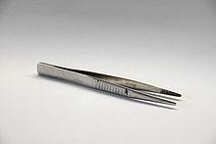
 | 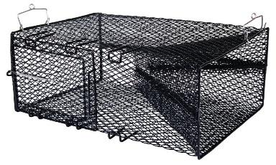
 | 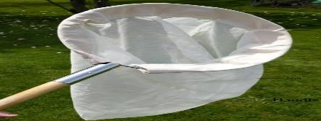

b.) State four precautions during collection and observation of specimen. (4mks)
………………………………………………………………………………………………………………
………………………………………………………………………………………………………………
…………………………………………………………………………………………………………
……………………………………………………………………………………………………………
- Differentiate between plants and animals in terms of nutrition. (2mks)

………………………………………………………………………………………………………

………………………………………………………………………………………………………

- Define the term species. (2mks)
………………………………………………………………………………………………………
………………………………………………………………………………………………………

- State three principles of binomial nomenclature (3mks)

………………………………………………………………………………………………………

………………………………………………………………………………………………………

- Name the tissue in plants responsible for.

- Transport of water and mineral salts. (1mk)

………………………………………………………………………………………………………

- Transport of synthesized food substances. (1mk)

………………………………………………………………………………………………………

- State the functions of the following cell organelles.

a) Golgi apparatus. (1mk)

………………………………………………………………………………………………………

b) Ribosomes (1mk)

………………………………………………………………………………………………………

- Lysosomes (1mk)

……………………………………………………………………………………………………..
- Name the organelle which carry out the following functions in a cell

- Transport of lipids (1mk)

…………………………………………………………………………………………………….

(b) Formation of cilia and flagella (1mk)

……………………………………………………………………………………………………..

- The table shows substances at different concentrations between sea-water and the cell sap of the root hair cells of sea weeds.

Substance | Iodine | Phosphorus | Potassium
Concentration in sea water | 20 | 50 | 33
Concentration in sea weed root hair cell | 40 | 42 | 21

- Name the process by which;

- The iodine molecules were absorbed by the root hair cell (1mk)
……………………………………………………………………………………………………
- The phosphorus molecules were absorbed by the root hair cell. (1mk)

……………………………………………………………………………………………………

- State four importance of studying Biology. (4mks)

………………………………………………………………………………………………………

………………………………………………………………………………………………………

………………………………………………………………………………………………………

………………………………………………………………………………………………………

- Give three properties of a cell membrane. (3mks)

……………………………………………………………………………………………………

……………………………………………………………………………………………………

……………………………………………………………………………………………………

- Explain three roles of diffusion in animals. (2mks)

…………………………………………………………………………………………………..

………………………………………………………………………………………………….

- The diagram below a red blood cell that was subjected to a certain treatment.

At start at the end of experiment
a) Account for shape of the cell at the end of the experiment. (2mks)
………………………………………………………………………………………………………
………………………………………………………………………………………………………

b) Draw a diagram to illustrate how a plant cell would appear if subjected to the same
treatment (1mk)

- Plant cells do not burst when immersed in distilled water. Explain (2mks)
………………………………………………………………………………………………………
………………………………………………………………………………………………………
- The following is a diagram of a light microscope.
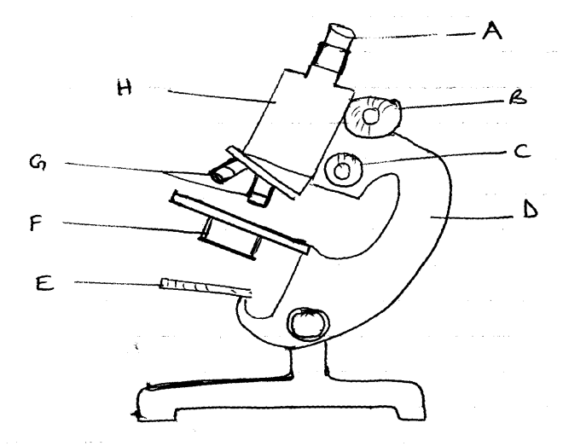

a) Name the parts labeled A, B, C, D and E. (5mks)
A…………………………………………………………………………………………….
B…………………………………………………………………………………………….
C…………………………………………………………………………………………….
D…………………………………………………………………………………………….
E…………………………………………………………………………………………….
b) State the functions of parts labeled F and G (2mks)
F ……………………………………………………………………………….………………

G …………………………………………………………………………………………
c. ) State the formular for calculating magnification in a Light Microscope. (1mk)

- Name the organelle that Contains enzymes that are capable of destroying old damaged cell. (1mk)
………………………………………………………………………………………………………………
21. The scientific name for beans is Phaseolus vulgaris
a) What taxa does the term Phaseolus represent (1mk)
………………………………………………………………………………………………………
b) State two rules that are followed when giving a scientific name to an organism (2mks)
……………………………………………………………………………………………………
………………………………………………………………………………………………………
. 23. List four careers that require knowledge in biology (4mks) ………………………………………………………………………………………………………………………………………………………………………………………………………………………………………………………………………………………………………………………………………………………………………………………………………………………………
24. Classify the following organisms into their kingdoms (4mks)
Organisms Kingdom
a) Maize,Beans ………………………………………..
b) Mushrooms,Yeast ……………………………………….
c) Protozoa, algae ……………………………………
d) Bacteria ……………………………………….

