BIOLOGY FORM 2
OPENER EXAM TERM 2 2023
NAME:_______________________________STREAM______DATE:__________SCHOOL _________________________________________________________

INSTRUCTIONS
- All Questions are Compulsory
- Write your Answers in the Spaces Provided
- Wrong Spelling of Technical Terms shall be Penalized

Max  Score | Student’s Score
80

- State the functions of the following vacuoles (2mks
i) Sap vacuole
………………………………………………………………………………………………
ii) Contractile vacuole
………………………………………………………………………………………………

- a) State TWO reasons why in experiments to study photosynthesis, plants are placed near source of light (2mks
………………………………………………………………………………………………………………………………………………………………………………………………………………………………………………………………………………………………
b) Explain how photosynthesis helps to ensure proper balance of components of air in the atmosphere (2mks
………………………………………………………………………………………………………………………………………………………………………………………………

- The following are photomicrographs of organelles from a living cell
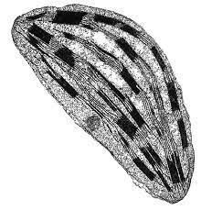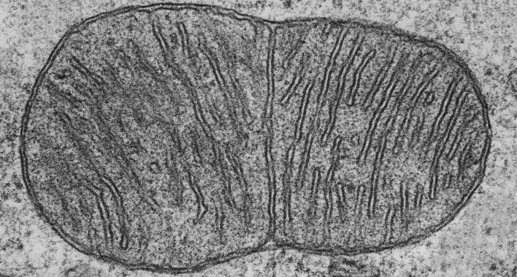
P
Q
- Identify organelle Q ………………………………………………………… (1mk
- Which letter represent an organelle that is abundant in the following cells: (2mks
i) Muscle …………………………………………………………………………
ii) Palisade………………………………………………………………………..
- How is organelle P important to metabolic reactions in organelle Q? (2mks
……………………………………………………………………………………………………………………………………………………………………………………

- Use the diagram shown below to answer questions that follow
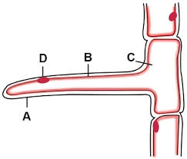
- Name the specialized cell shown above (1mk
…………………………………………………………………………………………
- How do the following help the cell in its functions? (2mks
i) Components of part C
…………………………………………………………………………………………
ii) Part A being elongated
…………………………………………………………………………………………

- The appearance of a plant cell after being placed in Solution Q is as shown below
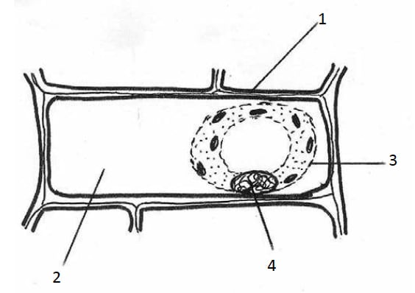
- Solution Q was later found in part 2. Name the process that allowed its entry? (1mk
…………………………………………………………………………………………
- Account for the appearance of the cell (3mks
………………………………………………………………………………………………………………………………………………………………………………………………………………………………………………………………………………
- Explain how the cell shown can be made to resume its normal appearance (1mk
……………………………………………………………………………………………………………………………………………………………………………………

- Identify the functions of a light microscope as shown by the following diagrams (2mks

- Function …………………………………

- Function …………………………………..

- The following is a cross-section of part of a plant
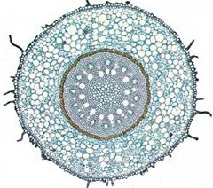
Samwel observed that this diagram represents a monocot root. Give a reason why
i) It is a root (1mk
…………………………………………………………………………………………
ii) It is from a monocot plant (1mk
…………………………………………………………………………………………

- a) Outile TWO properties of the plasma membrane
………………………………………………………………………………………………………………………………………………………………………………………..(2mks
- Arrange the following from the most complex to the simplest: Organ, Organism, Cell, Organ system, Organelle, Tissue (1mk
……………………………………………………………………………………………………………………………………………………………………………………

- Give TWO functions of Hydrochloric acid in the stomach (2mks
………………………………………………………………………………………………………………………………………………………………………………………………
- The experimental set up shown below was left to stand for 1 hour
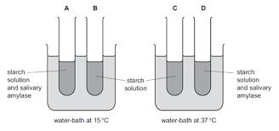
- What was the aim of the experiment? (1mk
…………………………………………………………………………………………
- Which two test tubes acted as control experiments? (1mk
…………………………………………………………………………………………
- Account for the results when Iodine test is carried out on test tube D (2mks
………………………………………………………………………………………………………………………………………………………………………………………………………………………………………………………………………………

- The following are patterns of lignification of a tissue found in flowering plants
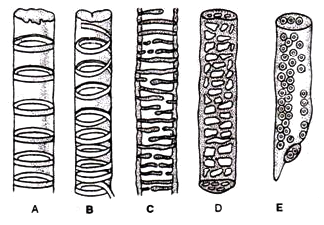
- Identify the patterns labelled i) A ………………………………...…………(1mk
ii) C ………………………………...…………(1mk
- Give a non-transport function of the tissues shown above? (1mk
…………………………………………………………………………………………
- Give TWO adaptations of the tissues above to their transport function (2mks
……………………………………………………………………………………………………………………………………………………………………………………
- An experiment was carried out as shown below to study enzymatic reactions. After 30minutes, Biuret’s test was carried out on contents of each test tube to get results. Fill in the table below to offer explanation for the results obtained (4mks
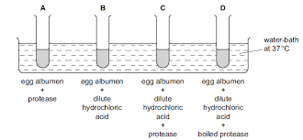
Test Tube | Result | Explanation
C | Blue
D | Purple

- Explain the following (4mks
- The stomach lining is made of protein but is not digested by protein-digesting enzymes
……………………………………………………………………………………………………………………………………………………………………………………
- Digestion of starch does not continue in the stomach
……………………………………………………………………………………………………………………………………………………………………………………
- One easily suffers nose bleeding when climbing mountain
……………………………………………………………………………………………………………………………………………………………………………………
- A camel can stay for 60 days without drinking water
……………………………………………………………………………………………………………………………………………………………………………………

- Give functions of each component of saliva (3mks
………………………………………………………………………………………………………………………………………………………………………………………………………………………………………………………………………………………………
- The following set up was placed in the sunshine for 1 hour to study a physiological process
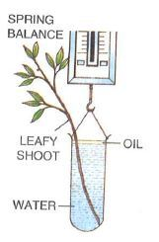
- What was the role of oil in the set up? (1mk
………………………………………………………………………………………………………………………………………………………………………………………………
- Account for observation made after 1 hour (2mks
………………………………………………………………………………………………………………………………………………………………………………………………

- Distinguish between Systemic circulation and Pulmonary circulation (2mks
………………………………………………………………………………………………………………………………………………………………………………………………………………………………………………………………………………………………

- How do the following factors increase rate of diffusion? (2mks
- Larger surface area to volume ratio
………………………………………………………………………………………………………………………………………………………………………………………………
- High temperature
………………………………………………………………………………………………………………………………………………………………………………………………
- Use the structure shown below to answer questions that follow
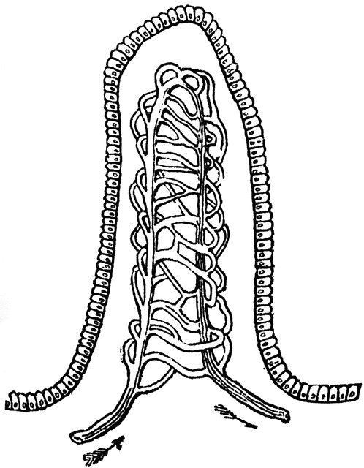
G
- Give the name and function of the structure shown above (2mks
Name………………………………………………………………………………………
Function……………………………………………………………………………………
- How does part G adapt the structure to its function? (1mk
………………………………………………………………………………………………

- State the importance of the following parts to the functioning of the heart (2mks
- Interventricular septum
………………………………………………………………………………………………………………………………………………………………………………………………
- Tricuspid valves
………………………………………………………………………………………………………………………………………………………………………………………………

- Give THREE importance of transpiration to plants (3mks
………………………………………………………………………………………………………………………………………………………………………………………………………………………………………………………………………………………………………………………………………………………………………………………………

- The diagram below shows onion cells in a field of view of a light microscope
X400
Using the dark line as diameter of field of view, determine the actual diameter of one cell
………………………………………………………………………………………………………………………………………………………………………………………………………………………………………………………………………………………………………………………………………………………………………………..………(4mks

- Why do the following have a higher energy demand? (2mks
- Children
………………………………………………………………………………………………………………………………………………………………………………………………
- Males
………………………………………………………………………………………………………………………………………………………………………………………………

- a) Name the following that are required during the process of blood clotting (2mks
i) Mineral Ion ………………………………………………………………………………
ii) Vitamin ………………………………………………………………………………….
b) State TWO ways in which blood clotting is important to the human body (2mks
………………………………………………………………………………………………………………………………………………………………………………………………………………………………………………………………………………………………………………………………………………………………………………………………
- Use the diagram shown to answer the questions that follow
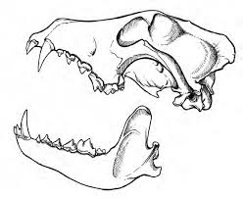
- Identify the mode of feeding for the animal with the dentition shown above (1mk
………………………………………………………………………………………………
- Why do such animals with the dentition shown have a shorter alimentary canal?
……………………………………………………………………………………………………………………………………………………………………………………….(2mks
- Consider the set ups shown below where B and D are results of the experiment A and C respectively which had been placed in the sunshine for 3 hours
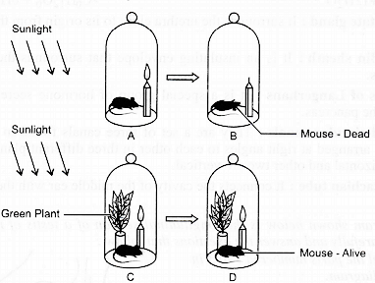
Explain why:
i) The Mouse died in B (2mks
……………………………………………………………………………………………………………………………………………………………………………………
ii) The Mouse was alive in D (2mks
……………………………………………………………………………………………………………………………………………………………………………………

