NAME…………………………..…………………ADM NO……………..…..CLASS…………
232/3
PHYSICS
PAPER 3
END OF TERM 1 EXAM 2023
TIME: 2 $\frac{1}{2}$HOURS.

Instructions to candidates
- Write your name and admission number in the space provided above
- Answer all questions on the question paper
- You are supposed to spend the first 15 minutes allowed for this paper reading the whole paper carefully before commencing your work and confirming your apparatus.
- Marks are given for a clear record of the observations actually made, (or their suitability and accuracy and or the use made of them)
- Candidates are advised to record observations as soon as they are made.
- Mathematical tables or electrical calculators may be used
- Candidates should answer all the questions in English
For examiner use only.
Question | Maximum | Candidates score
1 | 20
2 | 20
Total | 40

QUESTION 1
You are provided with following apparatus
- A pendulum bob
- A cotton thread about1m long
- A retort stand and clamp
- A metre rule
- A stopwatch
- Two pieces of wood
- Vernier calipers(to be shared)
Proceed as follows
- Using the vernier calipers measure the diameter of the pendulum bob. (1mk)

…………………………cm

- Clamp the pendulum as shown starting with L=80cm

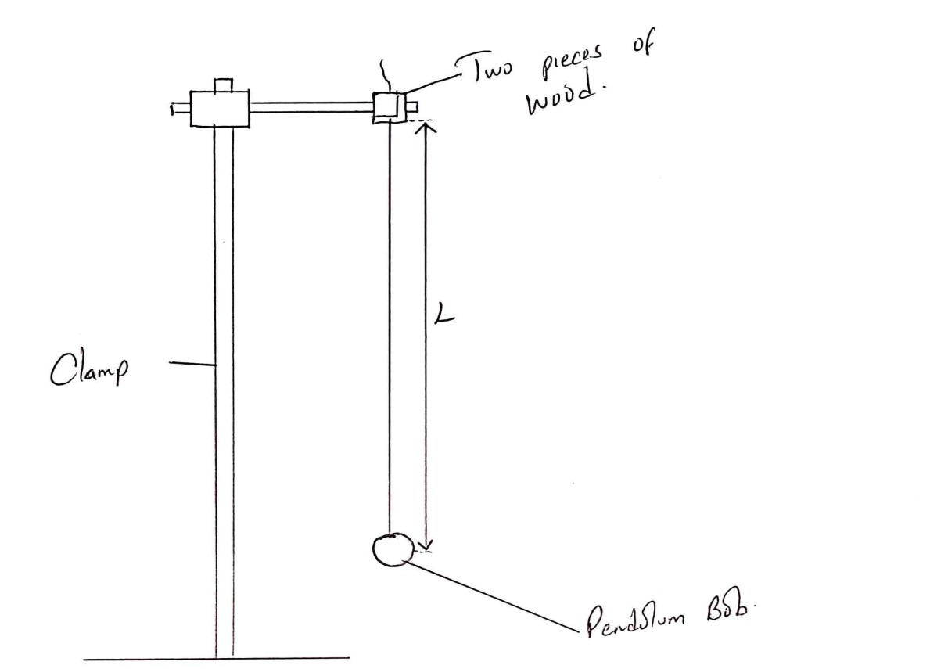
Figure 1

- Give the bob a small displacement and record the time t for 20 complete oscillations. Record also periodic time T for one complete oscillation.

- Repeat the procedure above for values of L as shown in the table. Record and complete the table.(8marks)
Length L (cm) | L (m) | Time for 20 oscillations | Period T | (T²)  (s²)
80
70
60
50
40
30
20

- Plot the graph of T² against L(m)(5marks)

- Determine the slope of the graph(3marks)

- The equation for the graph is given by T² = $\frac{4π^{2}L}{g}$ where g is a constant. From the graph find the value of g.(2marks)

- What is the significance of g.(1mark)

QUESTION 2
APPARATUS
- concave mirror
- lens holder
- screen
- candle
- proceed as follows;

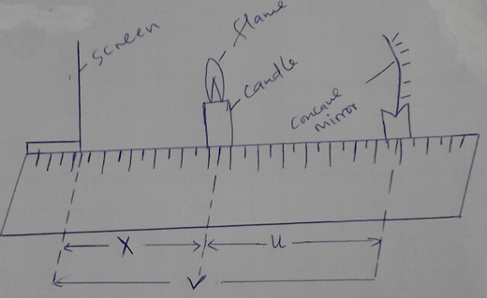
Figure 2
Procedure
- Set the apparatus as shown in figure 2
- Place the candle at a distance x=5.0 cm from the screen
- Move the mirror to and fro to focus a clear; sharp image of the candle on the screen
- Measure and record the distance u between the mirror and the candle and the distance v between the screen and the mirror.
- Repeat the experiment for other values of x and complete the table below (8MKS)

x (cm) | 5.0 | 10.0 | 15.0 | 20.0 | 25.0 | 30.0
u (cm)
v (cm)
( u + v)
(cm)
uv (cm)

Vi) Draw a graph of ( u + v) cm against u v (cm) (5MKS)

Vii) Determine the slope S of the graph 3mks
……………………………………………………………………………………………………………………………………………………………………………………………………………………………………………………………………………………………………………………………………………………………………………………………………………………………………………………………………………………………………………………………
viii) Using the value of S obtained above in (viii); determine the value of f, the focal length of the mirror, 2mks
………………………………………………………………………………………………………………………………………………………………………………………………………………………………………………………………………………………………………………………………………………………………………………………………………………………………………………………………………………………………………………………………………………………………………………….
Given that R = 4f/s² 2mks
………………………………………………………………………………………………………………………………………………………………………………………………………………………………………………………………………………………………………………………………………………………………………………………………

