NAME: ………………………………… ADM NO: ………… CLASS: …………
312/1
GEOGRAPHY
PAPER 1
FORM THREE
TIME: 2 ¾ HOURS

INSTRUCTIONS TO CANDIDATES:
- This paper consists of three sections; A, B and C.
- Answer all questions from section A and B.
- In section C, answer any three questions. All answers must be written on the answer sheets provided.

SECTION A:
Answer all the questions in this section.

1. (a) Name two types of earth movements. (2 mks)

(b) The diagram below represents tectonic plate boundary. Name the areas marked S, T and U.
(3 mks)
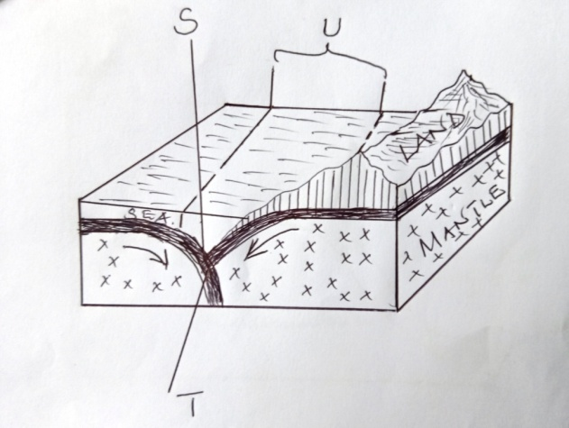

2. (a) Differentiate between seismic focus and epicenter. (2 mks)

(b) State two ways through which a river transports its load. (2 mks)

3. (a) Apart from exfoliation, name two other physical weathering processes influenced by
temperature changes. (2 mks)

(b) Describe exfoliation process. (4 mks)

4. (a) State two ways through which a river transports its load. (2 mks)

(b) State three conditions necessary for the formation of a delta. (3 mks)

5. (a) The diagram below shows a process of slow mass wasting.
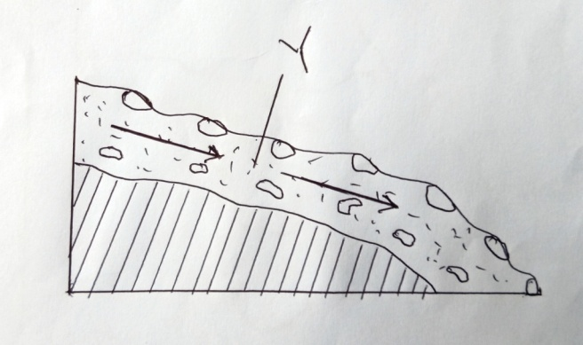
(i) Identify the process. (1 mk)

(ii) Name the feature marked Y. (1 mk)

(b) State three conditions which may influence occurrence of landslides. (3 mks)

STUDY THE MAP OF YIMBO (1:50,000 SHEET 115/1) provided and answer the following questions
6. (a) (i) Name two natural features found in grid square 3696. (2 mks)

(ii) Give two types of scales used on Yimbo map. (2 mks)

(iii) Give the six figure grid reference of the trigonometrical station point 1207 (115 1 27) (2 mks)
(b) (i) Give the adjoining sheet found to the North-east of Yimbo map . (1 mk)

(ii) Give the latitudinal and longitudinal extent of the area covered by the map extract.
(2 mks)
(c) Identify three types of natural vegetation in the area covered by the map. (3 mks)

(d) (i) Give three methods used to show relief in the area covered by the map. (3 mks)

(ii) Give the height of the highest and the lowest points on the map. (2 mks)

(e) You are required to carry out a field study on economic activities carried out in the area
covered by the map.
(i) Outline the ways in which you will pr e pare before the study. (5 mks)

(ii) List the activities you will be involved in during the study. (3 mks)

7. (a) (i) What is fog? (2 mks)

(ii) State two conditions necessary for the formation of fog. (2 mks)

(b) With the aid of a labeled diagram, describe how relief rainfall is formed. (7 mks)

(c) Use the map of Africa below to answer the questions that follow.
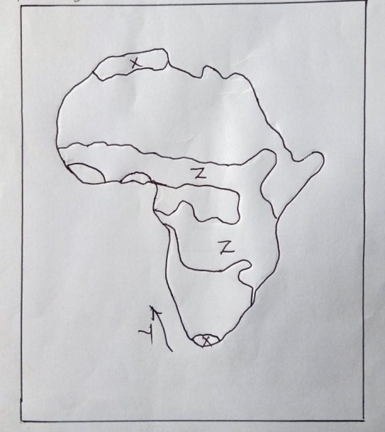
(i) Name, the type of climate experienced in the region marked X. (1 mk)

The ocean current marked Y. (1 mk)
(ii) Describe the characteristics of the type of climate found in the area marked Z. (6 mks)

(d) Suppose your class carried out a field study on weather around the school environment;
(i) Explain two effects of wind on climate that they are likely to have identified.
(2 mks)
(ii) Give two methods the class used to collect data in the field. (2 mks)

(iii) Give two follow-up activities the class was involved in after the field study. (2 mks)
8. (a) Distinguish between magma and Lava. (2 mks)

(b) The diagram below shows intrusive volcanic landforms. Use it to answer the questions that
follow.
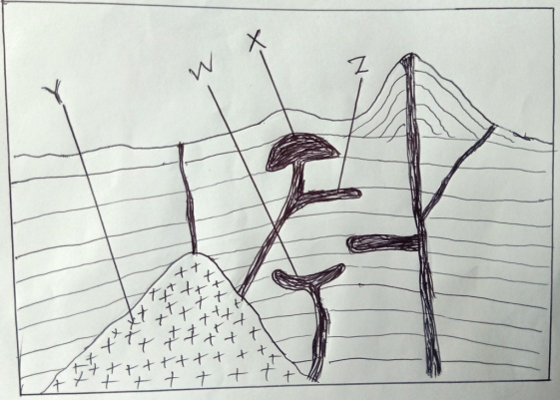
(i) Name the features marked W, X and Y. (3 mks)

(ii) Describe how feature Z is formed (4 mks)

(c) (i) Name two features that result from fissure eruption. (2 mks)

(ii) List two types of lava. (2 mks)

(d) (i) Describe how a composite volcano is formed. (6 mks)

(ii) Explain the significance of volcanic features to human activities. (6 mks)

9. (a) (i) Define Secondary Vegetation. (2 mks)

(ii) State three climatic factors which influence the distribution and type of vegetation.
(3 mks)
(iii) Give three uses of mangrove trees. (3 mks)

(b) The diagram below represents zones of natural vegetation on a mountain slope. Use it to
answer the questions that follow.
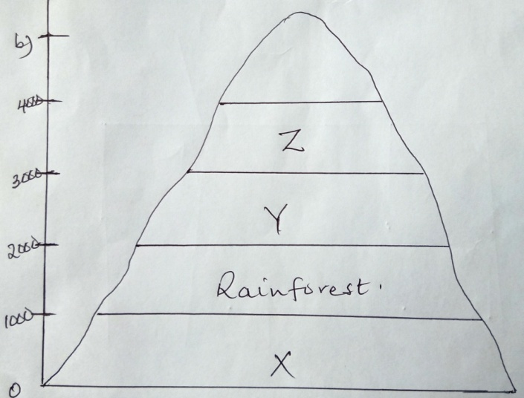
(i) Name the vegetation zones marked X, Y and Z. (3 mks)

(ii) Describe the characteristics of the rainforest vegetation. (6 mks)

(c) You are required to carry out a field study on natural vegetation within your local
environment.
(i) Give three types of information for your study. (3 mks)

(ii) State three way s you would do to identify the different types of plants. (3 mks)

(iii) State two ways in which the information collected during the study would be useful to
the local community. (2 mks)
10. (a) (i) Define the term Ocean. (2 mks)

(ii) State three sources of salt in ocean water. (3 mks)

(iii) State three factors which determine the temperature of the ocean water. (3 mks)

(b) (i) Describe three processes of wave erosion. (6 mks)

(ii) Name five features resulting from wave erosion. (5 mks)

(c) Your class is required to carry out a field study on wave erosion along the Kenyan coastline.

(i) Why would you need to carry the following?
A mosquito net. (1 mk)

Light clothes (1 mk)

(ii) Explain reasons why you think your study will be important to the government of Kenya.
(3 mks)

