NAME:…………………………………………………………………………………...…………
SCHOOL:…………………………………………………………………………………………..
A.D.M NO:……………………………………….. DATE:………………………………………
SIGNATURE:……………………………………

442/2
AGRICULTURE
PAPER 2
SECTION A

1. State four preparation practices carried out in a store before crop produce is brought in for storage (2mks)

2 Give problems associated with mineral deficiency imbalance in livestock (2mks)

3. State four factors that lowers the performance of an animal (2mks)

4. State one use of the following farm tools (2mks)
(a) Pipe wrench

(b) Sickle

(c) Slasher

(d) Tin snip

5. Explain briefly four factors that affect maintenance ration requirement of an animal
(2mks)

6. Give four factors considered when selecting dairy goat (2mks)

7. State four features for inbreeding (2mks)

8. Define cross breeding in livestock production

9. Name four meat breeds of rabbit (2mks)

10. State the gestation period of the following animals (1mk)

Saw -

Cattle -

11. Outline four characteristic that enable camels to survive in desert (2mks)

12. Name two commercial feeds fed to layers (1mk)

13. (a) What organic causes Newcastle disease in birds (2mks)

(b) State four specific symptoms of Newcastle disease (2mks)

(c) Give 2 methods of controlling the disease (1mk)

14. Give two feeding characteristics of goats which make them less vulnerable to internal
Parasite (2mks)

15. Give two characteristics of roughages (1mk)

16. Mention two methods of preventing rusting in farm tools (2mks)

SECTION B 20 MARKS

17. The diagram below represents a method of ration computation. Study and answer the
questions that follows
16%

(a) Identify the method above (1mk)

(b) In a practical lesson form three student of agriculture were supplied with the following specimens
(i) crushed marshed labeled I
(ii) Bloodmeal labeled J
Calculate the quantity of the specimen I (8% DCP) and J 28% DCP) that can be mixed to make 150 kg of feed containing 16% DCP (4mks)

18. The diagram below illustrate external parasite study the diagram and answer the question that follow

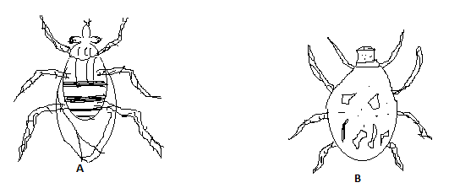
(a) Identify the two parasite labeled AB (2mks)

A

B

(b) Name one disease tramsimitted by A and B (2mks)

A

B

(c) Name the class of chemicals used to spray and control parasite Aand B (2mks)

A

B

(d) Mention two harmful effect of parasites A and B in livestock production apart from disease transmission (2mks)

A

B

SECTION C

19. (a) Describe the desirable features of a grain store (10mks)
(b) Describe the importance of keeping healthy animal (10mks)

20. Describe the process of egg formation in poultry production with an aid of a diagram (20mks)

21. (a) Define parasite as it applies in livestock management stating animals mostly
affected (4mks)
(b) What economic importance are parasite to livestock (10mks)
(c) Give 3 examples of internal and external parasite (6mks)

22. Diagram A, B, C, and D illustrate some farm tools and equipments

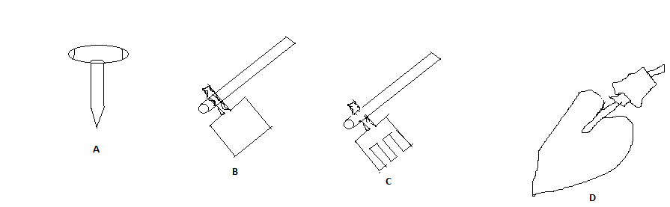

- Give their names (2mks)
A

B

C

D
- Give one function of each tools (2mks)
A
B

C

D
- Classify each tools in appropriate category (2mks)
A

B

C

D

- State one appropriate maintenance that can be done on tool A (1mk)

