NAME…………………………………………………. CLASS……….. ADM NO……………………..

**MATHEMATICS**

**FORM FOUR**

**MIDTERM ONE 2023**

**Time: 21/2 Hours**

***ANSWER ALL THE QUESTIONS IN THE SPACES PROVIDED***

1. Use logarithms to evaluate :  ( 4mks)

2 A sales man gets a commission of 2.5 % on sales up to sh. 100000. He gets an additional commission of 1.6 % on sales above this. Calculate the commission he gets on sales worth sh. 3200000 ( 3mks)

1. Make P the subject of the formula ( 3mks)

w = 

1. Solve the equation 6X2-13x+6=0 . Using the completing the square method. (2mks)
2. Brian and Bonface working together can do a piece of work in 6 days. Bonface working a lone would take 10 days to complete the work. They start working together but after 4 days Bonface leaves and the remaining work is done by Brian. Find how long Brian takes to complete the remaining work. ( 3mks)
3. Two variables M and N are such that M varies partly as N and Partly as the square root of N. given that N = 16 when M = 500 and N = 25 when M = 800. Find the equation connecting M and N ( 3mks)
4. Given log3 = 0.4771 and log 5 = 0.6990, find without using tables or a calculator:

log 0.045. (3mks)

1. A certain sum of money put to compound interest amounts to sh.5600 at the end of the first year. The interest added at the end of the second year is sh. 672 calculate the rate p.a and the sum invested. (3mks)
2. Using compass and ruler only construct a triangle Arc such that AB= 6cm ,BC = 5cm and angle

ABC = 67.5ᵒ measure the length of AC ( 4mks)

1. Find the constant term in the expansion  ( 3mks)
2. A tuktuk taxi travelling at 20m/s accelerates uniformly and in 4 seconds, its velocity is 30m/s. it maintains this velocity for another 5 seconds before decelerating uniformly to rest after 3 seconds. calculate the total distance travelled by the tuktuk during the journey. (3mks)
3. 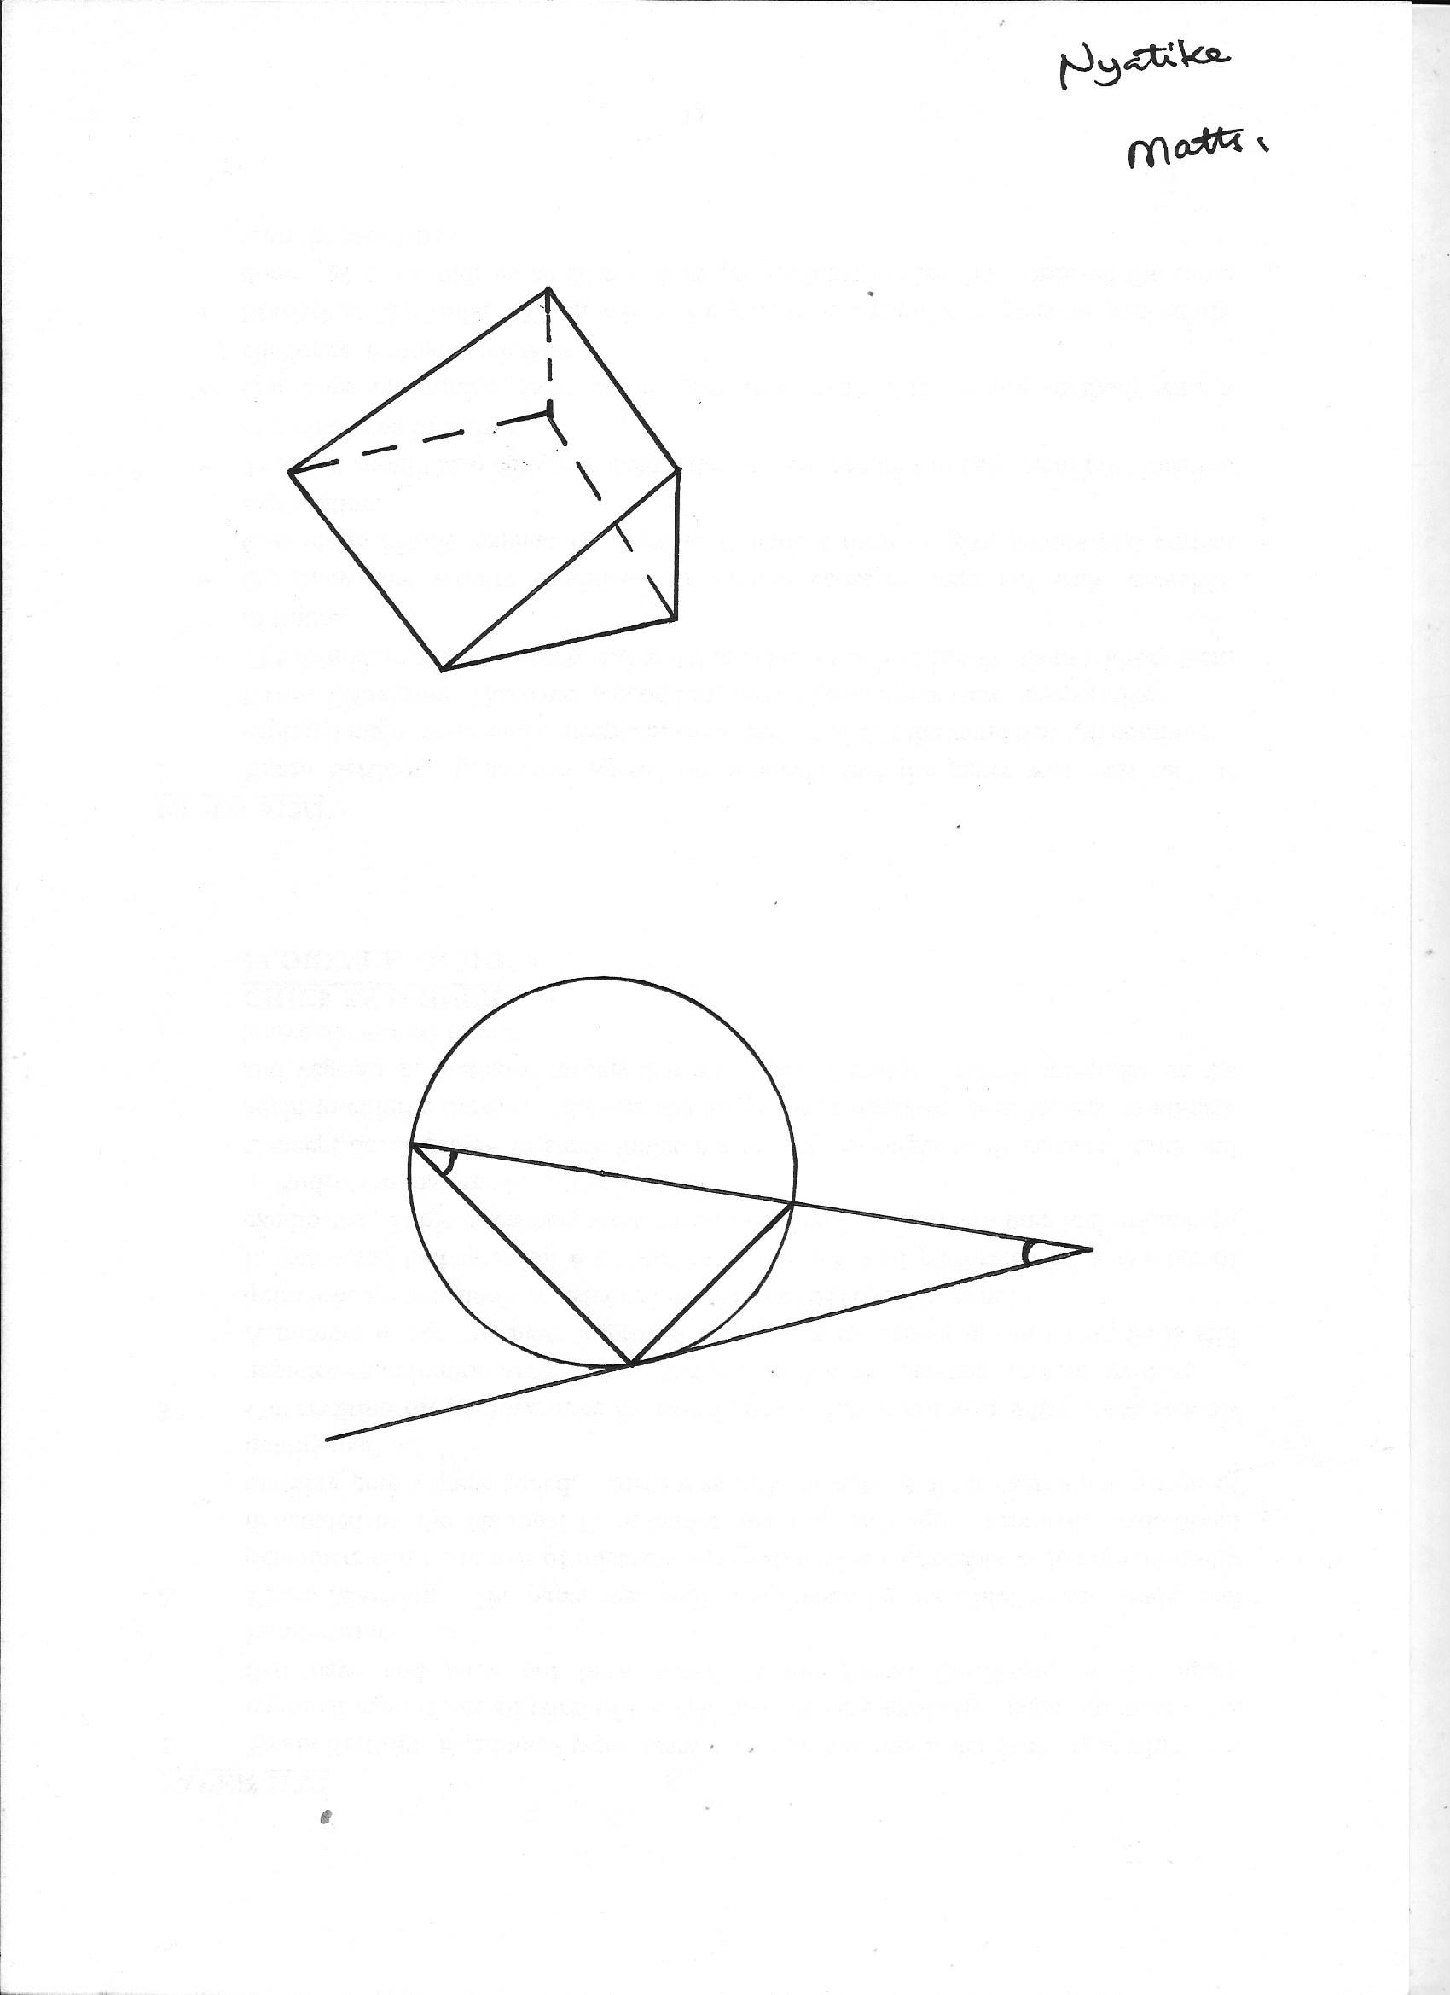 In the figure below, AB X is a tangent . Angle CAB = 17ᵒ and angle ACB = 36ᵒ calculate the size of angle BDC (3mks)

**C**

**36o**

**D**

**A**

**B**

**X**

1. Find  given that y═  ( 3mks)
2. The perimeter of a triangular field is 120m. two of the sides measures 21m and 40m. calculate the size of the largest angle of the field. (3mks)
3. Solve for x: 2 2x + 3 - 9 (2x) + 1 = 0 ( 3mks)
4. Peters joined a firm with a commencing salary of 20,000 per month with an annual increment of 10%. How much did he receive per month during the seventh year. (3mks)

**Section B (answer all questions in this section)**

1. Kamau, Njoroge and Kariuki are practicing archery. The probability for Kamau hitting the

target is $\frac{2}{5}$, that of Njoroge hitting the target is $\frac{1}{4}$ and that of Kariuki hitting the target is $\frac{3}{7}$.

Find the probability that in one attempt;

1. Only one hits the target (2mks)

b) All three hit the target (2mks)

c) None of them hits the target (2mks)

d) Two hit the target (2mks)

e) At least one hits the target (2mks)

1. Two points P and Q are found on the earth’s surface the position of P is ( 52oS, 66oW) and Q ( 52oS,114oE). Taking earth’s radius as 6370km,

(a) find the difference in longitude between the two points P and Q (1mk)

(b) calculate the shortest distance between points P and Q along

(i) the parallel of latitutde in km (3mk)

(ii) along the great circle in Km ( 3mks)

1. A plane travelling at 800km/hr leaves point P At 10.00am and sais through south pole to point q. Find the local time the plane arrives at point Q to the nearest minute. (3mks)
2. The distance S meters from a fixed point O, covered by a particle after t seconds B given by the equation S = t3 – 6t2 + 9t + 5

(a) Calculate the gradient of the curve at t = 0.5 seconds (3mks)

(b) Determine the values of S at the turning points of the curve ( 3mks)

(c) Sketch the curve in the space provided. (4mks )

20. (a) Use trapezium rule with 8 strips to find the area bounded by the curve y = x ² + 2 and the x – axis,

x = -2 and x = 2 (5mks)

(b) Calculate the actual area in (a) above Hence find the percentage error in the area. (5mks)

21. A triangle has vertices at A(1,2), B(-2,4) and C(3,5)

a) Plot the triangle on the grid provided (1mk)

b) Triangle ABC is mapped onto triangle A1B1C1 by a transformation given by M= $\left(\begin{aligned}-1 1 \\ 0 1\end{aligned}\right)$

State the co-ordinates of triangle A1B1C1 on the same grid plot triangle A1B1C1 (3mks)

c) Triangle A11B11C1**1** is the image of triangle A1B1C1 under a reflection on the line y = 0.

Plot the triangle A**1**1B11C11 and state its co-ordinates (2mks)

d) Triangle A11B11C11 is further rotated through -90 $°$ about (0,0) to obtain triangle

A111B111C111. Plot the triangle A111B111C111 state its coordinates.

(2mks)