NAME: ……………………………………. ADM NO: ………… CLASS: ……….

FORM 2
GEOGRAPHY
MID TERM EXAMS
TERM 1 2023
TIME: 1 HOUR 15 MINUTES

1. (a) Name the two types of earth movements. (2 mks)

(b) State four causes of earth movements. (4 mks)

2. (a) Describe the continental drift theory. (7 mks)

(b) Name three landforms that may form along the extension boundaries. (3 mks)

3. (a) Give five characteristics of the earths moon. (5 mks)

(b) Give two effects of the revolution of the earth. (2 mks)

4. (a) Identify three types of folds. (3 mks)

(b) Outline three factors which determine the formation of features by folding.

(3 mks)

5. (a) Explain three ways in which faulting occurs. (3 mks)

(b) Use the diagram below to answer the questions that follow.

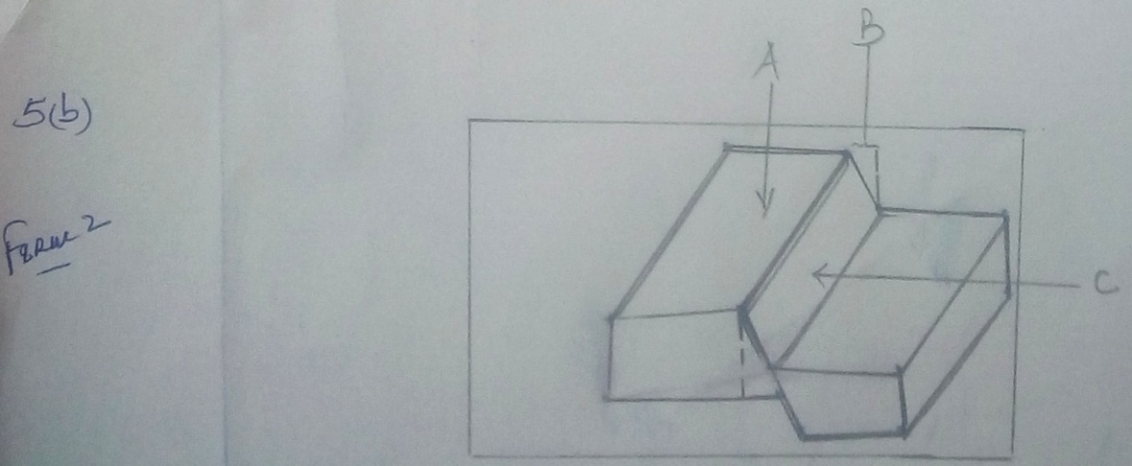

S(i) Name the features marked A, B and C. (3 mks)
A -

B –

C –

(ii) Apart from feature C, identify three other features of faulting. (3 mks)

6. (a) Apart from rainfall, name three other forms of precipitation. (3 mks)

(b) Describe how orographic rainfall is formed. (6 mks)

(c) Give three factors which influence distribution of atmospheric pressure on the surface
of the earth. (3 mks)

