NAME: ……………………………………. ADM NO: …………CLASS: ………….
FORM 3
BIOLOGY
MID TERM EXAMS
TERM 1 YEAR 2023
TIME: 2 HOURS

Answer all the questions in the spaces provided.

1. Name three tissues in plants that provide mechanical support. (3 mks)

2. State the mode of feeding of lion in the food web. (1 mk)

3. Name the fluid that is produced by sebaceous glands. (1 mk)

4. Name the end product of light stage in photosynthesis. (2 mks)

5. Name four ways in which respiratory surfaces are suited to their function.(4 mks)

6. Distinguish between diffusion and osmosis. (2 mks)

7. An experiment was set up as shown below. Study it and answer the questions that follow.

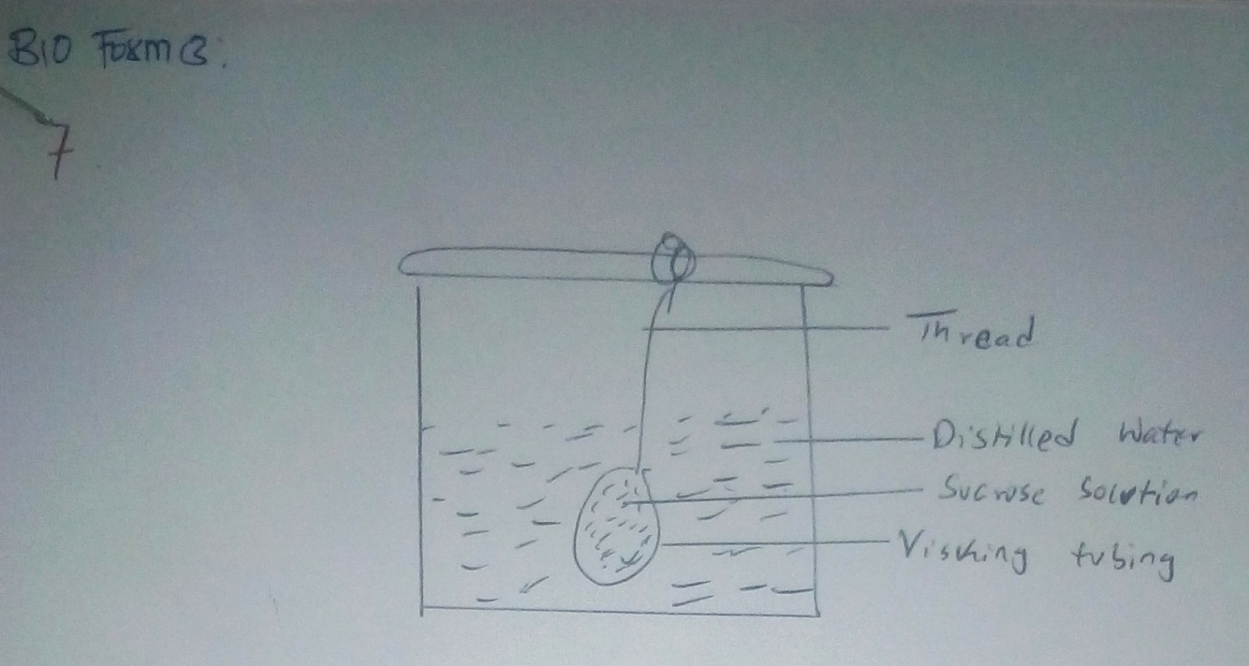

(i) The set up was left for 20 minutes. State the expected results. (1 mk)

(ii) Explain your answer in (i) above. (2 mks)

8. Give the function of the following cell organelle. (1 mk)
(i) Ribosome –

(ii) Lysosome - (2 mks)

9. Name the type of carbohydrates (polysaccharides) found in the following parts of living
organisms.
(i) In the exoskeleton of arthropods

(ii) In the xylem vessels –

(iii) In the animals blood –

10. The diagram below represents a transverse section through a plant organ. Study it and
answer the questions that follow.

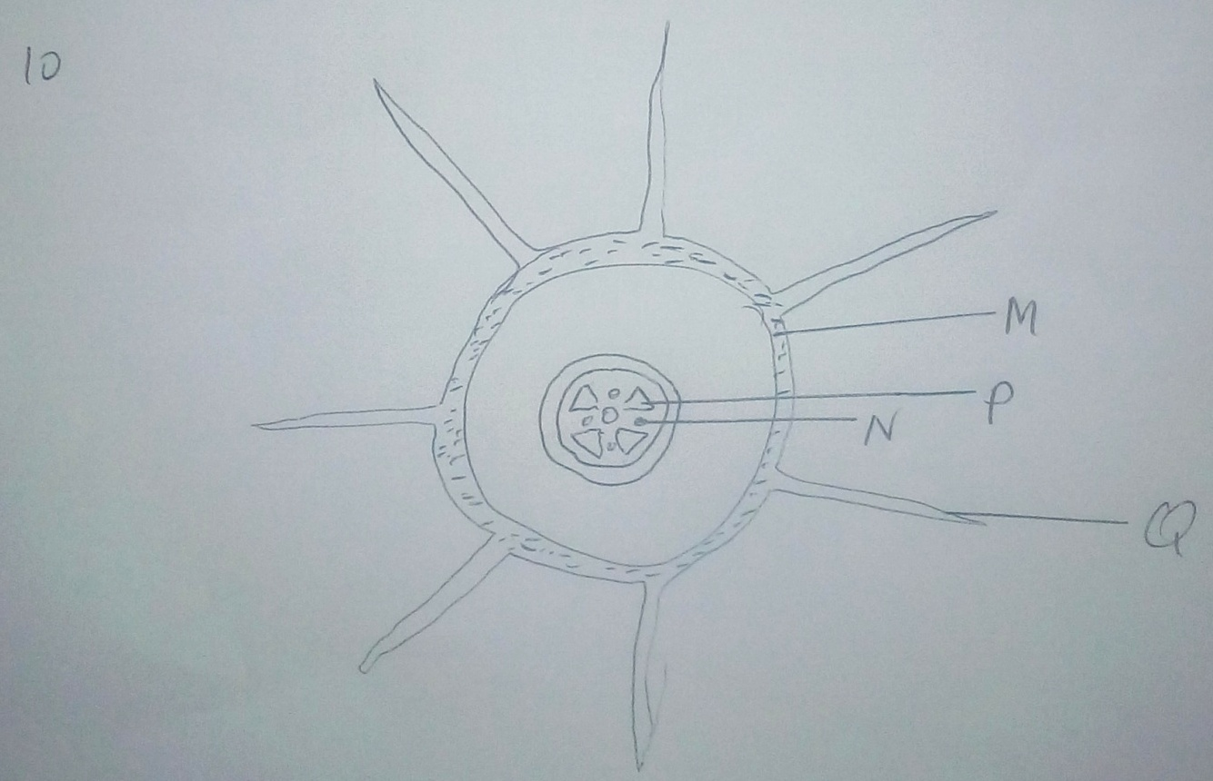

(a) From which plant organ was the section obtained. (1 mk)

(b) Name the parts labeled Q, N and P. (3 mks)
Q –
N –
P –

11. How are leucocytes adapted to their functions? (2 mks)

12. The diagram below illustrates the structure of a gill from bony fish.

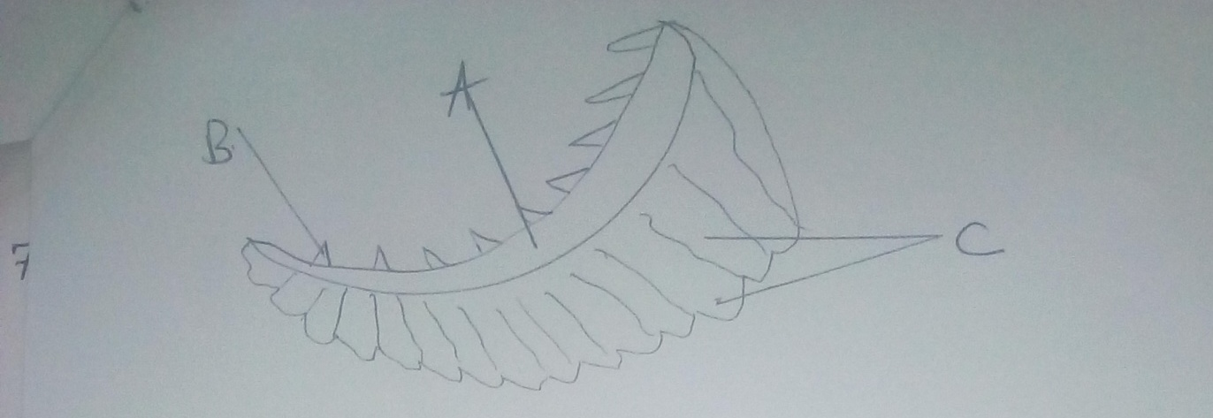

(a) Name the structures labeled A, B and C and give their functions. (3 mks)
A –
B –
C –

(b) In what ways are the structures labeled C adapted for their function? (3 mks)

13. (a) Which substance accumulates in the muscles when respiration occurs in absence of
oxygen. (1 mk)

(b) Which physiological changes occur in the body that enable the body to break down the
substance named in (a) above. (2 mks)

14. Name the product of anaerobic respiration in:
(i) Plants (2 mks)

(ii) Animals (2 mks)

(b) Explain the term Basal Metabolic Rate. (2 mks)

15. Name three organic waste products in plants. (3 mks)

16. Give the advantages of excreting nitrogenous waste products in the form of Uric acid as
compared to urea. (2 mks)

17. What is homeostasis? (1 mk)

(b) State the importance of ultrafiltration in the nephrone of human kidney. (2 mks)

18. (a) Name the hormone whose deficiency may lead to the excretion of glucose in urine.
(1 mk)

(b) Name the hormone that controls the reabsorption of sodium ions in the kidney tubules.
(1 mk)

19. Name the only plant subdivision, which produces flowers. (1 mk)

20. Besides the abdomen, name the other body part of members of Arachnida. (1 mk)

21. Name the phylum whose members possess a notochord. (1 mk)

22. The diagram below shows a mould of the genus Rhizopus. Study it and answer the
questions that follow.

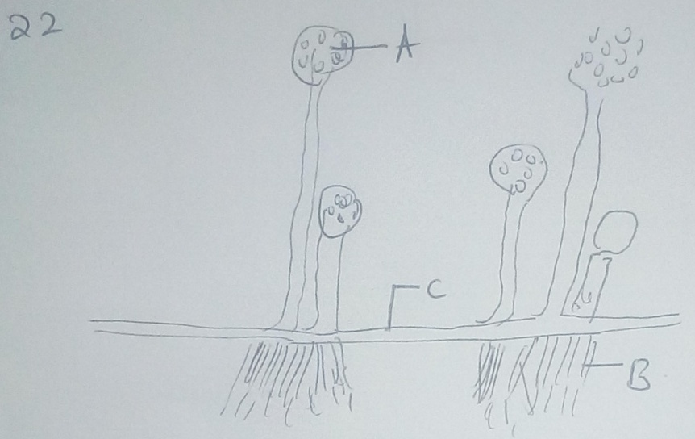

(a) Name the kingdom to which it belongs. (1 mk)

(b) Name the structure labeled A, B and C.
A –
B –
C –

23. Give three characteristics of kingdom montra. (2 mks)

24. State three characteristics of phylum chordate not found in other kingdom.(3 mks)

25. (a) Name the class to which centipede belongs. (1 mks)

(b) Give one structural feature that can be used to differentiate crustaceans and arachnids.
(1 mk)

26. State the organism shown below and answer the questions that follow.

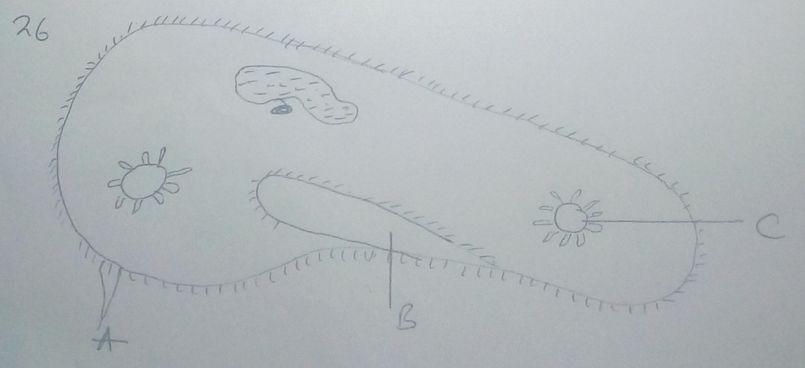

(a) Name the kingdom to which organism belong and give a reason for your answer.
(2 mks)

(b) Name the structures labeled A, B and C (3 mks)
A –
B –
C –

(c) Give the function of the structure labeled C. (1 mk)

27. In an investigation, the pancreatic duct of a rat was blocked by tying it with a string.
Explain how this affected the following processes.
(a) Digestion of food. (2 mks)

(b) Regulation of blood glucose level. (2 mks)

28. Give three differences between class chilopoda and diplopoda. (3 mks)

