NAME: ……………………………………. ADM NO: ………… CLASS: ……….
ANESTAR SCHOOLS
FORM ONE BIOLOGY
MID TERM EXAMS
TERM 1 2023
TIME: 1 HOUR
Attempt all the questions in the spaces provided.

1. Define the term Biology. (1 mk)

2. Name and define the two main branches of biology. (4 mks)

3. State the name given to the following:. (2 mks)
(i) Study of living things and their surrounding.

(ii) Study of inheritance and variation

(iii) Study of insects

(iv) Study of parasites.

4. State four ways in which study of biology is useful. (4 mks)
(i)

(ii)

(iii)

(iv)

5 . (a) List eight characteristics of living organisms. (9 mks)

(i)

(ii)

(iii)

(iv)

(v)

(vi)

(vii)

(viii)

(ix)

(b) Define each of the characteristics of living thins stated in 5(a) above. (8 mks)
(i)

(ii)

(iii)

(iv)

(v)

(vi)

(vii)

(viii)

(ix)

6. (a) What is a specimen? (1 mk)

(b) Explain how the following apparatus are used in collection of specimen. (3 mks)

Apparatus | Use
Sweep net
Fish net
Pooter
Bart trap
Pit fall trap
Pair of forceps

7. Study the apparatus shown below.

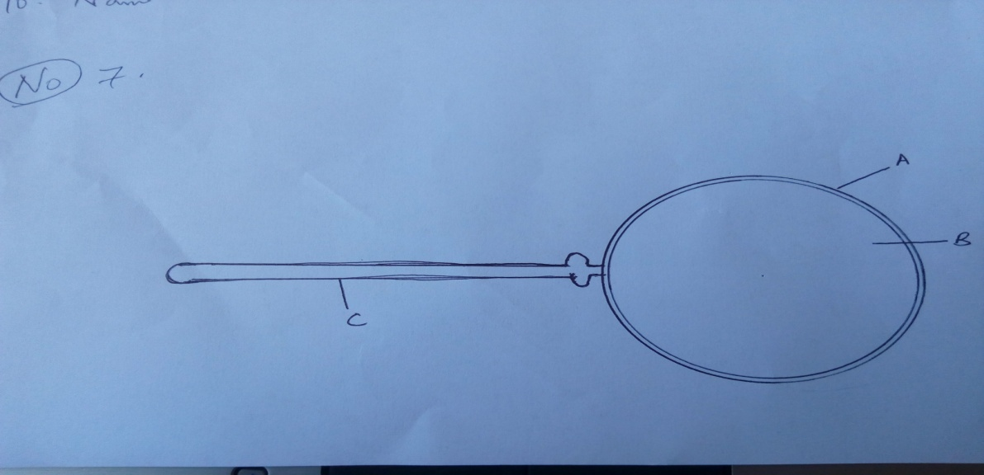

(a) Name the apparatus shown. (1 mk)

(b) State the use of the apparatus. (1 mk)

(c) Name the parts A ___________________

B ____________________

C__________________________
8. (a) List four difference between plants and animals (4mks)
Plants | Animals

9. Outline four precautions during collection and observation of specimens. (4mks)

