MID-TERM EXAM
TERM ONE FORM FOUR
AGRICULTURE
TIME: 2 HOURS
NAME……………………………………………….. ADM……………….. CLASS……...

SECTION A: (30 MARKS)

Answer ALL questions in this section in the spaces provided.

- State four advantages of artificial incubation. (2 marks)

- Give two uses of a gear box in a tractor. (1 mark)

- Name four tractor drawn implements that are attached to the three-point hitch. (2mark)

- Give four ways of stimulating milk let down in a dairy cow . (2marks)

- List two advantages of Biogas. ( 1mark)

- Name three temperate dairy goat breed and three light breed of poultry (3 marks)

- Distinguish between land subdivision and land fragmentation (1mark)

- List two operational differences between a disc and a mouldboard plough(2marks)

- State four factors affecting maintenance requirement of an animal.(2 marks)

- Mention four methods of breaking seed dormancy. (2marks)

- Give four possible observations during for egg candling. (2marks)

- State four qualities of healthy and clean milking man should have. (2 marks)

- List four characteristics of clean and quality milk.(2marks)

- Give four conditions necessary for artificial incubation.(2marks)

- Name four bacterial diseases affecting cattle.(2marks)

- State the precautions a farmer should take when using the workshop tools. (2marks).

SECTION B (20MARKS)
Answer all the question in this section in the spaces provided
- The diagram below represents an egg. Study it and answer the questions that follow.

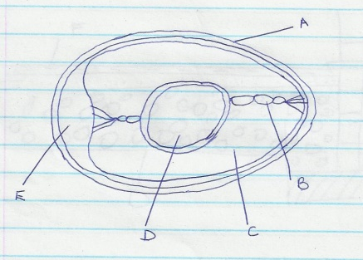

  - Name the part labeled B and D. (2 marks)

  - State two qualities of the part labeled A that should be considered when selecting eggs for incubation. (2 marks)

  - What is the function of the part labeled D in a fertilized egg? (1 mark)

- A farmer wants to prepare a ration for layers containing 18% DCP using maize germ 20% DCP and wheat bran 10% DCP.
- Calculate using Pearson’s square method the amount of each feed-stuff needed in order to prepare 100kg of feed (5marks)

- Name one other method the farmer can use to compute the ratio (1mark)

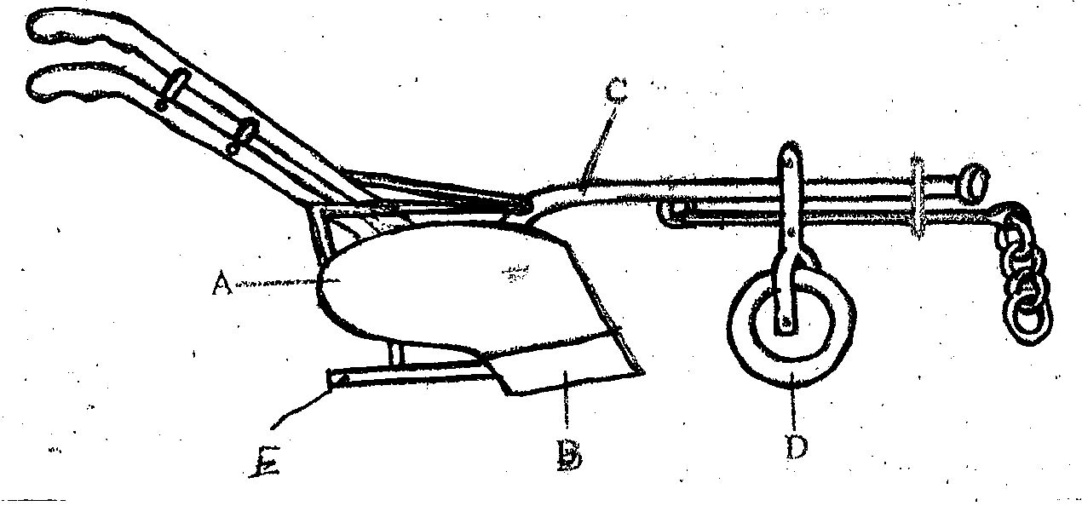
- Below is a diagram of a farm implement

A

E
B
D
- Identify the implement (1 mark)

- Label the parts marked A,B, and C (3 makes)

- State the functions of the parts labeled E and D (2marks)

- The diagrams below illustrate a four stroke cycle engine system. Study it and answer the questions that follow

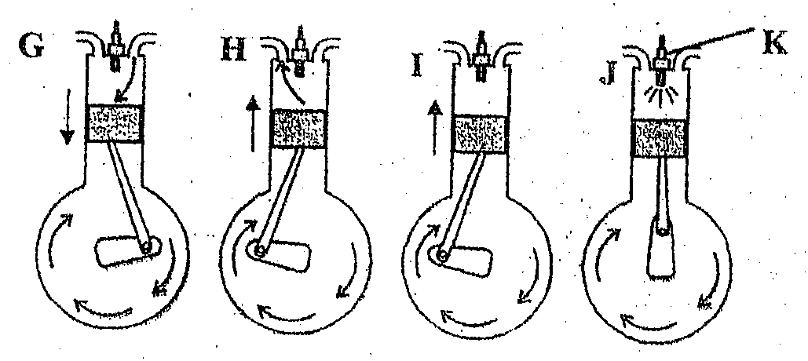

- State the four stages of the four stroke cycle engine G,H,I and J (2marks)

- Mention one disadvantages of a four stroke engine (1mark)

SECTION C (40MARKS)
Answer only two questions in this section.

- a) Outline six function of a manager in a farm (6marks)
b) Name four factors of production involved in agriculture. (4marks)
c) Discuss the differences between four stroke cycle and two stroke cycle (10 marks)
22. a) Name five condition that influence egg eating in poultry (5 marks)
b) What are factors that cause stress in poultry (5 marks)
a) What are the advantages of a battery cage system 10marks)
23. a) outline four rules to be observed during milking. (4 marks)
b) State six materials necessary during milking (6 marks)
c) . Describe ten general methods of disease control in cattle. (10 marks)

