Name: …………………………………………………………….. Adm No: …………………

School: ……………………………………………………………. Class: …………………….

232/2

PHYSICS PAPER 2 JUNE-2022
TIME: 2 HOURS

SUKELLEMO -2022
Kenya Certificate of Secondary Education (K.C.S.E.)

INSTRUCTIONS TO THE CANDIDATES:
- Write your name and index number in the spaces provided above
- This paper consists of two sections A and B.
- Answer all questions in section A and B in the spaces provided.
- All working must be clearly shown in the spaces provided.
- Mathematical tables and electronic calculators may be used.

For Examiners’ Use Only

SECTION | QUESTION | MAXIMUM SCORE | CANDIDATE’S SCORE
A | 1 – 12 | 25
B | 13 | 10
 | 14 | 08
 | 15 | 13
 | 16 | 12
 | 17 | 12
TOTAL |  | 80

This paper consists of 10 printed pages. Candidates should check to ascertain that all pages are printed as indicated and that no questions is missing

SECTION A (25 MARKS)
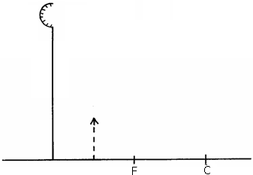
- The diagram below shows the image formed by a convex mirror. Complete the diagram to show the position of the object. (2mks)

- Explain why sound cannot be heard from far when one shouts in a forest. (1mk)

- The chart below shows an arrangement of different parts of the electromagnetic spectrum.

Radio | A | Visible | Ultraviolet | X-Rays | Gamma rays

Name the radiation represented by A. (1mk)

- The figure below shows a magnet. Point A and B are in front of the magnet.

A B

S N

On the axes provided, sketch a graph showing how the magnetic field strength changes from A to B. (2mks)

Magnetic field

A Distance B

- (a)Machines at a textile industry experiences electrostatic forces at certain points. Suggest a method that can be used to reduce these forces. (1mk)

(b) A sharp point of a pin is held over a positively charged electroscope. State and explain the observation made on the electroscope.
(2mks)

- The figure below shows two conducting wires A and B passing through a horizontal piece of cardboard.
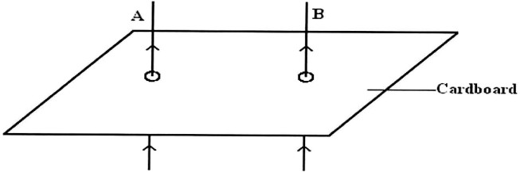

- Sketch the resultant magnetic field patterns when the currents of high magnitude are flowing on both wires as shown. (1mk)

- What is the resulting effect of the field on the wires at the loose ends? (1mk)

- If the current in B were to be reversed, state how resulting would affect the wire conductors.
(1mk)

- The figure shows a wave traveling along a medium.
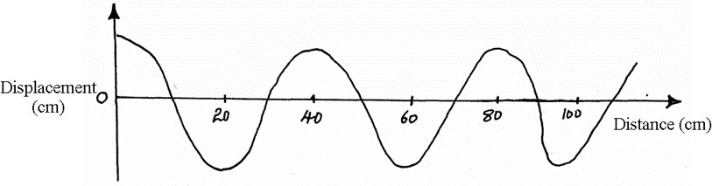

Determine the speed of the wave if the source produces 480 vibrations per minute. (3mks)

- State two things that determines the carrying capacity of an accumulator. (2mks)

- Explain why when the pinhole of a pinhole camera is enlarged, a brighter but very blurred image is seen on the screen (2mks)

- Calculate the operating current of a heating element rated 3kW, 240 Volts. (3mks)

- State two factors affecting resistance of a resistor. (2mks)

- Distinguish between an amplitude and wavelength of a wave. (1mk)

SECTION B

- (a)A lens forms an image four times the size of the object on the screen. The distance between the object and the screen is 60cm when the image is sharply focused.
  - State with a reason what type of lens was used. (2mks)

  - Determine:
- The object distance. (2mks)

- The image distance. (2mks)

- The figure below shows the basic parts of a simple lens camera.
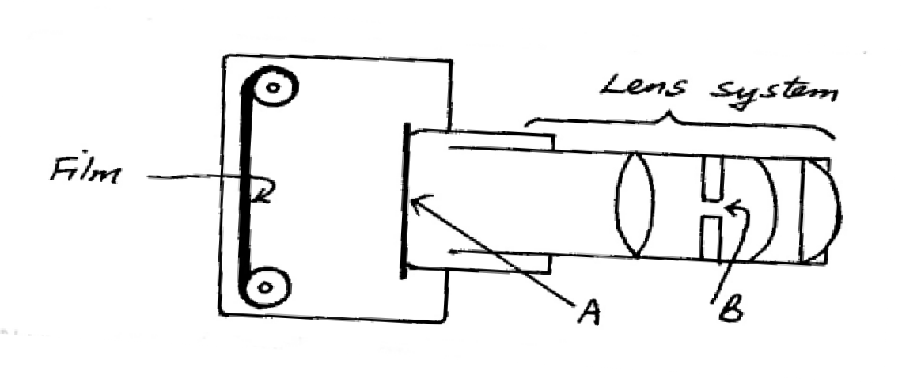

  - Name the parts labeled A and B. (2mks)

  - State the function of each of the parts A and B. (2mks)

- The graph below shows the variation of p.d (V) across the terminals of a cell and the current drawn from the cell.
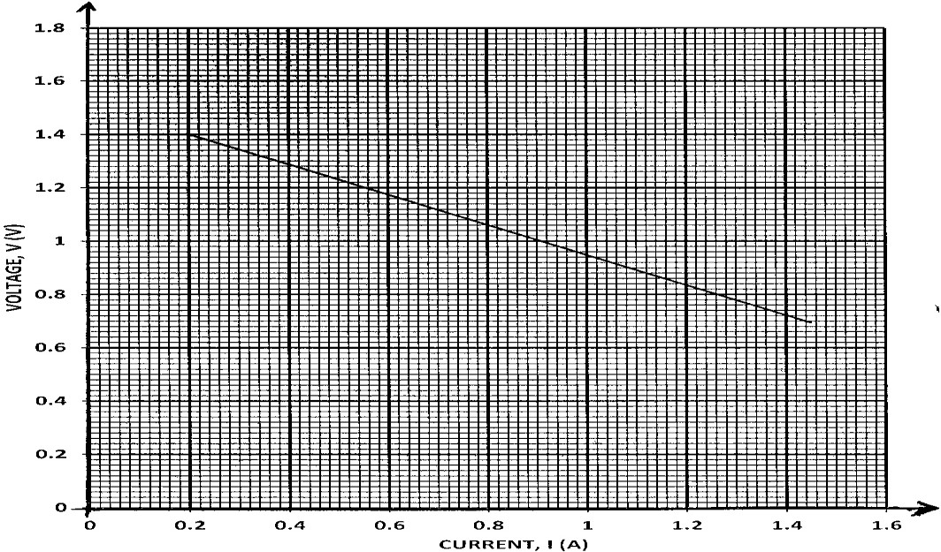

- Use the graph to determine:
  - The electromotive force (e.m.f) E of the cell. (1mk)

  - The internal resistance r, of the cell given that E = V + Ir. (3mks)

- Draw a circuit diagram that may be used to obtain the values plotted in the graph. (2mks)

- Describe briefly how the circuit you have drawn may be used to carry out the experiment to obtain the values in the graph. (2mks)

- (a) State Snell’s law. (1mk)

- A coin is placed beneath a transparent block of thickness 10cm and refractive index 1.56. Calculate the vertical displacement of the coin. (3mks)

- The speed of green light in a prism is 1.94 × 10⁸m/s.
  - Determine the refractive index of the prism material.
(Speed of light in air = 3.0 × 10⁸m/s). (2mks)

  - Determine the critical angle of the prism material. (2mks)

- State two advantages of using optical fibre in communication. (2mks)

- 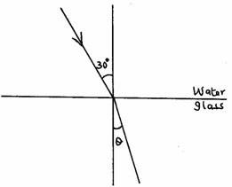The refractive indices of water and glass are ³/2 and ⁴/3 respectively. Find the value θ in the figure below.
(3mks)

- The figure shows a system of capacitors connected to 100V supply.

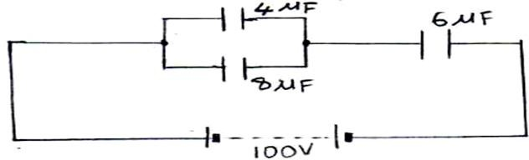
- Determine:
  - The effective capacitance of the circuit. (3mks)

  - The charge through the 6µF capacitor. (3mks)

  - The p.d. across the 8µF capacitor. (4mks)

- State two factors that affect the capacitance of a parallel plate capacitor. (2mks)

- Some plane water waves were produced in a ripple tank. They pass from a region of deep water into a region of shallow water. The figure shows what the waves look like from above.
Boundary

Waves move this way

Deep water Shallow water

- State what happens at the boundary to:
  - The frequency of the waves. (1mk)

  - The speed of the waves (1mk)

  - The wavelength of the waves (1mk)

- The waves have a speed of 0.12 m/s in the deep water. Wave crests are 0.08m apart in the deep water. Calculate the frequency of the source producing the waves. (2mks)

- State one difference between a stationary wave and a progressive wave. (1mk)

- The figure below represents crests of straight waves produced in a ripple tank.
9cm
G F E D C B A

Determine the wavelength of the waves. (2mks)

- In an experiment to observe interference of light waves, a double slit is placed close to the source S of light as shown in the figure below.

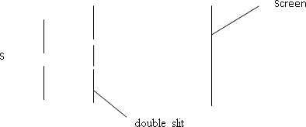

  - State the function of the double slit. (1mk)

  - Describe what is observed on the screen. (2mks)

  - State what is observed on the screen when the slit separation is reduced. (1mk)

