NAME ____________________________________ INDEX NO._______________
SCHOOL _______________________________ SIGNATURE_______________ DATE _______________

312/2
GEOGRAPHY

PAPER 2

JUNE, 2022

TIME: 2¾ HOURS

SUKELLEMO JOINT PRE-MOCKS 2022

INSTRUCTIONS TO CANDIDATES
- This paper has two sections: A and B.
- Answer all the questions in section A.
- Answer question 6 and any other two questions from Section B.
- Each question in section B must be answered in separate foolscaps.
- This paper consists of 6 printed pages.
- Candidates should check the question paper to ascertain that all pages are printed as indicated and that no questions are missing.

QUESTION | A | 6 | 7 | 8 | 9 | 10 | TOTAL
MARKS

1. a) What is Human Environment? (2 mks)
b) Identify three areas of study under Human Environment. (3 mks)
2. a) The diagram below shows the occurrence of petroleum in the earth’s crust.

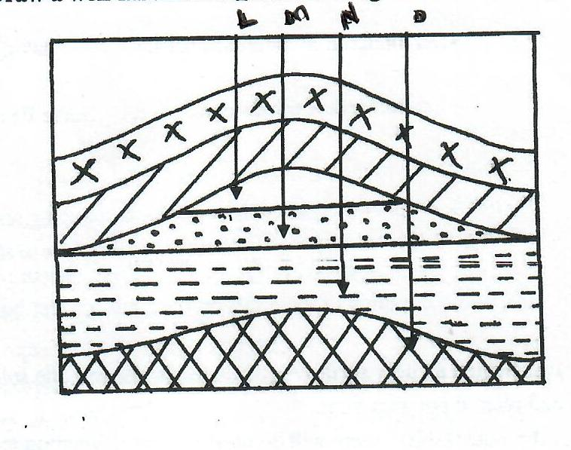
Name the substances labelled L, M and N. (3 mks)
b) Give two by-products obtained when crude oil is refined. (2 mks)
3. a) State three environmental conditions which favour commercial beef farming in Kenya. (3 mks)
b) Name two exotic breeds of cattle reared in commercial ranches in Kenya.
(2 mks)
4. a) Give two reasons why wildlife conservation is encouraged in Kenya. (2 mks)

b) Apart from national parks, outline three other ways in which wildlife is conserved in Kenya. (3 mks)
5 .a) Name two polders that were created in Zulderzee project. (2 mks)

b) State three ways in which the salinity of the polders is reduced in the Netherlands. (3 mks)

SECTION B - Instructions: Answer question six (6) and any other two questions from this Section.

6. The data below represents crop exports from Kenya between 1995 and 1998. Use it to answer the questions that follow: -

Crops/Year | 1995 | 1998
Maize  Coffee  Tea  Others | 224  168  320  200 | 286  310  368  461
Total | 912 | 1,445

a) Using a scale of 1 cm represents 10 units, prepare proportional divided circle from the data above using
the square root method. (9 mks)

b.i) Name two varieties of coffee grown in Kenya. (2 mks)

ii) State three reasons why Brazil leads in the production of coffee. (3 mks)

c) Discuss the processing of sugarcane after harvesting. (6 mks)

d.i) The map below represents cocoa growing areas in Ghana. Identify the towns marked A and B. (2 mks)
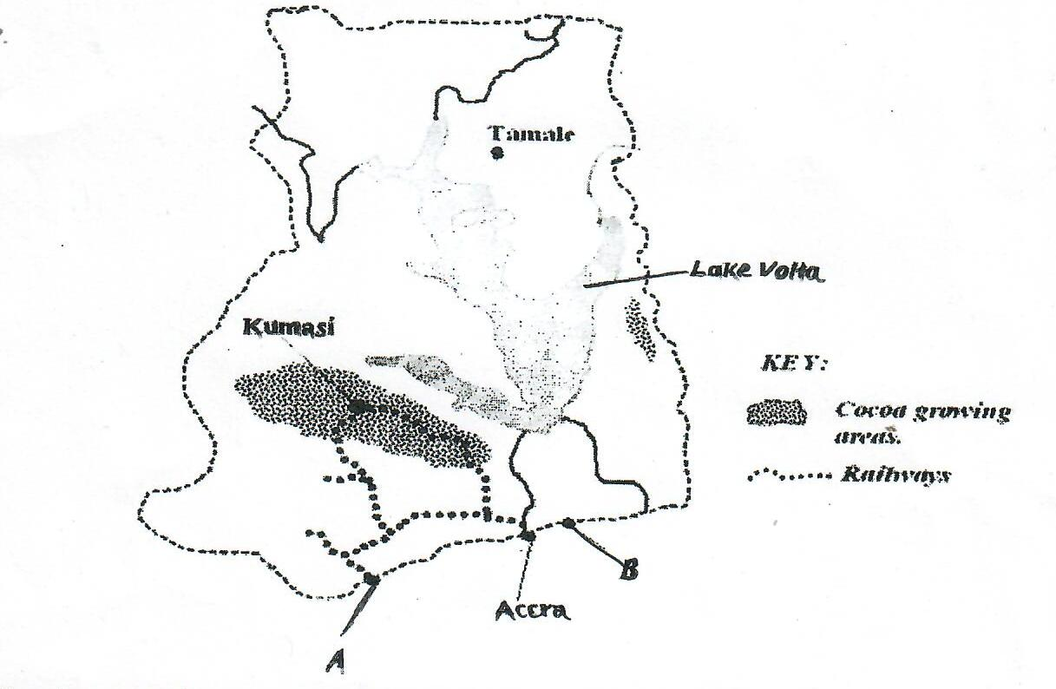

ii) Give the reasons for each of the following stages in the processing of Oil palm. (3 mks)
- Steaming
- Stripping
- Pulping

7. a.i) Apart from Coniferous forest, name two other types of natural forests. (2 mks)

ii) State two characteristics of Coniferous forests. (2 mks)

b) Explain four factors that favour the exploitation of softwoods in Canada. (8 mks)
c) i) List any four indigenous softwood tree species that grow on the Kenya highlands. (4 mks)
ii) State three problems facing forestry in Kenya. (3 mks)

d) Your class intends to carry out, field study on forestry in Karura Forest. (3 mks)

i) List three objectives of your study. (3 mks)

ii) List three types of sampling techniques used during filestury. (3 mks)

8.a. i) Name any two types of fishing. (2 mks

ii) What is fish farming? (2 mks)

b) Describe harpooning as a method of fishing. (4 mks)

c) The map below shows the major fishing grounds of the world. Use it to answer questions (i) and (ii).
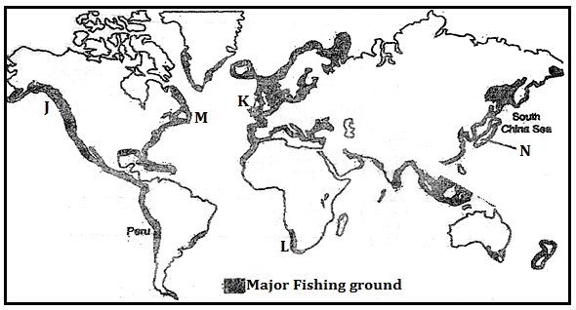

i) Name the fishing grounds labeled J, K, and M. (3mks)

(ii) Explain three physical factors that have favoured fishing along the grounds marked N. (6mks)

(d) Explain four measures being fronted by the Kenya government to reduce overfishing in Lake Victoria. (8 marks)

9. (a) Identify three sources of non- renewable energy. (3 mks)

b) State three advantages of biomass as a source of energy. (2 mks)

c) Apart from the HEP projects in Kenya and Uganda, name three other HEP projects in Africa.
(3 mks)
d i) What is energy crisis? (2 mks
ii) Explain four ways in which energy crisis has impacted on developing countries. (8 mks)

e) You are planning to carry out a field study on hydro- electricity production in the Kenyan seven folks dam.
i) State two types of hypotheses you would use for the study . ( 2mks)

ii) What are possible follow-up activities that you will be involved in after the study?
( 3 mks)
iii) Give two reasons why you would require a route map. (2mks )

10. The table below shows the population of a country in Western Europe in ‘000’s. Use it to answer Part a – c.
Age Group | Male | Female
0 – 9  10 – 19  20 – 29  30 – 39  40 – 49  50 – 59  60 – 69  70 – 79  80+ | 460  447  630  635  610  541  470  460  451 | 455  449  632  639  615  563  468  459  453

a) Using a scale of 1 cm to represent 100,000 people, draw a population pyramid from the above data. (10 mks)
b) Give five characteristics of the above population structure shown by the pyramid. (5 mks)
c) Explain three problems likely to be experienced due to the population trend in the above country. (6 mks)
ii) State four causes of urban-urban migration. (4 mks)

