SUKELLEMO PRE-MOCK JUNE 2022
GEOGRAPHY PAPER 2 MARKING SCHEME
SECTION A
1.a) What is Human Environment?
Deals with the different activities that people perform on the earth’s surface. (2 marks)
b) Areas of study under Human Environment. (3 marks)
- Farming
- Fishing
- Mining
- Transport
- Trade e.t.c.
2. The substances
L - Gas
M - Oil/petroleum
N - Water
b) Two by-products obtained from crude oil.
- Wax
- Bitumen/Tar/Pitch/Asphalt
- Sulphur
- Lubrication oil
- Petro-chemical
3. Three environmental conditions which favour commercial beef farming.
- presence of undulating landscape.
- Adequate water supply.
- Large trucks of land/expansive tracts of land.
- Adequate pasture for the animals.
- Tsetse-fly free areas.
(3x1 = 3 marks)

b) Name two exotic breeds of cattle reared in commercial ranches in Kenya. (2 marks)
- Aberdare Angus
- Charolois
- S
- Galloway
- Santa Gertrudis
`(2x1 = 2 marks)

4. Two reasons why wildlife is encouraged in Kenya. (2 marks)
- To promote tourism/tourists
- for posterity/future generation
- to generate foreign exchange/revenue
- To protect the endangered species (both plant and animal)
- For education/research purposes
- for aesthetic value/beauty.
b) Apart from national parks, outline three other ways in which wildlife is conserved in Kenya. (3 marks)
- Banning of trade in wildlife products.
- Encouraging individuals to set up game ranches.
- Employing anti-poaching unit/forest rangers in the game parks.
- Protecting endangered species in orphanages/sanctuaries/natural reserves.
- Setting up a game reserve/forest reserves.
- Promotion of peaceful co-existence between wildlife and human beings.
(3 marks)
5.a) Two polders created:-
- marketward polder
- Wieringer meer polder
- North Eastern polder
- Eastern Flevoland polder
- South Flevoland

b) Three ways in which the salivity of the polders is reduced.
- Chemicals are applied to lower salts in the soil.
- Fresh water is flushed to the soils to remove and dilute the excess salts.
- Reeds re planted to use up the excess salts.
- There is continuous pumping of water from the polders.
6. Year Totals Absolute
1995 ` 912 900
1998 1445 1,000 31.6 = 32
Year Radii of the circle
1995 30 ÷ 10 = 3 cm
1998 32 ÷ 10 = 3.2 cm
1995 – Calculations for the segments
Maize 224 x 360º
912 = 88.4º

Coffee 168 x 360º = 66.3o
912

Tea 320 x 360º = 126.3o
912

Others 200 x 360º = 78.9º
912
1998
Maize 286 x 360º = 71.3º
1,445

Coffee 310 x 360º = 96.7º
1,445

Tea 388 x 350º = 96.7º
1,445

Others 461 x 361 = 114.9º
1,445

Proportional Divided Circles showing Crop exports from Kenya Between 1915 and 1998.

1995 1918

b.i) Two varieties of coffee grown in Kenya. (2 marks)
- Robusta
- Arabica

ii) Reasons why Brazil leads in the production of coffee. (3 marks)
- Due to the country’s large plantation area.
- Climate in brazil is well suited for growing excellent coffee.
- Extensive plateaus.
c) Processing of sugarcane after harvesting. (6 marks)
- Processing must be done within 48 hours after the cane is cut.
- at the factory, it is weighed while still on the lorries and tractors.
- It is then offloaded and washed.
- It is passed through a machines which cuts it into pieaces
- Passed through rollers which squeeze
- the juice is put in clariper where the fine matter in suspension and soluble non-sugars are precipitated forming a dark colures substances.
- its separated from the juice.
- Juice is put into boilers called evaporation
- Mixed with lime until it becomes thick syrup.
- A dark brown mixture is formed.
- It is put in centrifuges where crystals are separated from molasses.
- raw and course sugar is brown.
- It is then refined to brown and white sugars.

d.i) A is Takoradi
B is Tema (2 marks)
ii) Reasons for the following stages in processing of Palm. (3 marks)
Steaming - Ensures that the oil does not change into fatty acids.
Pulping - To remove the oil.
7.a.i) - Tropical hard wood forests
- Temperature hardwood forests
- Mountains forests
ii) Characterizes of Coniferous forests. (2 marks)
- Most of the tree species are softwood which mature faster than hardwoods.
- Common trees are sparse, fir, pine and
- Most species are ever green
- Trees have this needle-like leaves
- Trees occur in big pure stands
- Have little undergrowth
- Trees are more stunted towards the polar side.
b) Factors that favour the exploitation of softwoods in Canada. (8 marks)
- Presence of mild winters with is-free waters in British Colombia making it possible to transport logs throughout the year.
- Plenty of Hydro Electric Power provided by many rivers.
- Rivers provide water needed to convert timber into pulp and paper.
- Cheap and efficient transport system 9water and land) is available to ferry logs to the factories and finished products to the market.
- Presence of major ports allow the exportation of timber to U.S.A., Europe and Japan e.g. Quebec.
- There is a high demand for forest products locally and internationally.
c.i) Indigenous softwood tree species in Kenya. (4 marks)
- Junifer (Kenya Cedar)
- Podo
- African Penid
- Bamboo
ii) Problems facing forestry in Kenya. (3 marks)
- Large tracts of forest are destroyed by pests such as Aphids.
- Forest fires caused by honey harvesters, game poachers, illegal loggers, charcoal burners etc
- Over-explatation leading to soil erosion.
d.i) Objectives of the study. (3 marks)
- To find out the type of forest Karura is.
- To find out the uses of forest products from the forest.
- To find out the tree species found in Karura forest.
ii) Sampling techniques –
- Random sampling
- Systematic sampling
- Strategic sampling. (3 marks)

8.a) (i) Name any two types of fishing. (2 marks) Inshore fishing
- Fresh water fishing
- Demersal fishing
- Pelagic fishing
- Anadromous fishing
(ii) What is fish farming? (2 marks)
The rearing of fish in pond
(b) Describe harpooning as a method of fishing. 4mks
- It involves the use spears, arrows or sticks to strike the fish in water
- Fish found in clear shallow water is identified
- Fish is struck using the spears, arrows or stick
- Fish is then pulled out of the water with the stick/arrow
- Mainly used to catch limited fish/for subsistence use . (Any 4x1=4mks)
(c)The map below shows the major fishing grounds of the world. Use it to answer questions (i) and (ii).
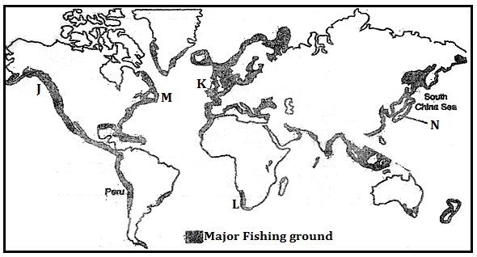
(i)Name the fishing grounds labeled J, K, and M 3mks
- J – North East Pacific
- K – North East Atlantic
- M – North West Atlantic

(ii)Explain three physical factors that have favoured fishing along the grounds marked N. 6mks
- Broad, shallow and extensive continental shelf that favors the growth of planktons which is food for fish
- Convergence of the cold Oyasiwo and warm Kurosiwo currents that makes the coast ice free allowing fishing all year round as well as provision of ideal conditions for plankton growth .

- Indented coastline of the North East Asian with numerous islands, bays and sheltered inlets that favor fish breeding and development of fishing ports.
- Limited agricultural potential especially in Japan with rugged landscape; leaving fishing as alternative source of protein/food.

(d)Explain four measures being fronted by the Kenya government to reduce overfishing in Lake Victoria. 8mks
- More vigilant surveillance of the Lake Victoria to check on illegal fishing activities
- Licensing of fishermen to control their numbers and activities in the lake.
- restocking the lake with new fingerlings to replace the depleted specie.
- Prohibiting/banning use of small meshed gill nets that harvest all fish sizes.
- Introduction of fish farming in the hinterland to reduce overdependence on fish from Lake Victoria.
- Banning/prohibiting fishing for some time to let the fish regenerate

8. (a) Identify three sources of non- renewable energy 3 mks
- Petroleum
- Coal
- Natural gas
- Nuclear gas

b) State three advantages of biomass as a source of energy. 2 mks
- It is inexhaustible as long as there is organic matter.
- It can produce fuels which are efficient, viable and clean.
- It is a cheap source of energy since it uses waste products.
- It uses low level technology to produce.
- It is environmentally friendly because it makes use of waste products.
c) Apart from the HEP projects in Kenya and Uganda, name three other HEP projects in Africa.
3 mks
- Akosombo in Ghana.
- Keinji in Nigeria
- Inga in D.R.C
- Aswan in Egypt.
- Kefue in Zambia
- Kariba in Zambia/Zimbabwe
- Cabora Bassa .
- Ronx/P.k in South Africa
- Goriep in South Africa
- Luanza in Angola

d i) What is energy crisis? 2 mks
Energy crisis is the situation whereby the demand for oil is higher than the amount supplied leading to high oil prices.
ii) Explain four ways in which energy crisis has impacted on developing countries. 8mks
- It has led to the increase in the prices of many commodities due to increased cost of transport triggered by the increase in oil prices.
- Industries have suffered industrial setback leading to laying off of some workers and slowing down of industrial growth due to increased cost of production
- Prices of other forms of energy e.g. charcoal and gas have risen.
- It has affected agricultural inputs e.g. fertilizers whose prices have risen resulting to lower crop production.
- Air fares have escalated making it very difficult to travel hence affecting the tourism sector.
- Has led to environmental problems e.g. deforestation for firewood and charcoal.
e) You are planning to carry out a field study on hydro- electricity production in the Kenyan seven folks dams.

i) State two types of hypotheses you would use for the study (2 marks)
- Null hypotheses
- Declarative/ substantive hypothesis
ii) What are possible follow-up activities that you will be involved in after the study? (3 marks)

- Reading more on the topic.
- Display photographs/items collected.
- Draw diagrams.
- Write reports/presenting reports.
- Discuss with the rest of the class.
- Analyze/assess the information collected against the hypothesis.
- Model of the area of study.
- Confirming/rejecting of the hypothesis based on the findings.

iii) Give two reasons why you would require a route map. (3 marks)
- To guide in estimating time for the field study
- To help identify the direction to be followed
- To help estimate distance to be covered
- To help in locating the area
- To help in preparing a work schedule

10. The table below shows the population of a country in Western Europe in 1000. Use it to answer part a – e.
Age group | Male | Female
0 – 9 | 450 | 455
10 – 19 | 447 | 449
20 – 29 | 630 | 532
30 – 39 | 635 | 639
40 – 49 | 616 | 615
50 – 59 | 541 | 563
60 – 69 | 470 | 468
70 – 79 | 468 | 459
80+ | 451 | 451

- Using a scale of 1 cm to 100,000 people, draw a population pyramid from the above data.
(7 marks)
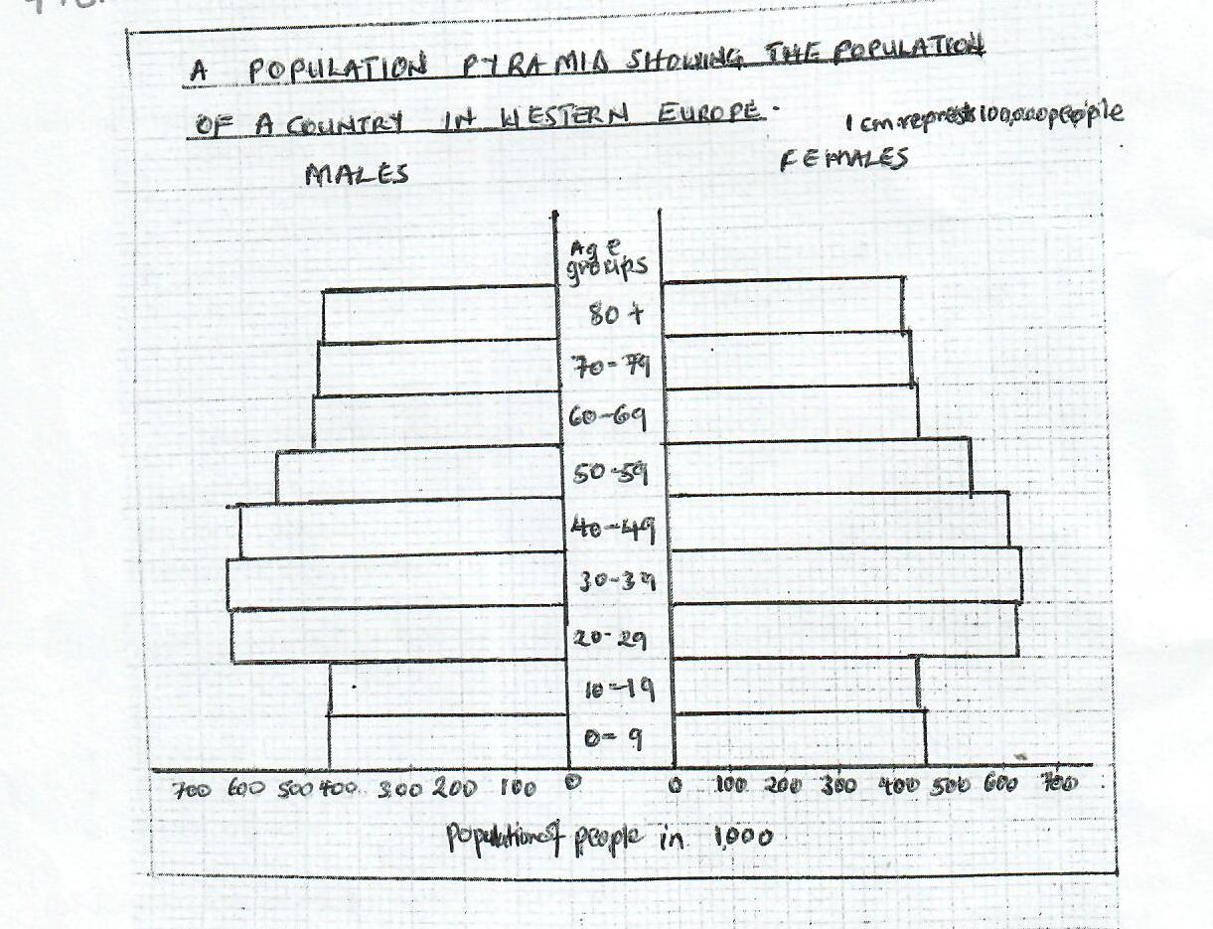
- State four characteristics of the above population structure shown by the pyramid.(4 marks)
- Has high life expectancy
- Has a large working population
- Has a low dependency ratio
- Has a low fertility rate
- Has a low death rate
(5x1 = 5 marks)
- Explain three problems likely to be experienced due so the population trend in the above country. (4 marks)
- Inadequate manpower making labour expensive.
- Rural depopulation due to increase in urbanization/leading to labour shortage.
- High old age dependency ratio due to high life expectancy.
- Under-utilization of solid amenities due to low birth rate.
d.i) Define the term fertility rate. (2 marks)
The number of children born live to women of child-bearing age i.e. 15 – 49 years.
ii) Give three factors that influence fertility. (3 marks)
- Level of education
- Family planning/use of contraceptives
- Religion practices which limit use of contraceptives
- Medical care or hygiene
- Nutrition/healthy diet
iii) State three causes of urban-urban migration. (3 marks)
- Search for better housing.
- Nearness to place of work/cheap transport cost
- Availability of social amenities
- Insecurity in some parts of the town force people to move
- Cultural/religious priorities where people are attracted to worship.
- Cheaper housing.

