**233/1**

**CHEMISTRY**

**PAPER 2**

**THEORY**

**TIME – 2HRS**

**SUKELLEMO PRE MOCK JOINT EXAMS**

Pre Mock Examination

JUNE 2022

**MARKING SCHEMES**

a)i) To remove dust particles√ - than would otherwise “poison” that catalyst (1mk)

ii) 9 atmospheres √1 (1mk)

iii) To pre heat NH3 and air to an optimum temperature (reactants)√

To cool No (product) √ (2mks)

iv) Platinum –Rhodium catalyst √ (1mk)

v) I : 4NH3(g) +502(g) 4NO(g) +6H20 (g) √1  (1mk)

II : 2NO(g) +O2(g 2NO2(g)√1 (1mk)

III 4NO2(g)  + O2(g)  +2H2O(l)  4 HNO3(aq)

b)i)

2NaNO3(S)  2NaNO2(g)  +O2(g)√

NaNO3  =23 + 14 + 48 =85

Moles of NaNO3  =21.25√ ½

85 (3mks)

Moles of O2  ½ x 0.25

= 0.125 √ ½

Volume of O2  09.125 X 22.4

= 2.8dm3

V = 280 cm3

ii) Manufacture of fertilizers√

Manufacture of explosives√

Manufacture dyes and drugs √ (2mks)

Purification of metals eg.silver and gold

Etching designs on some metals

2. (a) this is the maximum mass of salt/solute that can saturate 100g of water at a given temperature.

(b)

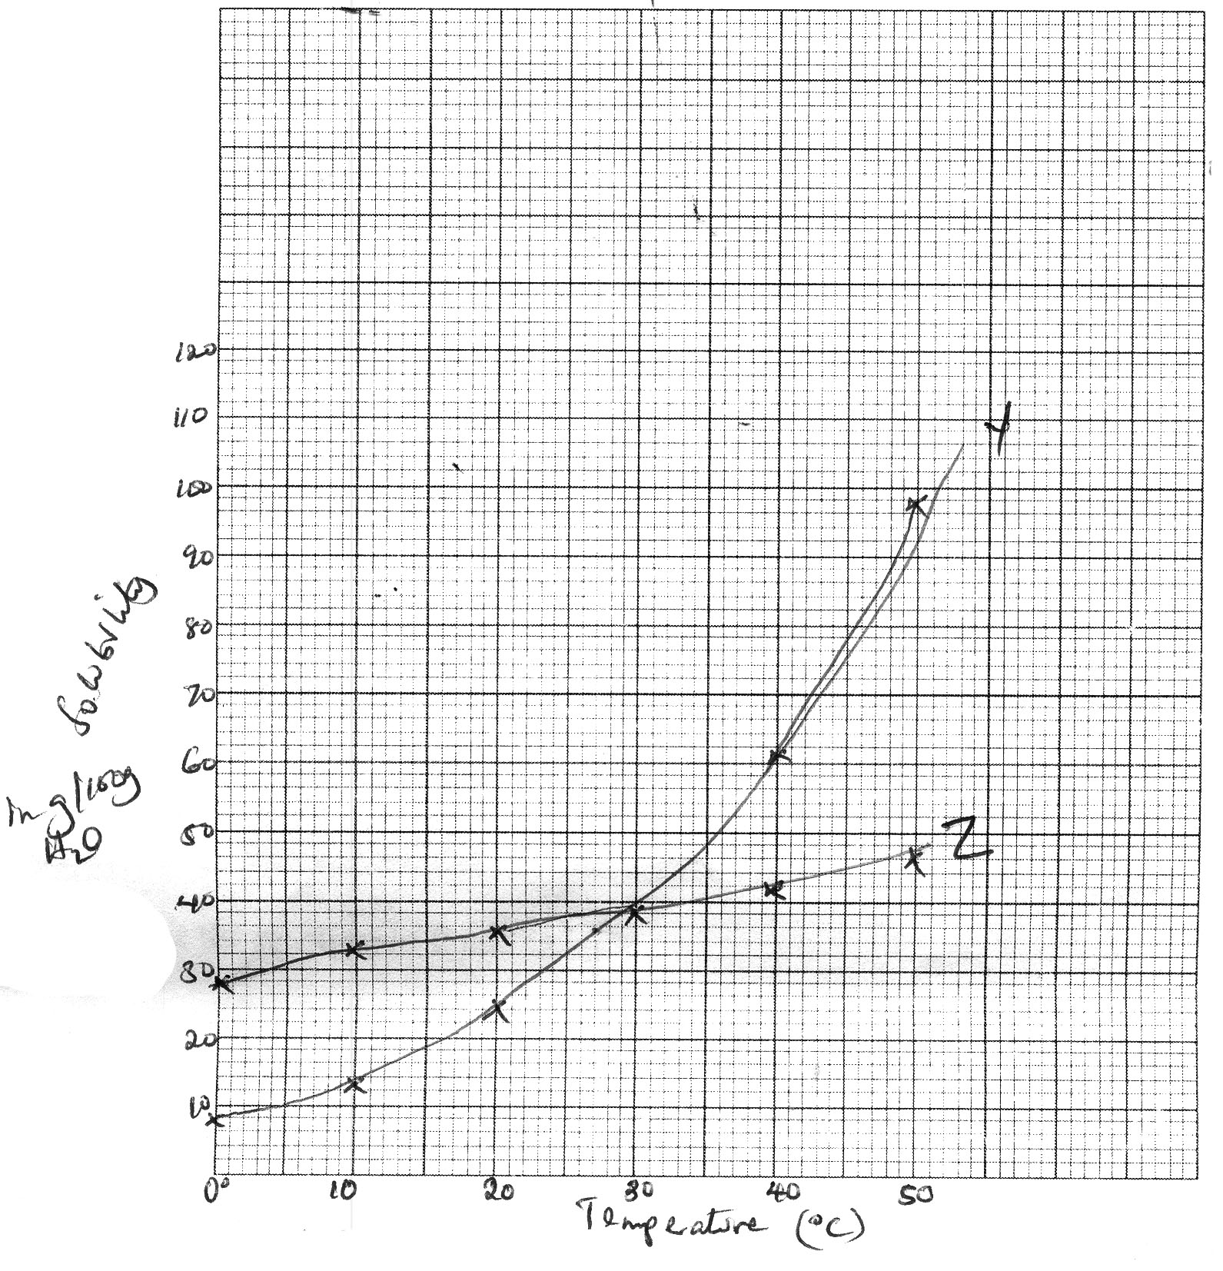

(c) (i) 30g of H2O Accept 36g/100g water

(ii) 33.5oC

(d) (i) Sol at 40oC = 61g/100g H2O

At 27oC

(ii) Sol at 40oC = 61g/100g H2O

Sol at 27oC = 35g/100g H2O

Sol at 5oC = 10g/100g of H2O

(e) Y is more soluble than Z.

Y dissolves better at higher temperatures than Z

(f) Fractional crystallization – Separation of mixtures with different solubilities

3. (a) (i) I: Zn(OH)2 🗸¹

II: ZnCl2 🗸¹

III: ZnO 🗸¹

(ii)  🗸¹

1. White precipitate soluble in excess. 🗸¹
2. Ammonia gas is polar and ionizes 🗸¹ in water which is polar.

While it does not ionize in methylbenzene which is non polar.

(c) (i) Calcium carbonate/magnesium carbonate.

(ii) Passing a solution of dilute hydrochloric acid or nitric (V) acid

in the boiler. (1mk)

(d) 

4a

i) Hygroscopy

ii) Deliquescence

iii) Efflorescence

2-

b) i) (Zn(OH)4) 2-🗸1mk ii) Cu(OH)4 √1

|  |  |  |  |
| --- | --- | --- | --- |
| Fe | S | O | H2O |
| 20.2 | 11.5 | 23.0 | 45.3 |
| 56 | 32 | 16 | 18 |
| 0.36 | 0.36 | 1.44 | 2.52🗸1mk |
| 1 | 1 | 4 | 7 |

(FeSO4.7H2O)=278

278n=278

n=1🗸1mk

Formula FeSO4.7H2O🗸1mk

ii) No. of moles 🗸1mk

0.025moles-250cm3

1000

🗸1mk

d)

* Add exess lead carbonate to dilute HNO3, 🗸 1mk
* shake and filter to remove unreacted carbonate 🗸1/2mk
* Add excess dilute HCl to the mixture 🗸1/2mk
* Filter to obtain lead(II) chloride as the residue 🗸1/2mk
* Rinse and Dry between filter paper to obtain solid PbCl2🗸1/2mk

5. i)

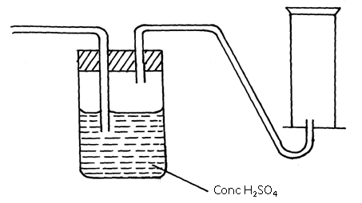

ii) – Catalyst Nickel

- Temperature 150ºC to 250ºC

iii) magnesium is very expensive

it gives a mixture of gases including bad smelling and poisonous hydrogen sulphide

CuSO4. 5H2O

v) – Manufacture of ammonia

- Manufacture of hydrochloric acid

- Welding and cutting of metals

- Rocket fuel and in fuel cells.

b) i) Slowly to allow ample time for reaction repeatedly to ensure all active air (oxygen) is used up

ii) The brown copper turnings slowly changed black.

iii) 

 = 20.41667%

6. (a) B – 2 : 8 √ ½

D – 2 : 8 : 8√ ½

(b) (i) D √ ½

(ii) E √ ½

(c ) Atomic radius of B is larger √1 than that of C. C has more protons. The outer energy level electrons are pulled √1 strongly to the nucleus reducing the atomic size.

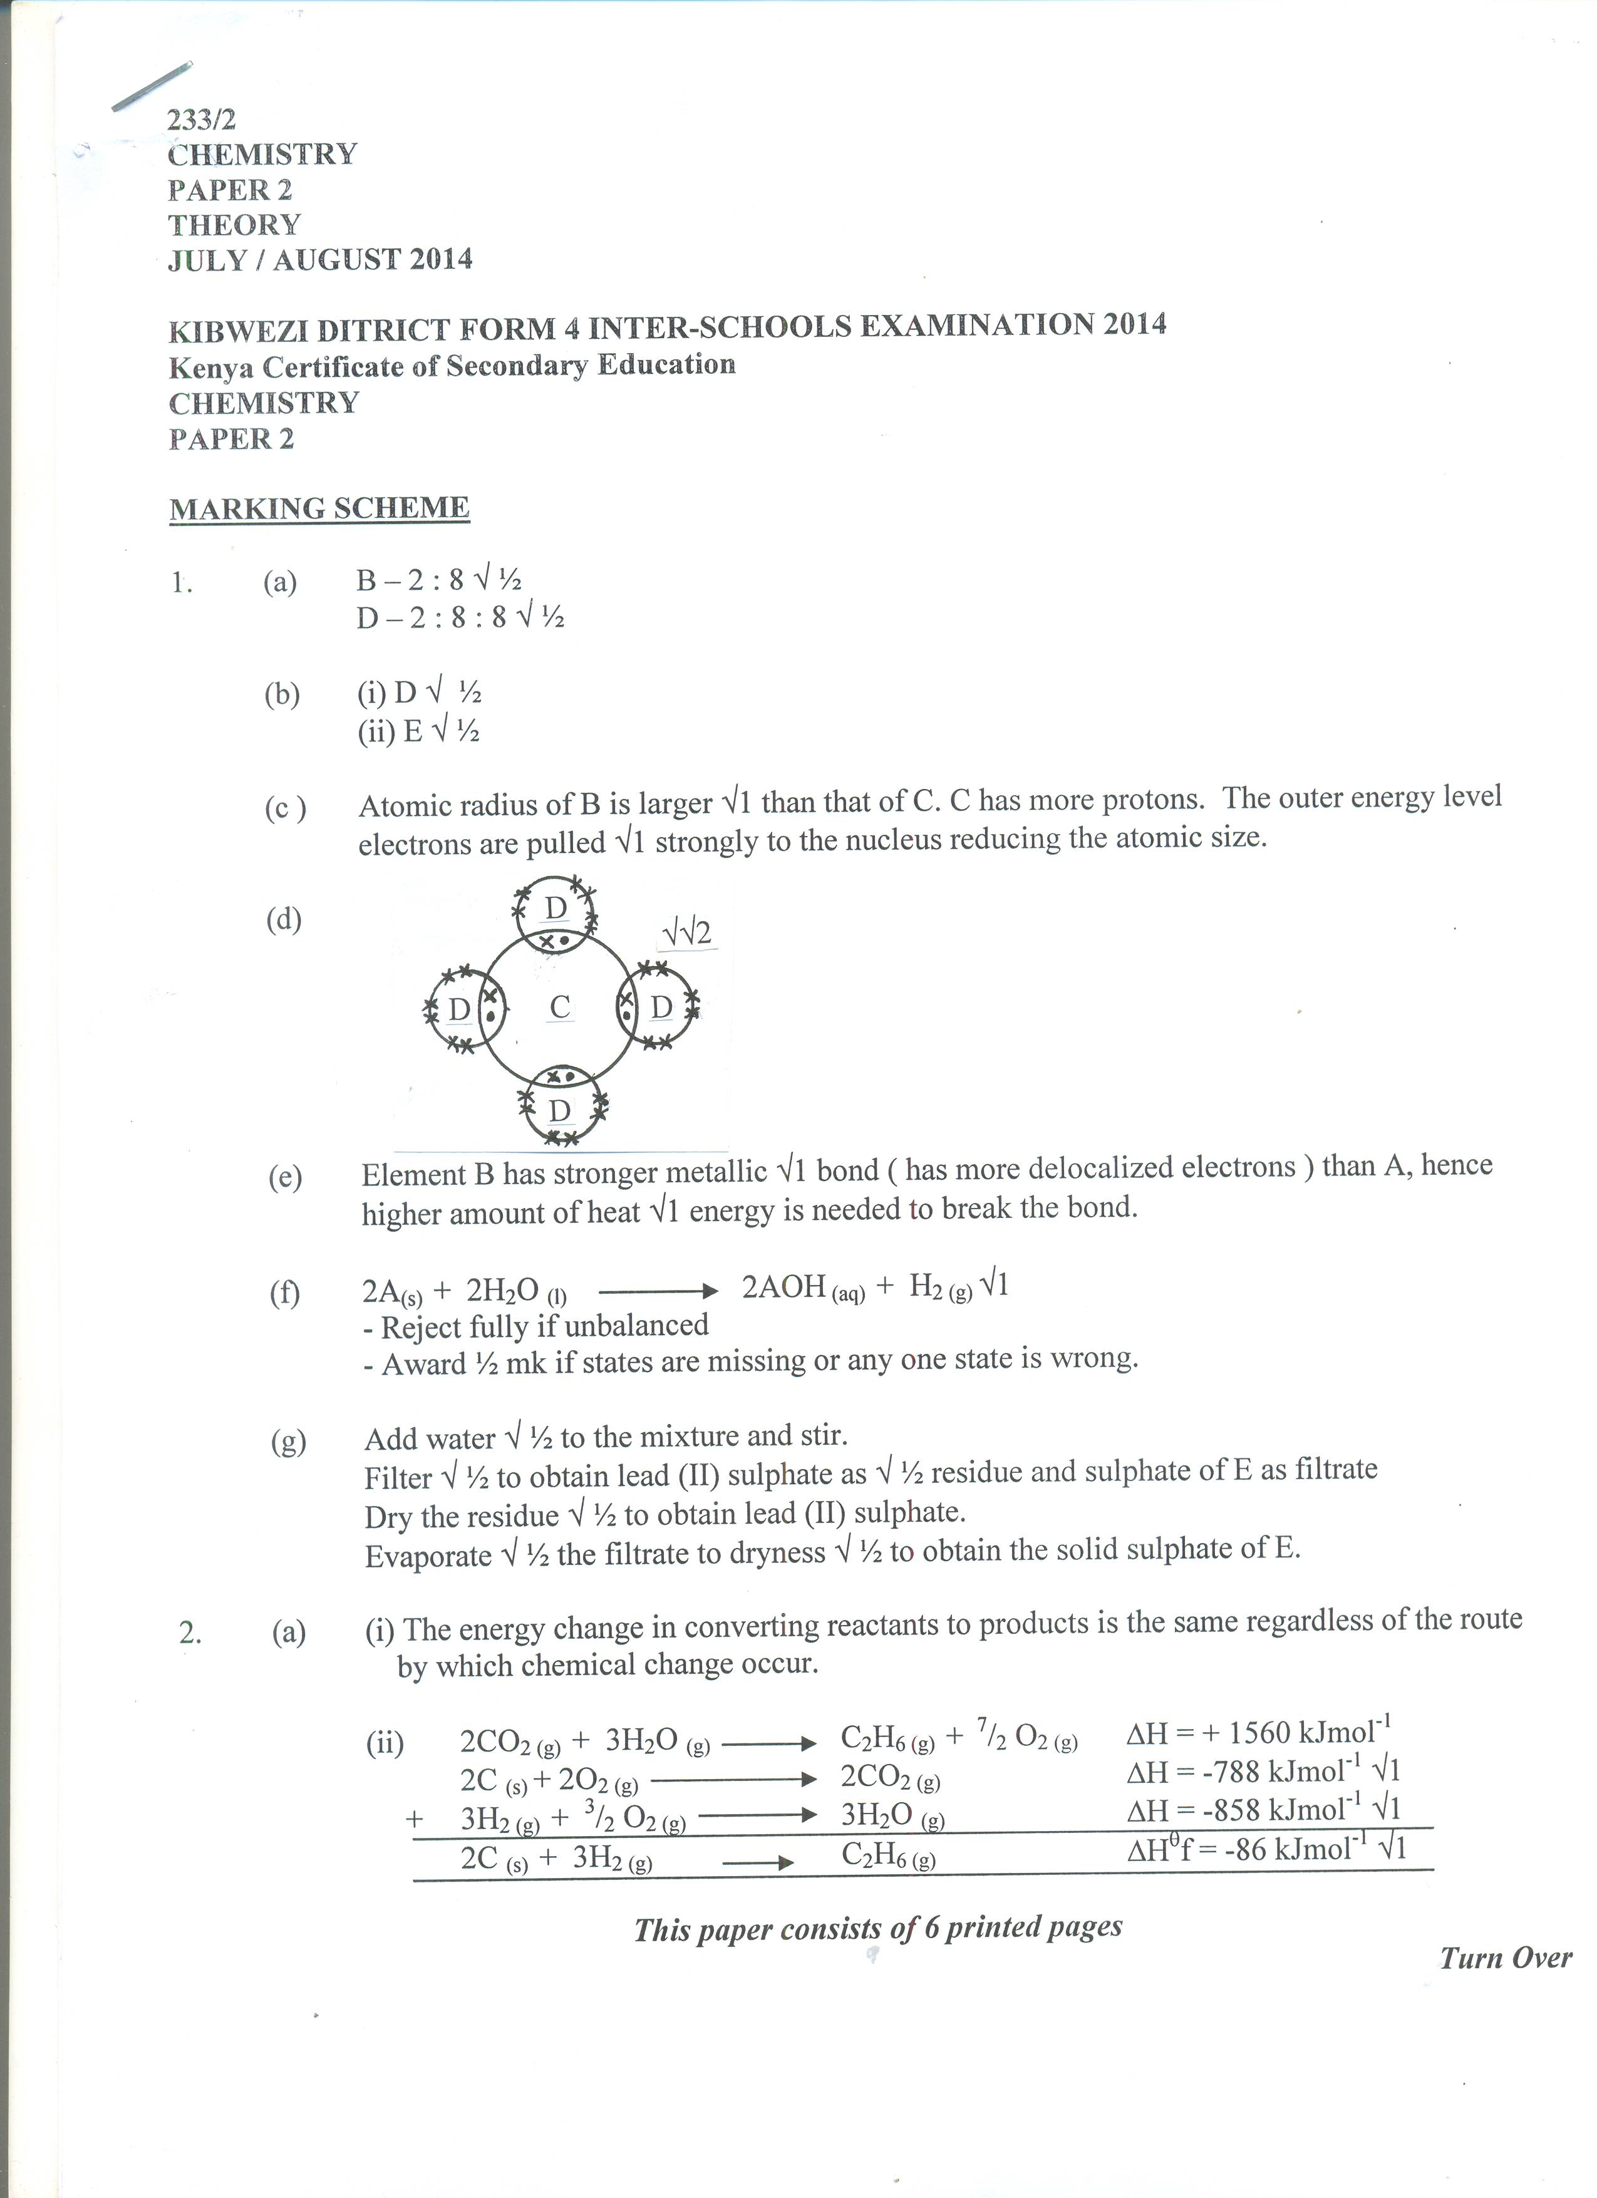

(d)

(e) Element B has stronger metallic √1 bond ( has more delocalized electrons ) than A, hence higher amount of heat √1 energy is needed to break the bond.

(f) 2A(s) + 2H2O (l)  2AOH (aq) + H2 (g) √1

- Reject fully if unbalanced

- Award ½ mk if states are missing or any one state is wrong.

(g) Add water √ ½ to the mixture and stir.

Filter√ ½ to obtain lead (II) sulphate as √ ½ residue and sulphate of E as filtrate

Dry the residue √ ½ to obtain lead (II) sulphate.

Evaporate √ ½ the filtrate to dryness √ ½ to obtain the solid sulphate of E.

1. Ethylpropanoate
2. But-2,3-diene

b) i) A - yeast √1 (1mk)

I - fractional distillation (1mk)

B - Sodium ethoxide (1mk)

C - Hydrogen ( 1mk)

D - Ethene (1mk)

E – polyethene / polythene (1mk)

(4mks)

iii) I : C6H12O6 →2C2H5O +2CO2 √ (1mk)

II  (3mks)