SUKELLEMO JOINT EXAMINATION
CHEMISTRY PAPER 1
JUNE 2022- 2 HOURS
Name------------------------------------ School-------------------------
Class--------------------------------------Index number------------------
Instructions to candidates
- Answer all the questions in the spaces provided on the question paper.
- Non programmable silent electronic calculators and KNEC mathematical tables may be used.
- All working must be clearly shown where necessary.

For examiners use only

Question | Maximum Score | Candidate’s score

- The element Y is represented by ²⁷₁₃ Y.
- What does letter Y represent? (1 mark)

- What name and symbol is given to the superscript and what does it represent? (1 mark)

- Element W (not the actual symbol) belongs to period 3 and group VI of the periodic table. Write the formula of its most stable ion. (1 mark)

- An alkanol has the following composition by mass: Hydrogen 13.5%, Oxygen 21.6% and Carbon 64.9%)
  - Determine the empirical formula of the alkanol. (C=12, H=1, O=16) (2 marks)

  - Given that the empirical formula and the molecular formula of the alkanol are the same, draw the structure of the alkanol. (1 mark)

- With the help of an equation, show how chlorine water bleaches (1 mark)

- The table below gives the ionization energies of group I elements.
Element | I | II | III | IV
Ionization energy (kJ/mole) | 94 | 418 | 519 | 576

Arrange the elements in order of reactivity starting with the most reactive ( 1 mark )

- Oxygen and Sulphur belong to group VI of the periodic table. Explain why there is a big difference in their melting points (melting point of Oxygen is -216ºC while that of Sulphur is 114ºC) (2 marks)

- Heated iron can react with both Chlorine gas and hydrogen chloride gas. Write an equation for each reaction (2 marks)

- Distinguish between a covalent bond and a co-ordinate bond (2 marks)

- Draw a dot (.) and cross (X) diagram of an Oxygen molecule (O₂) given that oxygen has an atomic number of 8. (2 marks)

- a) Differentiate between a strong acid and a concentrated acid ( 2 marks)

b). Identify the acid in the forward reaction given by the equation below. Explain ( 2 marks)
HSO₄⁻_{(aq)} + H₂O_{(i)} H₂SO_{4 (aq)} + OH⁻_{(aq)}
Acid

Reason

- Describe how a sample of Lead (II) chloride can be prepared in the laboratory starting with Lead metal. ( 3 marks )

- The table below gives information on four elements represented by the letters K, L, M and N. Study it and answer the questions that follow. The letters do not represent the actual symbol of the elements.

Element | Electron Arrangement | Atomic Radius (nm) | Ionic Radius
K | 2.8.2 | 0.136 | 0.065
L | 2.8.7 | 0.099 | 0.181
M | 2.8.8.1 | 0.203 | 0.133
N | 2.8.8.2 | 0.174 | 0.099

- Which two elements have similar chemical properties? Explain (2 marks)

- What is the most likely formula of the oxide of L? (1 mark)

- Which element is a non-metal? (1 mark)

- a) Define a binary electrolyte. (1 mark)

- Solid Lead (II) Iodide does not conduct electricity, but fused Lead (II) Iodide does. Explain. (2 marks)

- Write a half equation for what is formed at the cathode in the reaction above. (1 mark)

- The diagram below shows a setup that can be used to obtain nitrogen gas in an experiment.

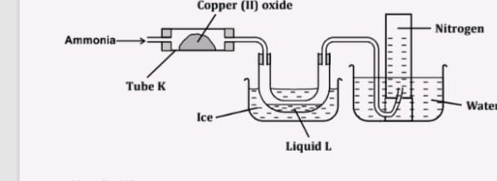

- Name liquid L (1 mark)

- What observation would be made in tube K after heating for some time?
(1 mark)

- Write an equation for the reaction that took place in tube K
(1 mark)

- 60cm³ of Oxygen gas diffused through a porous partition in 50 seconds. How long would it take 60cm³ of Sulphur (IV) Oxide gas to diffuse through the same partition under the same conditions?
(S=32, O=16)
(2 marks)

- 30cm³ of 0.06M Sodium Hydroxide reacted with 25cm³ of a dibasic acid HOOC(CH₂)_{x}COOH containing 4g/litre. Calculate the value of X .
( C=12, H=1 O=16, Na=23). (3 marks)

- Water from a town in Kenya is suspected to contain sulphate. Describe how the presence of sulphate ions in the water can be tested. (2 marks)

- The figure below was set up by a student to investigate the reaction between chlorine gas and hydrogen sulphide gas.

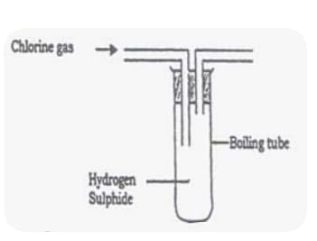

- Write an equation for the reaction that took place in the flask. (1mark)

- What observation was made in the flask? (1 mark)

- What precaution should be taken when carrying out the experiment? ( 1 mark)

- Describe how Sulphur is extracted by the frasch process (2 marks)

- a) State Gay Lussac’s law (1 mark)

- 250cm³ of Ammonia reacted with 350cm³ of Oxygen gas to form 200cm³ of Nitrogen (II) Oxide and 300cm³ of steam. 50cm³ of Oxygen remained unreacted. Determine the equation for the reaction. (2 marks)

- Wooden splints F and G were placed in different zones of a Bunsen burner flame. The diagram below gives the observations that were made.
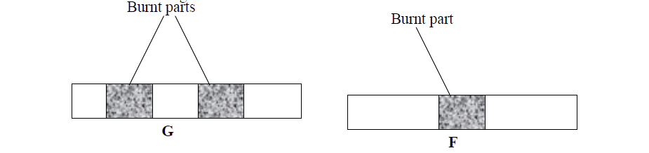

- Explain the difference between F and G. (2 marks)

- Name the type of flame that was used in the above experiment. (1 mark)

- 1g of potassium carbonate was placed in two different tubes. 2M sulphuric (VI) acid was added into one test of the tubes and in the other test tube 2M ethanoic acid was added. Explain the observations that were made. ( 3 marks).

- Draw a set up of apparatus to show how dry sulphur (IV) oxide can be prepared in the laboratory starting with dilute hydrochloric acid. ( 3 marks)

- Give the formula of the polymer formed from the following monomers.
- H₂N – R – NH₂ and HOOC – R – COOH (1 mark)

- Name the type of polymerization shown in (i) above (1 mark)

- What substance is lost during the polymerization named above? (1 mark)

- Study the diagram below and answer the questions that follow.
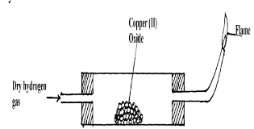

- Why is it necessary to pass hydrogen through the tube before lighting the hydrogen gas?(1 mark)

- After reduction is complete, the apparatus is allowed to cool while hydrogen is still passed over the reduced oxide. Explain (1 mark)

- Name another gas that can be used to reduce the metal oxide other than hydrogen. (1 mark)

- The table below shows solubility of two salts A and B at different temperatures.
Temp (⁰C) | Salt | 0 | 10 | 20 | 30 | 40 | 50
Solubility (g/100g H₂O) | A | 3.0 | 5.0 | 7.4 | 10.0 | 14.0 | 19.0
 | B | 15.0 | 17.0 | 20.7 | 28.7 | 29.9 | 33.3

- If both A and B were present in 100 cm³ of a saturated solution at 50⁰ C. What would be the total mass of crystals formed if the solution is cooled to 20⁰ C. (2 marks)

- Solubility of gases decreases as the temperature increases. Explain. (1 mark)

- A certain salt C dissolves with absorption of heat from the surroundings. How would its solubility change with an increase in temperature? Explain.(2 marks)

- The scheme below was used to prepare a cleansing agent. Study it and answer the questions that follow:
Solution of cleansing agent and an alcohol
NaoH(step 1)

Step 2
fat

Solid cleansing agent

- Name the category of cleansing agent prepared by the method above.(1 mark)

- Name one chemical substance added in step 2.(1 mark)

- What is the purpose of adding the chemical substance named in ii) above (1 mark)

- Name another suitable substance to be used in step 1. (1 mark)

- Melting and boiling points of Hexanoic acid is higher than hexan-1-ol. Explain. (1 mark)

- Classify the following processes as chemical changes or physical changes.
- Neutralization

- Sublimation

- Fractional distillation

- Displacement
(2 marks)
- Study the heating curve below and answer the questions that follow:
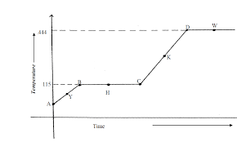

- What physical changes occur at H and W? ( 1 mark )

- Explain what happens to the melting point if sodium chloride is added to this substance.( 1 mark)

- Give the names of the intermolecular forces of attraction in the segments: (1 mark)
- AB

- CD

