NAME…………………………………………………… CLASS………. ADM NO…..…….
DATE……………………………… SIGN………………………………….
231/2 BIOLOGY PAPER 2 THEORY JUNE 2022 TIME: 2 HOURS

SUKELLEMO JOINT EXAMS BIOLOGY EXAMINATIONS Kenya Certificate of Secondary Education (K.C.S.E)

INSTRUCTIN TO CANDIDATES
- Write your name and index number in the spaces provided above. - Sign and write the date of examination in the spaces provided above. - This paper consists of two sections A and B. - Answer all the questions in Section A in the spaces provided. - In section B answer questions 6 (compulsory) and either question 7 or 8 in the spaces. provided.
For examiner’s use only
SECTION | QUESTIONS | MAXIMUM SCORE | CANDIDATES SCORE
A | 1 | 8
 | 2 | 8
 | 3 | 8
 | 4 | 8
 | 5 | 8
B | 6 | 20
 | 7 | 20
 | 8 | 20
 | TOTAL | 80

SECTION A (40MKS)
1. A group of students set up an experiment to investigate a certain physiological process. The set up was as shown in the diagram below.
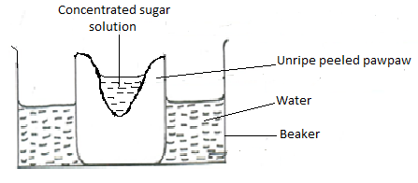

After some time, the students observed that the level of sugar solution had risen.
(a) What physiological process was being investigated? (1mk)
………………………………………………………………………………………………………
(b) Account for the rise in the level of sugar solution in this experiment. (4mks)
………………………………………………………………………………………………………
………………………………………………………………………………………………………
………………………………………………………………………………………………………
………………………………………………………………………………………………………
………………………………………………………………………………………………………
………………………………………………………………………………………………………
(c) (i) State the results the students would obtain if they repeated the experiment using a piece of boiled pawpaw. (1mk)
………………………………………………………………………………………………………
………………………………………………………………………………………………………
(ii) Give a reason for your answer in (c) (i) above. (2mks)
………………………………………………………………………………………………………
………………………………………………………………………………………………………
2. Use the diagram below to answer the questions that follow. 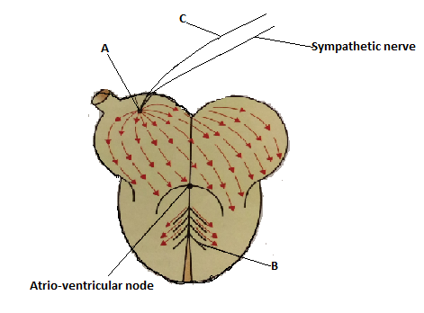
(a) (i) Name the parts labelled A, B and C. (3mks)
A…………………………………………………………………………………………………….
B…………………………………………………………………………………………………….
C……………………………………………………………………………………………………
(b) State the function of the part labelled C. (1mk)
………………………………………………………………………………………………………
(c) Explain the difference between pulmonary circulation and systemic circulation. (2mks)
………………………………………………………………………………………………………
………………………………………………………………………………………………………
………………………………………………………………………………………………………
………………………………………………………………………………………………………
(d) What is the advantage of having a double circulatory system over a single circulatory system? (2mks)
………………………………………………………………………………………………………
………………………………………………………………………………………………………
………………………………………………………………………………………………………
………………………………………………………………………………………………………
3. In an investigation, a variety of pea plants grown from seeds with smooth coats were crossed with plants grown from seeds with wrinkled coats. All the seeds obtained in the first filial (F1) generation had smooth seed coats.
(a) Using letter R to represent the gene for smooth seed coat, work out the genotypes of the F1generation. Show your working. (3mks)

(b) If F1 generation was selfed, determine the phenotypic ratio of the second filial (F2) generation. Show your working. (4mks)

(c) If the total number of seeds in the F2 generation was 14640, calculate the number of seeds with wrinkled coats. Show your working. (1mk)

4. The apparatus below was set up by a student to find out the changes in gases during germination of bean seeds. Study it and answer the questions that follow.
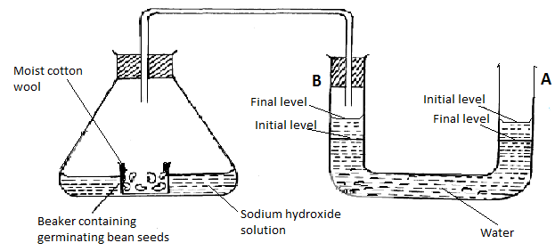
(a) After 48 hours the level of water in U-tube A had dropped and rose in B as indicated above. Explain this observation. (3mks)
………………………………………………………………………………………………………
………………………………………………………………………………………………………
………………………………………………………………………………………………………
………………………………………………………………………………………………………
………………………………………………………………………………………………………
(b) The equation below shows the process that takes place in mammalian muscles.
2C₅₁H₉₈O₆ + 145O₂ 102CO₂ + 98H₂O + Energy
(i) Calculate the respiratory quotient from the equation above. (2mks)

(ii) Identify the substrate being respired from the equation above. (1mk)
………………………………………………………………………………………………………
(iii) Explain why it is difficult to calculate the respiratory quotient in plants. (2mks)
………………………………………………………………………………………………………
………………………………………………………………………………………………………
………………………………………………………………………………………………………
5. The diagram below illustrates the components of a simple reflex that takes place when a person’s finger is accidentally pricked by a sharp pin.

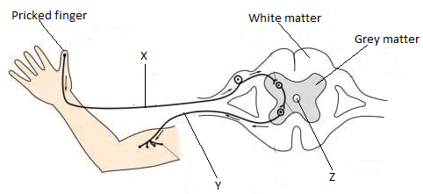
(a) Name the neurones labelled X and Y. (2mks)
X…………………………………………………………………………………………………….
Y.……………………………………………………………………………………………………
(c) State one function of the fluid found in the part labelled Z. (1mk)
………………………………………………………………………………………………………
(c) Explain how the above simple reflex action takes place. (5mks)
………………………………………………………………………………………………………
………………………………………………………………………………………………………
………………………………………………………………………………………………………
………………………………………………………………………………………………………
………………………………………………………………………………………………………
………………………………………………………………………………………………………
………………………………………………………………………………………………………
SECTON B (40 MKS)
Answer question 6 (compulsory) and either question 7 or 8 in the spaces provided.
6. In a population growth, two species of flour beetles, Tribulum confusum and Tribulum casteanum were grown in a box with unlimited supply of flour (food). The box was kept at 24⁰C and 30% relative humidity. The beetles were counted at certain intervals and the results tabulated as shown below.
No. of days after introduction |  | 0 | 10 | 50 | 60 | 80 | 100 | 120 | 140 | 180 | 200
No. of beetles present in the box. | T. confusum | 20 | 20 | 300 | 800 | 1330 | 1440 | 1620 | 1600 | 1620 | 1600
 | T. casteanum | 20 | 20 | 300 | 430 | 500 | 400 | 150 | 60 | 20 | 10

(a) Using the same axis, draw graphs of number of beetles in the box against time. (8mks)

(b) How many beetles were present on the 76th day? (2mks)
(i) T. confusum..............................................................................................................................
(ii) T. casteanum...........................................................................................................................
(c) Account for the shape of T. confusum curve between day 1 and 180. (5mks)
………………………………………………………………………………………………………
………………………………………………………………………………………………………
………………………………………………………………………………………………………
………………………………………………………………………………………………………
………………………………………………………………………………………………………
………………………………………………………………………………………………………
………………………………………………………………………………………………………
(d) (i) What happens to T. casteanum between day 80 and 160? (1mk)
………………………………………………………………………………………………………
………………………………………………………………………………………………………
(ii) What biological phenomenon is represented by observation in (d) (i) above? (1mk)
………………………………………………………………………………………………………
………………………………………………………………………………………………………
(e) State any three factors that determine the distribution of animals in their habitat. (3mks)
………………………………………………………………………………………………………
………………………………………………………………………………………………………
………………………………………………………………………………………………………
………………………………………………………………………………………………………

7. (a) Explain how the human ileum is adapted to its function. (10mks)
(b) Explain the role of the liver in regulation of blood sugar. (10mks)

8. (a) Explain the economic importance of fungi. (9mks) ( (b) Describe the adaptations of flowers to insect pollination. (11mks)
………………………………………………………………………………………………………
………………………………………………………………………………………………………
………………………………………………………………………………………………………
………………………………………………………………………………………………………
………………………………………………………………………………………………………
………………………………………………………………………………………………………
………………………………………………………………………………………………………
………………………………………………………………………………………………………
………………………………………………………………………………………………………
………………………………………………………………………………………………………
………………………………………………………………………………………………………
………………………………………………………………………………………………………
………………………………………………………………………………………………………
………………………………………………………………………………………………………
………………………………………………………………………………………………………
………………………………………………………………………………………………………
………………………………………………………………………………………………………
………………………………………………………………………………………………………
………………………………………………………………………………………………………
………………………………………………………………………………………………………
………………………………………………………………………………………………………
………………………………………………………………………………………………………
………………………………………………………………………………………………………
………………………………………………………………………………………………………
………………………………………………………………………………………………………
………………………………………………………………………………………………………
………………………………………………………………………………………………………
………………………………………………………………………………………………………
………………………………………………………………………………………………………
………………………………………………………………………………………………………
………………………………………………………………………………………………………
………………………………………………………………………………………………………
………………………………………………………………………………………………………
………………………………………………………………………………………………………
………………………………………………………………………………………………………
………………………………………………………………………………………………………
………………………………………………………………………………………………………
………………………………………………………………………………………………………
………………………………………………………………………………………………………
………………………………………………………………………………………………………
………………………………………………………………………………………………………
………………………………………………………………………………………………………
………………………………………………………………………………………………………
………………………………………………………………………………………………………
………………………………………………………………………………………………………
………………………………………………………………………………………………………
………………………………………………………………………………………………………
………………………………………………………………………………………………………
………………………………………………………………………………………………………
………………………………………………………………………………………………………
………………………………………………………………………………………………………
………………………………………………………………………………………………………
………………………………………………………………………………………………………
………………………………………………………………………………………………………
………………………………………………………………………………………………………
………………………………………………………………………………………………………
**********************************LAST PRINTED PAGE*************************************

