SUKELLEMO BIO PP2 MS
1. A group of students set up an experiment to investigate a certain physiological process. The set up was as shown in the diagram below.
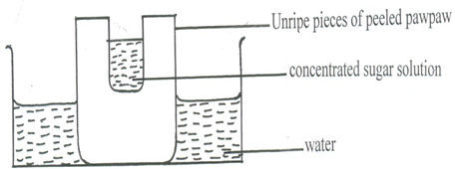

After some time, the students observed that the level of sugar solution had risen.
(a) What physiological process was being investigated? (1mk)
Osmosis
(b) Account for the rise in the level of sugar solution in this experiment. (4mks)
Sugar solution is hypertonic to the cell sap of adjacent cells of the pawpaw; water is drawn from the adjacent cells through osmosis; adjacent cells become hypertonic than their neighbouring cells and draws water; process continues until peripheral cells become concentrated and draws water from the beaker; causing rise in level of sugar solution;
(c) (i) State the results the students would obtain if they repeated the experiment using a piece of boiled pawpaw. (1mk)
Sugar solution level will not rise / remain the same.
(ii) Give a reason for your answer in (c) (i) above. (2mks)
Boiling kills the cells; making them osmotically inactive;
2. Use the diagram below to answer the questions that follow. 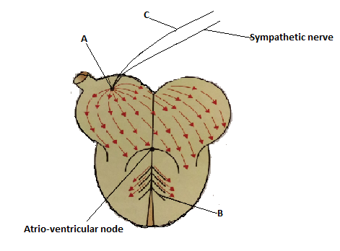
(a) (i) Name the parts labelled A, B and C. (3mks)
A – Sino atrial node
B – Purkinje tissue
C – Vagus nerve
(b) State the function of the part labelled C. (1mk)
Slows down the rate of the heartbeat;
(c) Explain the difference between pulmonary circulation and systemic circulation. (2mks)
Pulmonary circulation is the flow of deoxygenated blood to the lungs via pulmonary artery and oxygenated blood from the lungs to the heart via pulmonary vein; while systemic circulation is the flow of oxygenated blood from the heart to the rest of the body tissues via aorta and deoxygenated blood from the body tissues to the heart via venacova;
(d) What is the advantage of having a double circulatory system over a single circulatory system? (2mks)
- Blood is pumped under high pressure hence nutrients and oxygen reach the tissues faster; - Oxygenated and deoxygenated blood does not mix;
3. In an investigation, a variety of pea plants grown from seeds with smooth coats were crossed with plants grown from seeds with wrinkled coats. All the seeds obtained in the first filial (F1) generation had smooth seed coats.
(a) Using the letter R to represent the gene for smooth seed coat, work out the genotypes of the
F1generation. Show your working. (3mks)
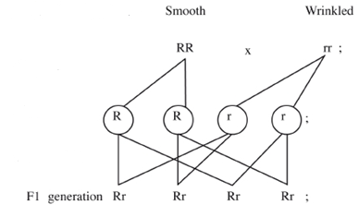
(b) If F1 generation was selfed, determine the phenotypic ratio of the second filial (F2) generation. Show your working. (4mks)
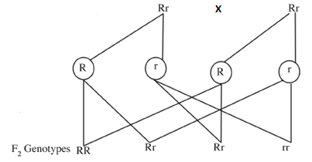
Phenotypic ratio; 3 smooth coats : 1 wrinkled coat
(c) If the total number of seeds in the F2 generation was 14640, calculate the number of seeds with wrinkled coats. Show your working. (1mk)
The total number of wrinkled seeds.
1/4 x 14,640 = 3660;
4. The apparatus below was set up by a student to find out the changes in gases during germination of bean seeds. Study it and answer the questions that follow.
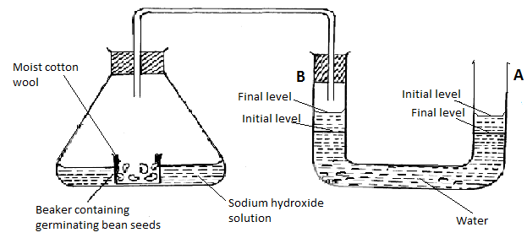
(a) After 48 hours the level of water in U-tube A had dropped and rose in B as indicated above. Explain this observation. (3mks)
Germinating seeds respired using oxygen and released carbon (IV) oxide; which was absorbed by sodium hydroxide; creating a partial vacuum inside conical flask leading to atmospheric pressure pushing water down in A and up in B;
(b) The equation below shows the process that takes place in mammalian muscles.
2C₅₁H₉₈O₆ + XO₂ 102CO₂ + 98H₂O + Energy
(i) Calculate the respiratory quotient from the equation above. (2mks)
Respiratory quotient = amount of carbon (IV) oxide used a amount of oxygen used
= 102 1 145
= 0.7 =
(ii) Identify the substrate being respired from the equation above. (1mk)
Lipids
(iii) Explain why it is difficult to calculate the respiratory quotient in plants. (2mks)
Carbon (IV) oxide produced during respiration is utilized in photosynthesis; oxygen produced during photosynthesis is used in respiration;

5. The diagram below illustrates the components of a simple reflex that takes place when a person’s finger is accidentally pricked by a sharp pin.

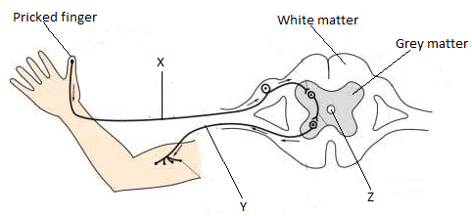
(a) Name the neurones labelled X and Y. (2mks)
X – Sensory neurone
Y – Motor neurone
(c) State one function of the fluid found in the part labelled Z. (1mk)
- Acts as shock absorber protecting the spinal cord from mechanical damage; - Provides oxygen and nutrients to the spinal cord;
(c) Explain how the above simple reflex action takes place. (5mks)
Pain receptors are stimulated to generate an impulse; which is transmitted to the spinal cord through the sensory neurone; the impulse is passed from the sensory neurone to the relay neurones across a synapse; then to the motor neurone across another synapse; The motor neurone then conveys the impulse to the biceps muscles; the biceps muscles contracts and the finger is withdrawn from the painful stimuli;

SECTON B (40 MKS)
Answer question 6 (compulsory) and either question 7 or 8 in the spaces provided.
6. In a population growth, two species of flour beetles, Tribulum confusum and Tribulum casteanum were grown in a box with unlimited supply of flour (food). The box was kept at 24⁰C and 30% relative humidity. The beetles were counted at certain intervals and the results tabulated as shown below.

No. of days after introduction |  | 0 | 10 | 50 | 60 | 80 | 100 | 120 | 140 | 180 | 200
No. of beetles present in the box. | T. confusum | 20 | 20 | 300 | 800 | 1330 | 1440 | 1620 | 1600 | 1620 | 1600
 | T. casteanum | 20 | 20 | 300 | 430 | 500 | 400 | 150 | 60 | 20 | 10
(a) Using the same axis, draw graphs of number of beetles in the box against time. (8mks)
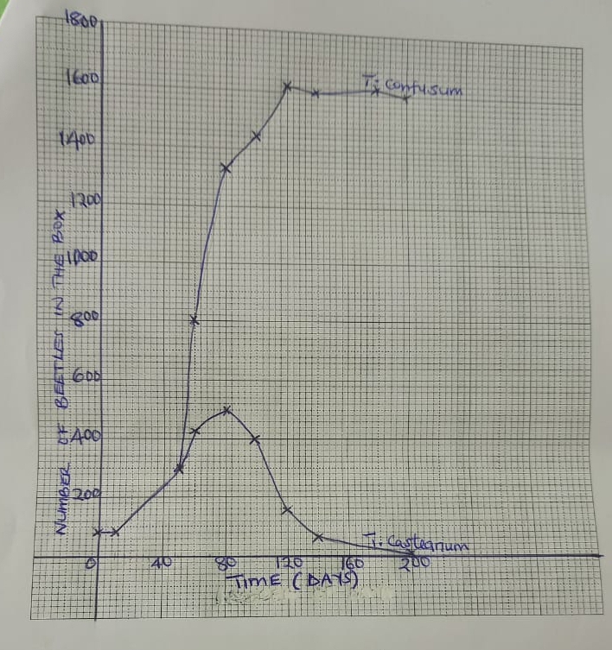
(b) How many beetles were present on the 76th day? (2mks)
(i) T. confusum – 1240 20
(ii) T. casteanum – 500 20
(c) Account for the shape of T. confusum curve between day 1 and 180. (5mks)
Day 1 to day 50, growth rate is slow; the beetles are still adapting to the new environment; the number of reproducing individuals is small;
Day 50 to day 120, growth rate is faster / rapid; the beetles have adapted to the environment; the number of reproducing beetles is high; food and space are unlimited hence no competition;
Day 120 to day 180, population growth is constant / no population change; number produced is equal to the number dying;
(d) (i) What happens to T. casteanum between day 80 and 160? (1mk)
Competitive exclusion;
(ii) What biological phenomenon is represented by observation in (d) (i) above? (1mk)
Competition / intra specific competition;
(e) State any three factors that determine the distribution of animals in their habitat. (3mks)
Food availability; Space availability; Predators; Mates;
7. (a) Explain how the human ileum is adapted to its function. (10mks)
- Long to increase SA for digestion & absorption of nutrients; - Highly coiled to slow down movement of food to allow more time for digestion and absorption; - Has villi and micro villi to increase SA for absorption; - Narrow lumen to bring digested food into close contact with walls of ileum for efficient absorption; - Has lacteal for absorption of fatty acids and glycerol; - Highly vascularised to create a steep concentration gradient for absorption; and transportation of nutrients; - Numerous mitochondria to yield energy for active absorption of nutrients; -Has thin epithelial lining to reduce absorption distance; -The epithelium has goblet cells which secret mucus that lubricates the food to reduce friction; and prevent autodigestion of gut wall; - Walls of ileum contain intestinal glands (crypts of Lieberkuhn) that secrete digestive intestinal enzymes that completes digestion of food;
(b) Explain the role of the liver in regulation of blood sugar. (10mks)
Normal amount of glucose in the blood is 90 mg/100cm³; Increase in blood glucose level is detected by beta cell in the pancreas; which secrete insulin hormone; insulin stimulates the liver cells to convert excess glucose glycogen; further excess glucose is converted to fats; increase oxidation of glucose to yield energy; and inhibit conversion of glycogen to glucose to lower blood sugar back to normal; Decrease in blood sugar level below normal is detected by alpha cells in the pancreas; which secrete glucagon hormone; that stimulate the liver cells to convert stored glycogen in muscles and liver to glucose; convert fats and amino acids to glucose; and reduce oxidation of glucose to raise blood sugar back to normal;
8. (a) Explain the economic importance of fungi. (9mks)
- Some cause food spoilage; - Some cause diseases to human e.g ring worm; - Some fungi e.g Penicillium is used in the production of antibiotics; - Some fungi e.g mushrooms are used as food; - Some cause diseases to crops e.g tomato plight; - Saprophytic fungi are important in nutrient recycling through decomposition; - Yeast is used in brewing of alcohol; and baking of bread; - Mycorrhizal association is important in forest development; - Some fungi produce toxic substances e.g Aspergillus flavus;
(b) Describe the adaptations of flowers to insect pollination. (11mks)
- Have large brightly coloured petals; which attract insects; - Presence of nectaries; that secrete sweet scented nectar; which serve as bait for the insects; - Have small; sticky stigma; which enables the pollen grains from the insects body to stick onto it; -Anthers are small; and held firmly onto the filaments; to ensure that the y don't break when the insects rub against them as they crawl into the flower; - Have large; heavy and sticky pollen grains so as to stick on the insects' body; - The anthers produce few but large grains; to increase the chances of their transfer to a stigma for pollination; -Flowers normally have shapes that are convenient for the insects body thus the insects land and fit comfortably e.g. flower petals forming a corolla tube;

